Luis Cortez
Date: June 7, 2026
Assignment: Module 1.2 – GitHub Repository Setup

- GitHub repository URL
https://github.com/LUISCORTEZUSA2018/csd-310.git

- Screenshot of GitHub repository
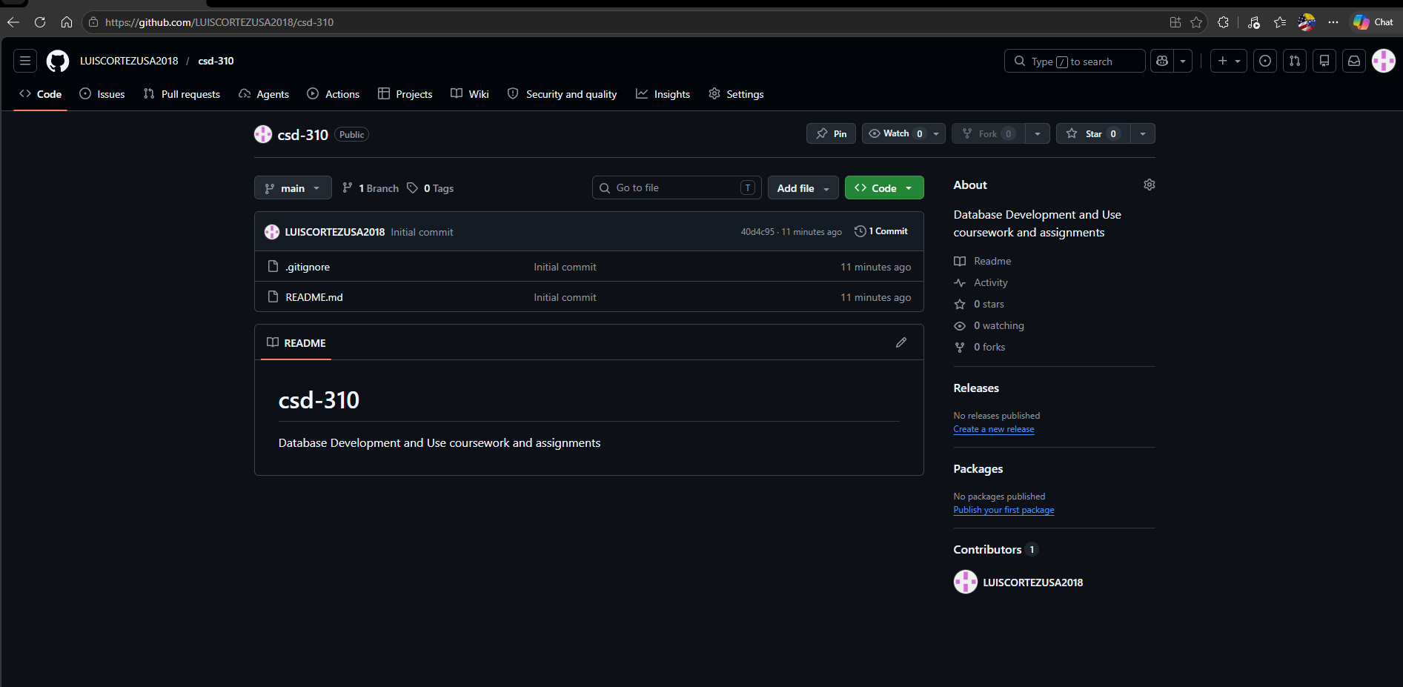

- Screenshot of local directory
