Luis Cortez
Module 2.2 Assignment – Documented Debugging + Flowchart
Date: June 13, 2026

- Flowchart
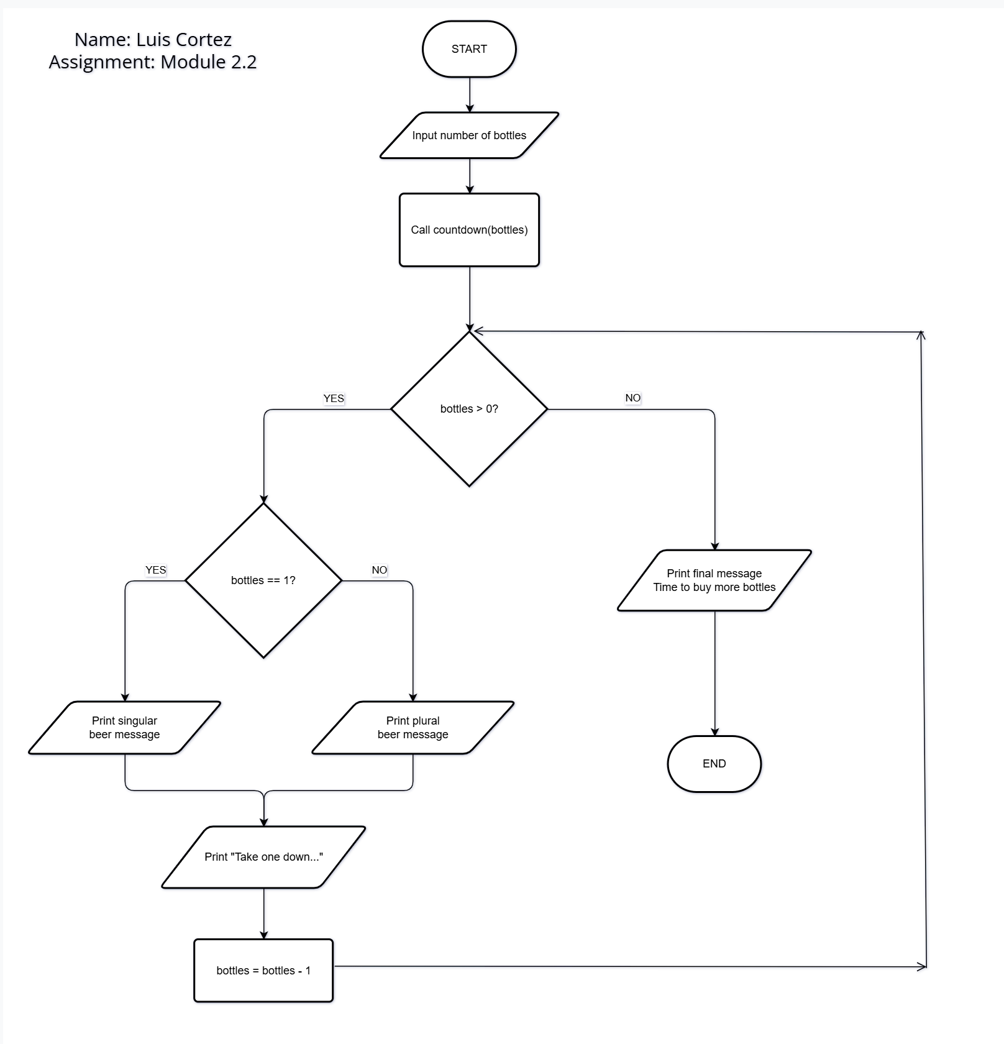

- Debugging documentation
Figure 1 – Breakpoint reached using pdb.set_trace()
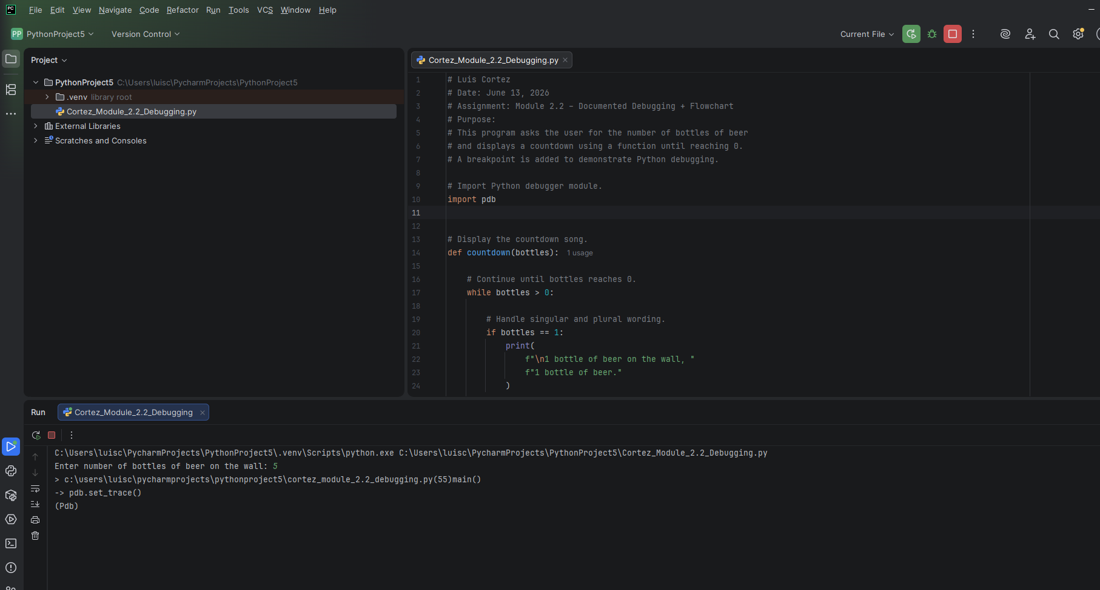

Figure 2 – Stepping through program execution using pdb (next command)
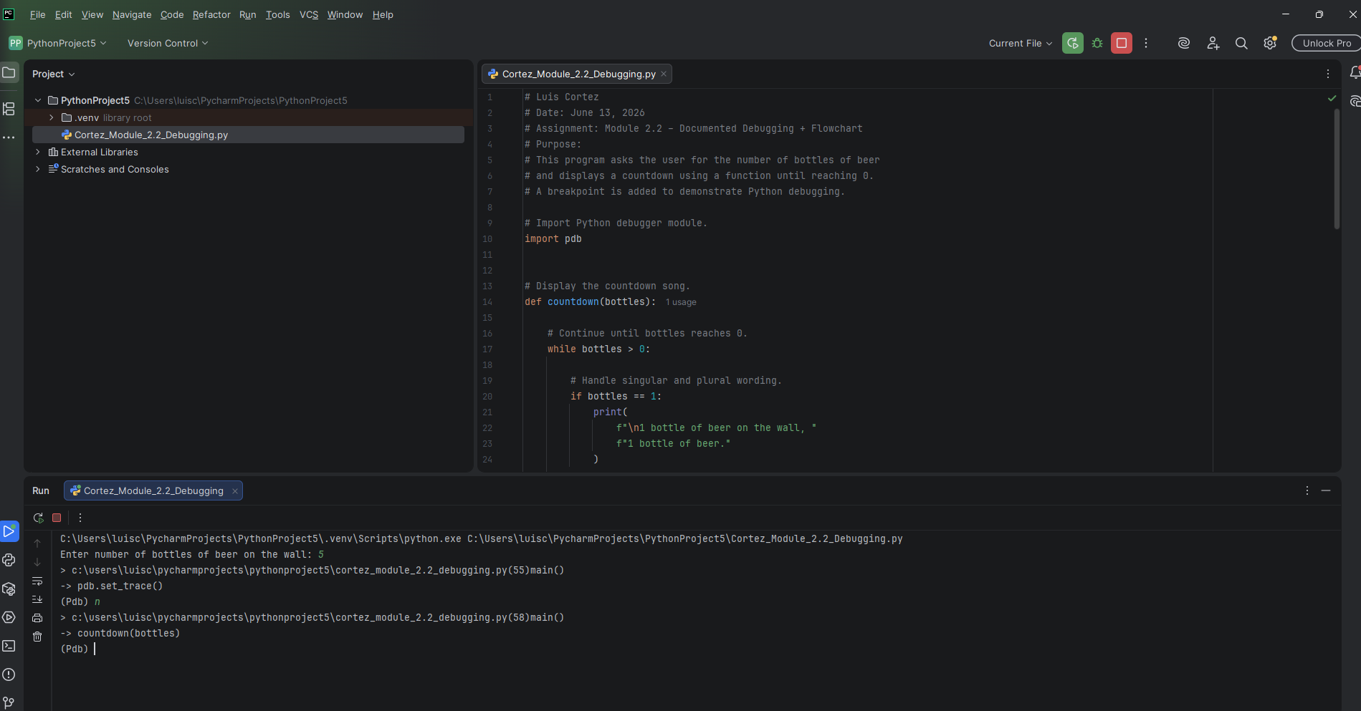

Figure 3 – Inspecting the value of the bottles variable
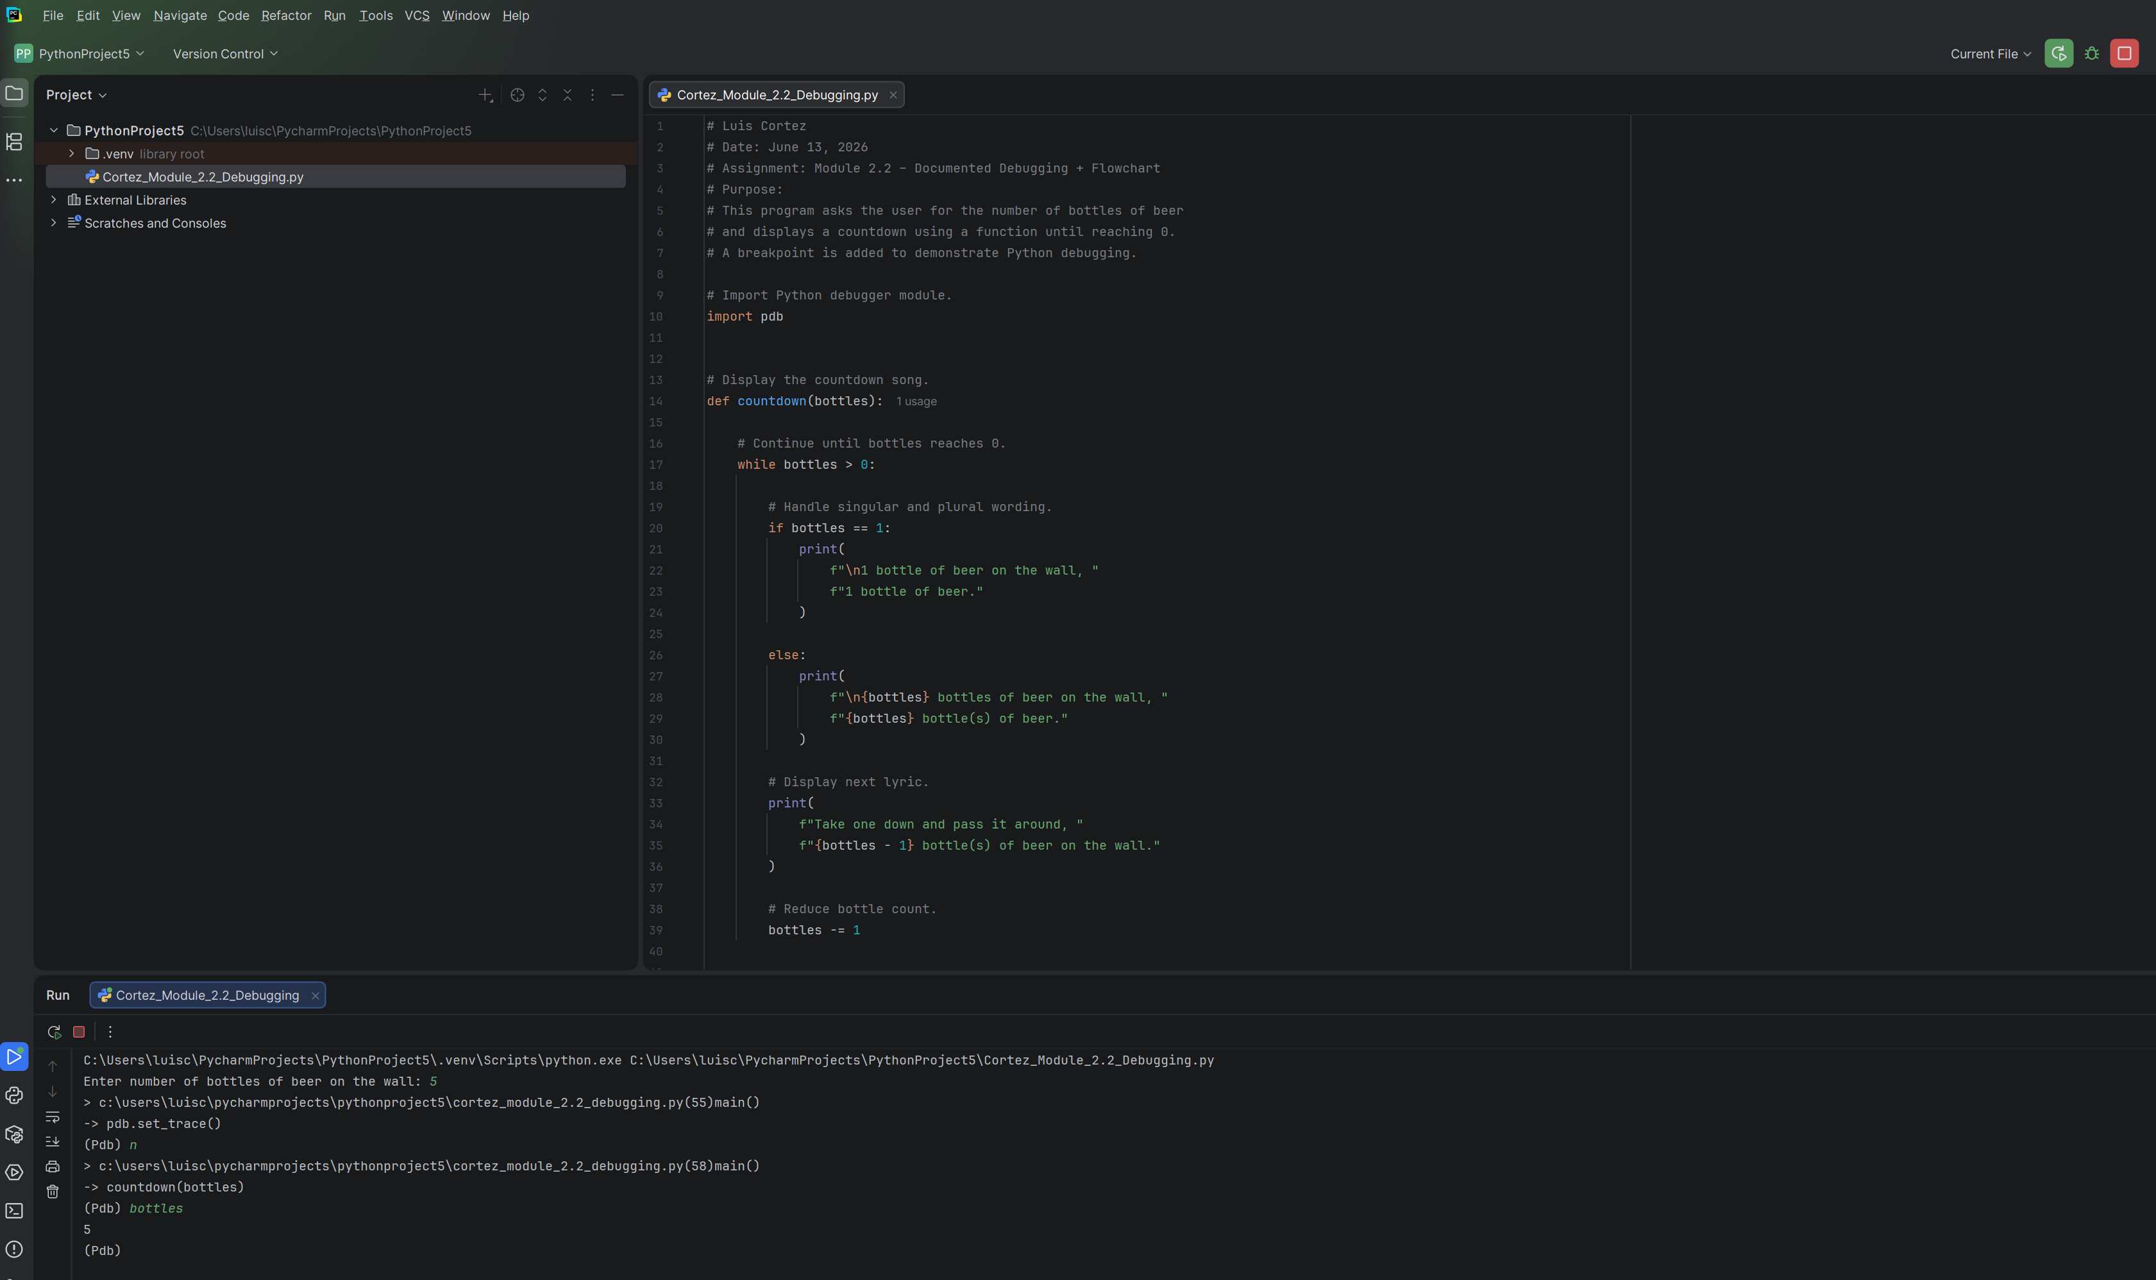

Figure 4 – Continuing execution after debugging using the continue command
