Luis Cortez
CSD-325: Advanced Python Programming
Module 5.2 Assignment – Forest Fire Simulation Flowchart
June 29, 2026

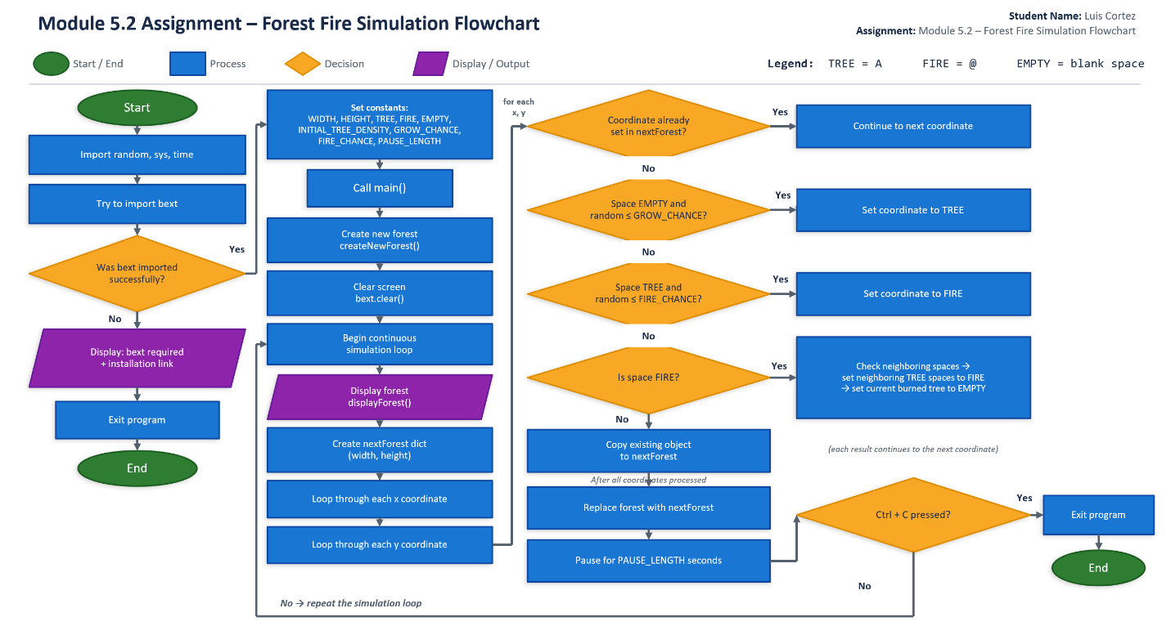
Figure 1. Forest Fire Simulation flowchart illustrating the execution flow of forestfiresim.py.

