Luis Cortez
CSD-325: Advanced Python Programming
Module 4.2 Assignment – High/Low Temperatures
June 29, 2026

Original Program Flowchart
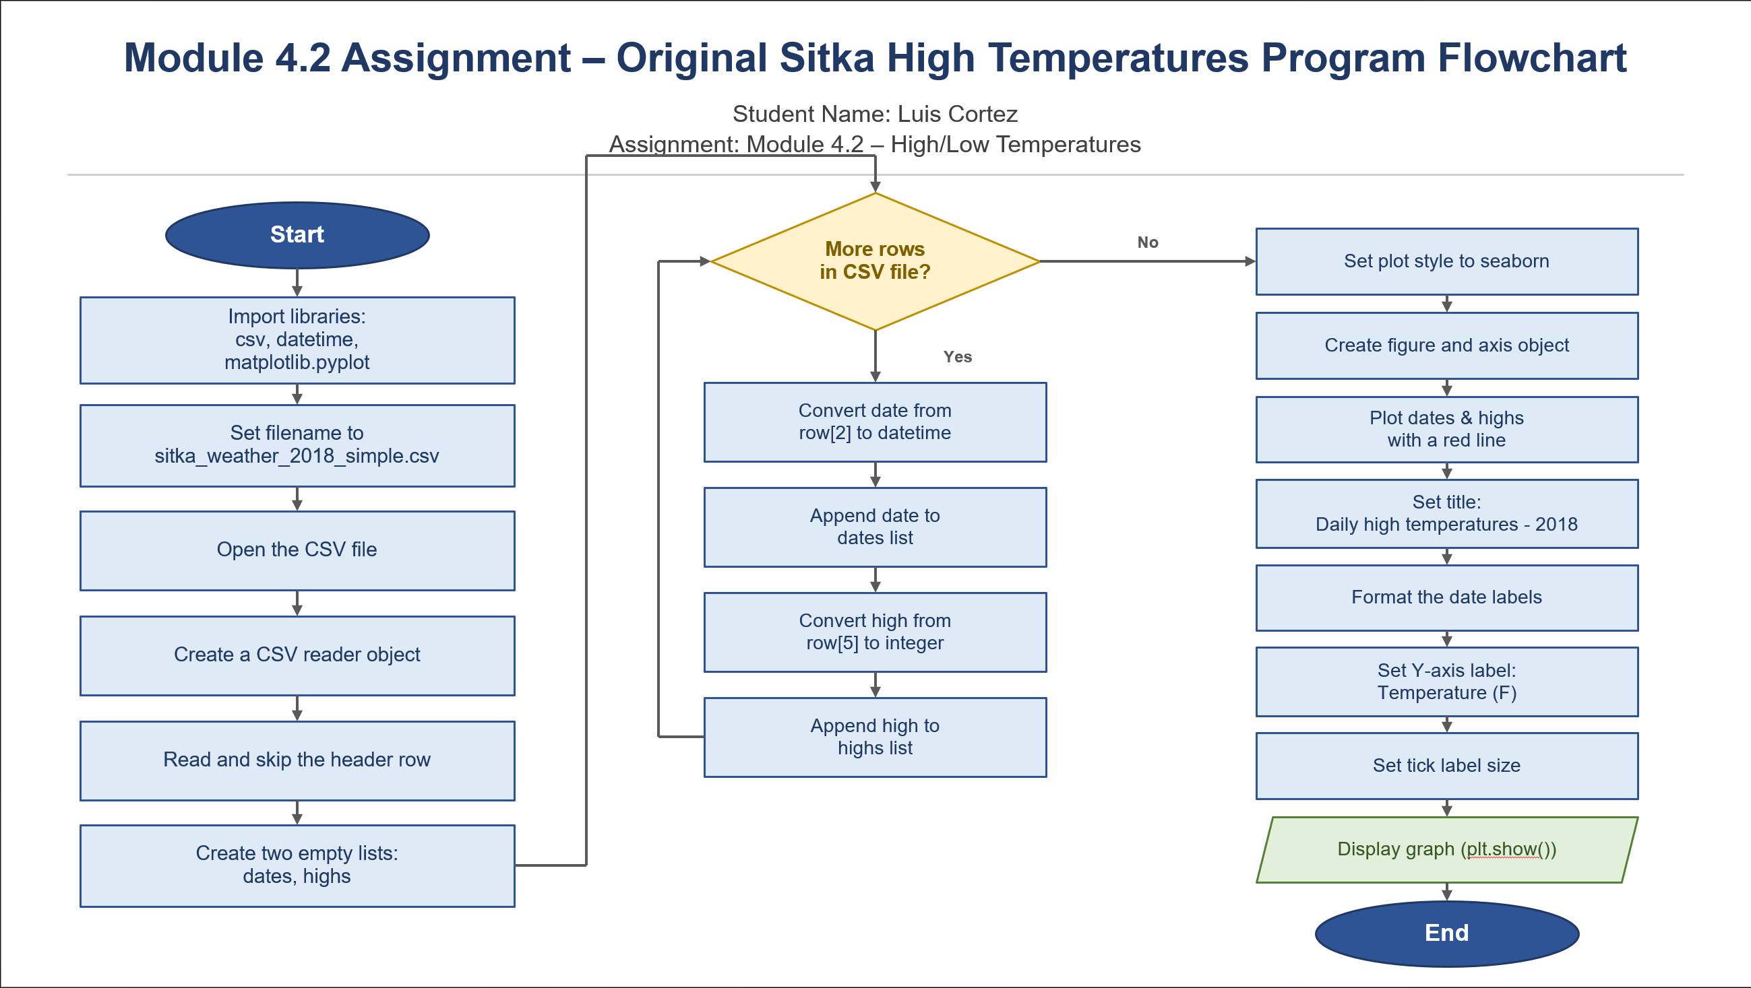
Figure 1. Original flowchart illustrates the execution of the provided sitka_highs.py program.

Revised Program Flowchart
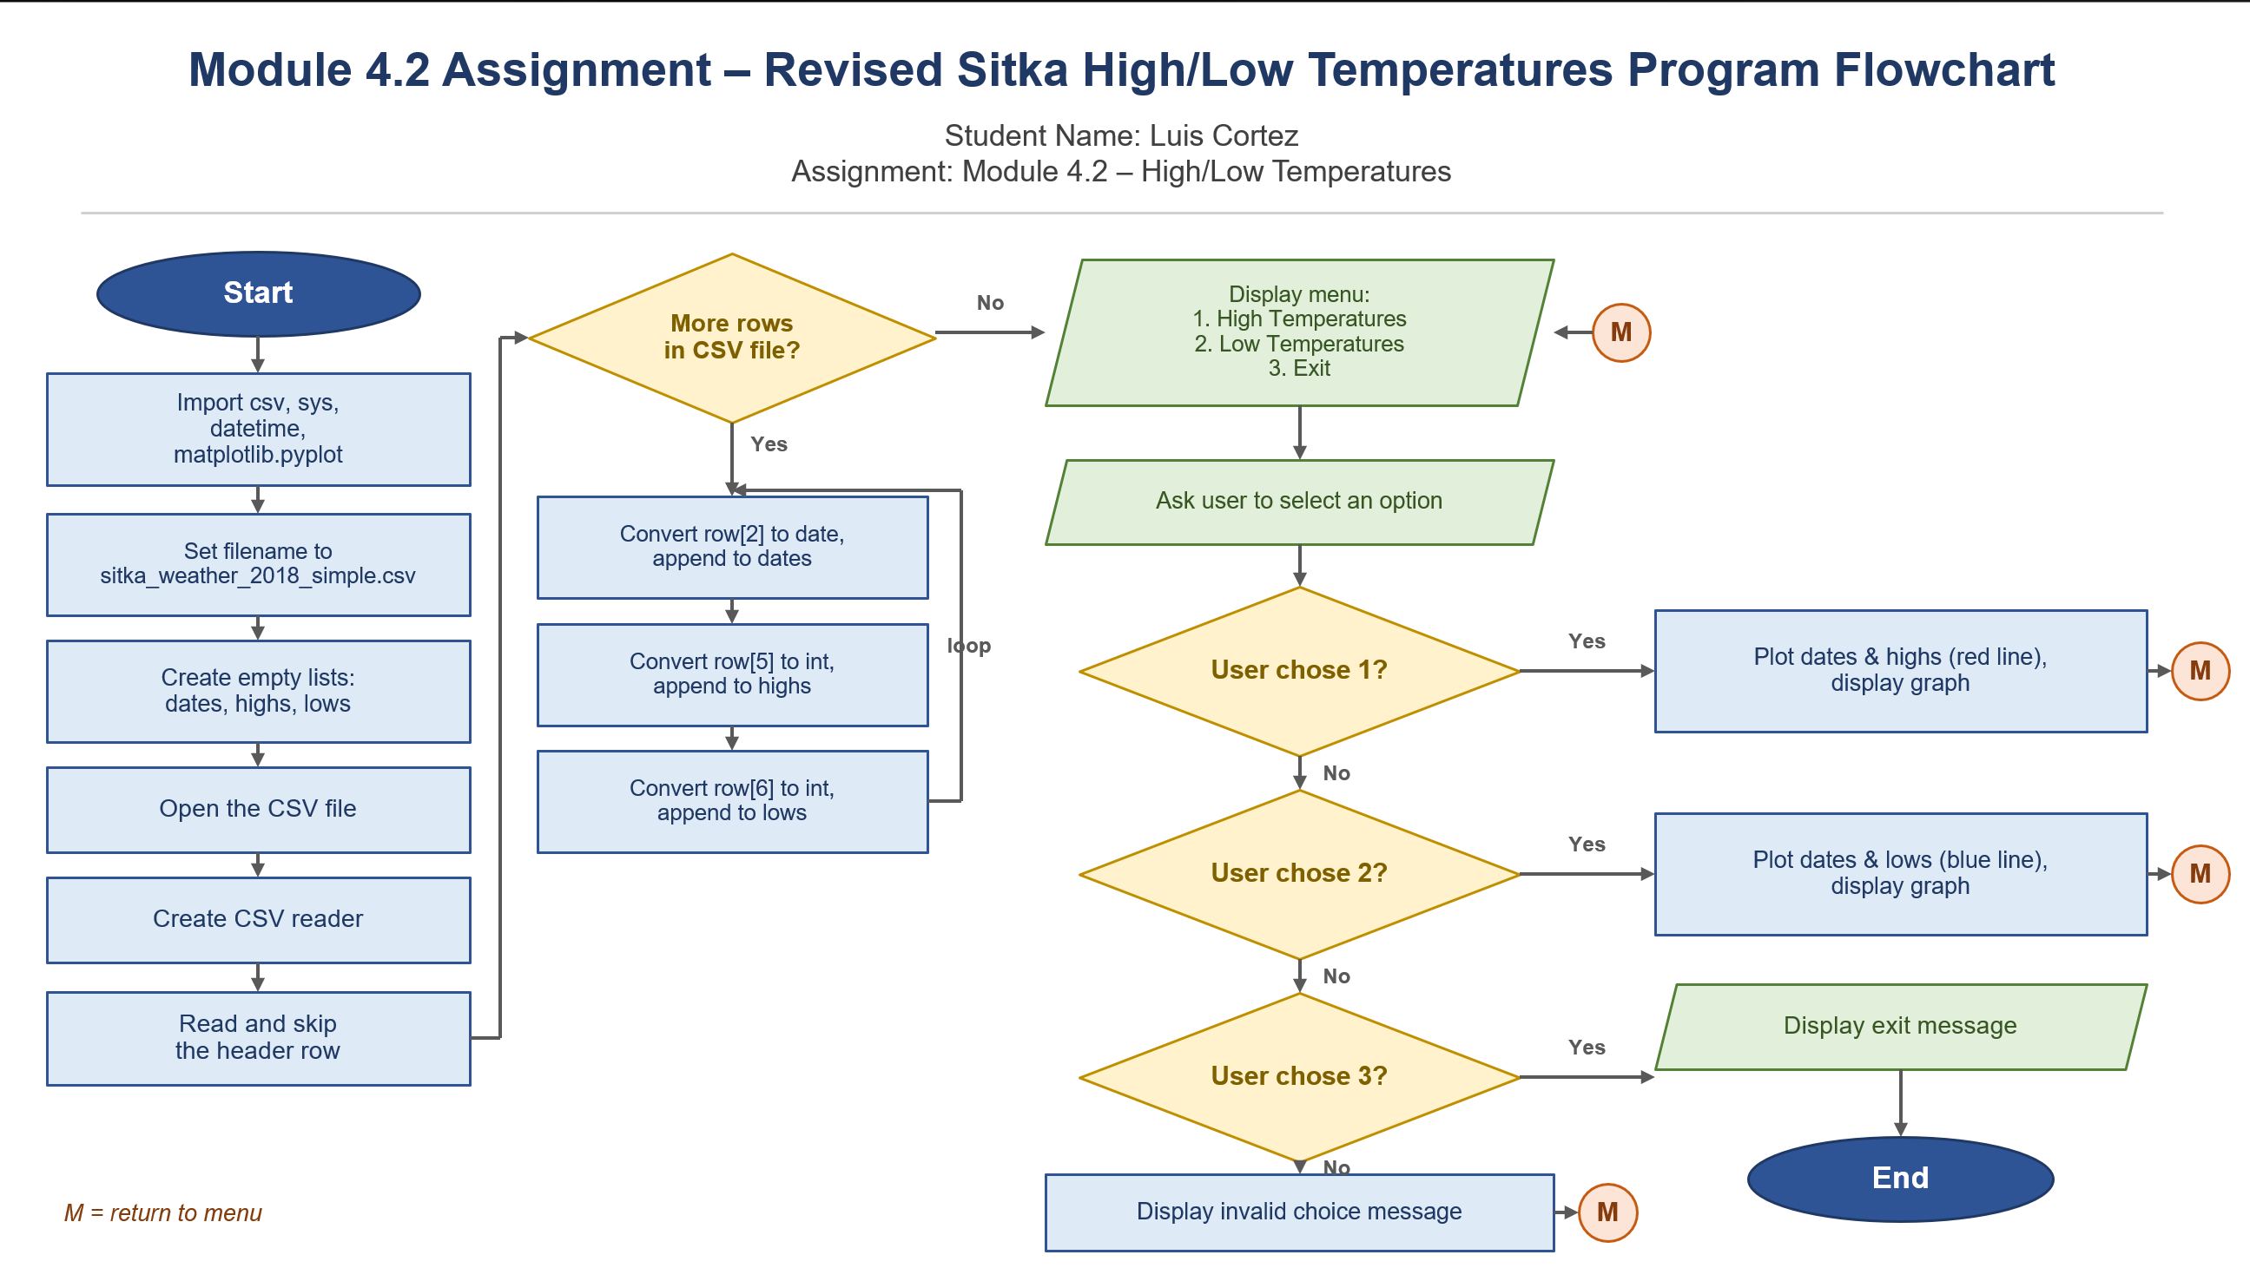

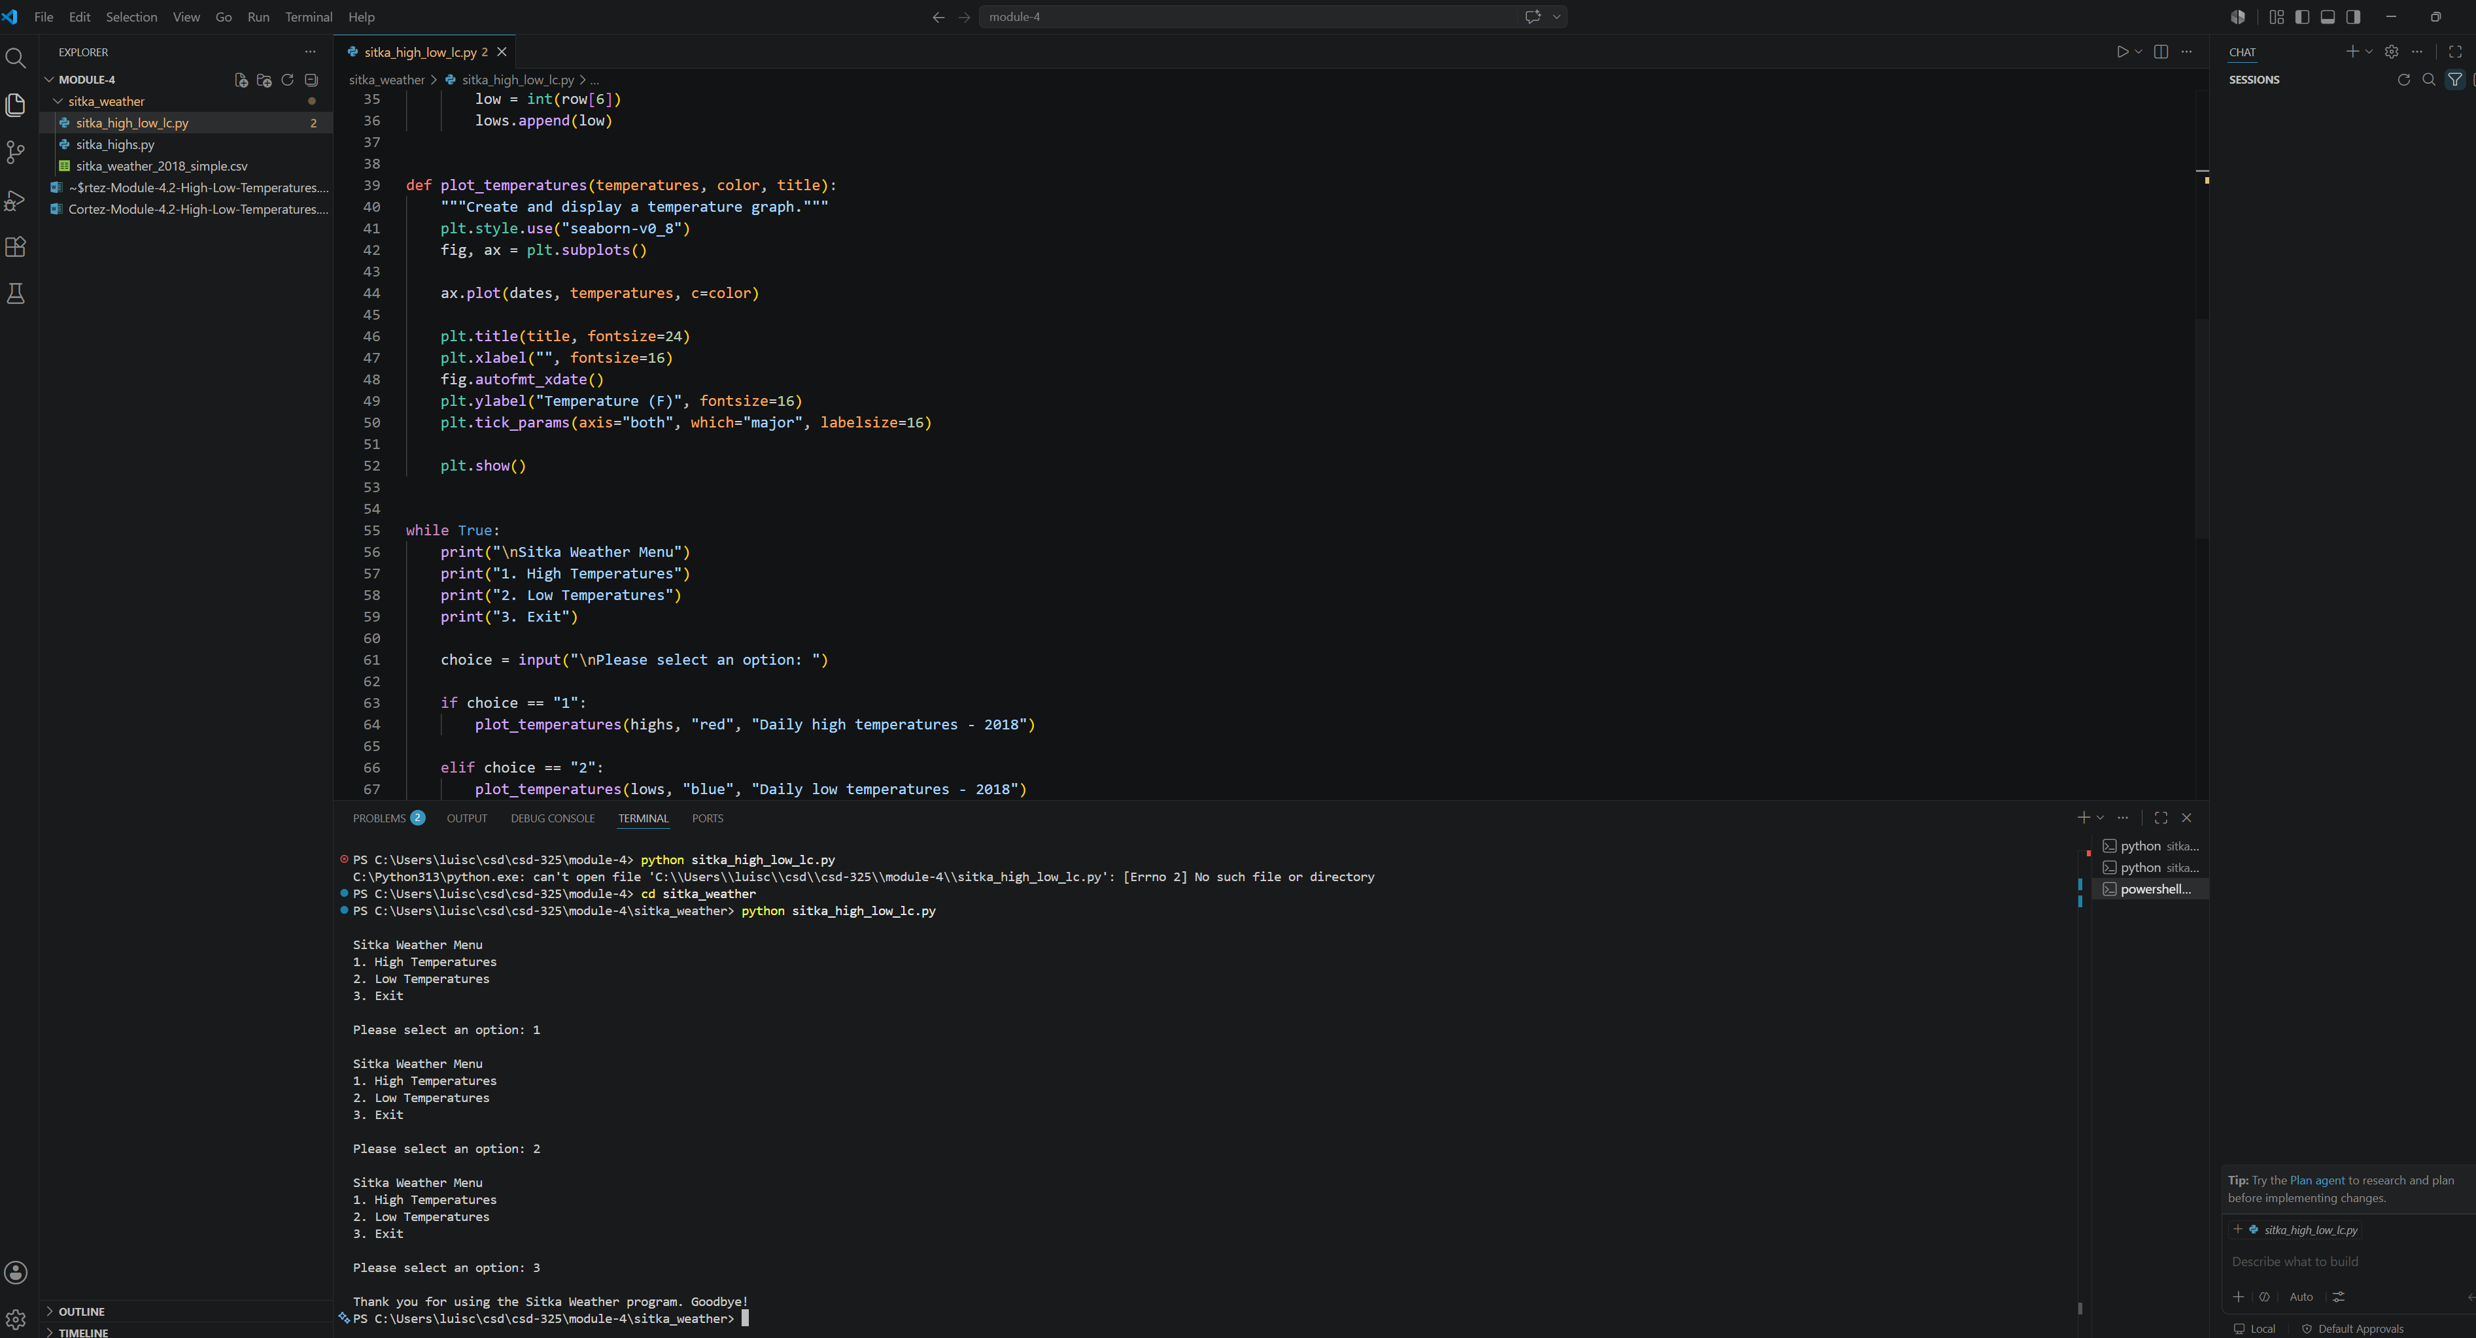
Figure 2. Revised flowchart illustrating the modified program that allows the user to display high temperatures, low temperatures, or exit the application.

Program Output

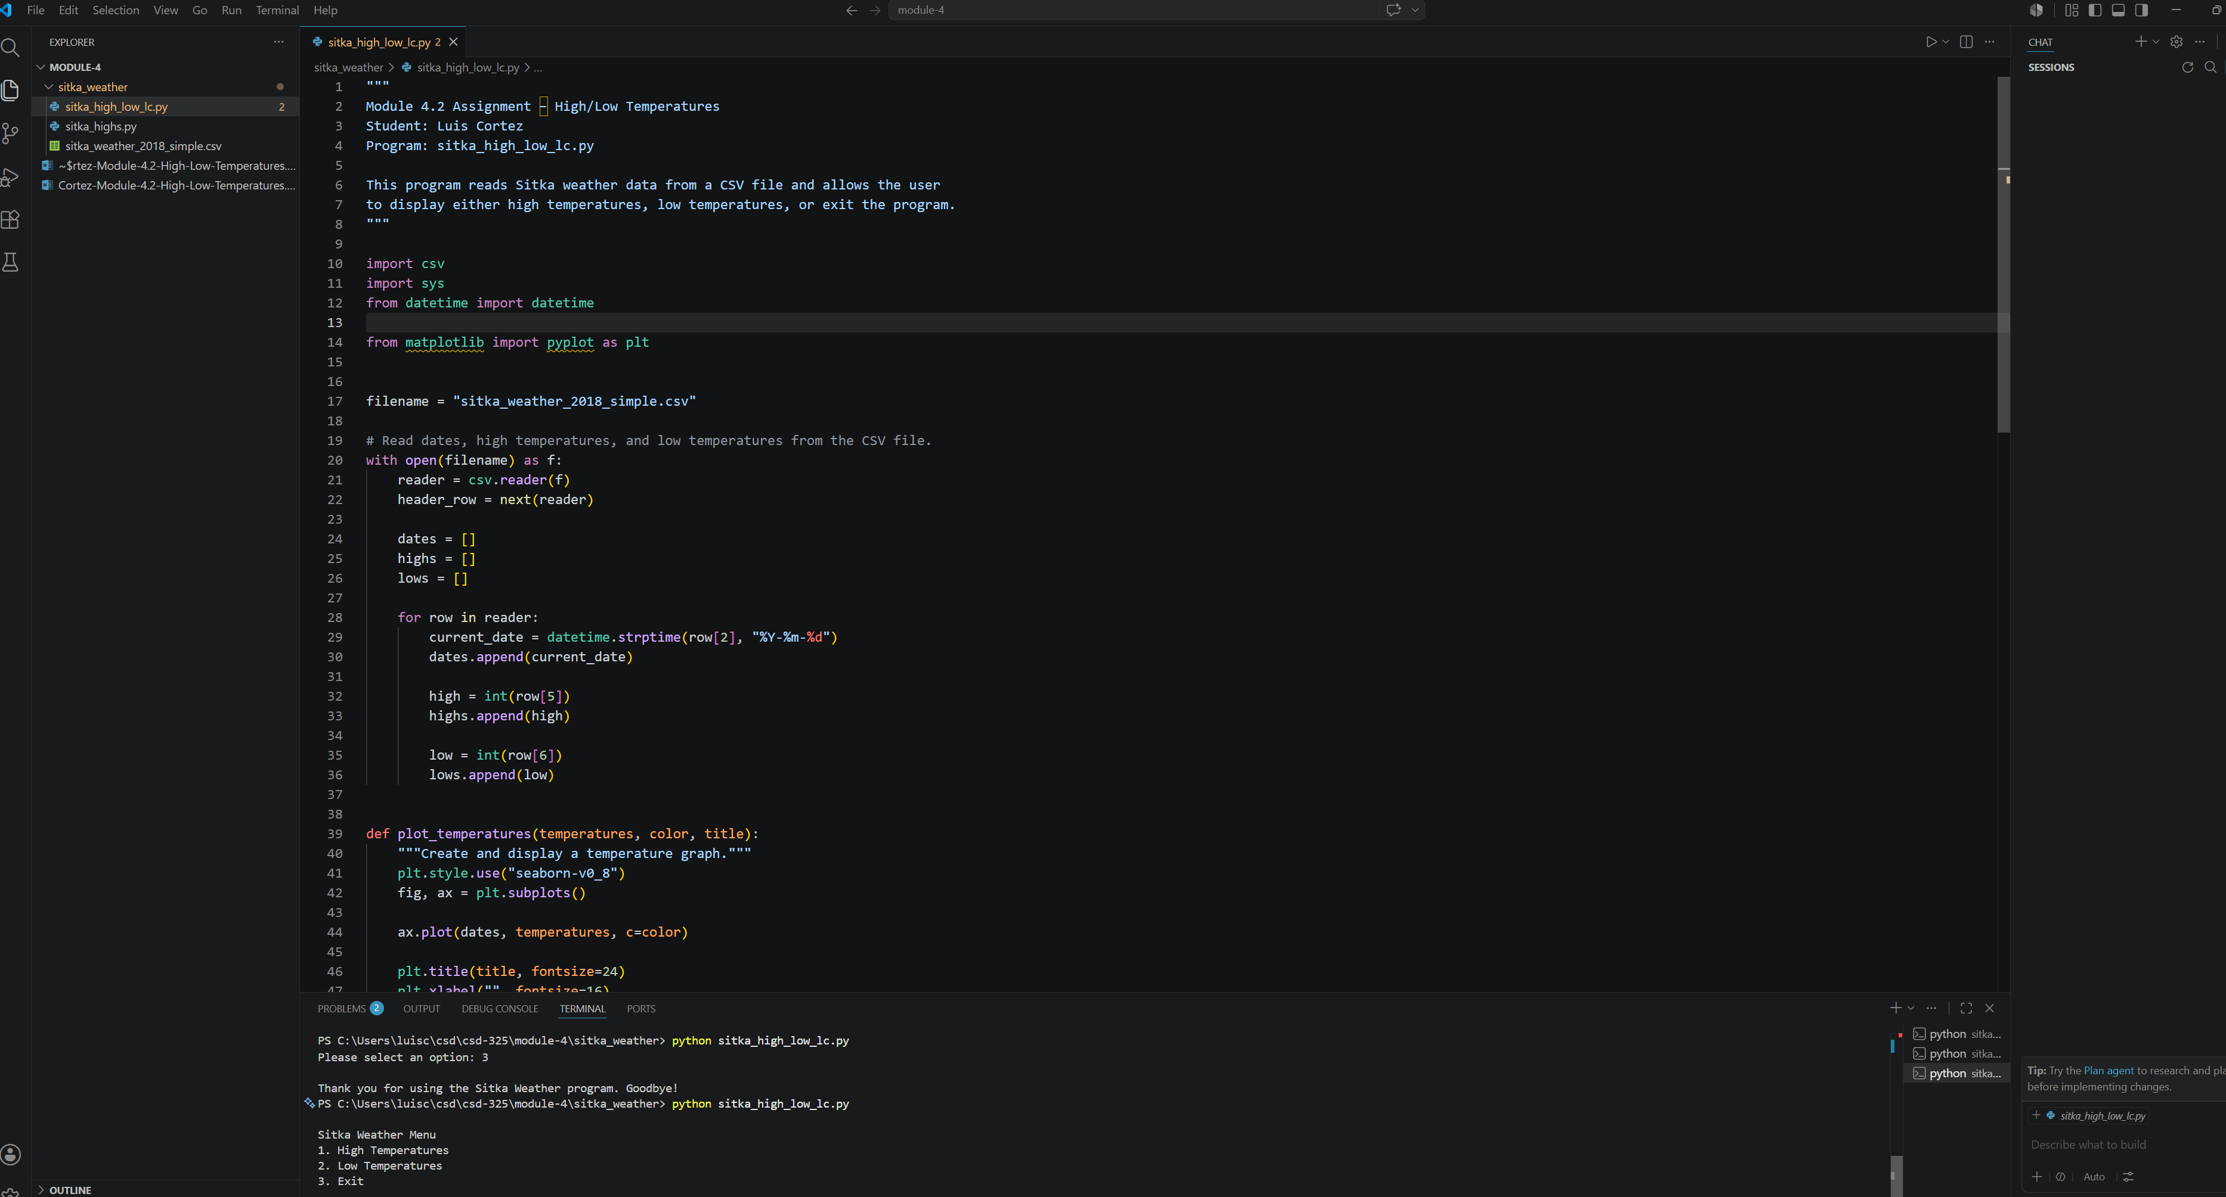
Figure 3. Program menu displayed.

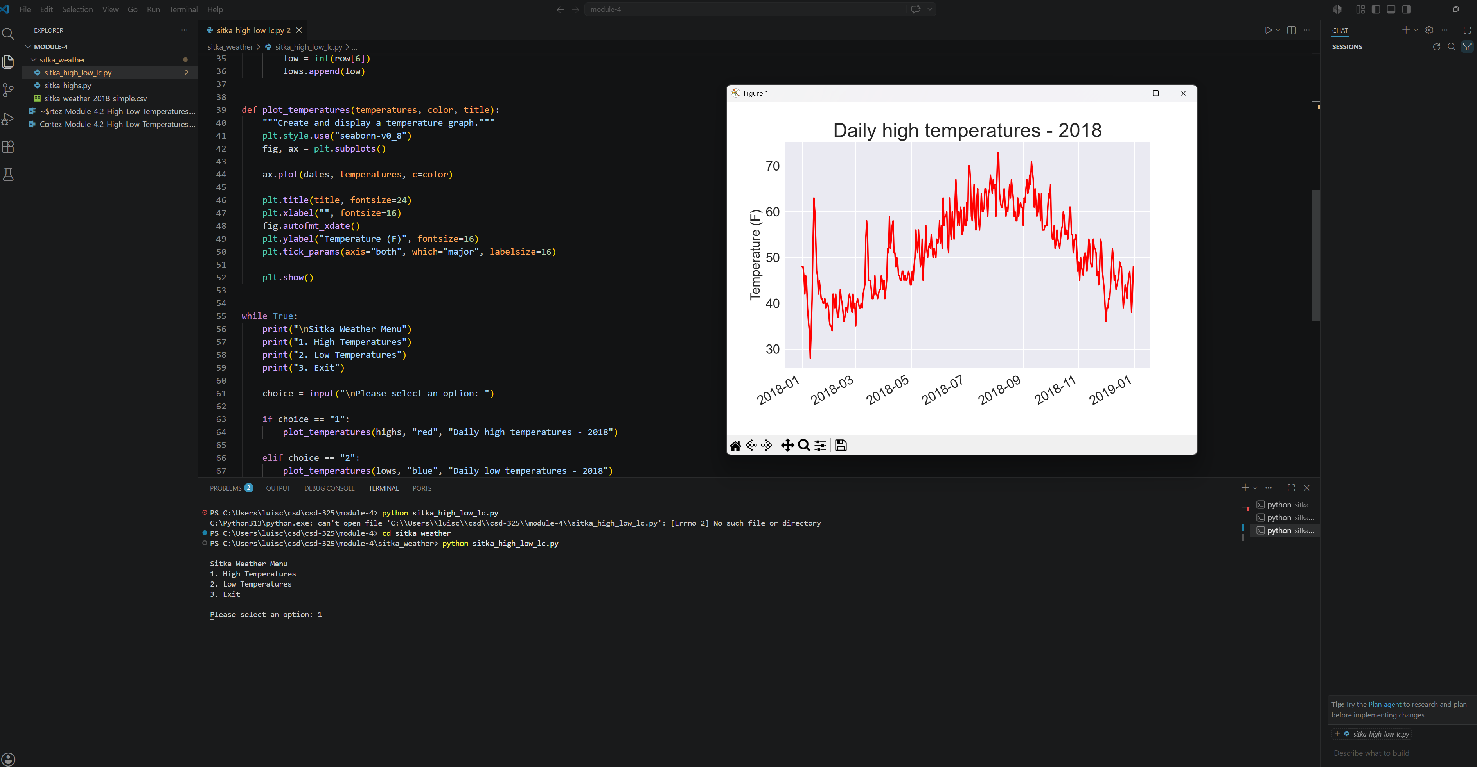
Figure 4. High temperatures graph.

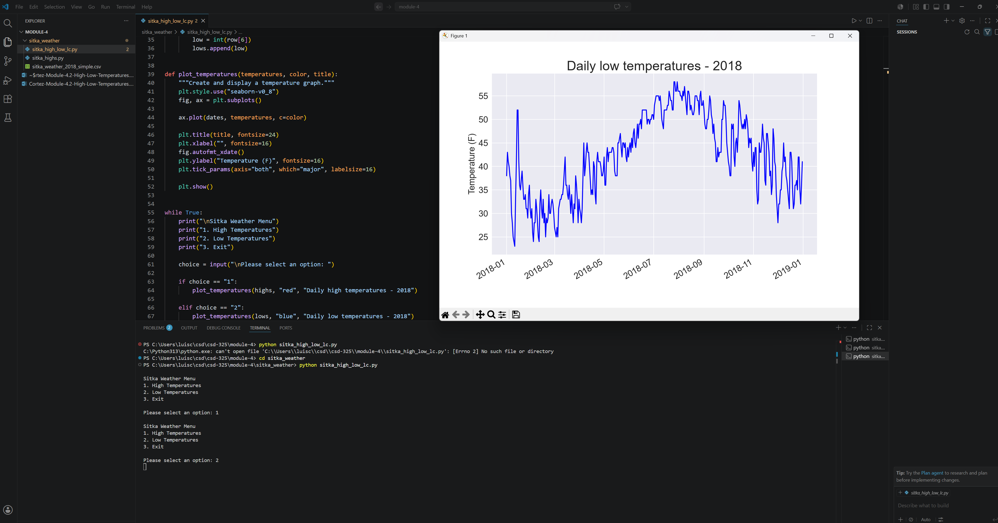
Figure 5. Low temperatures graph.

