Module 3.2 Assignment – Brownfield + Flowchart
Student Name: Luis Cortez
Date: June 2026

PART 1 – Flowchart
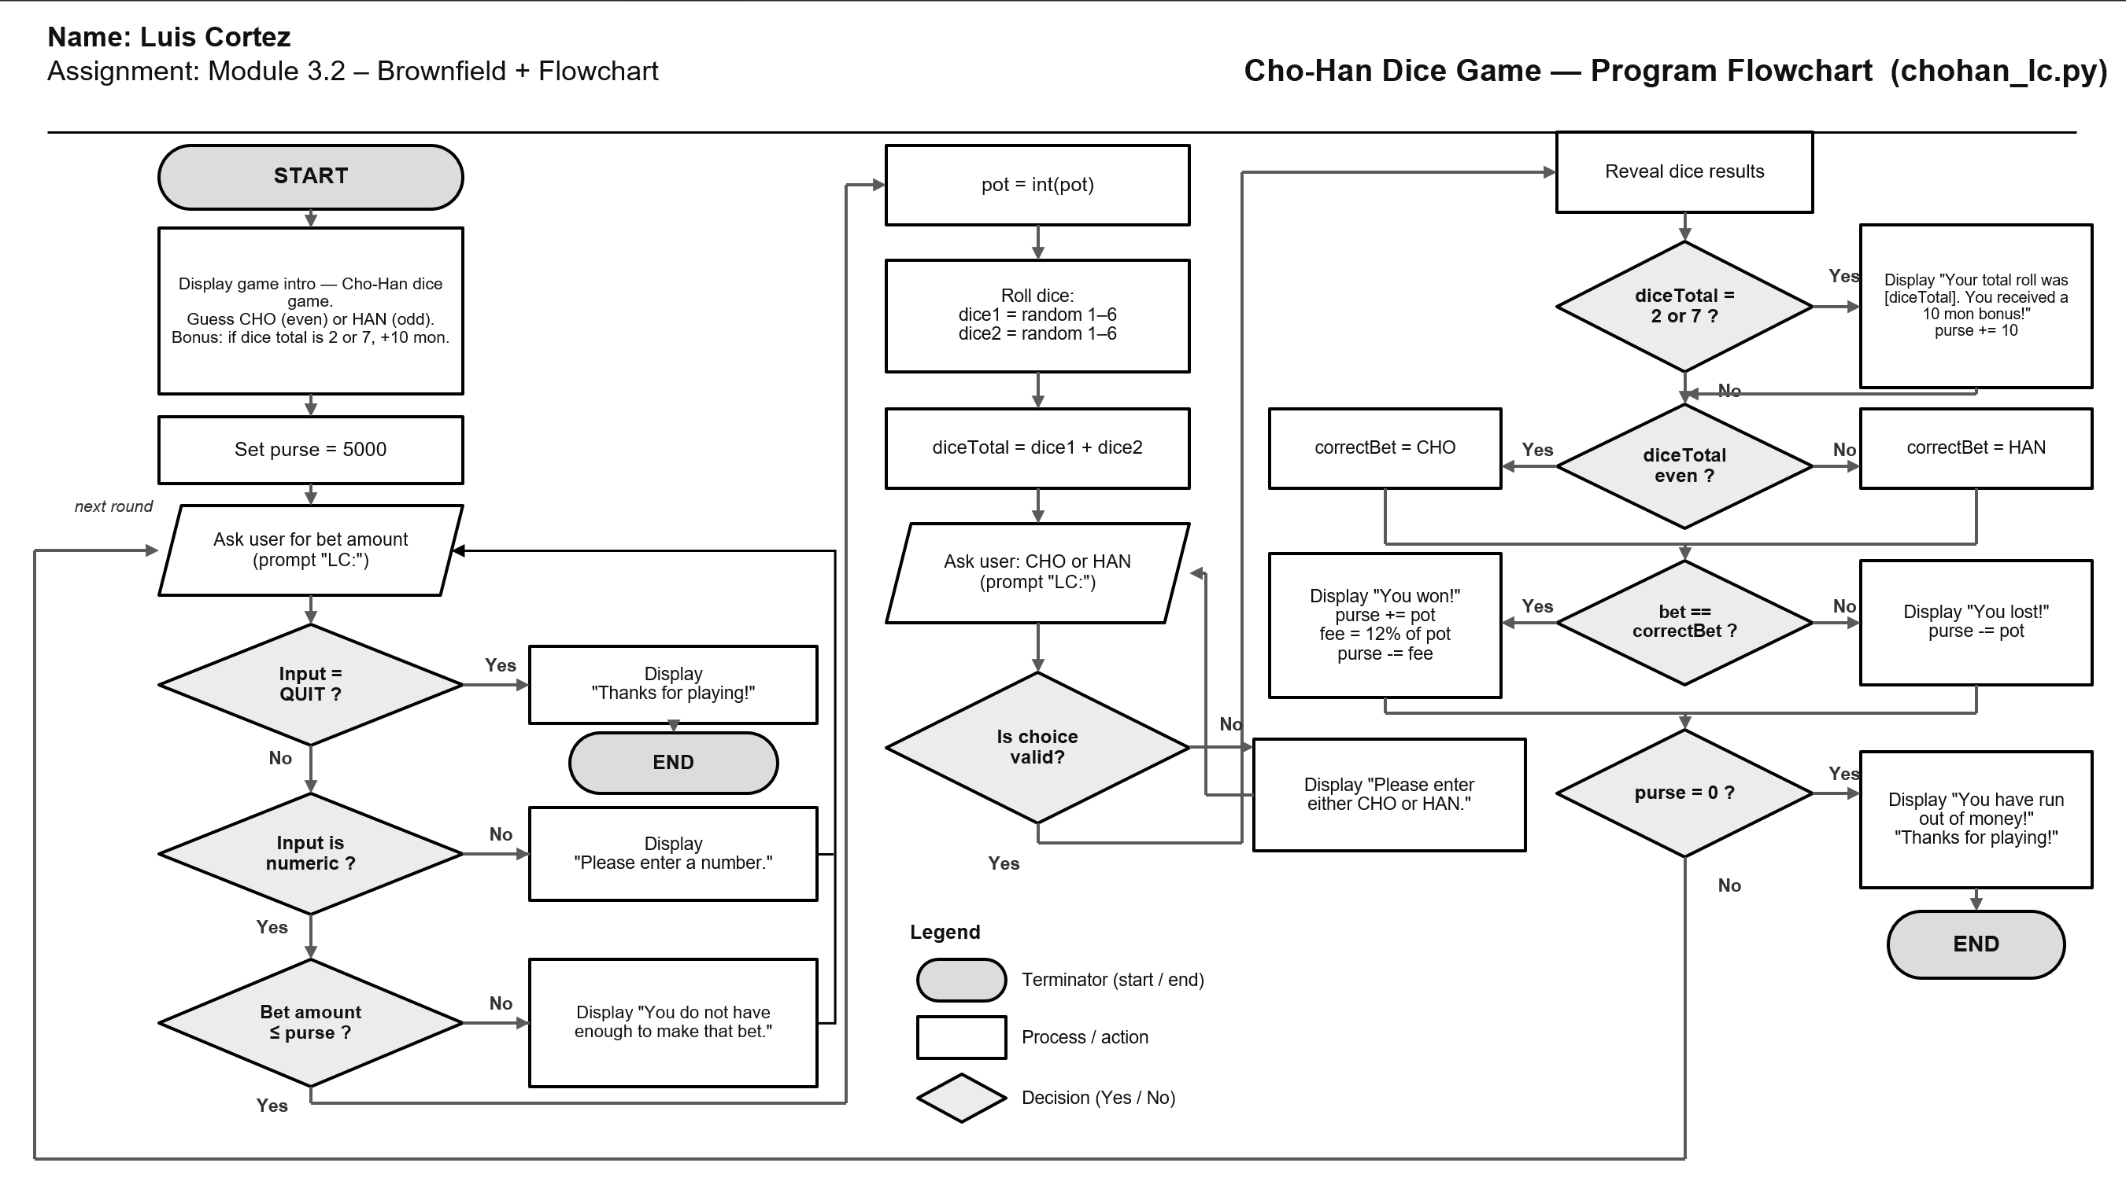

Figue 1. Flowchart illustrating the modified Cho-Han game program logic, including user input validation, bonus rule implementation, win/loss calculations, and game loop execution.

PART 2 – Documentation of program changes

Overview
This assignment required modifying the original Cho-Han Python program and documenting all implemented changes. The updated version introduces customized user prompts, adjusts the house fee percentage, and adds a new bonus rule while maintaining the original gameplay structure.
Change 1 – Customized Input Prompt
Original:
input('> ')
Modified:
input('LC: ')
Description:
The user input prompts were changed to display my initials followed by a colon as required by the assignment instructions.

Change 2 – House Fee Changed from 10% to 12%
Original:
purse = purse - (pot // 10)
Modified:
purse = purse - (pot * 12 // 100)
Description:
The original house collection amount of 10 percent was updated to 12 percent to satisfy assignment requirements.

Change 3 – Added Bonus Rule to Program Introduction
Added text:
"LC: Bonus Rule – If the dice total is 2 or 7, you receive a 10 mon bonus."
Description:
The game introduction was updated so users are informed of the additional bonus condition before gameplay begins.

Change 4 – Added Bonus Logic
Added:
if diceTotal == 2 or diceTotal == 7:
print('Your total roll was', diceTotal,
'. You received a 10 mon bonus!')
purse = purse + 10
Description:
A new gameplay feature awards the player an additional 10 mon whenever the combined dice total equals 2 or 7.

Change 5 – Added diceTotal Variable
Added:
diceTotal = dice1 + dice2
Description:
A dedicated variable was created to simplify bonus validation and even/odd calculations.

Change 6 – Program File Renamed
Original:
chohan.py
Modified:
chohan_lc.py
Description:
The modified file was renamed using my initials as required by the assignment.

PART 3 – Testing results

Testing was completed to confirm:
✓ User prompts display correctly using initials
✓ House fee correctly calculates at 12%
✓ Bonus activates when dice total equals 2 or 7
✓ Purse updates correctly after wins and losses
✓ Program exits successfully when QUIT is entered
Conclusion
The Cho-Han program was successfully modified according to assignment requirements while preserving the original game mechanics. The additional bonus rule and revised house fee were implemented and tested successfully.

