Luis Cortez
CSD 340 Web Development with HTML and CSS
Module 3.3 Assignment – Build a Webpage Exercise, Part 3
August 23, 2026

1. GitHub Pages URL
GitHub Pages URL:
[INSERT GITHUB PAGES URL HERE AFTER THE FILES ARE PUSHED TO GITHUB]

2. Module 3.3 Browser Output
The Module 3.3 webpage contains two side-by-side ordered lists. The first list displays my top ten favorite books, and the second list displays five things I have learned since the course started. The page also includes a “back to Landing Page” navigation link in the bottom-right corner that returns the user to the CSD 340 landing page.

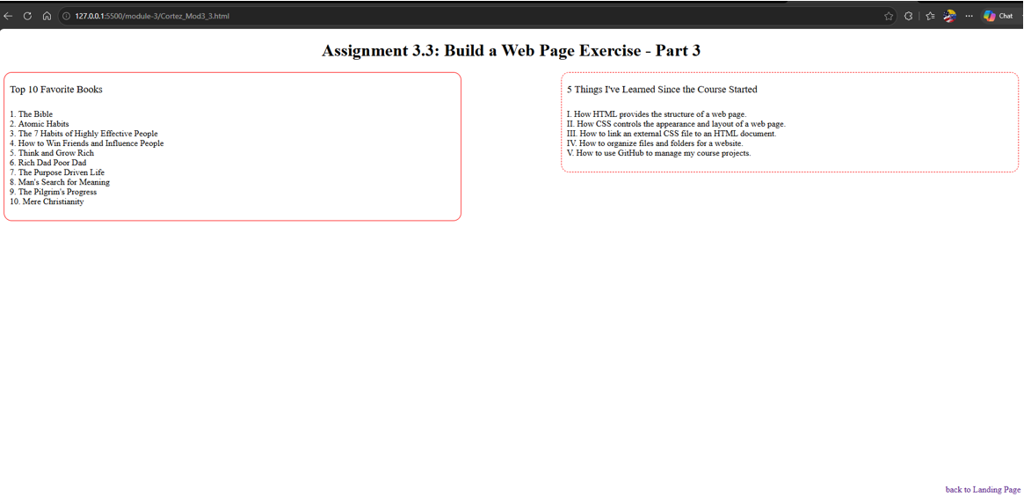Figure 1. Module 3.3 browser output showing the two ordered lists and the “back to Landing Page” navigation link.

3. HTML Validation
The Module 3.3 HTML file was checked using the Nu HTML Checker. The checker identifies the H1-to-H3 heading hierarchy. The H3 elements were retained because the Module 3.3 assignment instructions specifically require H3 tags for the two list headings.

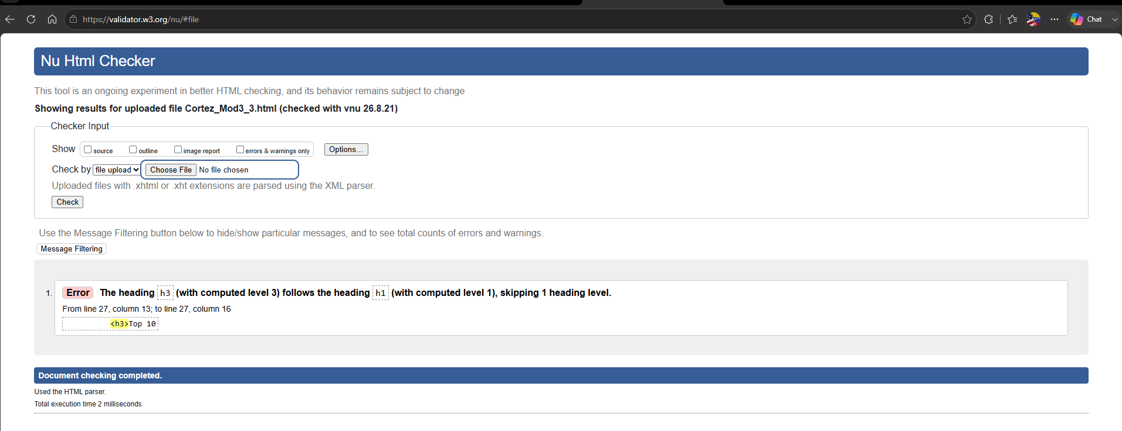Figure 2. HTML validation results showing the heading hierarchy message associated with the assignment-required H3 elements.

4. CSS Validation
The Module 3.3 CSS file was checked using the W3C CSS Validation Service. The CSS successfully passed validation with no errors.

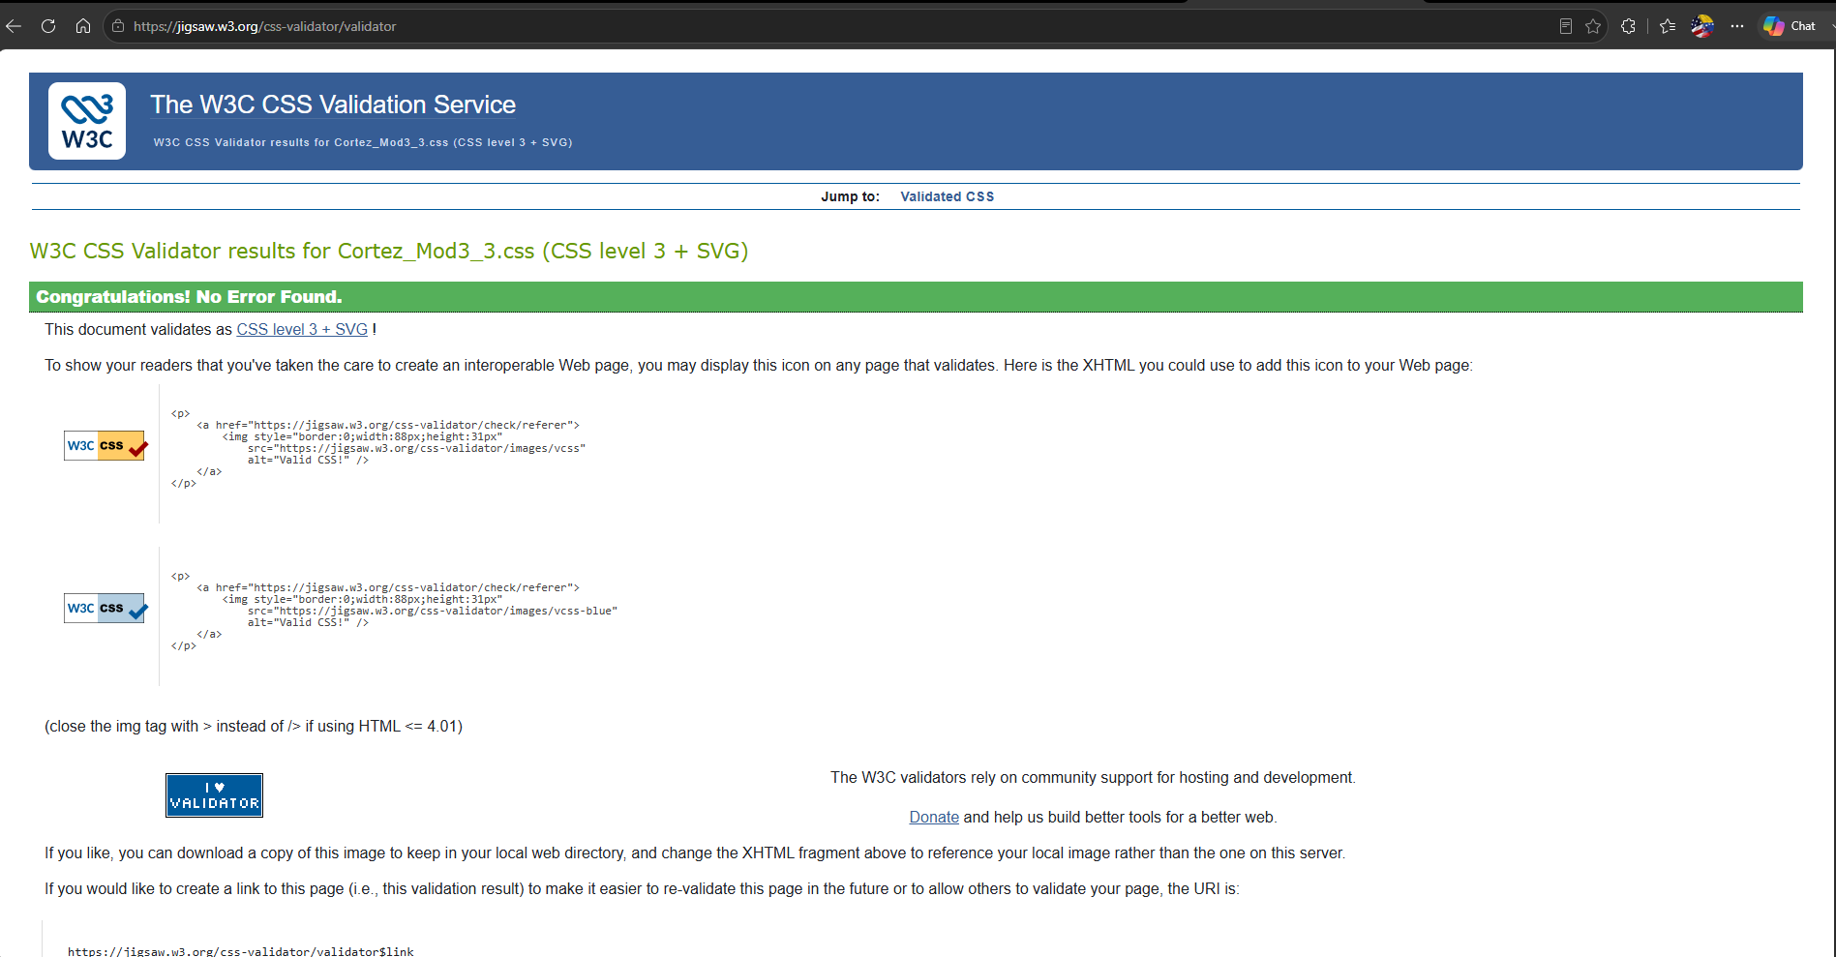Figure 3. W3C CSS validation results showing no errors found.

