Luis Cortez
August 23, 2026
Module 3.2 Assignment – GitHub Pages

HTML Validation Results

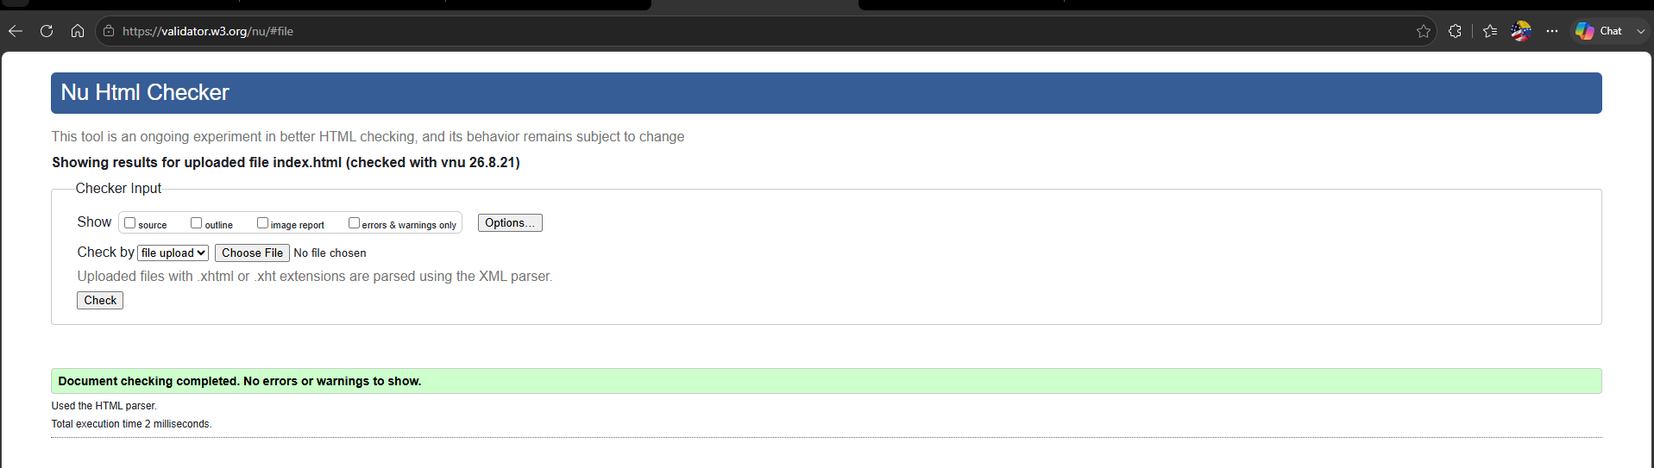

CSS Validation Results

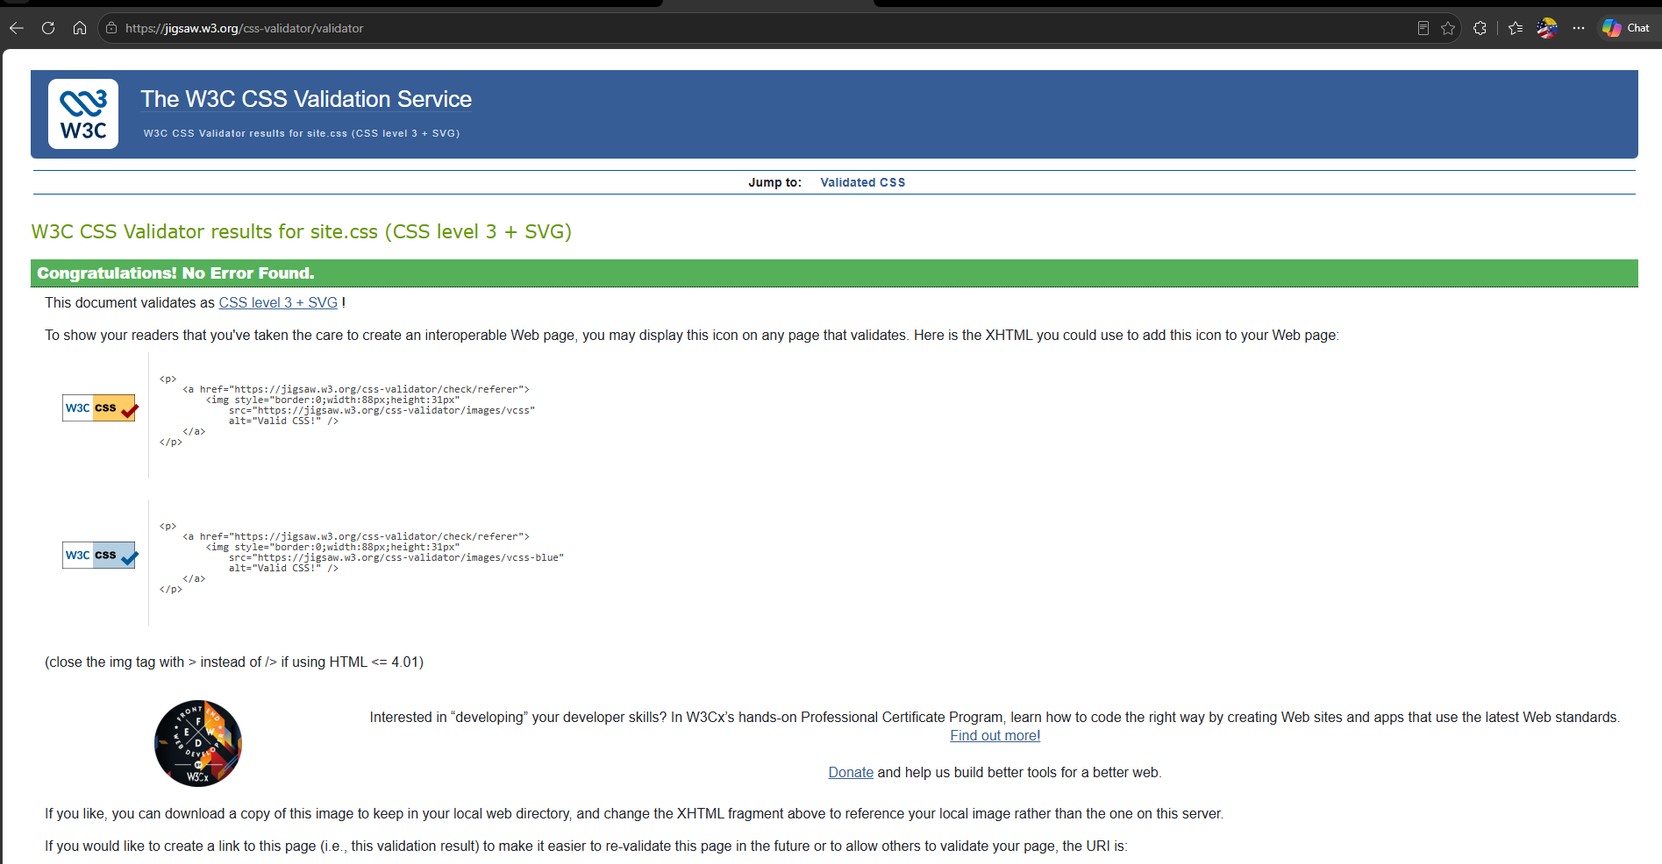

Browser Output

