Luis Cortez
August 16, 2026
CSD 402 – Java for Programmers
Module 1.2 Assignment – GitHub Repository Setup

- GitHub Repository Link
https://github.com/LUISCORTEZUSA2018/csd-402

- GitHub Repository Screenshot
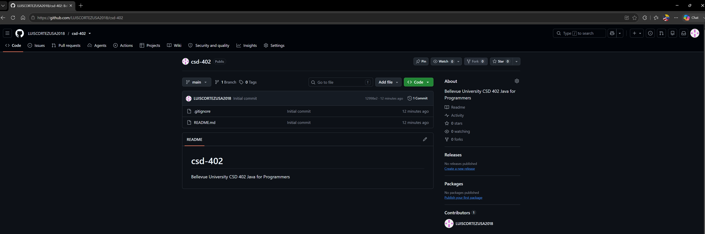

- Local Directory Screenshot
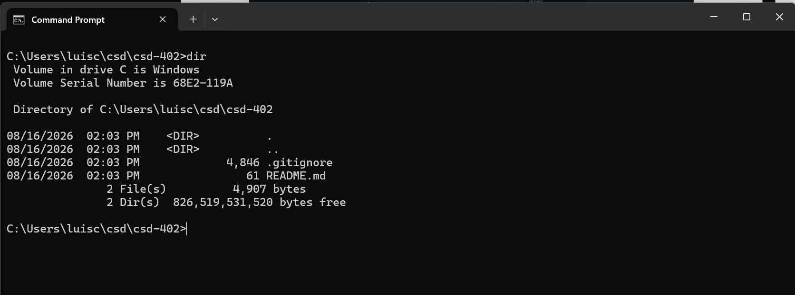

- JavaFX Installation and Configuration Verification
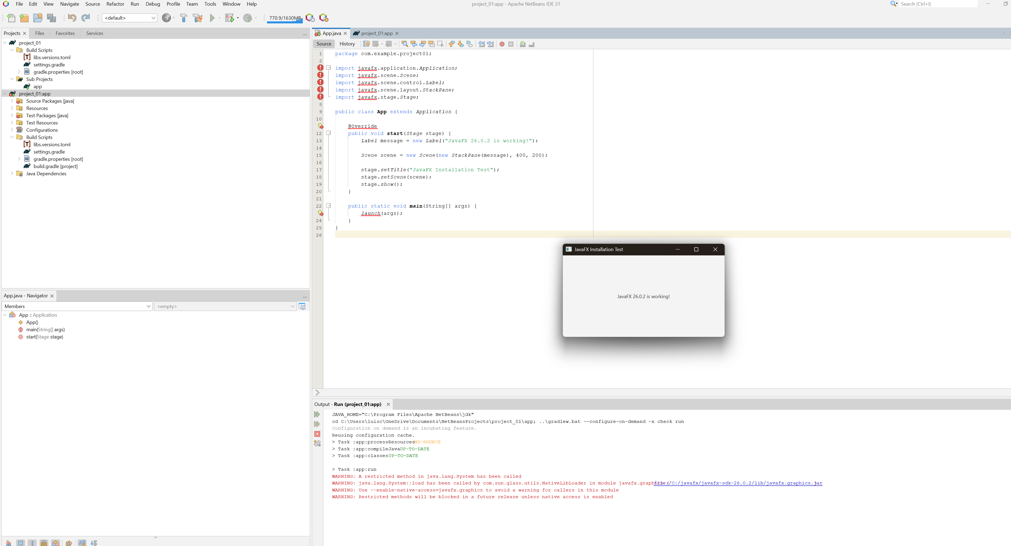

Figure 5. NetBeans output confirming the JavaFX test completed successfully with BUILD SUCCESSFUL.

