Module 1.3 Programming Assignment
JavaFX Random Playing Cards
Student: Luis Leonardo Cortez Velez
University: Bellevue University
Course: CSD420-300H – Advanced Java Programming
Instructor: Josh Guardino
Assignment: Module 1.3 – Programming Assignment
Date: October 24, 2026
Application Description
This JavaFX application displays four randomly selected playing cards from a standard 52-card deck. The program uses a lambda expression to handle the Refresh Cards button, allowing the user to generate another selection of four different cards.
The application was developed using Java, JavaFX, Apache NetBeans IDE 31, and Maven.
Screenshots
Figure 1. JavaFX Application Running in NetBeans
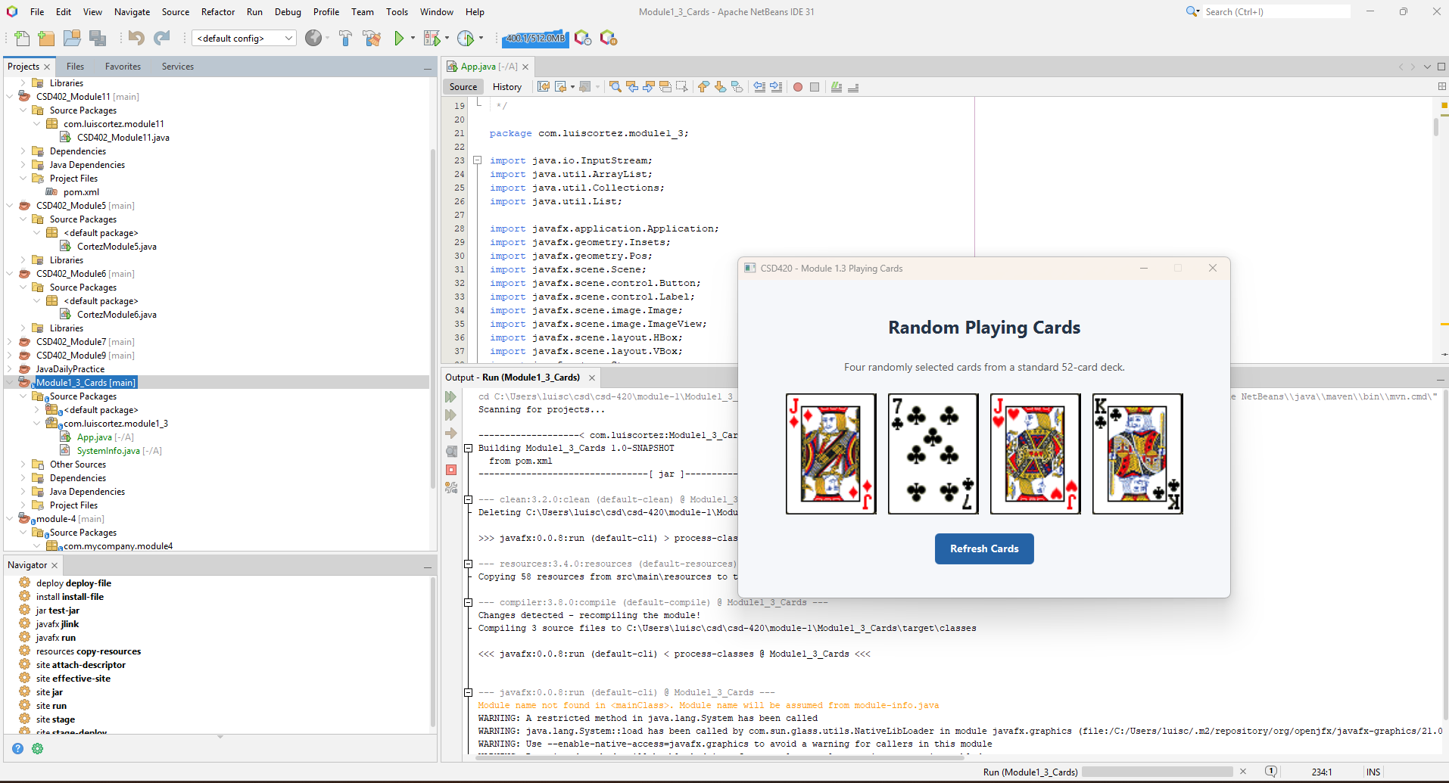

Figure 2. Refresh Cards Functionality
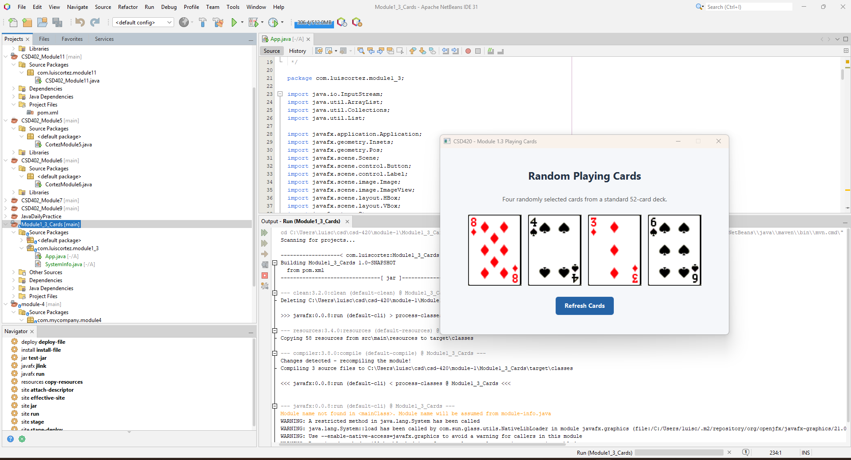

Figure 3. JavaFX Source Code in Apache NetBeans IDE 31
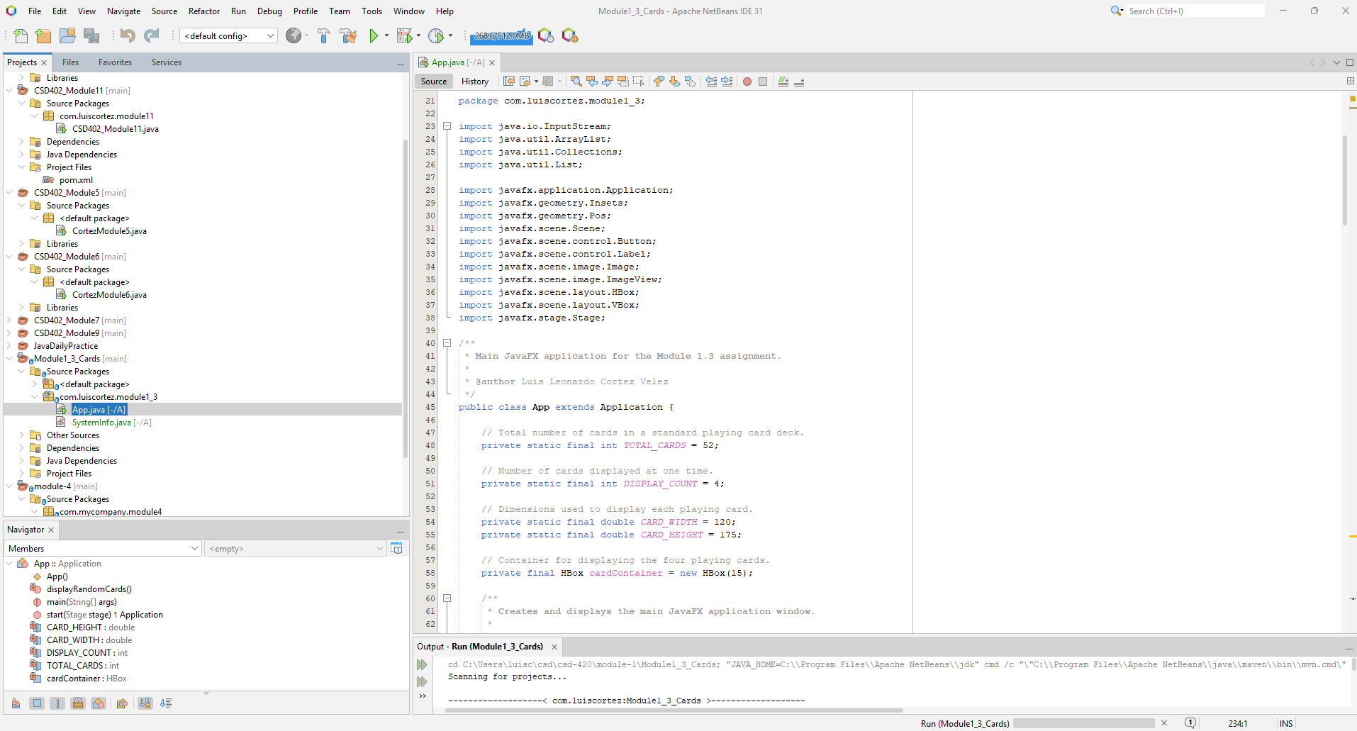
GitHub Repository
https://github.com/LUISCORTEZUSA2018/csd-420

