Luis Leonardo Cortez Velez
Bellevue University
Instructor: Josh Guardino
Course: CSD420-300H – Advanced Java Programming
Assignment: Module 1.2 – GitHub Repository Setup
Date: October 24, 2026

Figure 1. GitHub Repository Setup
The public csd-420 GitHub repository was successfully created with a README.md file and a Python .gitignore file.
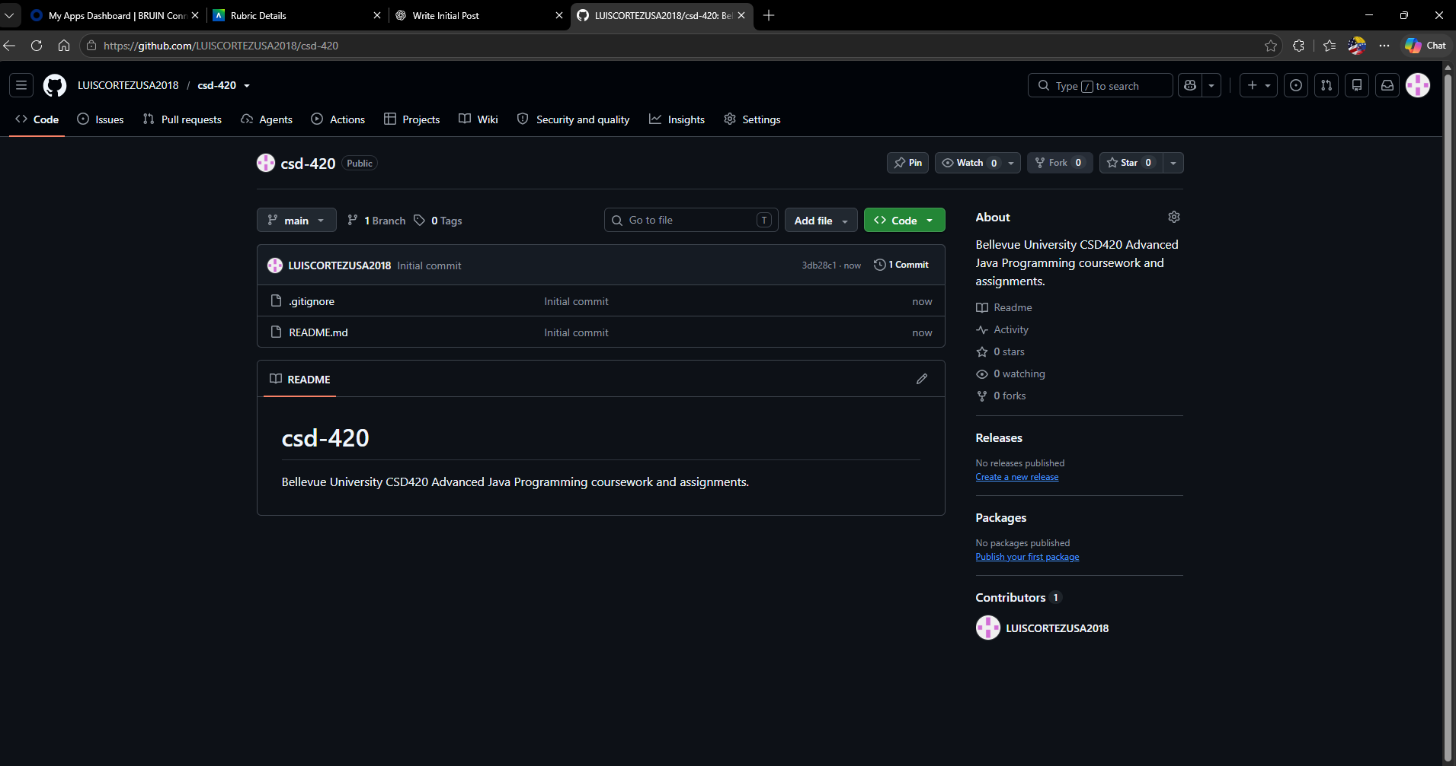

Figure 2. Local Repository Setup and Verification
The csd-420 repository was successfully cloned into the existing csd directory. PowerShell confirms that the local repository contains the required files and is synchronized with the remote GitHub repository.

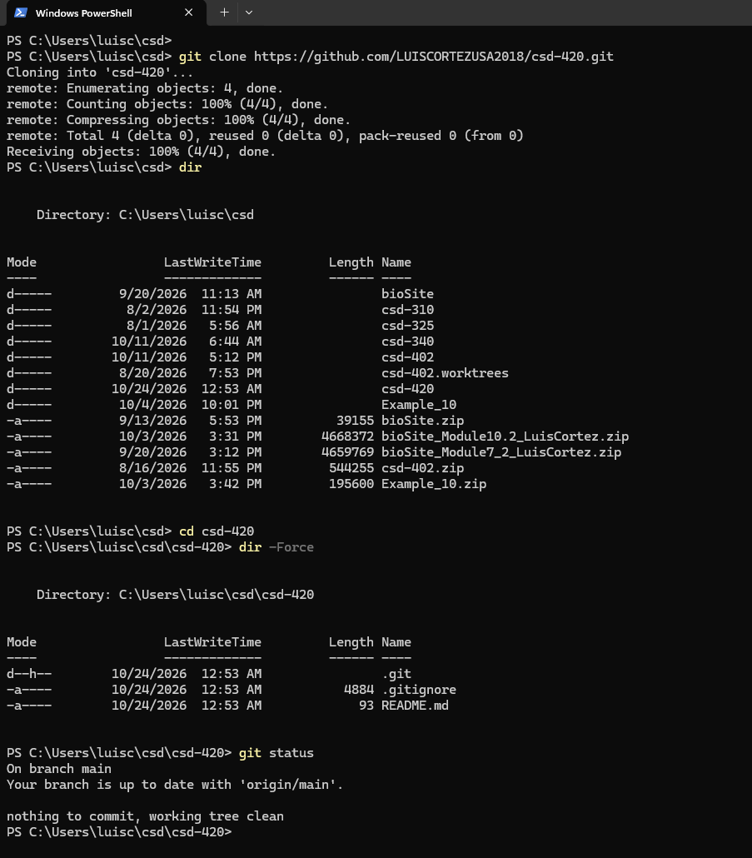

GitHub Repository URL:
https://github.com/LUISCORTEZUSA2018/csd-420

