CSD420 – Advanced Java Programming
Module 3.2 – Generics Programming Assignment
Student: Luis Leonardo Cortez Velez
University: Bellevue University
Date: November 7, 2026
Development Environment: Apache NetBeans IDE 31, Java JDK 26
Project: CSD420_Module3
1. Assignment Overview
This assignment demonstrates the use of Java generics and ArrayLists. The program generates 50 random integers between 1 and 20 and uses a generic static method to remove duplicate values while preserving the original ArrayList.
2. Program Implementation
The program implements the following generic method:
public static <E> ArrayList<E> removeDuplicates(ArrayList<E> list)
The method checks each element using contains() and adds it to a new ArrayList only if it is not already present. Input validation and exception handling are included to improve reliability.
Figure 1. Java Source Code
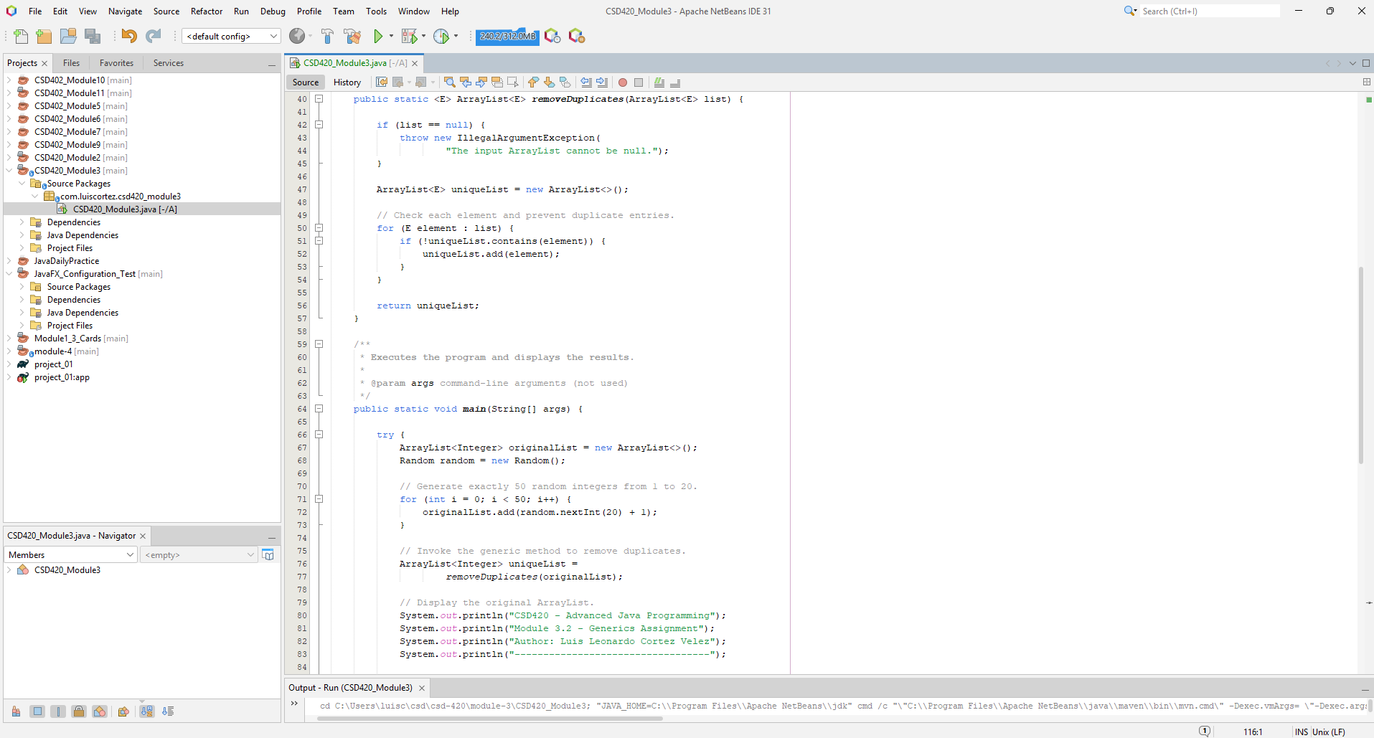
3. Execution and Results
The program compiled and executed successfully in NetBeans.
Test | Result
Original ArrayList | 50 integers
Random number range | 1–20
Unique elements | 18
Duplicates removed | 32
Execution status | BUILD SUCCESS
Figure 2. Program Output
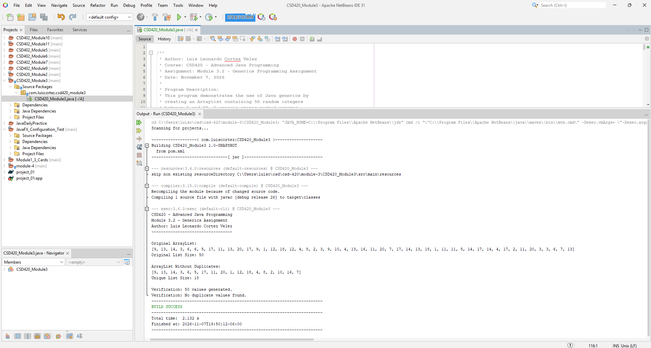
4. Conclusion
The program successfully demonstrated Java generics by returning a new ArrayList without duplicate elements. The original list remained unchanged, and the program executed without errors.

