Bellevue University
Student: Luis Leonardo Cortez Velez
Course: CSD420 — Advanced Java Programming
Assignment: Module 2.2 — Binary I/O Programming Assignment
Date: November 1, 2026
IDE: Apache NetBeans 31 | Java: JDK 26
1. Assignment Overview
This assignment demonstrates binary file input and output in Java. Two programs were developed: DataFileWriter.java generates five random integers and five random doubles, then writes them to a binary file. DataFileReader.java retrieves and displays the stored values. Existing data is preserved when the writer is executed again.
2. Java Project and Source Code
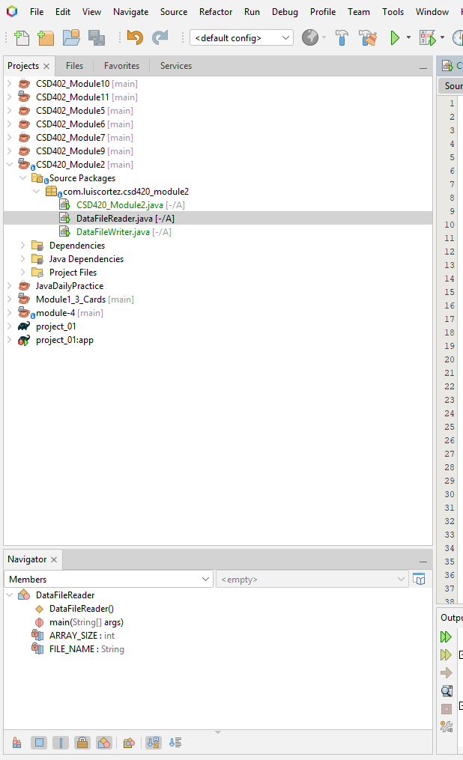
Figure 1. CSD420_Module2 project showing DataFileWriter.java and DataFileReader.java in the Source Packages panel.

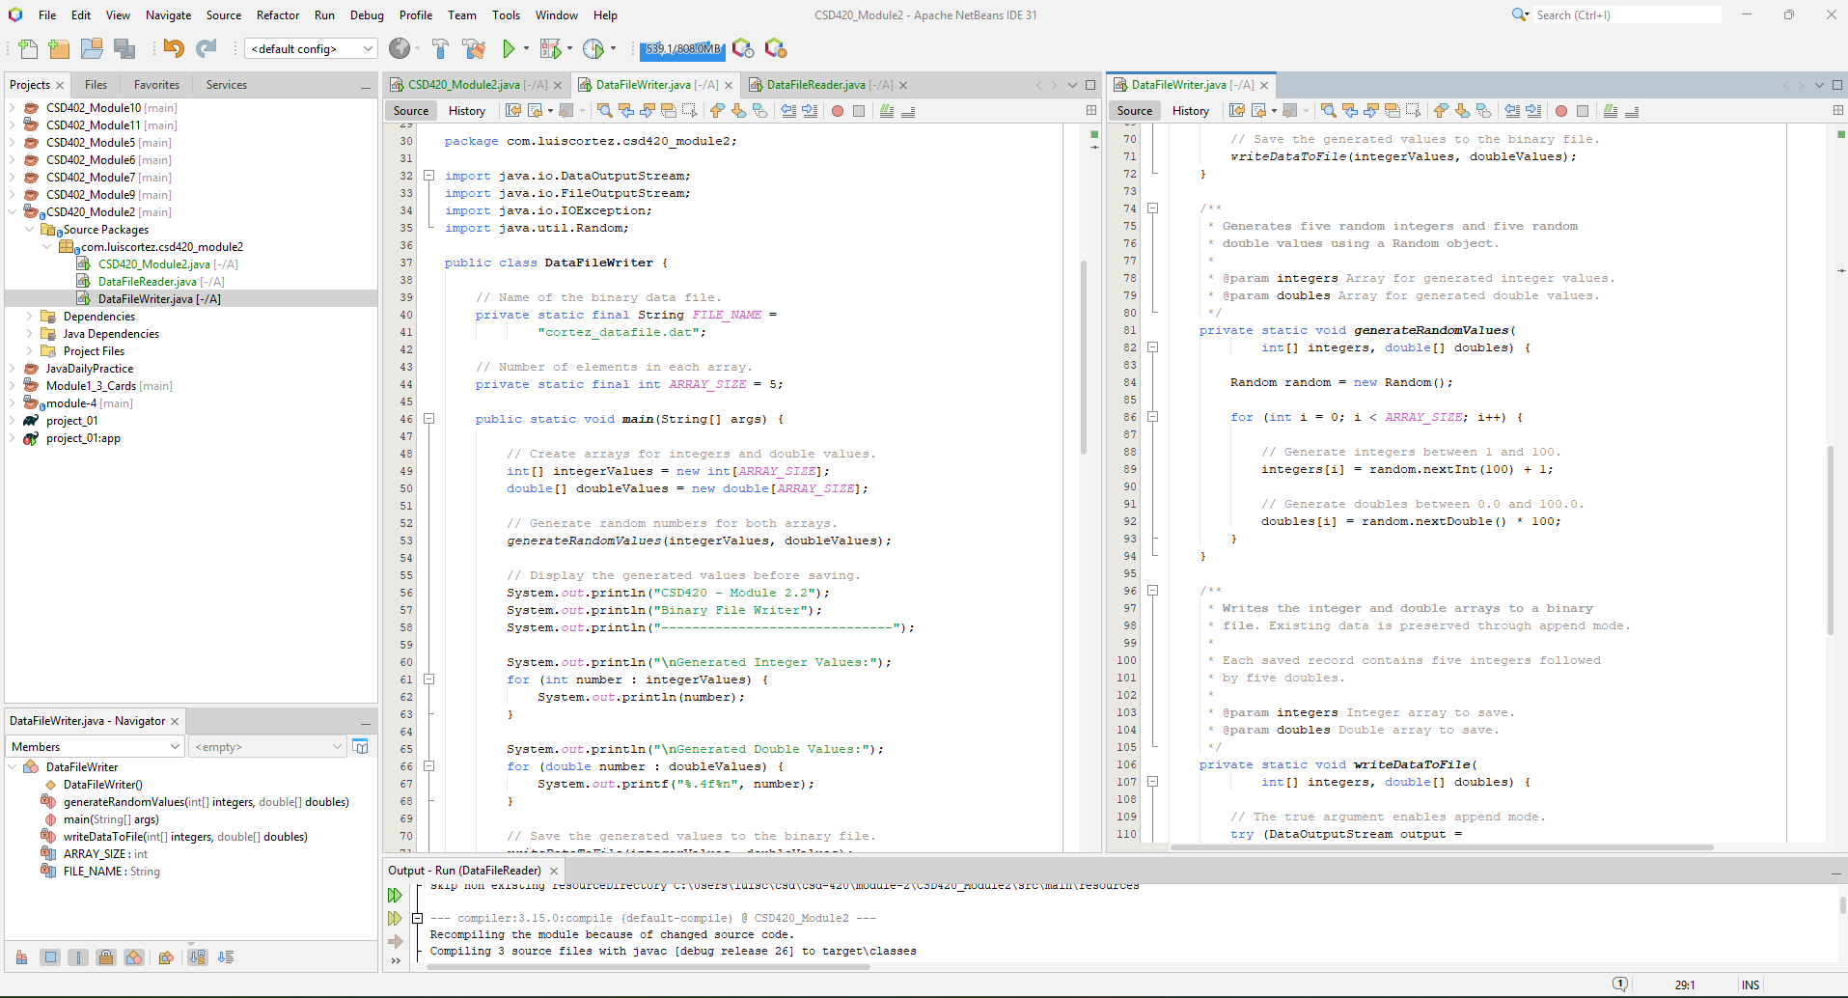
Figure 2. DataFileWriter.java source code demonstrating random number generation, binary file output, append functionality, and exception handling.

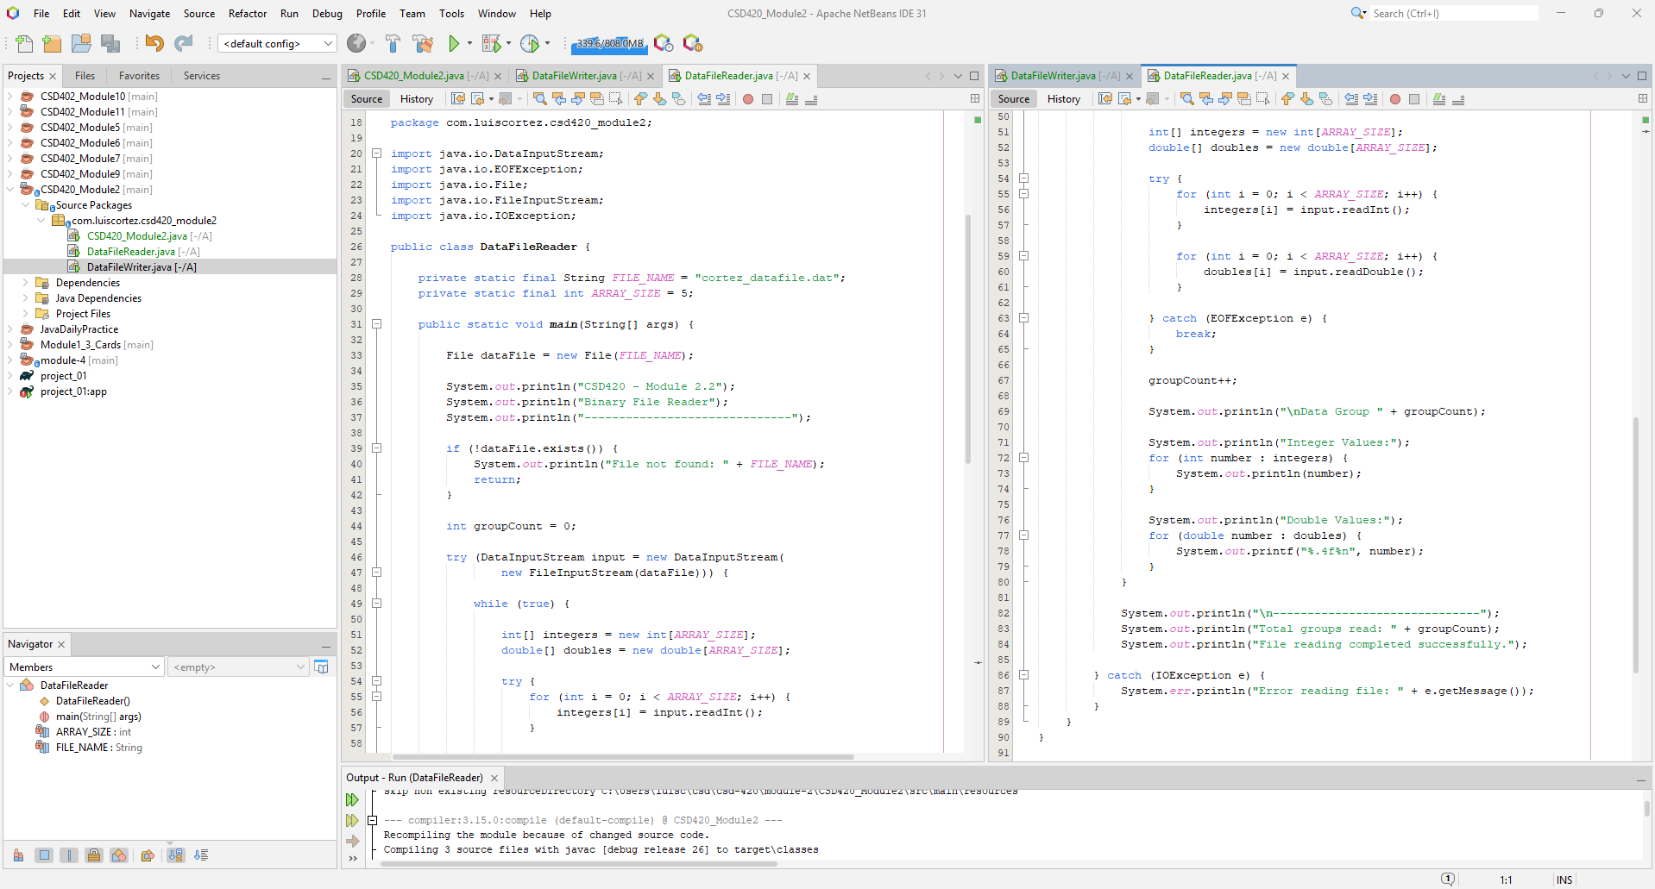Figure 3. DataFileReader.java source code demonstrating binary file input and retrieval of stored integer and double values.

3. Program Execution and Testing
Both programs were successfully executed in Apache NetBeans IDE 31.

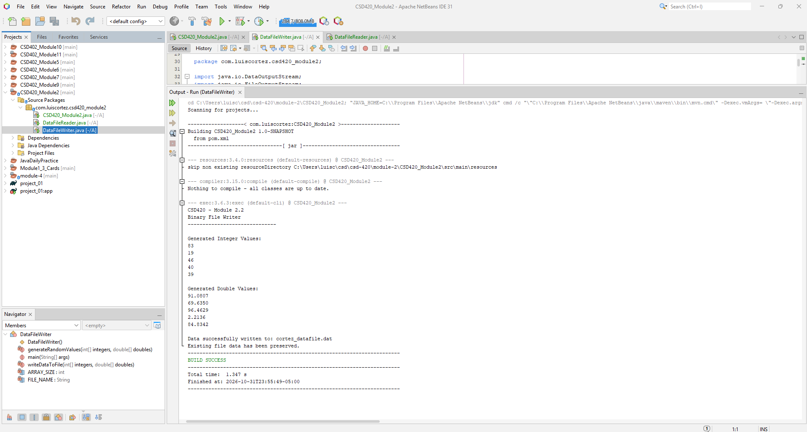
Figure 4. Successful execution of DataFileWriter.java, displaying generated integers and doubles and confirming that the binary file was updated.

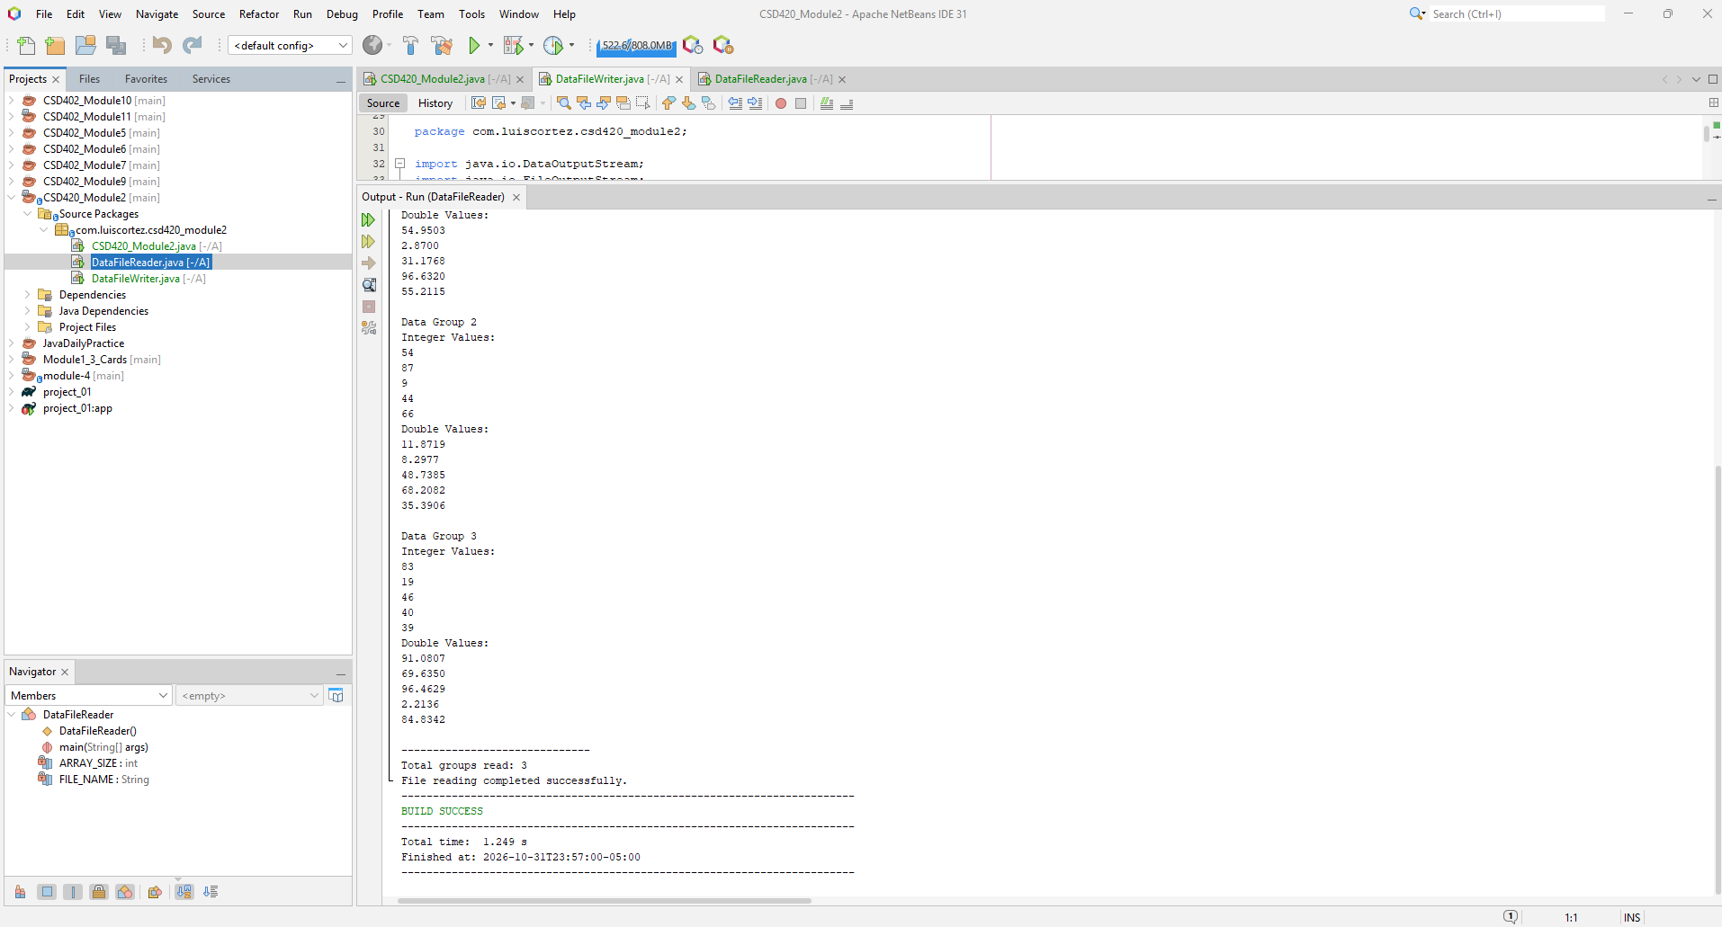
Figure 5. Successful execution of DataFileReader.java, displaying two groups of previously stored data and the BUILD SUCCESS message.

Executing the writer twice and then running the reader confirmed that the program creates the binary file, appends new data, preserves previous records, and retrieves the stored values correctly.
4. Conclusion
This assignment demonstrated the use of Java arrays, random number generation, DataOutputStream, DataInputStream, and exception handling. Both programs executed successfully, confirming that binary data can be stored, preserved, and retrieved.
5. Java and JavaFX Configuration
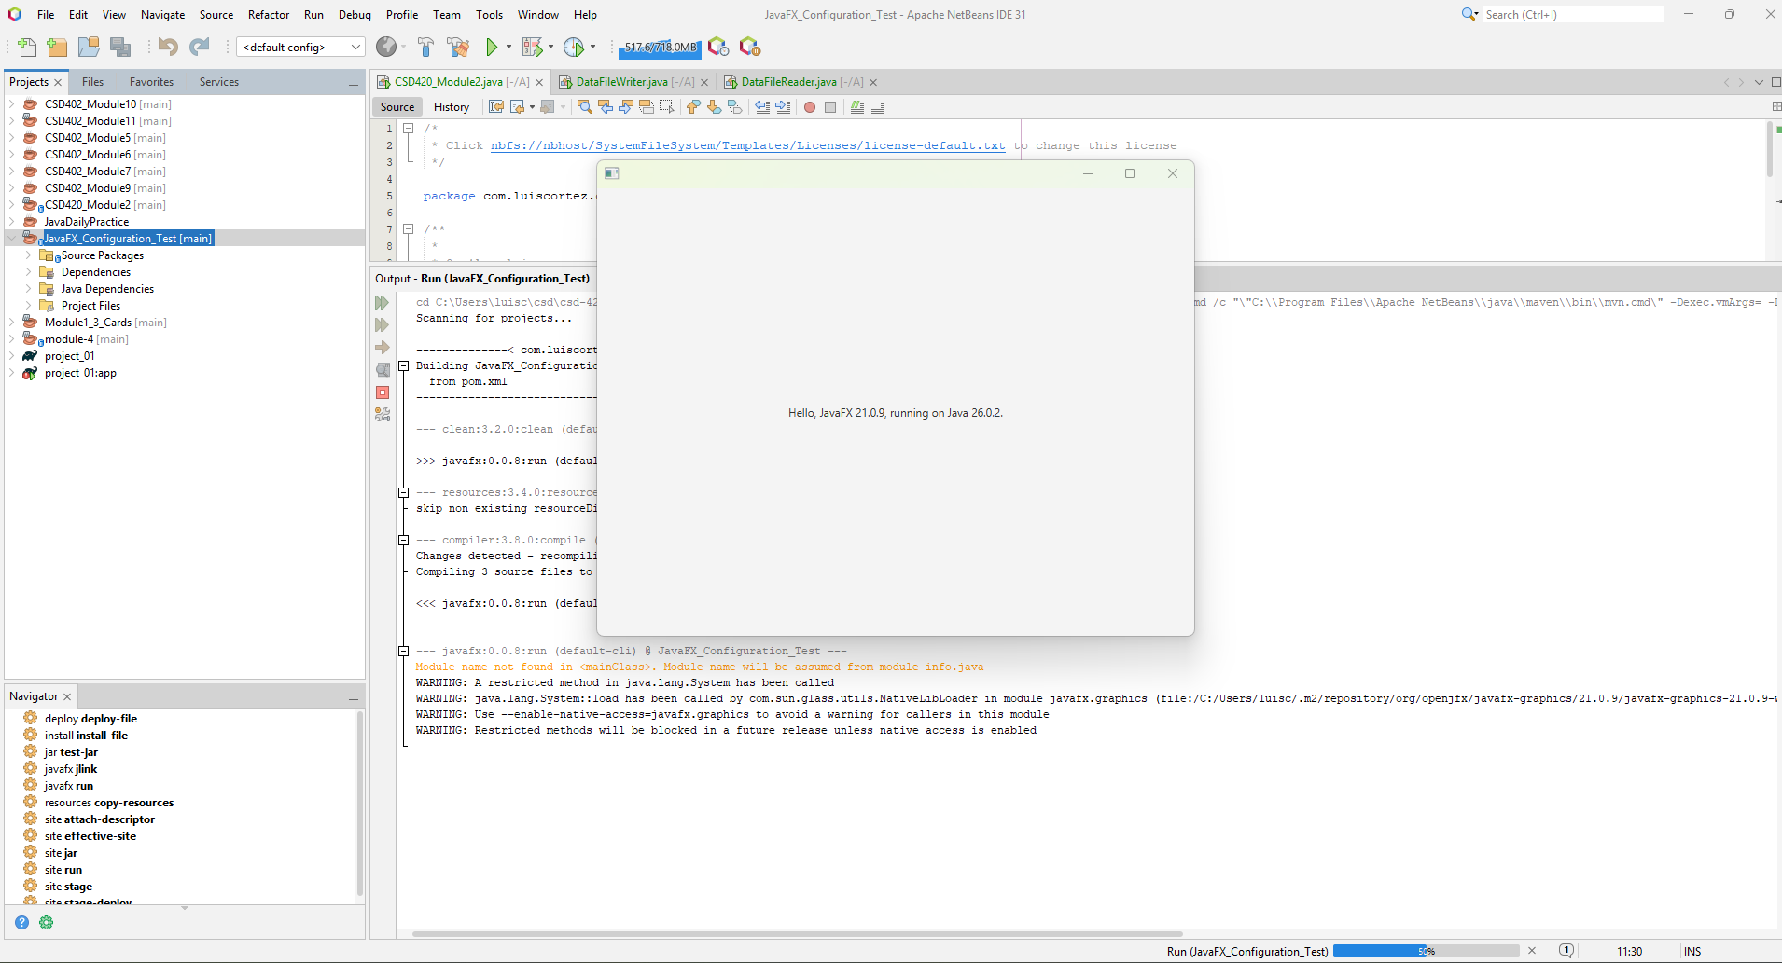
Figure 6. Java development environment and JavaFX configuration evidence, as requested in the assignment instructions.

