Module 4.2 Programming Assignment
LinkedList Traversal Performance Comparison
Student: Luis Leonardo Cortez Velez
Course: CSD420 – Advanced Java Programming
University: Bellevue University
Date: November 7, 2026
Assignment: Module 4.2
1. Program Description
This Java program compares the performance of two methods for traversing a LinkedList: using an Iterator and using the get(index) method. The program tests both methods with 50,000 and 500,000 integers to measure their execution times and demonstrate the difference in efficiency.
2. Source Code
The program creates a LinkedList<Integer>, measures traversal times using System.nanoTime(), and verifies that both methods process the data correctly.
Screenshot 1: Java Source Code – Program Setup
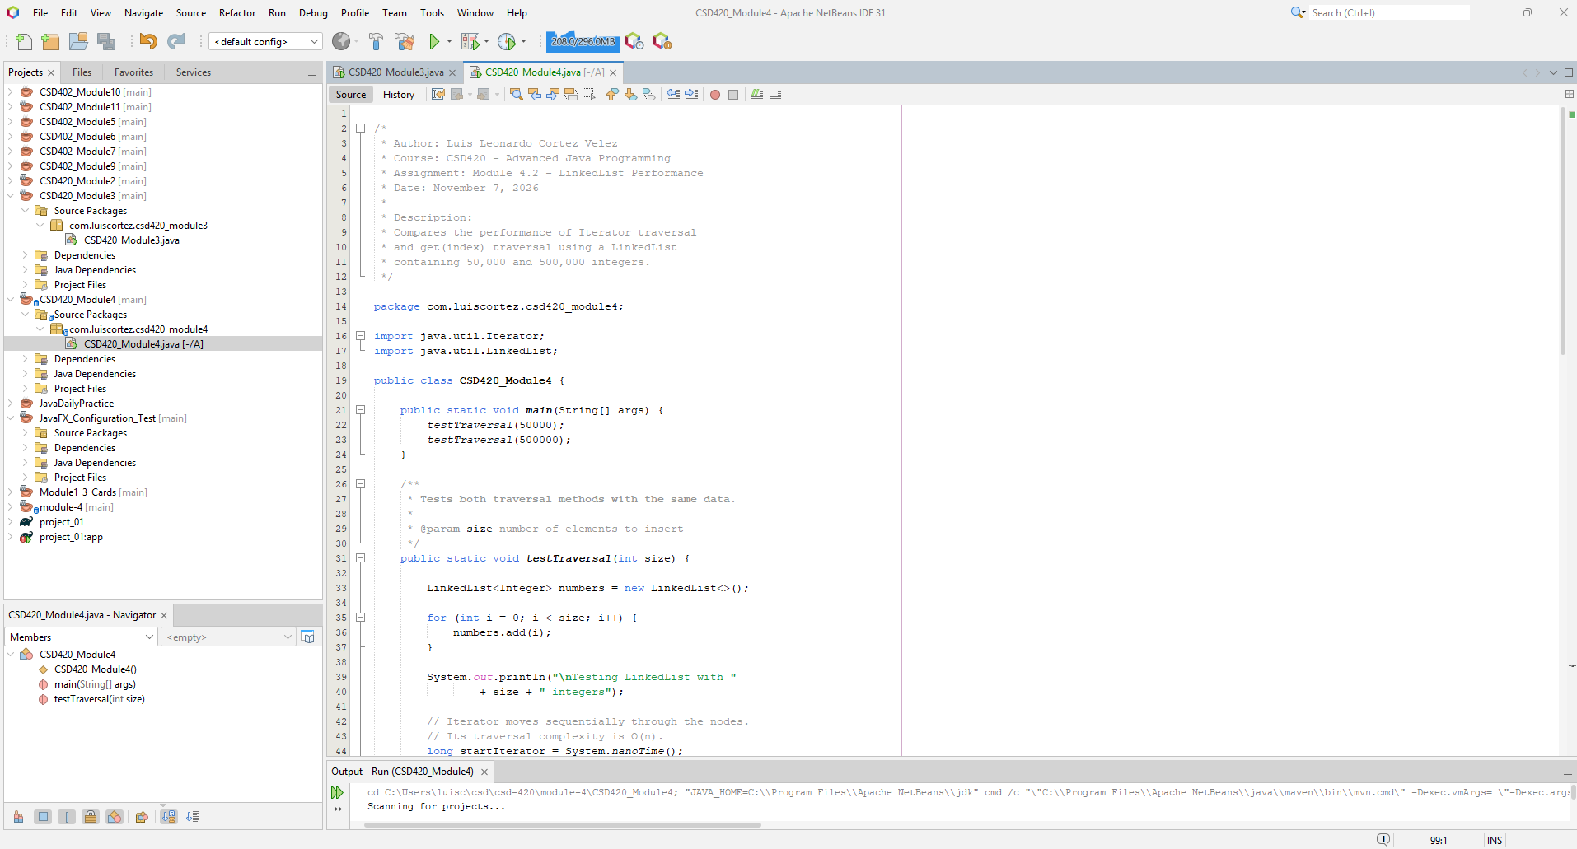

Screenshot 2: Java Source Code – Traversal Methods
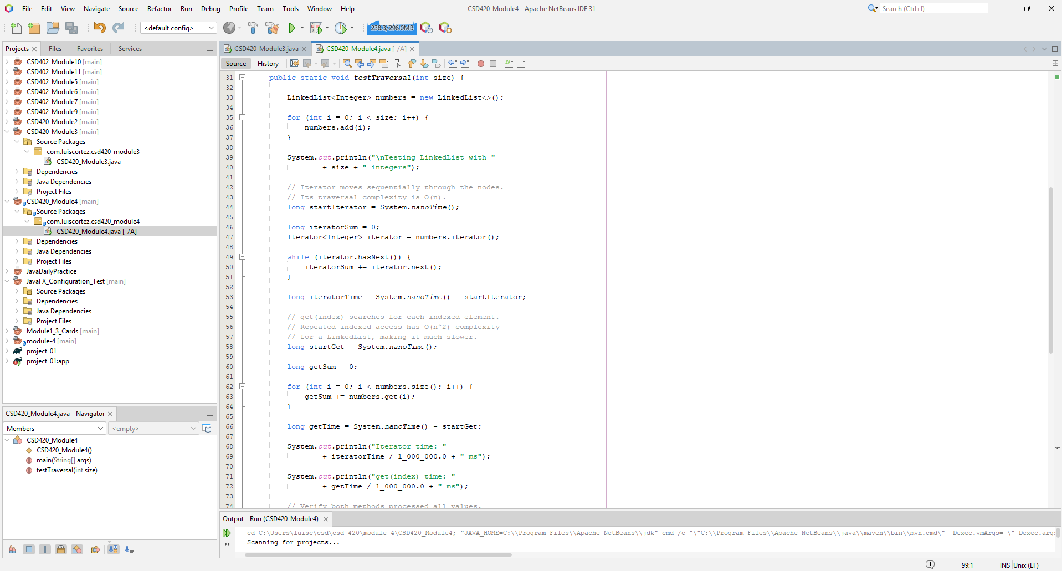

3. Program Execution and Results
The program successfully executed both tests in Apache NetBeans IDE 31.
List Size | Iterator | get(index)
50,000 integers | 4.032 ms | 1,253.8075 ms
500,000 integers | 6.3002 ms | 139,897.215 ms
Both tests passed verification, and the program finished with BUILD SUCCESS.

Screenshot 3: Program Output
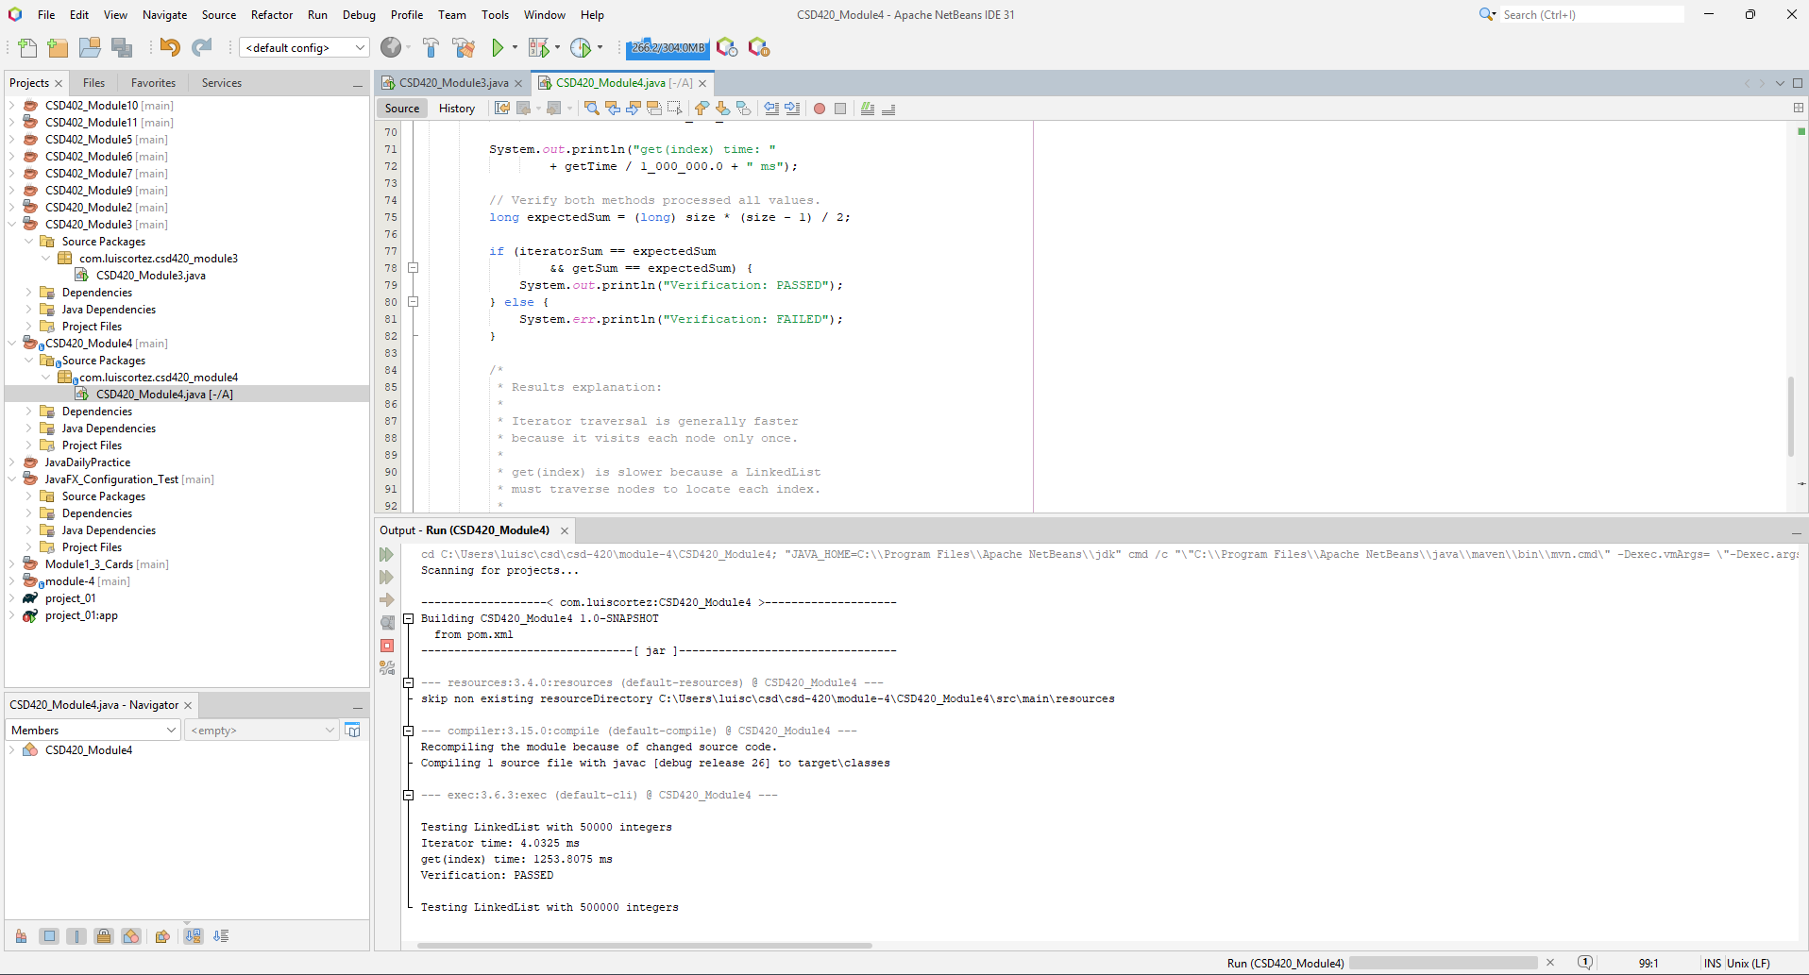
4. Results Analysis
The Iterator method was significantly faster for both list sizes because it traverses the LinkedList sequentially in O(n) time. In contrast, repeated get(index) calls require searching through the linked nodes, resulting in O(n²) total traversal time.
The performance difference became substantially larger when increasing the list size from 50,000 to 500,000 integers. These results demonstrate why an Iterator is generally more efficient for traversing large LinkedLists.
5. Conclusion
This assignment demonstrates the importance of selecting an appropriate traversal method for Java collections. Both methods returned correct results, but Iterator traversal provided substantially better performance.

