**Model: ejp_core_model_cytokines_view.png**

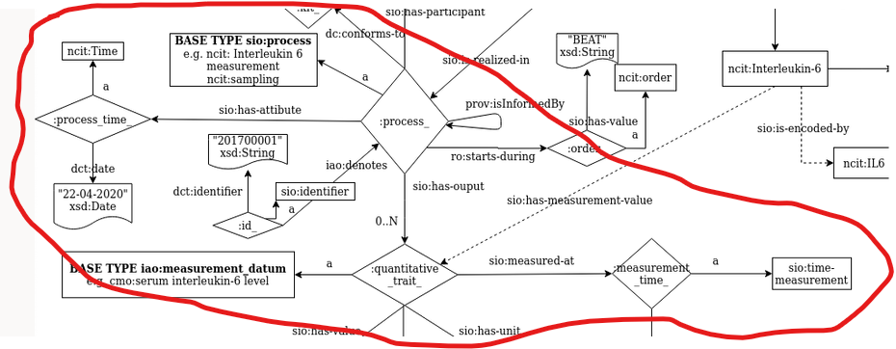

* I think it would be better if "*process_time*" have the *NCIT:Date* type, which refers to a date when an event took place. As far as I understood, time refers to the concept of "Time Dimension".
  + Time: <http://purl.obolibrary.org/obo/NCIT_C25207>
  + Date: http://purl.obolibrary.org/obo/NCIT_C25164
* If a *quantitative_trait* was measured in a process, and this process have the time stamp record, the "measuremenet_time" might be redundant. Still, I think it would be good if we keep this element, since it may make data easier to future analysis. Just keep this in mind.

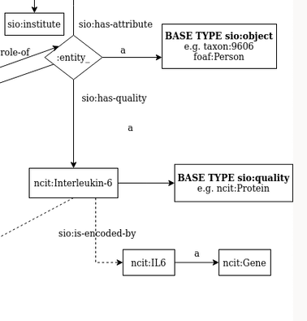

* I’m not sure about this, but I think that representing a cytokine as instance might confuse people trying to understand the model. What if we make it more evident? Like this:

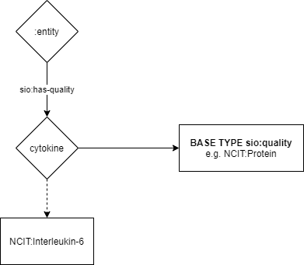

**Model: cytokines_extended_semantic_model.png**

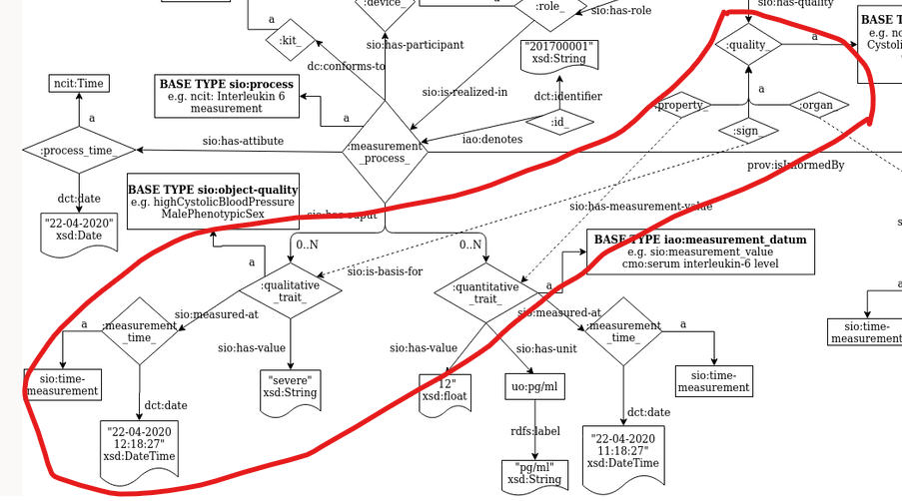

* In the project I work on here in Brazil, we’ve identified the need to have Signs that the patient explicitly does not have and the signs that were just unreported (e.g. the doctor simply didn’t ask the patient and she didn’t mention, but still it might be something she has). I may not be the problem in a better health system in Europe, but something I found worth mentioning.

**In general, I think I did an awesome work here. *Muito bom!***