**Visual query creation in ViziQuer/web: first steps**

There is separate visual query environment maintained for every user.

The demo@lumii.lv user environment may be shared by several people, so don’t be surprised, if your diagrams are changed or even deleted in a while.

The diagrams in the query environment are arranged in *projects*.

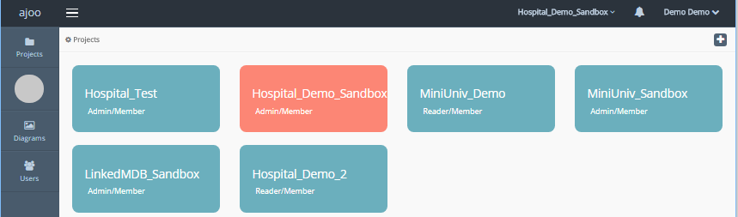

Single click on a project to open it.

There are further project management options (duplicate, edit (e.g. rename), delete) available as a context menu under ‘v’ sign at the upper right corner of the selected project (if the user has administration rights for the project).

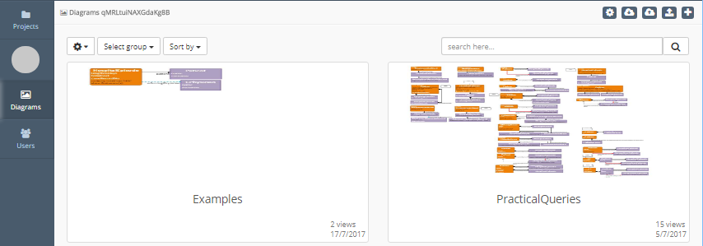

After opening the project, there is project management palette in the upper right corner, consisting of the following items:

* Settings (project parameters)
* Download as JSON (experimental)
* Upload from JSON (experimental)
* Upload ontology
* New diagram

For a project to be functional, it needs:

1. an uploaded ontology (data schema; there are example schemas and schema generation tools available from viziquer.lumii.lv/web), and
2. the connection information to the SPARQL endpoint set (behind the ‘Settings’ button); the connection information is not necessary for generation of SPARQL queries (the generated queries can then be manually copied over to the target SPARQL endpoint)

There are options for duplicating, editing and deleting diagrams within a project, as well (if the project is available in admin mode).

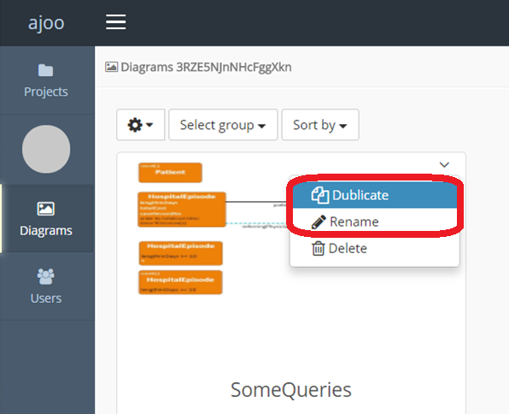

For a sandbox project within the demo environment it might be a good idea to duplicate and rename some of the diagrams, then freely change the dublicate.

New diagram creation is in the project management palette.

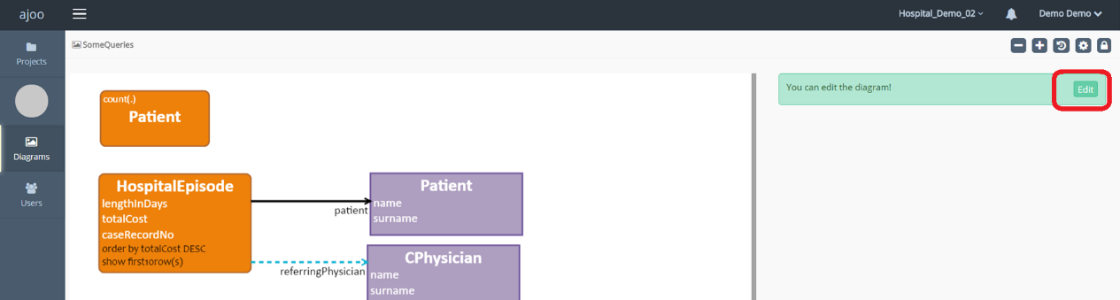

After opening the diagram, check that it is in edit mode. If the message bar says ‘You can edit the diagram’, click ‘Edit’. If the message bar says ‘You are editing the diagram’, you may go ahead with diagram edits.

Make sure your web browser window is wide enough to have the element property sheets to the right of the diagram pane (on narrow windows the property pane is below the diagram, what may not be the best from the user interface usability point of view).

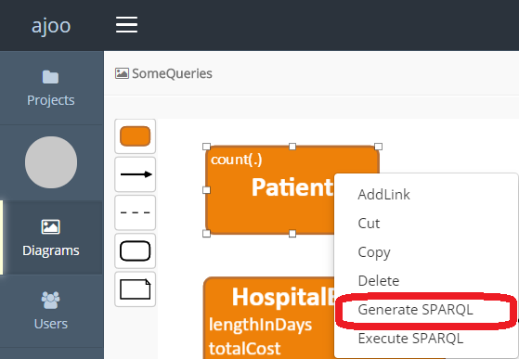

Right click on a single main query class (orange round rectangle) will allow you to generate or execute SPARQL from the single class.

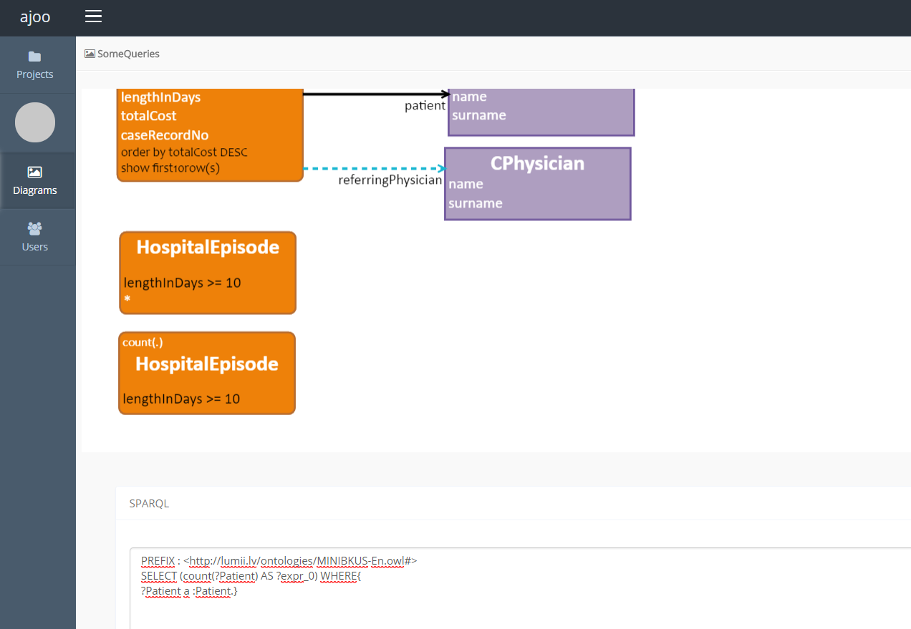

The generated SPARQL and/or the query execution results can be found at the bottom of the page (you may need to scroll down to see that).

It is possible to select an area with an entire query graph (a connected diagram fragment containing a single main query class), and have generated and executed SPARQL from the selected query.

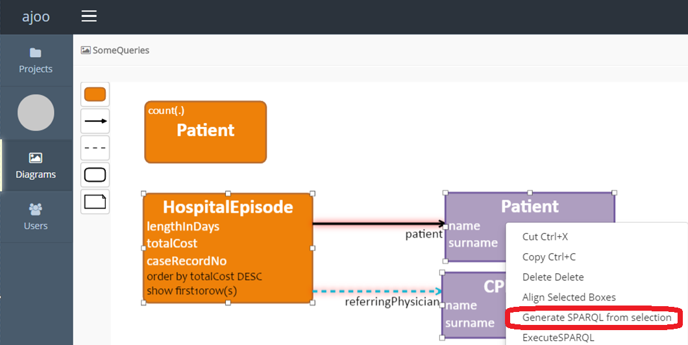

To generate SPARQL for a complex query you must select the visual elements belonging to the query.

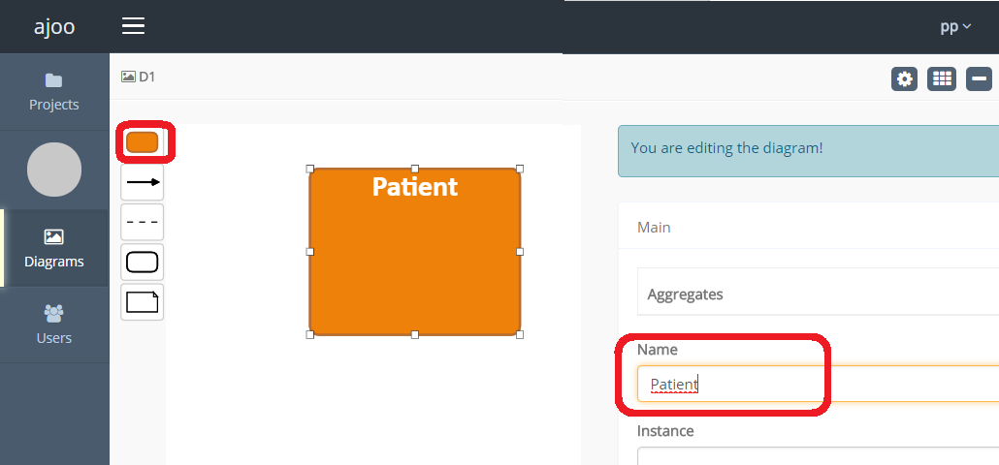

By choosing the orange class symbol from the palette you can start creating a new query. The names of the classes from the data model are pre-loaded in the class name search box.

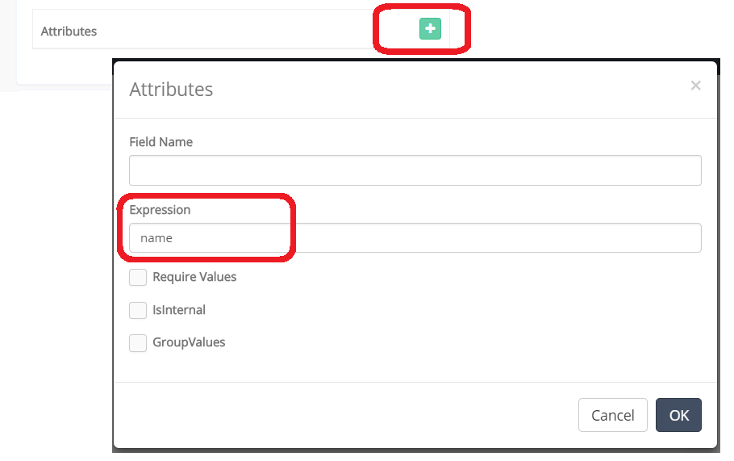

The attributes shown in a query can be added using “+” in the attribute compartment. The names of the attributes connected to the class in the data model, are offered as suggestions in the search box. Other attribute or query field names, as well as expressions, can be typed in the expression area.

Other fields in the property sheet can be filled in in a similar way (the order by and limit clauses are in the ‘Plus’ tab in the property sheet area).

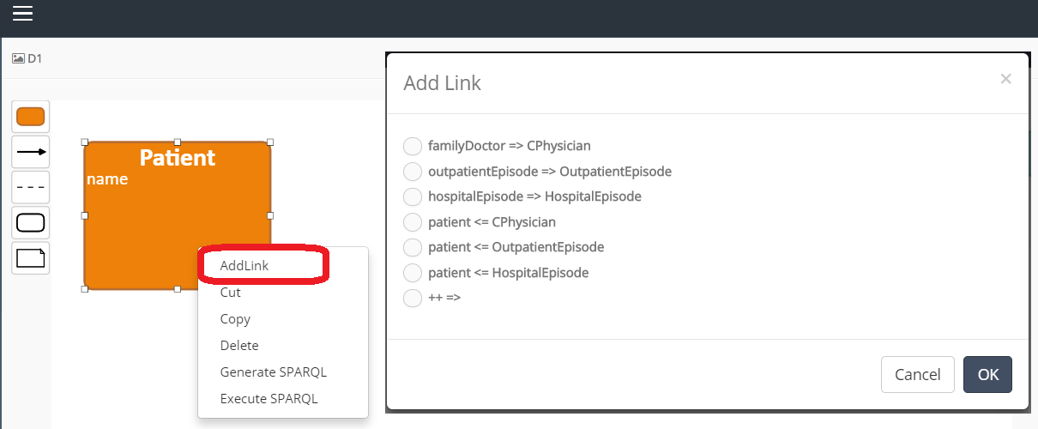

You can create a complex query using the command “AddLink”. After choosing a link from the list of available links, the link and target class will be created.