# Required Tools for Compilation

To compile TDA Kernel DLL, you need the following tools:

* JDK (Java Development Kit)
* Eclipse
* Eclipse C++ support  
  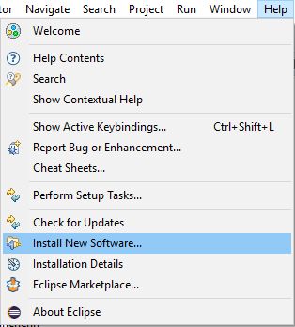  
  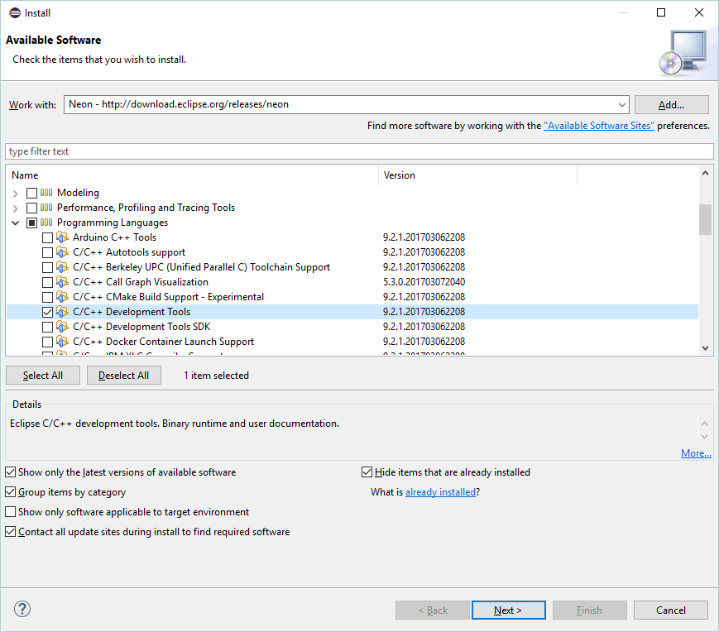
* MinGW (for Windows systems); MinGW for both 32-bit and 64-bit targets can be obtained from <http://mingw-w64.sourceforge.net/>
  + *To be able to compile TDA Kernel native part for 32-bit and 64-bit Windows targets:*
    - MinGW (32-bit executables and target) and MinGW-w64 (32-bit executables, Win64 target) should be installed. Although other combinations are possible, we recommend this combination since it will work on both 32-bit and 64-bit Windows versions.
    - We assume that the names of g++ and other MinGW programs targeting Win32 are not decorated.
    - We assume that the names of g++ and other MinGW programs targeting Win64 are x86_64-w64-mingw32-<program>.exe.
    - All these programs should be accessible from the PATH environment variable.
  + If you want to compile Windows binaries on a Linux system, you have to install Linux-versions of MinGW-w32 and/or MinGW-w64 (not considered in this document)

You can switch between target configurations in Eclipse:

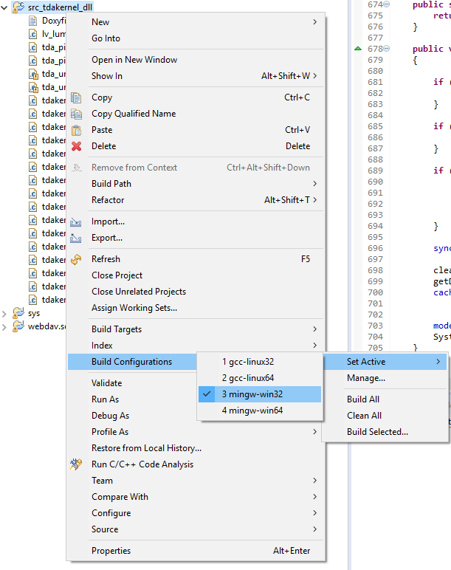

Then build the project:

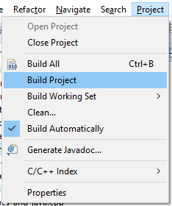

# Notes on MacOS targets

On MacOS, -rpath option is not supported by linker. More info on compiling the TDA Kernel .dylib with correct install path: <https://blogs.oracle.com/dipol/dynamic-libraries,-rpath,-and-mac-os>

On MacOS, you can compile both 32-bit and 64-bit versions of TDA Kernel native library. However, Apple and Oracle do not ship 32-bit Java version for MacOS anymore. Thus, if you wish to stick to 32-bit version, you will have to compile 32-bit OpenJDK by your own.