## 'FCL Interactive Map' — Explanatory And Exploratory Visualization Tool

Date: 03.11.2015

Authors: Maria PAPADOPOULOU (MP), Zeng WEI (ZW), Stephen CAIRNS (SC)

**Rationale, aim and significance**

Explanatory visualization tools are informative representations that intend to unveil key discoveries. Additionally, they facilitate the users in exploring the data while allowing them to uncover their own bits of knowledge that are pertinent or intriguing. Typically such visualizations are considered to be in an interactive format, but are not limited to being interactive, hence allowing the user to work either visually or interactively.

The aim of creating an interactive visualization map is to draw the linkages between the global phenomenon of urbanization and the state-of-the-art research produced at the Future Cities Laboratory (FCL). A world map that shows the historical timeline of world population density is used as a starting point. Different levels of information deriving from FCL will be also embedded into the design of the visualization tool: case-study locations, global network and researchers locations.

The result is an interactive, mapping tool with multiple layers of data to help view the interactions between FCL’s research projects with the prominent problem of population growth and through that promote emerging possibilities.

**Context and methods**

The explanatory visualization tool will be built on top of HTML, CSS, and javascript programming languages, with support of open-source, cross-platform visualization and web server libraries, such as ‘d3.js’ and ‘node.js’. The visualization will be built using ‘d3.js’ that handles the data to code mappings and consistency, and then drawn to an HTML canvas. The tool will support intuitive interactions, such as map navigation, selection and filtering.

An example of such explanatory visualization tool can be found at: http://d3.artzub.com/wbca/

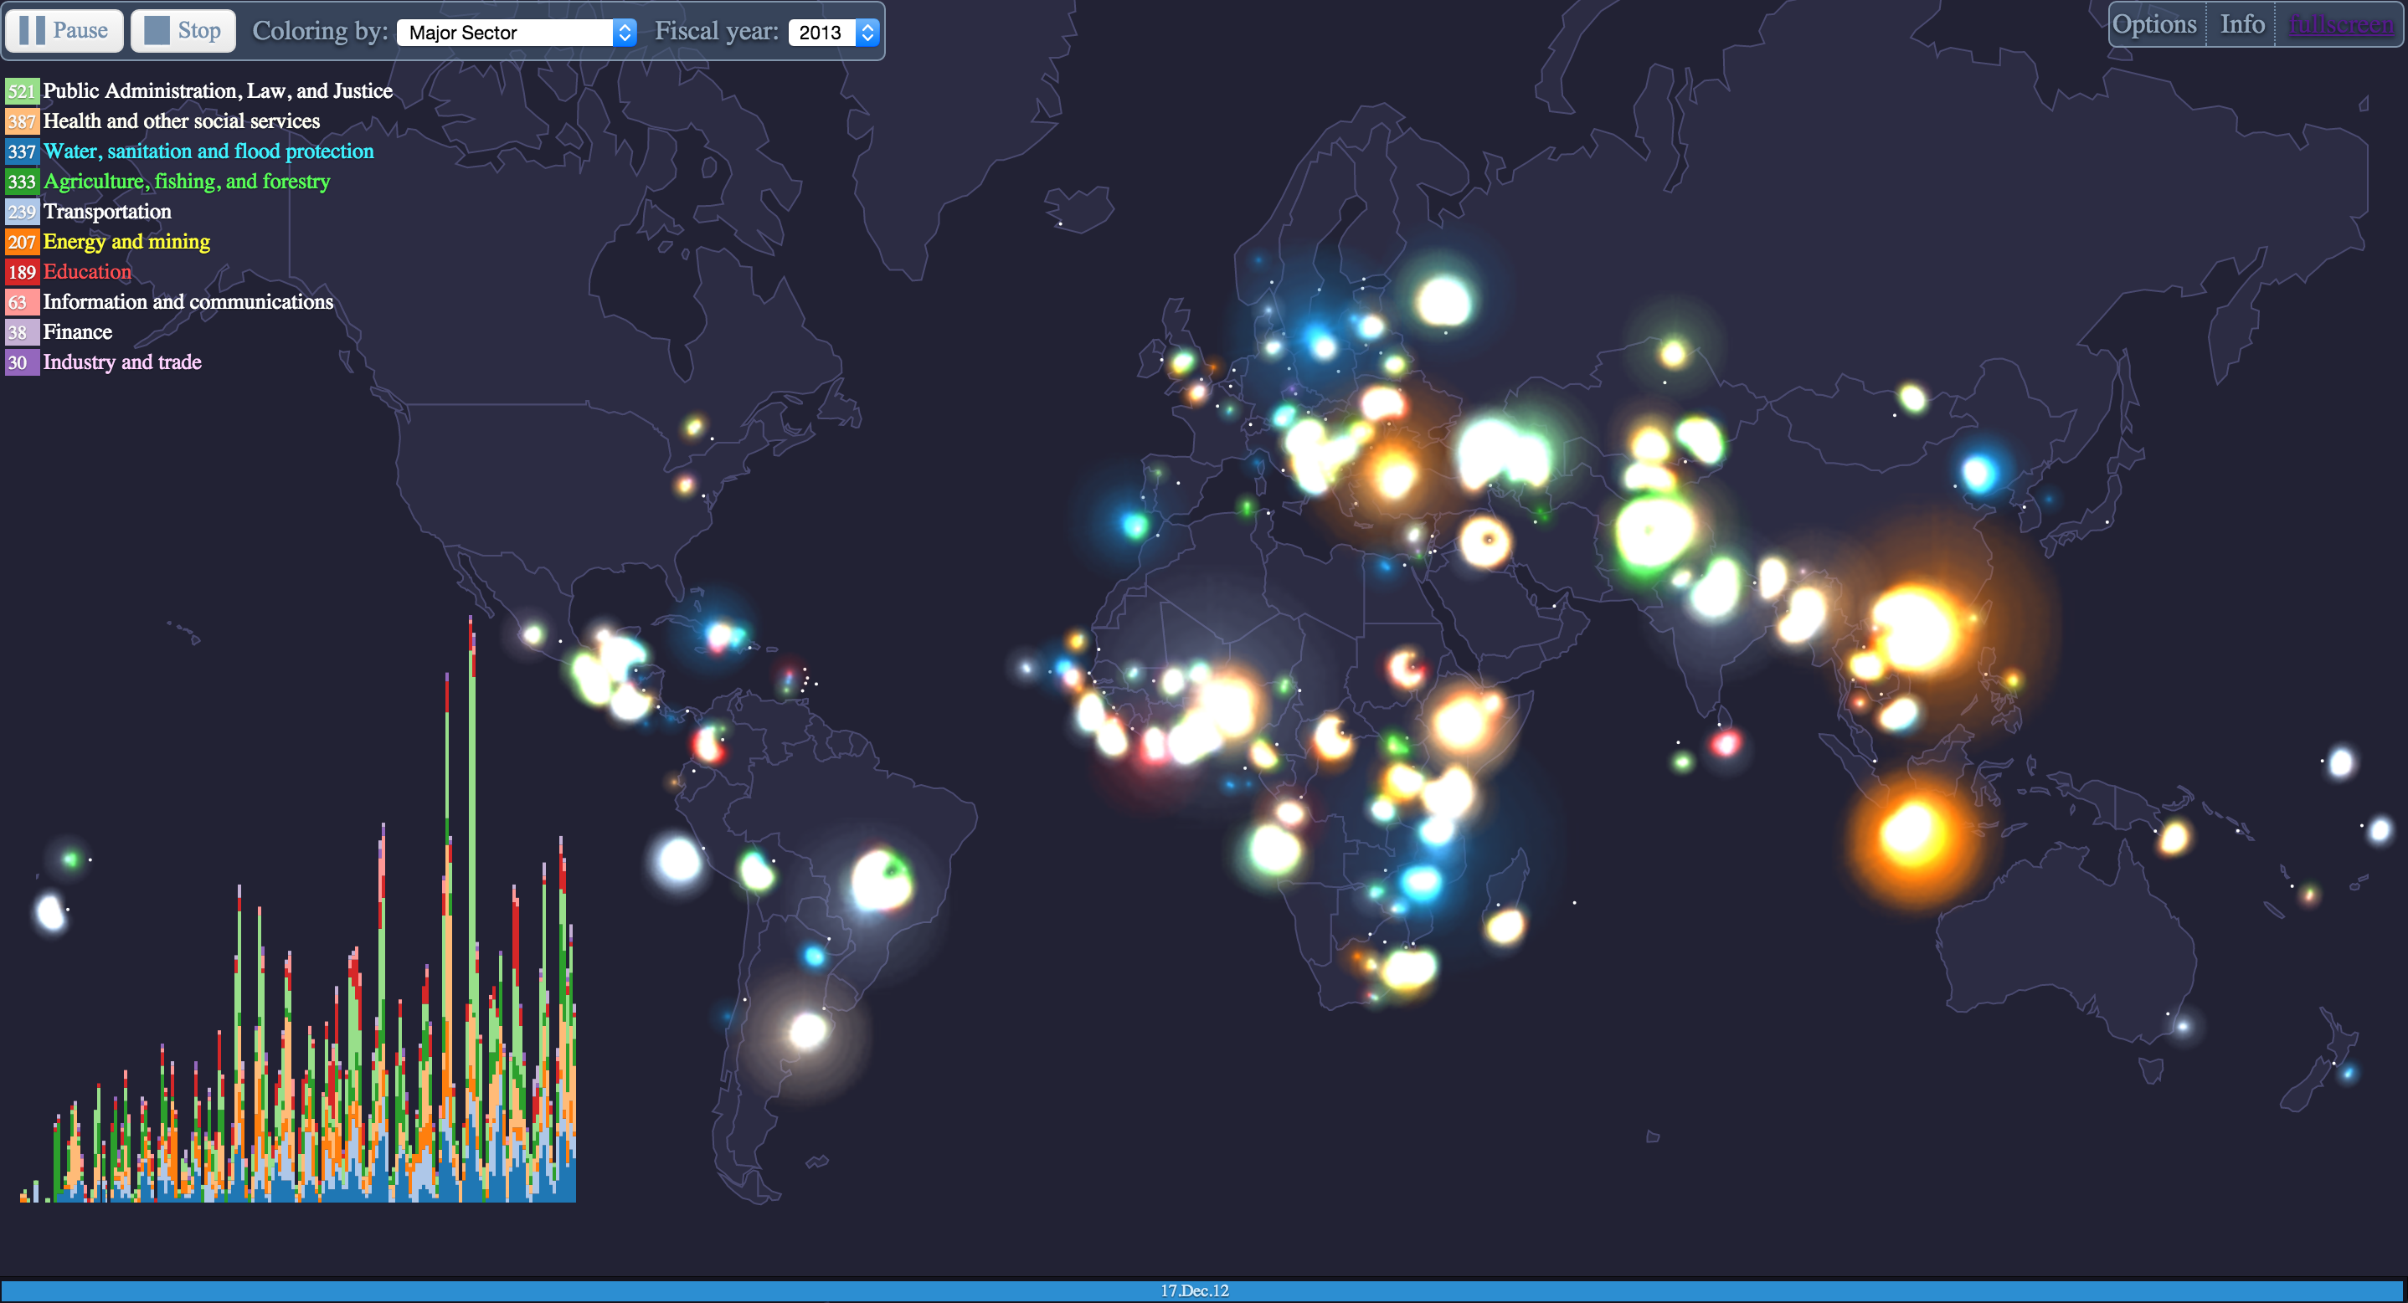

**Expected outcome**

Starting as an explanatory tool, the interactive visualization map will have the following features:

1. Updatable: able to update the input file as new data emerge from the FCL projects. Readable format will be
2. Multiple information layers:
   1. World population density
   2. Case studies of FCL research projects
   3. Global network
3. Expandable: allow to add additional layers, such as gross domestic product (GDP) per country

The interactive visualizations tool is expected to support the users in associating the functions of storytelling with the data and not propose a single narrative, nor actively draw out key insights or headlines. The tool has the potential to be further expanded (see point 3 above) and utilized as an explanatory tool to facilitate in data exploration and promote the discovery process. This is expected to lead to new findings and insights, depending on the user’s context.

**Alternative set-up**

In the case the proposal for the 'FCL Interactive Map' will not proceed the individual modules and research projects will have to revert to individual data collection and analysis strategies. This will have implications on the data that individuals can collect and reduce the validity and the interdisciplinary nature of the FCL would reamain underexplored.

**Timetable**

|  |  |  |  |  |  |  |  |  |  |  |  |  |  |  |
| --- | --- | --- | --- | --- | --- | --- | --- | --- | --- | --- | --- | --- | --- | --- |
|  |  | **2015** | | | |  |  |  |  |  | **2016** | | | |
|  |  | **November** | | | | **December** | | | | | **January** | | |  |
| **Task \ Week** |  | **1** | **2** | **3** | **4** | **1** | **2** | **3** | **4** | **5** | **1** | **2** | **3** | **4** |
| **Phase A** | **Data collection** |  |  |  |  |  |  |  |  |  |  |  |  |  |
| A1 | Global population density | x |  |  |  |  |  |  |  |  |  |  |  |  |
| A2 | Countries of case study | x |  |  |  |  |  |  |  |  |  | x |  |  |
| A3 | Global network | x |  |  |  |  |  |  |  |  |  |  | x |  |
| A4 | Researchers base | x |  |  |  |  |  |  |  |  |  |  | x |  |
| **Phase B** | **Project Management** |  |  |  |  |  |  |  |  |  |  |  |  |  |
| B1 | Project Specificiations & Graphics Design |  | x |  |  |  |  |  |  |  |  |  |  |  |
| B2 | Programming |  |  | x | x | x | x | x | x |  | x | x |  |  |
| B3 | Corrections & implementation of feedback |  |  |  |  |  |  |  | x |  |  | x | x | x |
| **Phase C** | **Milestones** |  |  |  |  |  |  |  |  |  |  |  |  |  |
| C1 | First draft |  |  |  |  |  |  |  |  |  | x |  |  |  |
| C2 | Second draft |  |  |  |  |  |  |  |  |  |  | x |  |  |
| C3 | Final version |  |  |  |  |  |  |  |  |  |  |  |  | x |

**Resources and budget**

The following data are needed as input:

|  |  |  |
| --- | --- | --- |
| **No.** | **Data** | **Responsible** |
| 1 | Population density (by country) | ZW |
| 2 | Countries of case study (for all FCL research projects) | MP |
| 3 | Global network (by country) | MP |
| 4 | Reseachers base (by country) | MP |

**Formalities**

To the knowledge of the participants there is no need for permissions.

**Members of the work-packages**

Maria PAPADOPOULOU (FCL research manager)

Zeng WEI (Collaborative Interactive Visualisation and Analysis Lab, Post-Doctoral researcher)

Stephen CAIRNS (FCL Programme Director and Principal Investigator of ‘Urban Rural Systems’)