


Database Management Assignment File (ENCS205)

Bachelor of Technology in
Computer Science and Engineering

Submitted by
Lucky Kumar (2401010012)
B. Tech CSE (Core) – 4th Semester Section: A

Submitted To:
MS. Mansi Kajal

School of Engineering & Technology
K. R. MANGALAM UNIVERSITY
Sohna, Haryana 122103, India feb-2026

ASSIGNMENT: 2

Objective:
To understand and implement SQL transactions using COMMIT, SAVEPOINT, and ROLLBACK, retrieve records using SELECT queries, and perform INSERT, UPDATE, and ALTER operations on tables.

Table Structures:

CLASS
D (NUMBER) and Name (VARCHAR).
The initial records in the table are (1, 'Bravo'), (2, 'Alex'), and (4, 'Cheng').

EMPLOYEES
Employee_Id (NUMBER), First_Name (VARCHAR), Last_Name (VARCHAR), Email (VARCHAR), Phone_Number (VARCHAR), Hire_Date (DATE), Job_Id (VARCHAR), Salary (NUMBER), Commission_Pct (NUMBER), Manager_Id (NUMBER), and Department_Id (NUMBER).

DDL Questions (Data Definition Language):

How do you create a table named CLASS with appropriate data types?
CREATE DATABASE IF NOT EXISTS DBMS_LAB; USE DBMS_LAB;
CREATE TABLE CLASS ( id INT PRIMARY KEY, name VARCHAR(50)
);

INSERT INTO CLASS VALUES (1,'Bravo'); INSERT INTO CLASS VALUES (2,'Alex'); INSERT INTO CLASS VALUES (4,'Cheng');

How do you create a table named EMPLOYEES with the specified attributes?
CREATE TABLE EMPLOYEES (
Employee_Id INT PRIMARY KEY, First_Name VARCHAR(50), Last_Name VARCHAR(50),
Email VARCHAR(100),
Phone_Number VARCHAR(20), Hire_Date DATE,
Job_Id VARCHAR(20), Salary DECIMAL(10,2),
Commission_Pct DECIMAL(5,2), Manager_Id INT,
Department_Id INT
);

INSERT INTO EMPLOYEES VALUES (101,'John','Austin','john@gmail.com','9999999999',CURDATE(),'IT_PROG',5000,NULL,10 0,60), (102,'Sara','Smith','sara@gmail.com','8888888888',CURDATE(),'HR_REP',4500,NULL,100,7 0), (103,'David','Lee','david@gmail.com','7777777777',CURDATE(),'IT_PROG',4800,NULL,10 1,80), (104,'Chris','Martin','chris@gmail.com','6666666666',CURDATE(),'SA_REP',6000,NULL,10 0,60);

How do you create a table named Client_master with the specified attributes?
CREATE TABLE Client_master (
ClientNO VARCHAR(10) PRIMARY KEY, Name VARCHAR(50),
Address VARCHAR(100), City VARCHAR(50), State VARCHAR(50), Bal_due DECIMAL(10,2)
);

What SQL statement would you use to rename the table Client_master to Client12?

ALTER TABLE Client_master RENAME TO Client12;

How do you display the bal_due column heading as “BALANCE”?
SELECT Bal_due AS "BALANCE"
FROM Client_master;

Part A: Transactions and Savepoints (CLASS Table)
SET autocommit = 0; START TRANSACTION;

INSERT INTO CLASS VALUES (5,'Rahul');

UPDATE CLASS SET name='Abhijeet' WHERE id=5; SAVEPOINT A;

INSERT INTO CLASS VALUES (6,'Chris'); SAVEPOINT B;

INSERT INTO CLASS VALUES (7,'Bravo'); SAVEPOINT C;

SELECT * FROM CLASS;

ROLLBACK TO B; SELECT * FROM CLASS;

ROLLBACK TO A; SELECT * FROM CLASS;

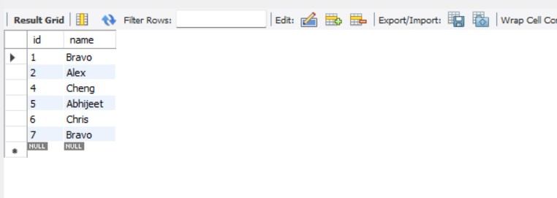

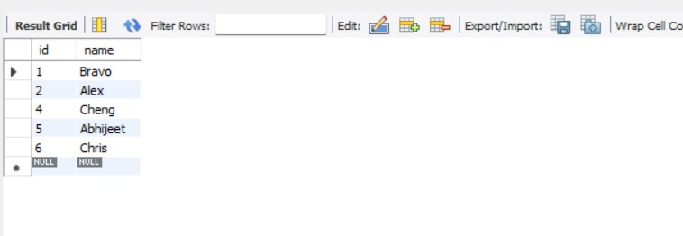

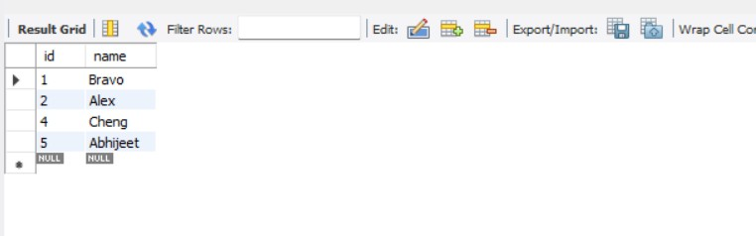

Part B: Retrieving Records (EMPLOYEES Table)

Find out the employee id, names, and salaries of all the employees.

SELECT Employee_Id, First_Name, Last_Name, Salary FROM EMPLOYEES;
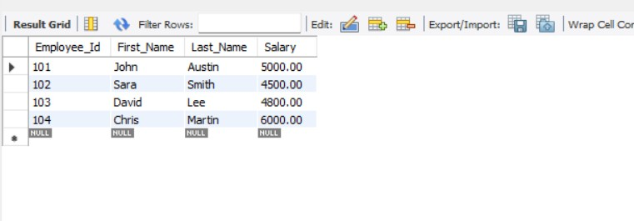

List out the employees who work under manager 100.
SELECT *
FROM EMPLOYEES
WHERE Manager_Id = 100;
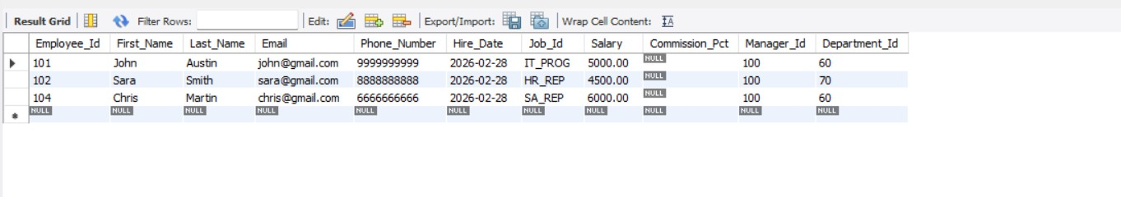

Find the names of the employees who have a salary greater than or equal to 4800.

SELECT First_Name, Last_Name FROM EMPLOYEES
WHERE Salary >= 4800;
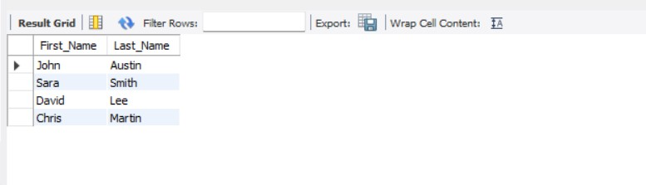

List out the employees whose last name is ‘AUSTIN’.
SELECT *
FROM EMPLOYEES
WHERE Last_Name = 'Austin';

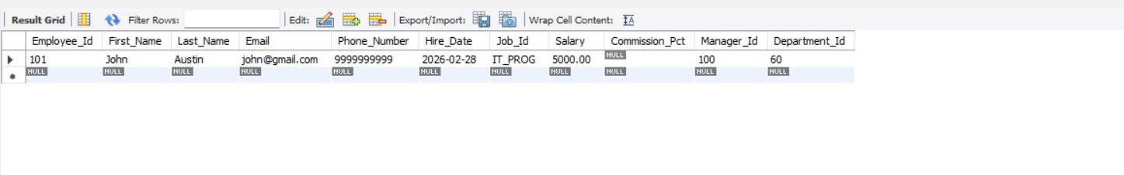

Find the names of the employees who work in departments 60, 70, and 80.
SELECT First_Name, Last_Name FROM EMPLOYEES
WHERE Department_Id IN (60,70,80);
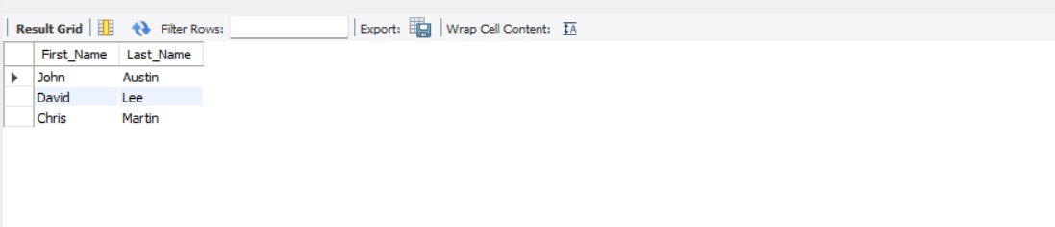

Display the unique Manager_Id.
SELECT DISTINCT Manager_Id FROM EMPLOYEES;
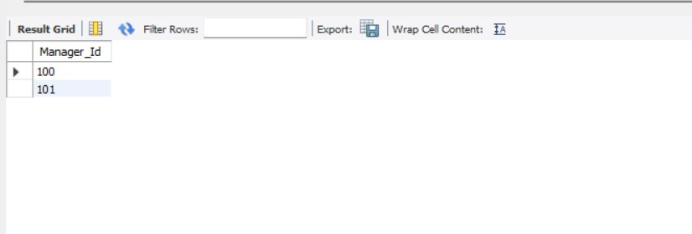

Part C: Updating Records (Client_master Table)

Insert five records into the Client_master table.
INSERT INTO Client_master VALUES ('C101','Rohan','MG Road','Delhi','Delhi',4500),
('C102','Aman','Park Street','Kolkata','WB',6000),
('C123','Priya','Sector 10','Gurgaon','Haryana',4800),
('C104','Neha','Ring Road','Mumbai','Maharashtra',7000),
('C105','Vikas','Main Market','Jaipur','Rajasthan',3000); COMMIT;

Find the names of clients whose bal_due > 5000.

SELECT Name FROM Client_master
WHERE Bal_due > 5000;
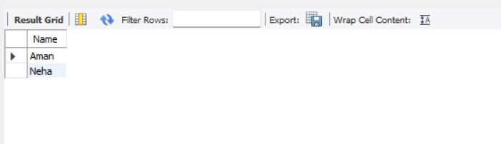

Change the bal_due of ClientNO "C123" to Rs. 5100.
UPDATE Client_master SET Bal_due = 5100 WHERE ClientNO = 'C123';

COMMIT;

