Department of Mechanical Engineering
Control Group


USER REGISTRATION

USER PARTICULARS

Name: | <NAME> |  |  |  |  |  |  |  |  | Matric No: |  |  |  | <ID>_____
Supervisor(s): |  | <SUPERVISOR> |  |  |  |  |  |  |  | Type of Project*: |  |  |  |  |  | PhD
Attachment Period: |  |  | From: | <DATE>____ |  |  |  |  |  | To: | <DATE>____
Contact No: |  | <PHONE>________ |  |  |  | Email: |  |  | <EMAIL>___________
Emergency Contact Information
Name: | <SUPERVISOR> |  |  |  |  |  | Contact No: |  |  |  | <CONTACT>_____________
*PhD/RF/RE/VStf/CSC/Others (please specify Program Type or Module Code)

[Please skip this section. To complete “Risk Assessment Form 04062021” instead.]
PROJECT RISK ASSESSMENT

- To be completed by Project Supervisor.
- Attach extra sheets if necessary.

Project Title:
Risk Assessment:
□ No Risk
□ Risk [Please tick the risks and indicate Assess Risks and Risks Control below]
□ Mechanical |  |  |  | □ Electrical |  |  |  | □ Chemical |  | □ Biological |  |  | □ Noise
□ Others (Please specify):
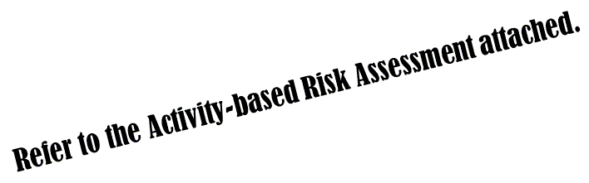Assessed Risks:
Risk Controls:
 |  |  | --- |  |  |  |  |  |  |  | ---
 |  |  | Name of Project Supervisor |  |  |  |  |  |  |  | Signature and Date

SAFETY VIDEO VIEWING

Safety Video Title | Date of Viewing
□ OSHGEN01 Laboratory Safety Induction Training | <DATE>____
□ OSHGEN02 Introduction to Laboratory Safety & Health in NUS | <DATE>____
□ OSHGEN03 NUS Requirements on Safety, Health & Emergency Management (Staff only)
□ OSHGEN06 Risk Management for Laboratory | <DATE>____
□ OSHERGO02 NUS Laboratory Ergonomics Training | <DATE>____
□ OSHFS01 Online Fire Safety Training Course (Staff only)

#GUIDELINES FOR APPROPRIATE USE OF LABORATORY FACILITIES

- Be responsible for your own safety and proper handling of your project setup. Think of the impact on others as a result of your action.
- Wear proper attire in the laboratory. No sandals, slippers or any open-toed shoes are allowed. Observe additional safety measures required at other areas.
- Do not work alone in the laboratory after office hour.
- Strictly NO FOOD is allowed in the laboratory.

No Visitors are allowed in the laboratory without permission from the laboratory management/Head of Department.
- Dispose wastes (e.g. chemicals and biologicals) in accordance to safety guidelines where appropriate.
- Sign your attendance on the LOG BOOK when accessing the laboratory after office hours.
- No operation of machines/equipment is allowed before any briefing on respective safe machine operation procedure. Follow the Standard Operating Procedures (SOPs). Report any unsafe practices and/or malfunctioned equipment to the laboratory staff.
- Report any incident or accident immediately to the laboratory staff during office hours and to the campus security officer/faculty safety officer after office hours. Check safety notice board for the contact numbers.

DECLARATION

☑ I agree to abide by the above Guidelines for Appropriate Use of Laboratory Facilities. #
☑ I shall not hold the University responsible or liable in the event of death, injury, disability or any mishaps while participating in the laboratory activities.
☑ I have read, understood and hereby acknowledged receipt of an exact copy of this Registration form.

 | <NAME>
 | Name |  | Signature and Date
# Not applicable for research office

