Week No: 12 | Date: | Roll No: 23071A05H0
Experiment:
Focuses on integrating JavaScript with servlets to enable dynamic cart updates without page reload.

Aim :
To integrate JavaScript with servlets for updating the shopping cart dynamically without refreshing the page.
Description :
This experiment involves building a web-based shopping cart system using Java Servlets, HTML, CSS, and JavaScript. It enables user registration, login, product browsing, and cart management. JavaScript communicates with servlets using asynchronous requests to update cart data dynamically without reloading the page.

HTML Elements Used :
- Form is used for user registration and login.
- Input is used to capture user details.
- Button is used for actions like add to cart and submit.
- Anchor tag is used for navigation between pages.
- Div is used for layout and content grouping.
- Table is used to display cart items and totals.
- Script is used to link JavaScript functionality.

CSS Styles Used :
- Background and color are used for dark theme design.
- Margin and padding are used for spacing.
- Border-radius is used for rounded UI components.
- Box-shadow is used for card-like effects.
- Display flex is used for layout structure.
- Text-align is used for alignment.
- Hover effects are applied for interactivity.

JavaScript Concepts Used :
- Functions are used for cart operations and validation.
- Event handling is used for button clicks and page load.
- Fetch API is used for asynchronous communication with servlets.
- DOM manipulation is used to update cart UI dynamically.
- JSON is used for data exchange between client and server.
- Local variables and objects are used to manage client-side data.

Servlet Concepts Used :
- HttpServlet is used to handle client requests.
- doGet() and doPost() methods process requests.
- HttpSession is used to store user and cart data.
- Request and response objects are used for communication.
- JSON response is used to send data back to frontend.
Steps to Execute :
Start
↓
User runs project on Apache Tomcat server
↓
Browser opens application URL
↓

Registration Phase
User opens register.html
↓
User enters details and submits form
↓
Request sent to RegisterServlet (POST)
↓
Servlet retrieves form data
↓
Stores user details in HTTP Session
↓
Response sent: Registration successful
↓

Login Phase
User opens login.html
↓
User enters credentials and submits
↓
Request sent to LoginServlet (POST)
↓
Servlet retrieves session data
↓
Validates email and password
↓
IF valid → Redirect to catalog.html
ELSE → Show error message
↓

Product Catalog Phase
User views products
↓
User clicks “Add to Cart”
↓
JavaScript function triggered
↓
Stock updated on UI (client-side)
↓
AJAX request sent to CartServlet (POST)
↓
Servlet updates cart data in session
↓
JSON response returned
↓

Cart Management Phase
User opens cart.html
↓
loadCart() sends request to CartServlet (GET)
↓
Servlet returns cart data (JSON)
↓
JavaScript renders cart table
↓
User actions:
Click “+” → increase quantity
Click “−” → decrease/remove item
↓
AJAX request sent to CartServlet
↓
Session updated
↓
UI updated dynamically
↓

End
User continues shopping or exits application

Code Implementation :
- CartServlet.java
import java.io.*;
import javax.servlet.*;
import javax.servlet.http.*;
import java.util.*;

public class CartServlet extends HttpServlet {

protected void doPost(HttpServletRequest request,
HttpServletResponse response)
throws ServletException, IOException {

String product = request.getParameter("productId");
String action = request.getParameter("action");
int price = Integer.parseInt(request.getParameter("price"));

HttpSession session = request.getSession();

Map<String,Integer> cart =
(Map<String,Integer>) session.getAttribute("cart");

Map<String,Integer> prices =
(Map<String,Integer>) session.getAttribute("prices");

if(cart == null){
cart = new HashMap<>();
prices = new HashMap<>();
}

int qty = cart.getOrDefault(product,0);

if("add".equals(action)){
cart.put(product, qty+1);
prices.put(product, price);
}

else if("remove".equals(action)){

if(qty > 1)
cart.put(product, qty-1);
else{
cart.remove(product);
prices.remove(product);
}

}

session.setAttribute("cart", cart);
session.setAttribute("prices", prices);

sendCart(response,cart,prices);
}

protected void doGet(HttpServletRequest request,
HttpServletResponse response)
throws ServletException, IOException {

HttpSession session = request.getSession();

Map<String,Integer> cart =
(Map<String,Integer>) session.getAttribute("cart");

Map<String,Integer> prices =
(Map<String,Integer>) session.getAttribute("prices");

if(cart == null){
cart = new HashMap<>();
prices = new HashMap<>();
}

sendCart(response,cart,prices);

}

private void sendCart(HttpServletResponse response,
Map<String,Integer> cart,
Map<String,Integer> prices) throws IOException{

response.setContentType("application/json");

PrintWriter out = response.getWriter();

StringBuilder json = new StringBuilder();
json.append("{\"items\":[");

int i=0;

for(String p:cart.keySet()){

if(i>0) json.append(",");

json.append("{\"name\":\""+p+"\",\"qty\":"+cart.get(p)+",\"price\":"+prices.get(p)+"}");

i++;

}

json.append("]}");

out.print(json.toString());
}

}

- LoginServlet.java
import javax.servlet.*;
import javax.servlet.http.*;
import java.io.*;

public class LoginServlet extends HttpServlet {

protected void doPost(HttpServletRequest request,
HttpServletResponse response)
throws ServletException, IOException {

String email = request.getParameter("email");
String password = request.getParameter("password");

HttpSession session = request.getSession();

String savedEmail = (String) session.getAttribute("userEmail");
String savedPassword = (String) session.getAttribute("userPassword");

if(email.equals(savedEmail) && password.equals(savedPassword)){

response.sendRedirect("catalog.html");

}
else{

response.getWriter().println("Invalid Login Credentials");

}

}
}

- RegisterServlet.java
import javax.servlet.*;
import javax.servlet.http.*;
import java.io.*;

public class RegisterServlet extends HttpServlet {

protected void doPost(HttpServletRequest request,
HttpServletResponse response)
throws ServletException, IOException {

String name = request.getParameter("name");
String email = request.getParameter("email");
String password = request.getParameter("password");

HttpSession session = request.getSession();

session.setAttribute("userEmail", email);
session.setAttribute("userPassword", password);

response.setContentType("text/html");

PrintWriter out = response.getWriter();

out.println("<h2>Registration Successful</h2>");
out.println("<a href='login.html'>Click here to login</a>");

}
}

- web.xml
<?xml version="1.0" encoding="UTF-8"?>
<web-app xmlns="http://xmlns.jcp.org/xml/ns/javaee" version="3.1">
<servlet>
<servlet-name>CartServlet</servlet-name>
<servlet-class>CartServlet</servlet-class>
</servlet>
<servlet-mapping>
<servlet-name>CartServlet</servlet-name>
<url-pattern>/CartServlet</url-pattern>
</servlet-mapping>
<servlet>
<servlet-name>LoginServlet</servlet-name>
<servlet-class>LoginServlet</servlet-class>
</servlet>
<servlet-mapping>
<servlet-name>LoginServlet</servlet-name>
<url-pattern>/LoginServlet</url-pattern>
</servlet-mapping>
<servlet>
<servlet-name>RegisterServlet</servlet-name>
<servlet-class>RegisterServlet</servlet-class>
</servlet>
<servlet-mapping>
<servlet-name>RegisterServlet</servlet-name>
<url-pattern>/RegisterServlet</url-pattern>
</servlet-mapping>
</web-app>

- style.css
body{
margin:0;
font-family:'Segoe UI',sans-serif;
background:#0f172a;
color:white;
}

/* container */

.container{
width:1100px;
margin:auto;
padding:30px;
}

/* title */

h1{
text-align:center;
margin-bottom:40px;
font-size:40px;
letter-spacing:2px;
}

/* product grid */

.products{
display:grid;
grid-template-columns:repeat(3,1fr);
gap:30px;
}

/* product card */

.product{
background:#1e293b;
padding:25px;
border-radius:15px;
text-align:center;
transition:.3s;
border:1px solid #334155;
}

.product:hover{
transform:translateY(-6px);
box-shadow:0 15px 30px rgba(0,0,0,0.5);
}

/* price */

.product p{
margin:10px 0;
color:#cbd5e1;
}

/* buttons */

button{
background:#38bdf8;
border:none;
color:black;
padding:12px 20px;
border-radius:30px;
cursor:pointer;
font-weight:bold;
transition:.3s;
}

button:hover{
background:#0ea5e9;
transform:scale(1.05);
}

/* cart link */

.cart-link{
display:block;
width:200px;
margin:40px auto;
text-align:center;
background:#22c55e;
padding:12px;
border-radius:30px;
text-decoration:none;
color:black;
font-weight:bold;
}

.cart-link:hover{
background:#16a34a;
}

/* table */
table{
width:100%;
border-collapse:collapse;
margin-top:30px;
background:#1e293b;
border-radius:10px;
overflow:hidden;
}
th{
background:#38bdf8;
color:black;
padding:14px;
}
td{
padding:14px;
border-bottom:1px solid #334155;
text-align:center;
}
/* forms */
form{
background:#1e293b;
padding:30px;
border-radius:15px;
width:350px;
margin:auto;
}
input{
width:100%;
padding:10px;
border:none;
border-radius:8px;
margin-top:5px;
margin-bottom:15px;
box-sizing:border-box;
}
a{
color:#38bdf8;
text-decoration:none;
}
h2{
text-align:center;
color:white;
}

p{
text-align:center;
}

- cart.js
var stock={
Laptop:10,
Mobile:15,
Headphones:20
};

function addItem(product,price){

if(stock[product]<=0){
alert("Out of stock");
return;
}

stock[product]--;
document.getElementById(product+"-stock").innerText=stock[product];

updateCart(product,"add",price);
}

function removeItem(product,price){
updateCart(product,"remove",price);
}

function updateCart(product,action,price){

fetch("CartServlet",{
method:"POST",
headers:{
"Content-Type":"application/x-www-form-urlencoded"
},
body:`productId=${product}&action=${action}&price=${price}`
})
.then(res=>res.json())
.then(data=>renderCart(data));

}

function loadCart(){

fetch("CartServlet")
.then(res=>res.json())
.then(data=>renderCart(data));

}

function renderCart(data){

let cartDiv=document.getElementById("cartSection");

if(!cartDiv) return;

let html="<table>";

html+="<tr><th>Product</th><th>Price</th><th>Qty</th><th>Total</th><th>Action</th></tr>";

let total=0;

data.items.forEach(item=>{

let t=item.qty*item.price;

total+=t;

html+=`
<tr>
<td>${item.name}</td>
<td>Rs.${item.price}</td>
<td>${item.qty}</td>
<td>Rs.${t}</td>
<td>
<button onclick="addItem('${item.name}',${item.price})">+</button>
<button onclick="removeItem('${item.name}',${item.price})">-</button>
</td>
</tr>
`;

});

html+=`<tr><td colspan="3"><b>Total</b></td><td colspan="2">Rs.${total}</td></tr>`;

html+="</table>";

cartDiv.innerHTML=html;

}

- register.html
<!DOCTYPE html>
<html>
<head>

<title>Register</title>
<link rel="stylesheet" href="css/style.css">

</head>

<body>

<div class="container">

<h1>Create Account</h1>

<form action="RegisterServlet" method="post">

<input type="text" name="name" placeholder="Name" required>

<input type="email" name="email" placeholder="Email" required>

<input type="password" name="password" placeholder="Password" required>

<button type="submit">Register</button>

</form>

<p style="text-align:center">
<a href="login.html">Back to Login</a>
</p>

</div>

</body>
</html>

- login.html
<!DOCTYPE html>
<html>
<head>

<title>Login</title>
<link rel="stylesheet" href="css/style.css">

</head>

<body>

<div class="container">

<h1>Login</h1>

<form action="LoginServlet" method="post">

<input type="email" name="email" placeholder="Email" required>

<input type="password" name="password" placeholder="Password" required>

<button type="submit">Login</button>

</form>

<p style="text-align:center">
<a href="register.html">Create Account</a>
</p>

</div>

</body>
</html>

- catalog.html
<!DOCTYPE html>
<html>
<head>

<title>Catalog</title>

<link rel="stylesheet" href="css/style.css">
<script src="js/cart.js"></script>

</head>

<body>

<div class="container">

<h1>Products</h1>

<div class="products">

<div class="product">
<h3>Laptop</h3>
<p>Price: Rs.60000</p>
<p>Stock: <span id="Laptop-stock">10</span></p>
<button onclick="addItem('Laptop',60000)">Add to Cart</button>
</div>

<div class="product">
<h3>Mobile</h3>
<p>Price: Rs.25000</p>
<p>Stock: <span id="Mobile-stock">15</span></p>
<button onclick="addItem('Mobile',25000)">Add to Cart</button>
</div>

<div class="product">
<h3>Headphones</h3>
<p>Price: Rs.3000</p>
<p>Stock: <span id="Headphones-stock">20</span></p>
<button onclick="addItem('Headphones',3000)">Add to Cart</button>
</div>

</div>

<a class="cart-link" href="cart.html">View Cart</a>

</div>

</body>
</html>

- cart.html
<!DOCTYPE html>
<html>
<head>

<title>Cart</title>

<link rel="stylesheet" href="css/style.css">
<script src="js/cart.js"></script>

</head>

<body onload="loadCart()">

<div class="container">

<h1>Your Shopping Cart</h1>

<div id="cartSection">
Loading cart...
</div>

<a class="cart-link" href="catalog.html">Continue Shopping</a>

</div>

</body>
</html>

OUTPUT :

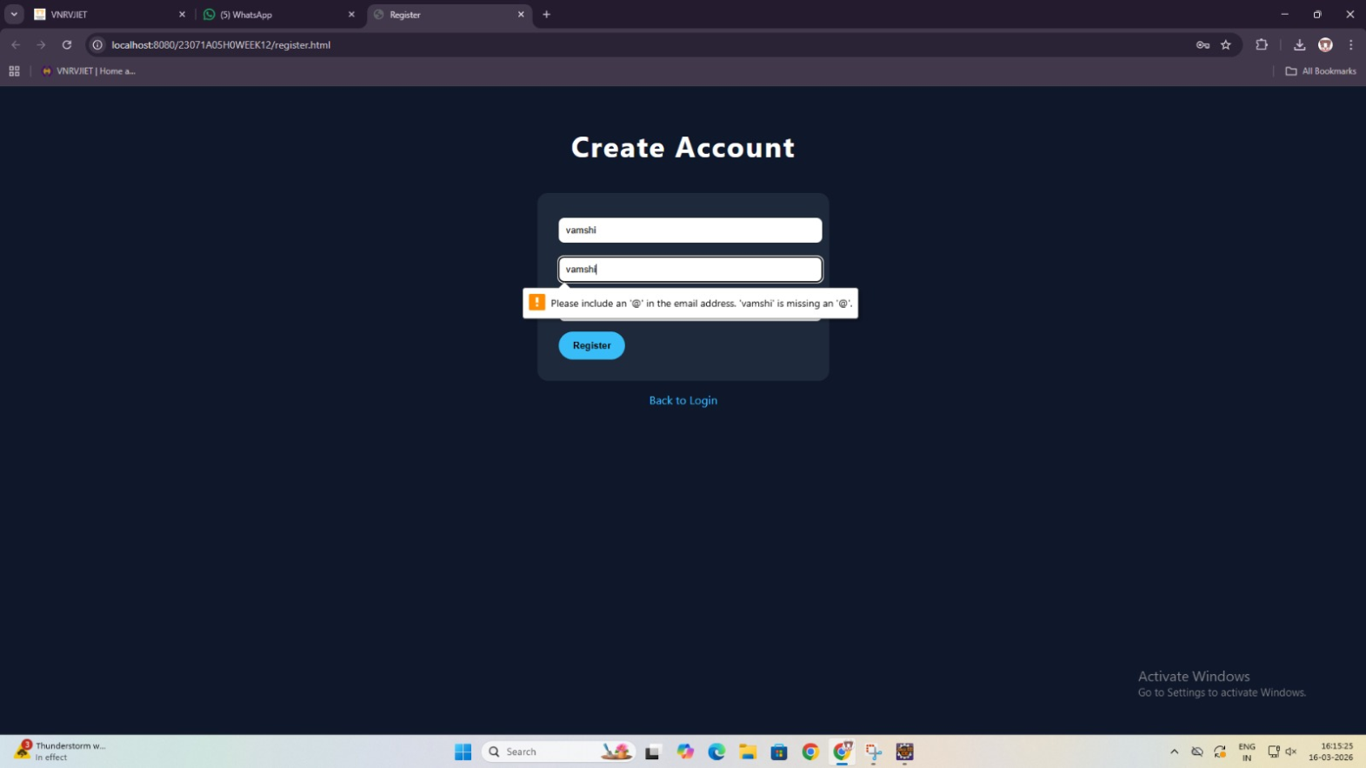

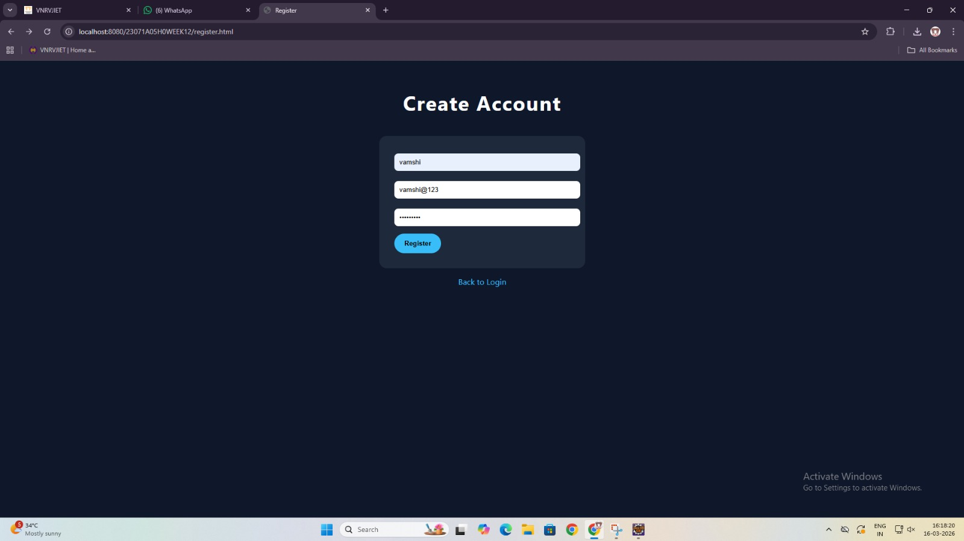

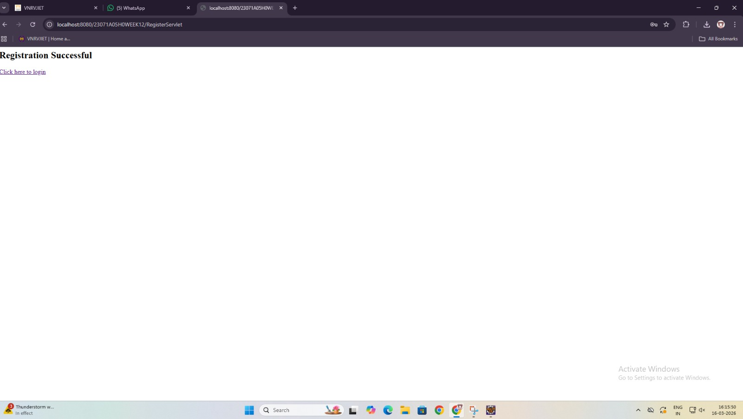

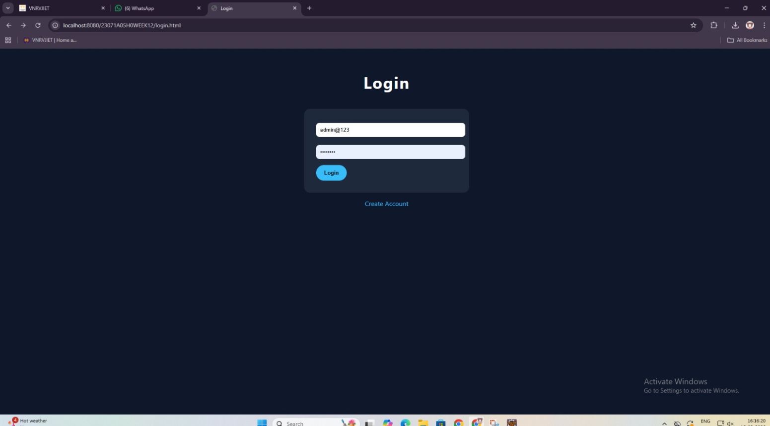

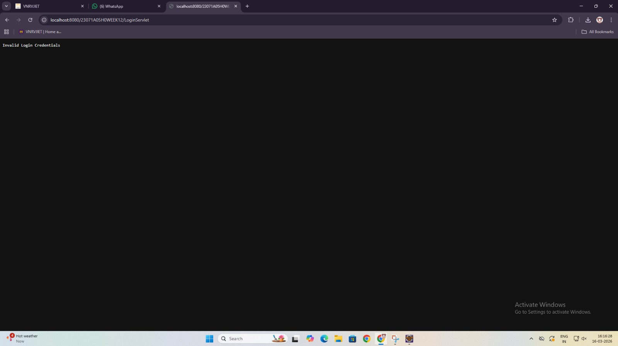

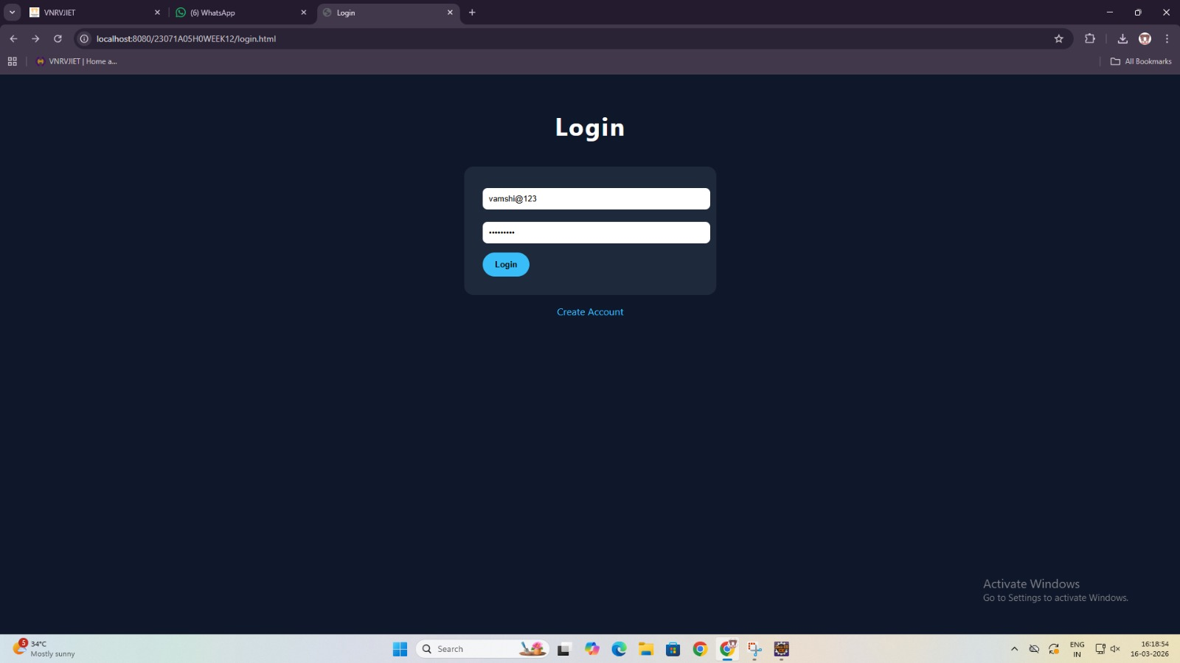

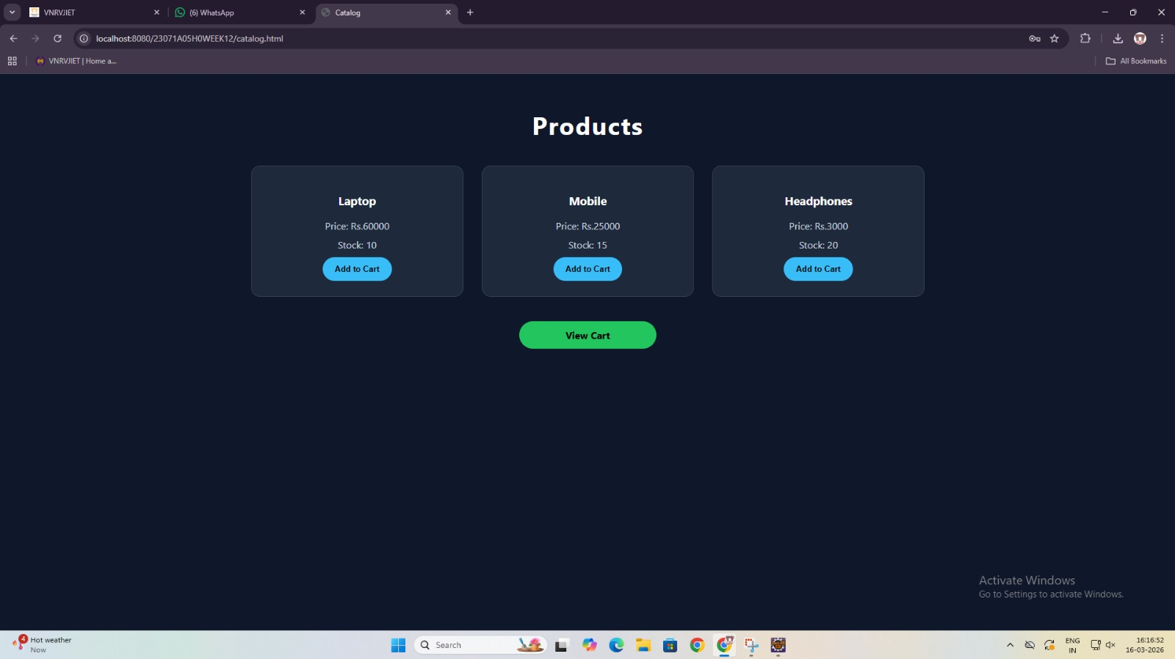

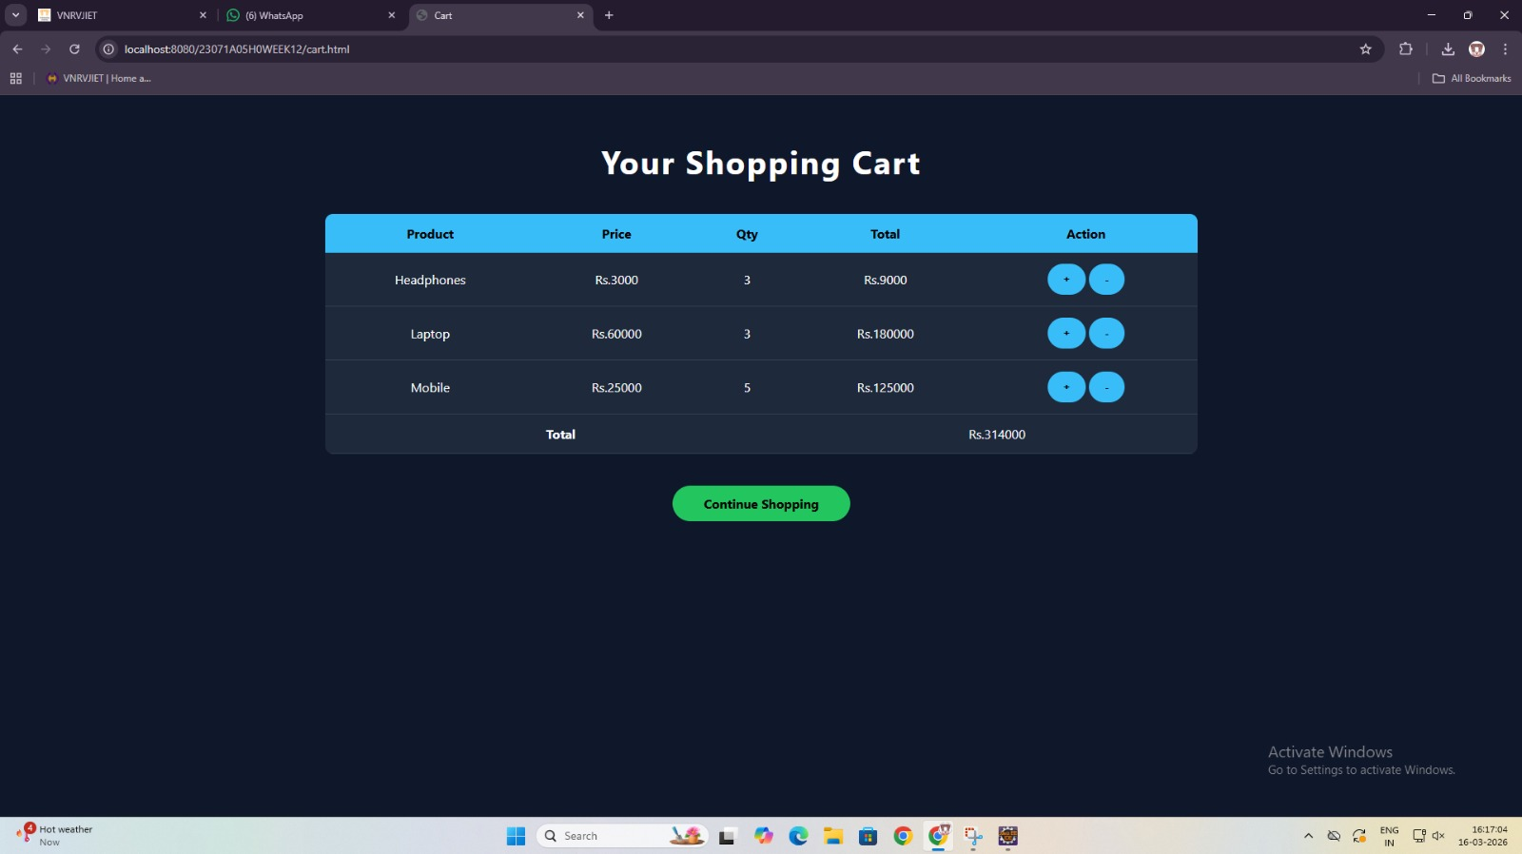

Week No: 8 | Date: | Roll No: 23071A05H0
Experiment:
Servlet developed to fetch book details from the database and display them dynamically in the content frame.

Aim :
To develop a Java Servlet that connects to a MySQL database, retrieves book information, and displays it dynamically in a web browser
Description :
This experiment demonstrates the development of a dynamic web application using Java Servlets integrated with a MySQL database through JDBC. The servlet processes client requests, connects to the database, retrieves book information using SQL queries, and dynamically generates HTML content to display the results in a structured tabular format on the browser, showcasing the interaction between frontend and backend components.

Concepts Used :

Java Servlet Components
- HttpServlet – Base class used to create web servlets
- doGet() – Handles client HTTP GET requests
- HttpServletRequest – Retrieves data sent by the client
- HttpServletResponse – Sends output back to the browser
- PrintWriter – Writes dynamic HTML content to the response
- @WebServlet – Maps a URL pattern to the servlet

JDBC (Database Connectivity)
- DriverManager – Establishes connection with the database
- Connection – Maintains an active link to the database
- Statement – Executes SQL queries
- ResultSet – Holds and processes query results
- Class.forName() – Loads and registers the JDBC driver

Steps to Execute :

START
↓
User opens browser
↓
Enter URL → /BookServlet
↓
HTTP Request sent to Tomcat Server
↓
Tomcat maps URL → BookServlet (@WebServlet)
↓
doGet() method invoked
↓
Set response type (text/html)
↓
Load JDBC Driver
↓
Establish Database Connection
↓
Execute SQL Query (SELECT * FROM books)
↓
Retrieve ResultSet (data from DB)
↓
Loop through ResultSet
↓
Generate HTML Table dynamically
↓
Send response to browser
↓
Browser displays book records
↓
END

Code Implementation :
import java.io.*;
import java.sql.*;
import javax.servlet.*;
import javax.servlet.annotation.WebServlet;
import javax.servlet.http.*;

@WebServlet("/23071A05H0_books")
public class BookServlet extends HttpServlet {

protected void doGet(HttpServletRequest request, HttpServletResponse response)
throws ServletException, IOException {

response.setContentType("text/html");
PrintWriter out = response.getWriter();

out.println("<html><head>");
out.println("<style>");
out.println("body { font-family: Arial; background-color: #f4f6f7; }");
out.println("h2 { text-align: center; color: #2c3e50; }");
out.println("table { margin:auto; border-collapse: collapse; width:60%; }");
out.println("th, td { padding:10px; text-align:center; }");
out.println("th { background-color:#34495e; color:white; }");
out.println("tr:nth-child(even) { background-color:#ecf0f1; }");
out.println("</style>");
out.println("</head><body>");

out.println("<h2>Library Book Records</h2>");

try {
Class.forName("com.mysql.cj.jdbc.Driver");

Connection con = DriverManager.getConnection(
"jdbc:mysql://localhost:3306/library_db?useSSL=false&serverTimezone=UTC",
"root",
"root"
);

Statement stmt = con.createStatement();
ResultSet rs = stmt.executeQuery("SELECT * FROM books");

// ✅ CHANGED HERE
out.println("<h1>23071A05H0</h1>");

out.println("<table border='1'>");
out.println("<tr><th>ID</th><th>Book Name</th><th>Author</th><th>Price</th></tr>");

while (rs.next()) {
out.println("<tr>");
out.println("<td>" + rs.getInt("book_id") + "</td>");
out.println("<td>" + rs.getString("book_name") + "</td>");
out.println("<td>" + rs.getString("writer") + "</td>");
out.println("<td>₹" + rs.getDouble("cost") + "</td>");
out.println("</tr>");
}

out.println("</table>");
con.close();

} catch (Exception e) {
out.println("<h3 style='color:red;text-align:center;'>Error: "
+ e.getMessage() + "</h3>");
}

out.println("</body></html>");
}
}

OUTPUT :

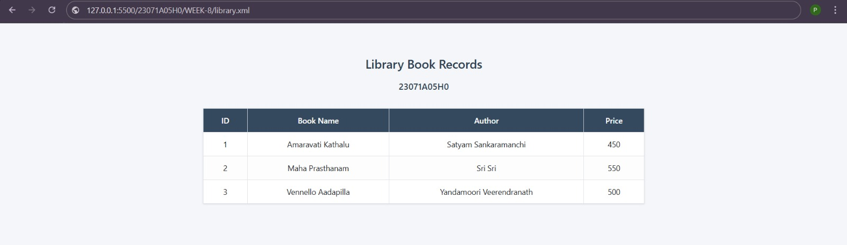

Week No: 9 | Date: | Roll No: 23071A05H0
Experiment:
XML structure designed to store user account details including username, encrypted password, email, and purchase history.

Aim :
To develop a web-based user authentication system using Java Servlets and JDBC, enabling user registration, login, session management, and logout functionality.
Description :

This experiment implements a basic authentication system where users can register and log in using their credentials stored in a database. Java Servlets handle client requests and responses, while JDBC is used to interact with the database for storing and validating user data. Session tracking using HttpSession ensures that only authenticated users can access protected pages. The system demonstrates the integration of frontend forms with backend processing and database connectivity.

Concepts Used :
Java Servlet Concepts
- HttpServlet – Base class for creating servlets
- doPost() / doGet() – Handles client requests
- HttpServletRequest – Retrieves form data
- HttpServletResponse – Sends response to browser
- HttpSession – Maintains user login state
- RequestDispatcher – Forwards request to JSP pages
- sendRedirect() – Redirects user after login/logout
JDBC Concepts
- DriverManager – Establishes DB connection
- Connection – Connects to database
- PreparedStatement – Executes secure SQL queries
- ResultSet – Stores query results
- SQL Operations – INSERT (register), SELECT (login validation)

Steps to Execute :
Start
↓
Create Database (wt_lab)
↓
Create users table
↓
Insert sample data (optional)
↓
Create Dynamic Web Project in Eclipse
↓
Configure Apache Tomcat Server
↓
Add MySQL Connector (JAR file)
↓
Create Servlets (Register, Login, Logout)
↓
Write JDBC code (Connect → Insert → Validate)
↓
Deploy project on Tomcat
↓
Open browser (register.jsp → login.jsp)
↓
Perform registration and login
↓
Access home page (session-based)
↓
Logout and invalidate session
↓
End

Code Implementation :
  - DBUtil.java
import java.sql.Connection;
import java.sql.DriverManager;
public class DBUtil {
private static final String URL = "jdbc:mysql://localhost:3306/wt_lab";
private static final String USER = "root";
private static final String PASS = "your_password";
public static Connection getConnection() throws Exception {
Class.forName("com.mysql.cj.jdbc.Driver");
return DriverManager.getConnection(URL, USER, PASS);
}
}

  - LoginServlet.java
import java.io.IOException;
import java.sql.Connection;
import java.sql.PreparedStatement;
import java.sql.ResultSet;

import javax.servlet.*;
import javax.servlet.http.*;

public class LoginServlet extends HttpServlet {

protected void doPost(HttpServletRequest request, HttpServletResponse response)
throws ServletException, IOException {

String email = request.getParameter("email");
String password = request.getParameter("password");

String sql = "SELECT email FROM users WHERE email=? AND password=?";

try (Connection con = DBUtil.getConnection();
PreparedStatement ps = con.prepareStatement(sql)) {

ps.setString(1, email);
ps.setString(2, password);

ResultSet rs = ps.executeQuery();

if (rs.next()) {
HttpSession session = request.getSession();
session.setAttribute("user", email);
response.sendRedirect("home.jsp");
} else {
request.setAttribute("error", "Invalid Credentials - 23071A05H0");
request.getRequestDispatcher("login.jsp").forward(request, response);
}

} catch (Exception e) {
request.setAttribute("error", "Database Error - 23071A05H0");
request.getRequestDispatcher("login.jsp").forward(request, response);
}
}
}

  - RegisterServlet.java
import java.io.IOException;
import java.sql.Connection;
import java.sql.PreparedStatement;

import javax.servlet.*;
import javax.servlet.http.*;

public class RegisterServlet extends HttpServlet {

protected void doPost(HttpServletRequest request, HttpServletResponse response)
throws ServletException, IOException {

String email = request.getParameter("email");
String password = request.getParameter("password");

String sql = "INSERT INTO users(email, password) VALUES(?, ?)";

try (Connection con = DBUtil.getConnection();
PreparedStatement ps = con.prepareStatement(sql)) {

ps.setString(1, email);
ps.setString(2, password);

int rows = ps.executeUpdate();

if (rows > 0) {
request.setAttribute("msg", "Registration Successful! - 23071A05H0");
request.getRequestDispatcher("login.jsp").forward(request, response);

} else {
request.setAttribute("msg", "Registration Failed - 23071A05H0");
request.getRequestDispatcher("errorLogin.jsp").forward(request, response);
}

} catch (Exception e) {
request.setAttribute("msg", "User already exists / DB Error - 23071A05H0");
request.getRequestDispatcher("errorLogin.jsp").forward(request, response);
}
}
}

  - LogoutServlet.java
import java.io.IOException;
import javax.servlet.*;
import javax.servlet.http.*;

public class LogoutServlet extends HttpServlet {

protected void doGet(HttpServletRequest request, HttpServletResponse response)
throws ServletException, IOException {

HttpSession session = request.getSession(false);

if (session != null) {
session.invalidate();
}

response.sendRedirect("login.jsp");
}
}

  - style.css
body {
background: linear-gradient(135deg, #667eea, #764ba2);
font-family: Arial;
display: flex;
justify-content: center;
align-items: center;
height: 100vh;
}

.container {
background: white;
padding: 30px;
border-radius: 10px;
width: 350px;
text-align: center;
}

input {
width: 100%;
padding: 10px;
margin: 10px 0;
}
.error { color: red; }
.success { color: green; }

  - web.xml
<web-app xmlns="http://xmlns.jcp.org/xml/ns/javaee" version="4.0">
<servlet>
<servlet-name>LoginServlet</servlet-name>
<servlet-class>LoginServlet</servlet-class>
</servlet>
<servlet-mapping>
<servlet-name>LoginServlet</servlet-name>
<url-pattern>/login</url-pattern>
</servlet-mapping>

<servlet>
<servlet-name>RegisterServlet</servlet-name>
<servlet-class>RegisterServlet</servlet-class>
</servlet>
<servlet-mapping>
<servlet-name>RegisterServlet</servlet-name>
<url-pattern>/register</url-pattern>
</servlet-mapping>

<servlet>
<servlet-name>LogoutServlet</servlet-name>
<servlet-class>LogoutServlet</servlet-class>
</servlet>
<servlet-mapping>
<servlet-name>LogoutServlet</servlet-name>
<url-pattern>/logout</url-pattern>
</servlet-mapping>

</web-app>

  - home.jsp
<%
if(session == null || session.getAttribute("user") == null){
request.setAttribute("msg","Please login first to access this page");
request.getRequestDispatcher("errorLogin.jsp").forward(request,response);
return;
}
String user=(String)session.getAttribute("user");
%>

<!DOCTYPE html>
<html>
<head>
<title>Home</title>
<link rel="stylesheet" href="css/style.css">
</head>
<body>

<div class="container">
<h2>Welcome <%= user %></h2>
<h3>Project: 23071A05H0 WEEK9</h3>

<a href="logout">Logout</a>
</div>

</body>
</html>

  - login.jsp
<!DOCTYPE html>
<html>
<head>
<title>Login</title>
<link rel="stylesheet" href="css/style.css">
</head>
<body>
<div class="container">
<h2>Login</h2>

<form action="login" method="post">
<input type="text" name="email" placeholder="Enter Email" required>
<input type="password" name="password" placeholder="Enter Password" required>
<input type="submit" value="Login">
</form>

<p class="error">
<%= request.getAttribute("error") != null ? request.getAttribute("error") : "" %>
</p>

<a href="register.jsp">Register</a>
</div>

</body>
</html>

  - register.jsp
<!DOCTYPE html>
<html>
<head>
<title>Register</title>
<link rel="stylesheet" href="css/style.css">
</head>
<body>

<div class="container">
<h2>Register</h2>

<form action="register" method="post">
<input type="text" name="email" placeholder="Enter Email" required>
<input type="password" name="password" placeholder="Enter Password" required>
<input type="submit" value="Register">
</form>

<p class="success">
<%= request.getAttribute("msg") != null ? request.getAttribute("msg") : "" %>
</p>

<a href="login.jsp">Back to Login</a>
</div>

</body>
</html>

  - error.jsp
<body>
<div class="container">
<h3 class="error">Invalid Login - 23071A05H0</h3>
<a href="login.jsp">Try Again</a>
</div>
</body>

  - errorLogin.jsp
<!DOCTYPE html>
<html>
<head>
<title>Error</title>
<link rel="stylesheet" href="css/style.css">
</head>
<body>

<div class="container">
<h2 class="error">
<%= request.getAttribute("msg") != null ? request.getAttribute("msg") : "Access Denied" %>
</h2>

<a href="login.jsp">Go to Login</a>
</div>

</body>
</html>

OUTPUT :
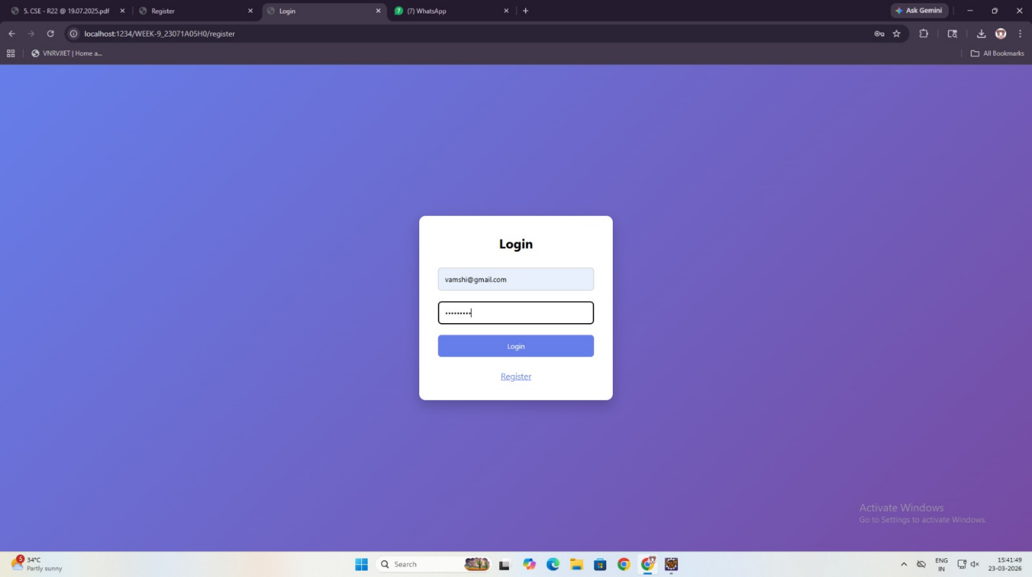
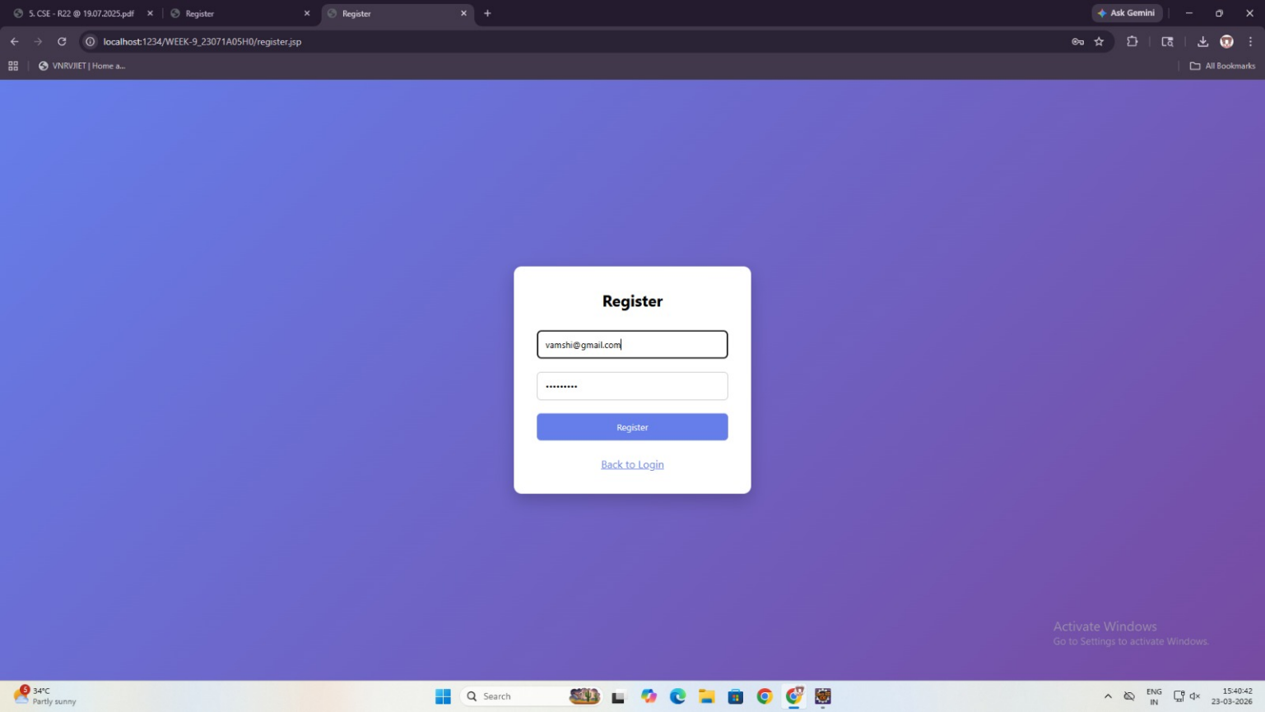

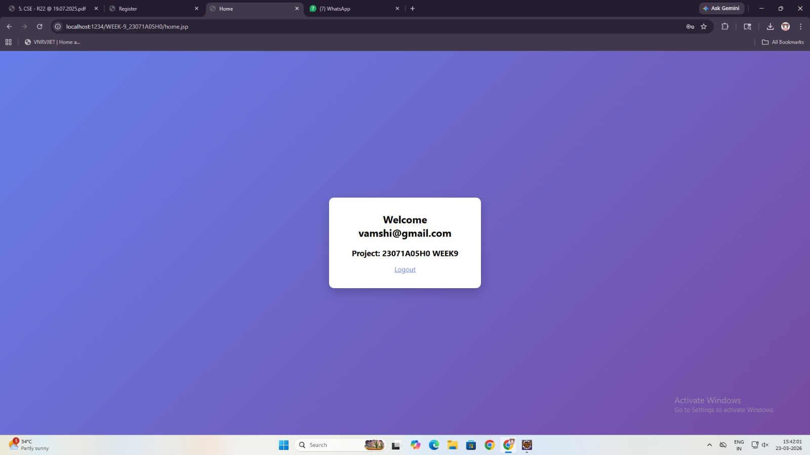
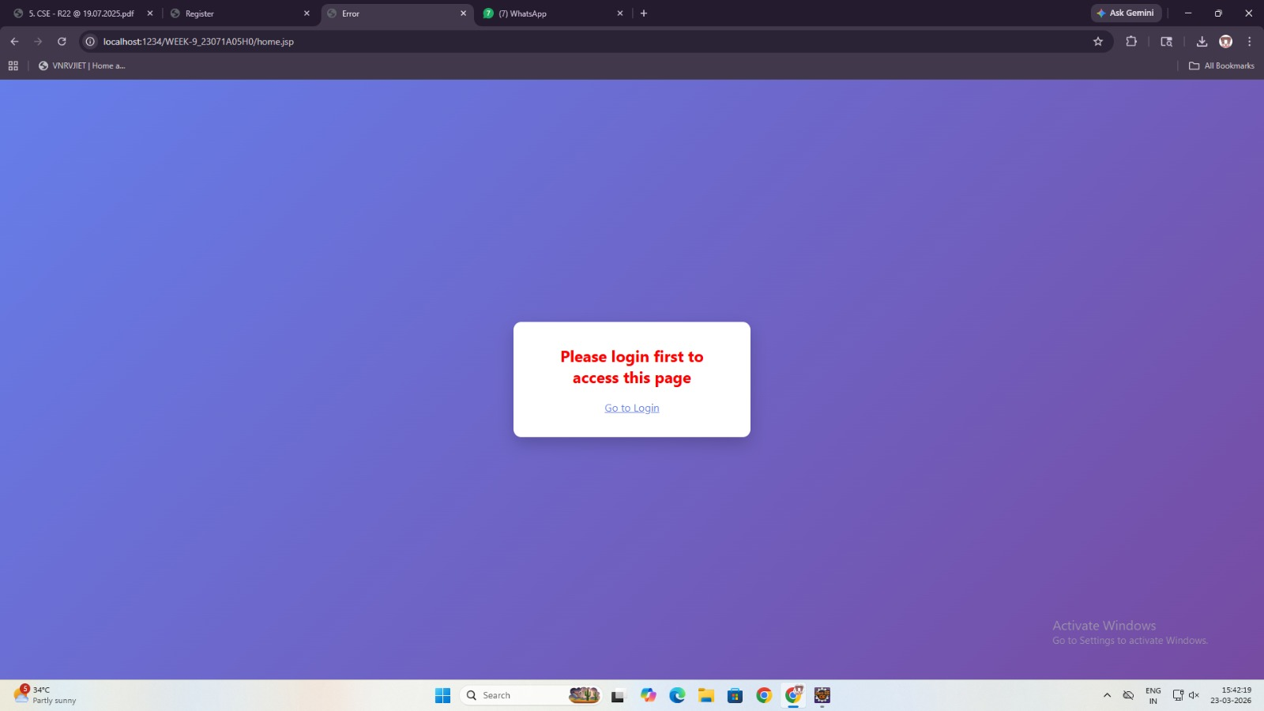

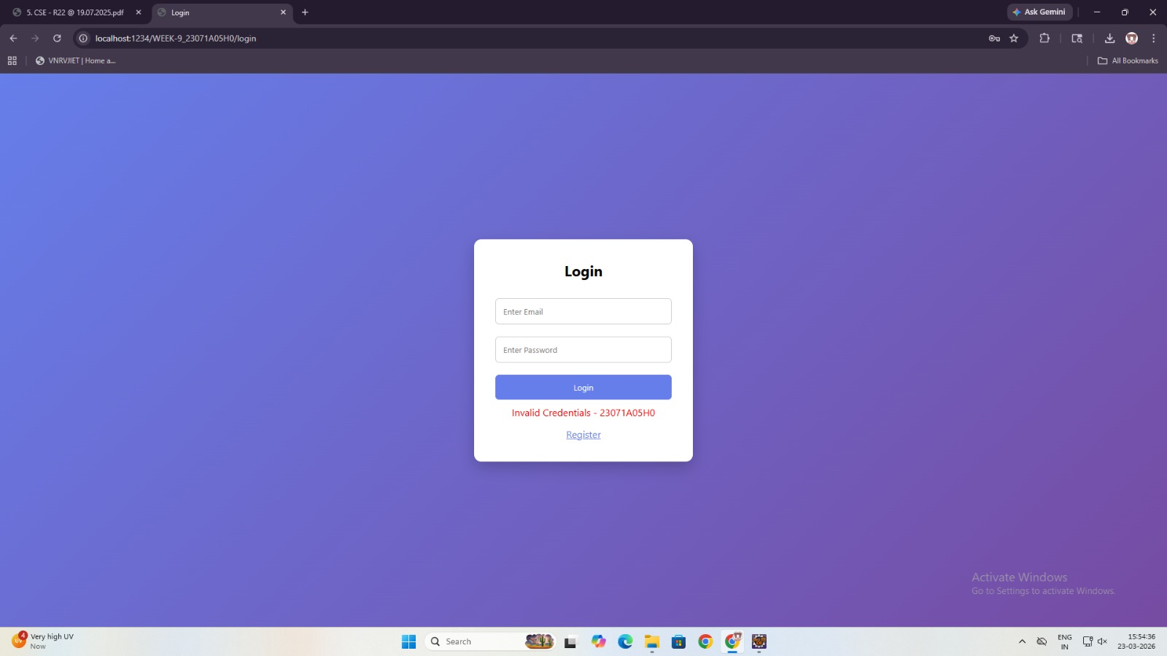

Week No: 13 | Date: | Roll No: 23071A05H0
Experiment: To implement a checkout process using Servlets and JSP that allows users to review their cart, enter shipping details, and complete the purchase.

Aim :

To implement a checkout process using Servlets and JSP that allows users to review their cart, enter shipping details, and complete the purchase.

Description :

In this experiment, a complete checkout workflow is developed for an online store using JSP and Servlets.

Users can browse products, add them to a shopping cart, and modify quantities. The cart data is stored in the session using Java collections.

During checkout, users review their selected items, view the total cost, and provide shipping information such as name and address. The CheckoutServlet processes the order, calculates the final amount, and confirms the purchase.

This experiment demonstrates session management, dynamic cart handling, and real-time order processing in a web application.

Technologies Used:

JSP – User interface

Servlets – Business logic

HTTP Session – Store cart data

Java Collections (Map) – Manage cart items

HTML/CSS – Page structure and styling

Concepts Used:

Session tracking (HttpSession)

Form handling (request.getParameter)

Cart management using HashMap

Dynamic content rendering in JSP

Total price calculation

Request redirection (sendRedirect)

Steps to Execute:

Start
↓
Create JSP pages → login.jsp, register.jsp, catalog.jsp, cart.jsp, checkout.jsp
↓
Create Servlets → LoginServlet, RegisterServlet, CartServlet, CheckoutServlet
↓
Deploy project on Tomcat
↓
Register user
↓
Login to system
↓
Browse catalog → Add items to cart
↓
View cart → Modify quantity
↓
Proceed to checkout
↓
Enter shipping details
↓
Place order → Order confirmation displayed
↓
End

Code Implementation:

catalog.jsp

<html>

<head>

<title>Catalog</title>

<link rel="stylesheet" href="css/style.css">

</head>

<body>

<h1>Product Catalog</h1>

<form action="CartServlet" method="post">

<h3>Laptop</h3>

<p>Price: 60000</p>

<input type="hidden" name="productId" value="Laptop">

<input type="hidden" name="price" value="60000">

<button name="action" value="add">Add to Cart</button>

</form>

<form action="CartServlet" method="post">

<h3>Mobile</h3>

<p>Price: 25000</p>

<input type="hidden" name="productId" value="Mobile">

<input type="hidden" name="price" value="25000">

<button name="action" value="add">Add to Cart</button>

</form>

<form action="CartServlet" method="post">

<h3>Headphones</h3>

<p>Price: 3000</p>

<input type="hidden" name="productId" value="Headphones">

<input type="hidden" name="price" value="3000">

<button name="action" value="add">Add to Cart</button>

</form>

<br>

<a href="cart.jsp">View Cart</a>

</body>

</html>

CartServlet.java

import java.io.*;

import javax.servlet.*;

import javax.servlet.http.*;

import java.util.*;

public class CartServlet extends HttpServlet {

protected void doPost(HttpServletRequest request,

HttpServletResponse response)

throws ServletException, IOException {

String product = request.getParameter("productId");

String action = request.getParameter("action");

int price = Integer.parseInt(request.getParameter("price"));

HttpSession session = request.getSession();

Map<String, Integer> cart =

(Map<String, Integer>) session.getAttribute("cart");

Map<String, Integer> prices =

(Map<String, Integer>) session.getAttribute("prices");

if (cart == null) {

cart = new HashMap<>();

prices = new HashMap<>();

}

int qty = cart.getOrDefault(product, 0);

if ("add".equals(action)) {

cart.put(product, qty + 1);

prices.put(product, price);

} else if ("remove".equals(action)) {

if (qty > 1) {

cart.put(product, qty - 1);

} else {

cart.remove(product);

prices.remove(product);

}

}

session.setAttribute("cart", cart);

session.setAttribute("prices", prices);

response.sendRedirect("cart.jsp");

}

}

cart.jsp

<%@ page import="java.util.*" %>

<%

Map<String,Integer> cart = (Map<String,Integer>) session.getAttribute("cart");

Map<String,Integer> prices = (Map<String,Integer>) session.getAttribute("prices");

%>

<html>

<head>

<link rel="stylesheet" href="css/style.css">

</head>

<body>

<h1>Your Cart</h1>

<%

if(cart == null || cart.isEmpty()){

%>

<p>Cart is empty</p>

<%

} else {

for(String item : cart.keySet()){

%>

<form action="CartServlet" method="post">

<p>

<%= item %> - Qty: <%= cart.get(item) %> - Rs.<%= prices.get(item) %>

</p>

<input type="hidden" name="productId" value="<%= item %>">

<input type="hidden" name="price" value="<%= prices.get(item) %>">

<button name="action" value="add">+</button>

<button name="action" value="remove">-</button>

</form>

<%

}

}

%>

<br>

<a href="catalog.jsp">Continue Shopping</a>

<br><br>

<a href="checkout.jsp">Proceed to Checkout</a>

</body>

</html>

checkout.jsp

<%@ page import="java.util.*" %>

<%

Map<String,Integer> cart = (Map<String,Integer>) session.getAttribute("cart");

Map<String,Integer> prices = (Map<String,Integer>) session.getAttribute("prices");

int total = 0;

%>

<html>

<head>

<link rel="stylesheet" href="css/style.css">

</head>

<body>

<h1>Checkout</h1>

<%

if(cart != null){

for(String item : cart.keySet()){

int sub = cart.get(item) * prices.get(item);

total += sub;

%>

<p><%= item %> - Rs.<%= sub %></p>

<%

}

}

%>

<h3>Total: Rs.<%= total %></h3>

<form action="CheckoutServlet" method="post">

Name: <input type="text" name="name"><br><br>

Address: <input type="text" name="address"><br><br>

<button type="submit">Place Order</button>

</form>

</body>

</html>

CheckoutServlet.java

import javax.servlet.*;

import javax.servlet.http.*;

import java.io.*;

import java.util.*;

public class CheckoutServlet extends HttpServlet {

protected void doPost(HttpServletRequest request,

HttpServletResponse response)

throws ServletException, IOException {

HttpSession session = request.getSession();

Map<String,Integer> cart =

(Map<String,Integer>) session.getAttribute("cart");

Map<String,Integer> prices =

(Map<String,Integer>) session.getAttribute("prices");

int total = 0;

if(cart != null){

for(String item : cart.keySet()){

total += cart.get(item) * prices.get(item);

}

}

session.removeAttribute("cart");

session.removeAttribute("prices");

response.setContentType("text/html");

PrintWriter out = response.getWriter();

out.println("<h2>Order Successful</h2>");

out.println("<p>Total Paid: Rs." + total + "</p>");

out.println("<a href='catalog.jsp'>Continue Shopping</a>");

}

}

LoginServlet.java

import javax.servlet.*;

import javax.servlet.http.*;

import java.io.*;

public class LoginServlet extends HttpServlet {

protected void doPost(HttpServletRequest request,

HttpServletResponse response)

throws ServletException, IOException {

String email = request.getParameter("email");

String password = request.getParameter("password"); // ❗ FIXED missing ;

HttpSession session = request.getSession();

String savedEmail = (String) session.getAttribute("userEmail");

String savedPassword = (String) session.getAttribute("userPassword");

if(email.equals(savedEmail) && password.equals(savedPassword)){

response.sendRedirect("catalog.jsp");

} else {

response.getWriter().println("Invalid Login");

}

}

}

RegisterServlet.java

import javax.servlet.*;

import javax.servlet.http.*;

import java.io.*;

public class RegisterServlet extends HttpServlet {

protected void doPost(HttpServletRequest request,

HttpServletResponse response)

throws ServletException, IOException {

String email = request.getParameter("email");

String password = request.getParameter("password");

HttpSession session = request.getSession();

session.setAttribute("userEmail", email);

session.setAttribute("userPassword", password);

response.sendRedirect("login.jsp");

}

}

OUTPUT:

