Lab 2: SDN Simulation

Name: ___Ranran Lyu____________ ID: ______rl3783________ Date: _____02/19/2020_______

Name: ___Lingfeng Zhao__________ ID: ______lz1973________ Date: _____02/19/2020_______

**(a)** **A screenshot of OpenFlow control messages you captured with WireShark**

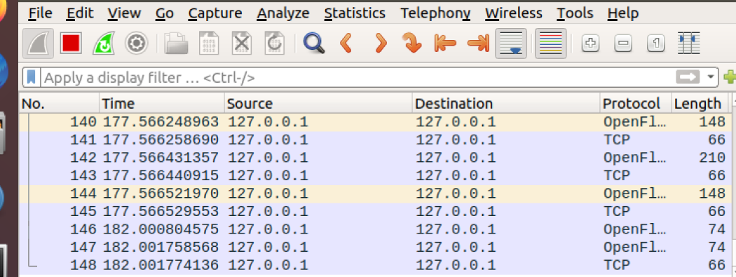

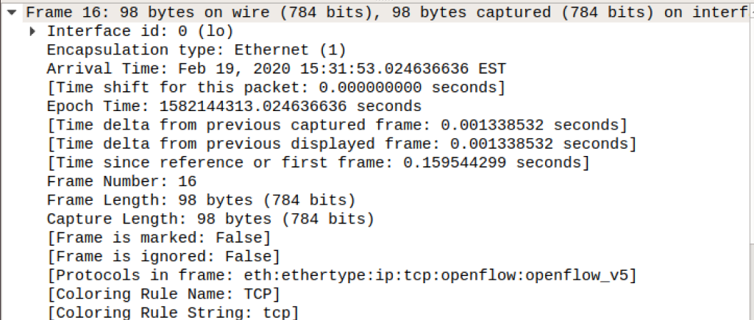 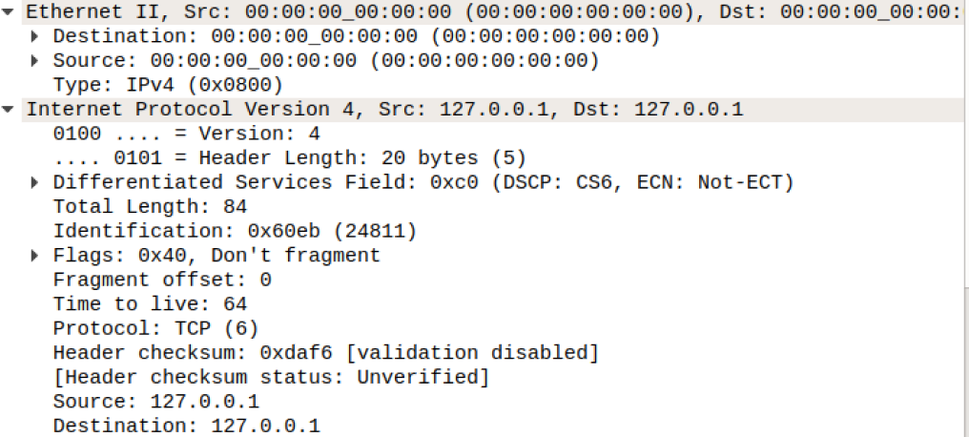

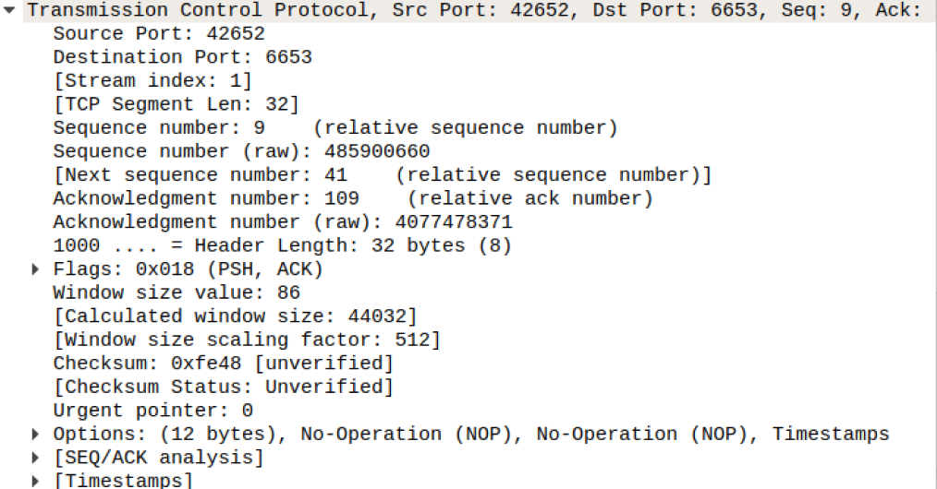

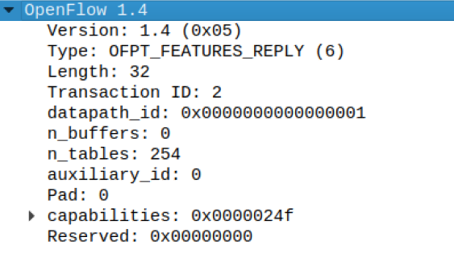

**(b)**

Output of mininet “net” for problem 3.2.2 topology.

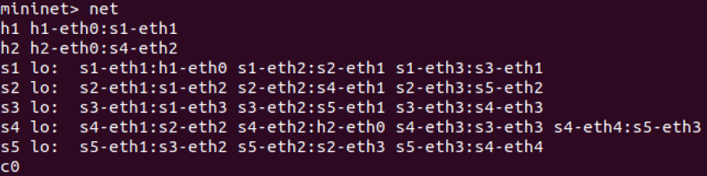

Output of mininet “net” for 3.2.3 fat tree topology when N = 6

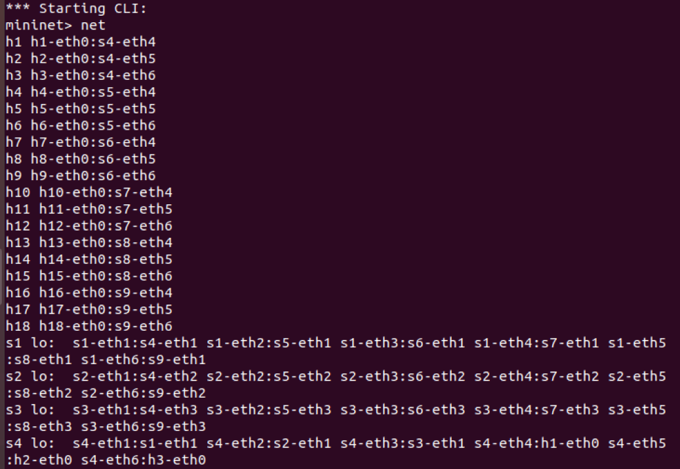

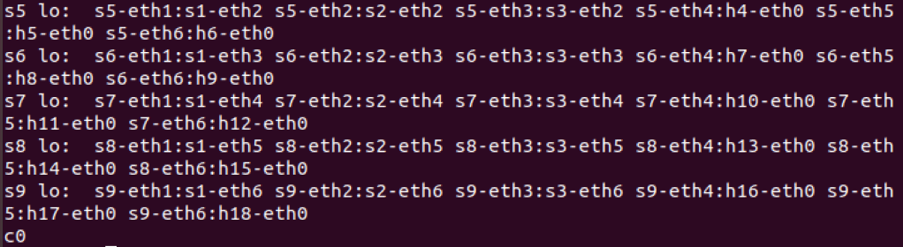

Output of mininet “net” for 3.2.3 fat tree topology when N = 8

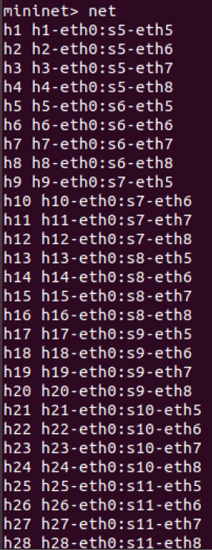

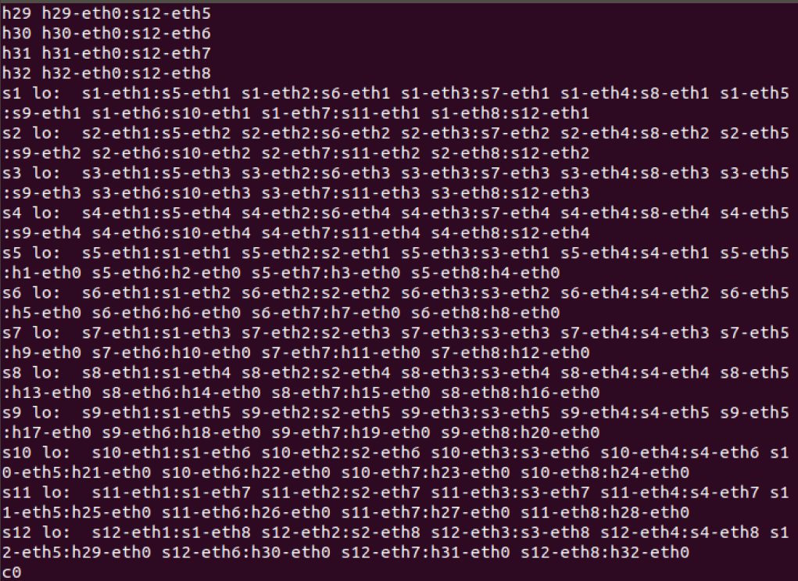

**(c)**

Mininet output while creating the problem 3.2.2 networks

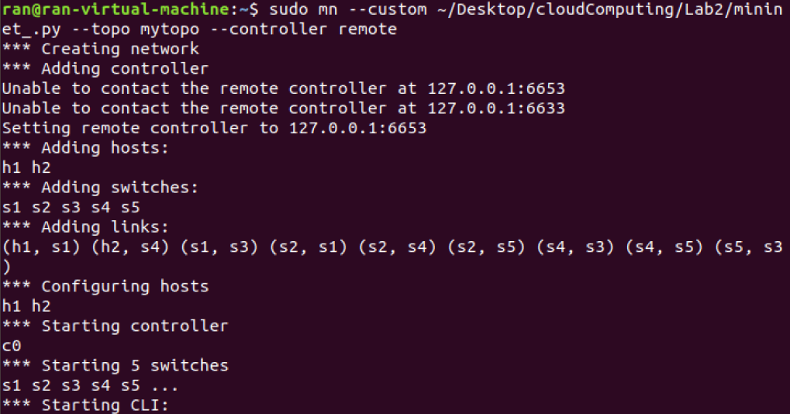

Mininet output while creating the problem 3.2.3 fat tree networks when N = 6

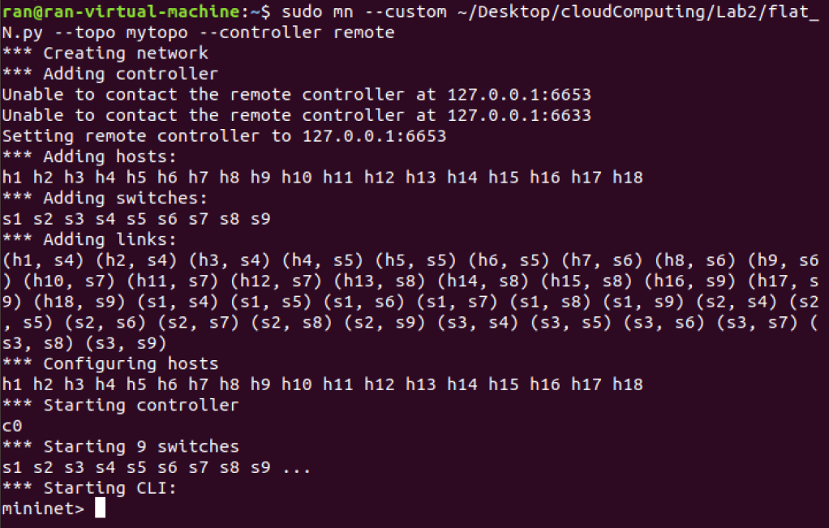

Mininet output while creating the problem 3.2.3 fat tree networks when N = 8

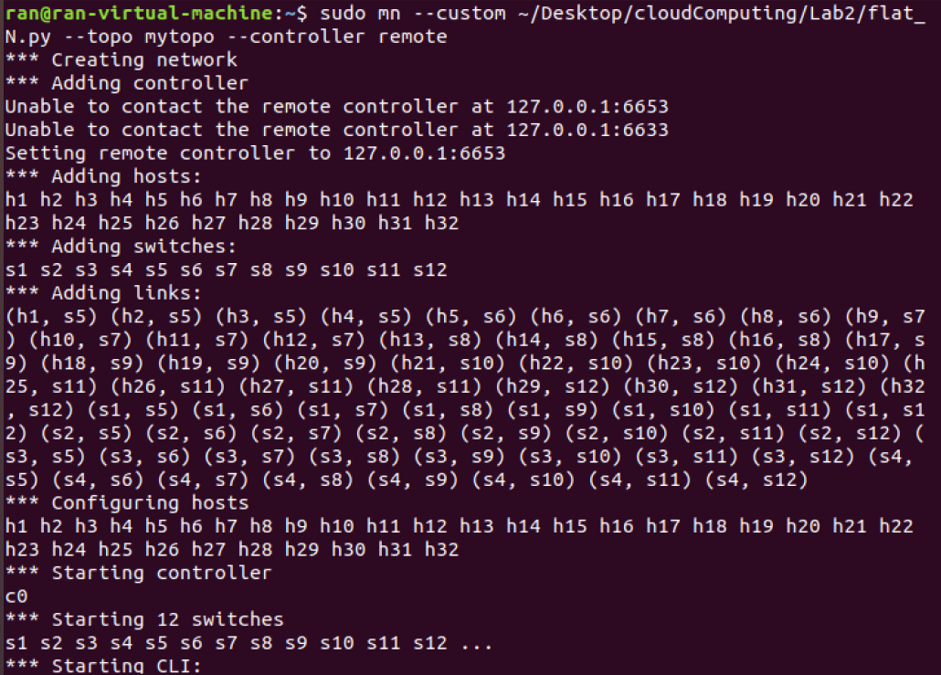

**(d)** **Briefly explain how you produce different traffic to verify whether the rules installed function correctly.**

Let h2 ping web server of h1 and capture packets from s2-eth1 port, we will find a HTTP(with OK flag) packet from h1 to h2 since HTTP traffic from h1 to h2 go through s2 switch.

Let h2 ping web server of h1 and capture packets from s3-eth3 port, we will find a HTTP(with GET flag) packet from h2 to h1 since HTTP traffic from h2 to h1 go through s3 switch.

Let h2 ping h1 and h1 ping h2 and capture packets from se-eth2 port, we will only find packets from h2 to h1 since traffic other than HTTP from h2 to h1 go through s2 switch but h1 to h2 not.

**(e)**

After typing “h1 python -m SimpleHTTPServer 80 &” “h2 wget -o -h1” under mininet

Capturing from s2-eth1:

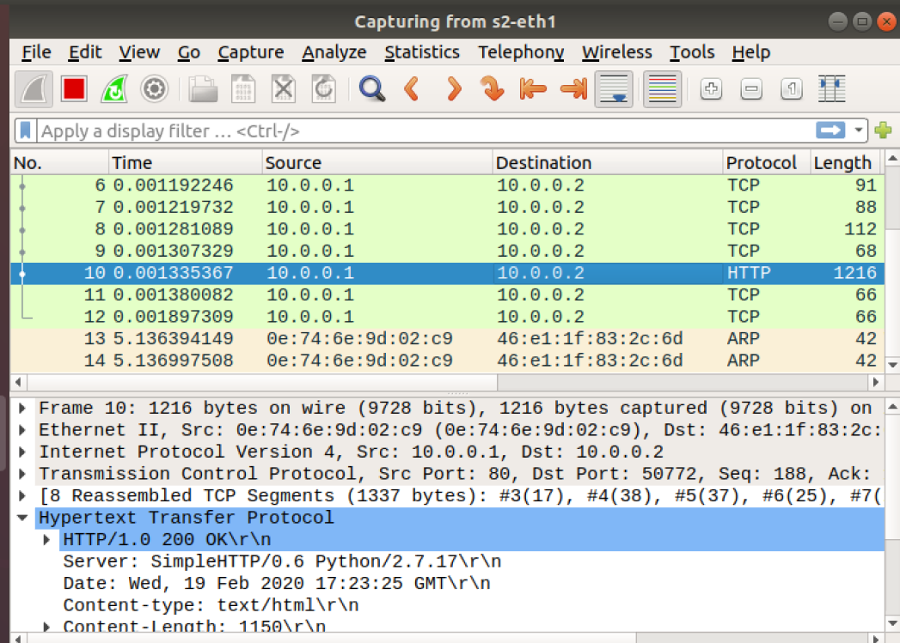

Capturing from s3-eth3

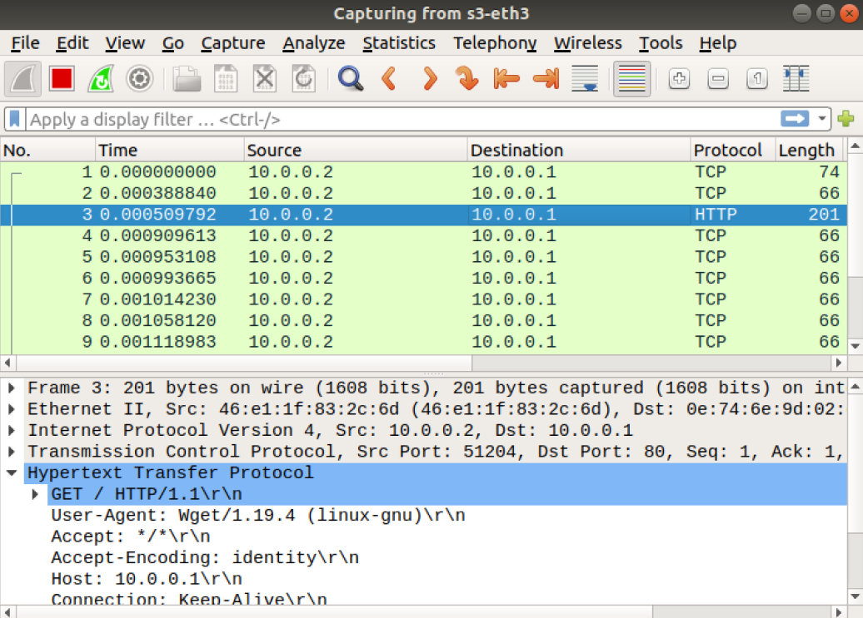

After typing “pingall”, capturing from s2-eth2

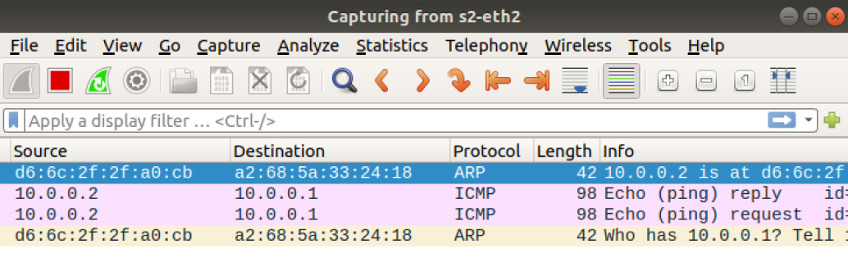

**(f)(g)**

https://drive.google.com/open?id=1NgSUtFFZY0qDwUGMOJ1JAdMXHCFjyIt3