Throughput of Tiered Document Parsing
Ada Example, Bela Minta
Abstract. We compare four parsing tiers on a small synthetic corpus and report how layout analysis, optical character recognition and formula recognition change throughput and fidelity.

1. Introduction
Let $x_{i}∈ℝ^{d}$ denote the feature vector of page i, and let $α∈(0,1)$ be a mixing weight. The empirical loss is $ℒ(θ)=\frac{1}{N}\sum_{i=1}^{N}{ℓ(f_{θ}(x_{i}),y_{i})}$ and the regulariser satisfies $‖θ‖_{2}≤1.^{1}$ The latency model that we fit is given by
$T(n)=a+bn+cn^{2},\int_{0}^{∞}{e^{−x^{2}}dx=\frac{\sqrt{π}}{2}}$ (1)
where is the number of pages and , , are fitted constants. In Section 2 we report the measuredn a b c latencies, and we discuss the Hungarian-language test page in Section 3.

2. Method
Each document is parsed once per tier. The median and the 95th percentile of the wall-clock time are recorded for every run, and the results are summarised in Table 1 on the next page.
1 The norm constraint is the usual unit-ball regularisation; it is stated here only as an example footnote.
Table 1. Parsing latency by tier (milliseconds).
Tier | Pages | Median | p95
flash | 12 | 810 | 1 240
basic | 12 | 1 126 | 2 980
standard | 12 | 4 310 | 9 870
advanced | 12 | 7 450 | 15 200
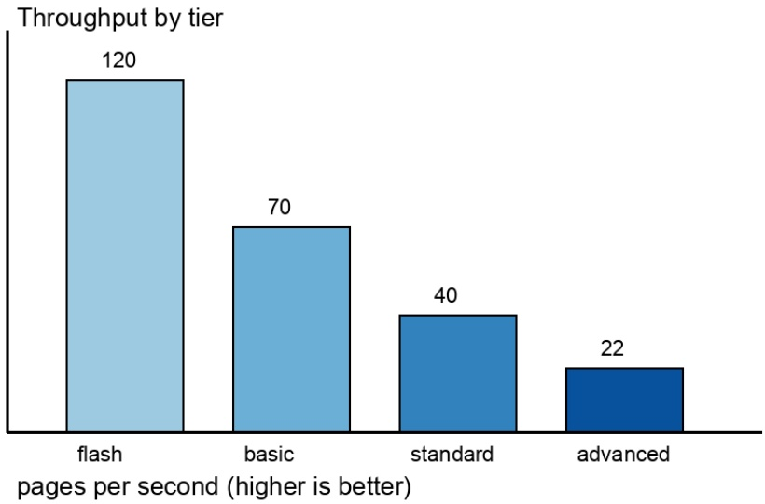
Figure 1. Relative throughput by tier.

3. Hungarian test page
Az árvíztűrő tükörfúrógép egy magyar pangram: minden ékezetes magyar betűt tartalmaz, így az ő és az ű betűt is. A dokumentum feldolgozása után a szövegnek pontosan meg kell maradnia. ÁRVÍZTŰRŐ TÜKÖRFÚRÓGÉP.
The quadratic term satisfies $c>0$ for every tier, and the fitted curve passes within $ϵ=0.05$ of each measurement.

