Design and Implementation of a Small School Network
VLAN segmentation, inter-VLAN routing and firewall controls (Packet Tracer)
Name: Adams Selah Mensah
Course: Fundamentals of Networking and Networking Security
Practical file: Practical_Activity_1(School_Network)

1. Introduction
In brief: This report designs a small school network with separate VLANs for learners, facilitators and administration, plus a server VLAN. It states which groups may communicate, what routing and firewall controls enforce that, and shows the design built and tested in Packet Tracer.
A school network holds data of very different sensitivity: learning materials that everyone should see, marking and test material that only staff should handle, and administrative records that must stay protected. Putting all of these on one flat network would let any learner reach any device. The design therefore separates each group into its own VLAN and controls the traffic between them.
Three security principles guide every decision in this report:
- Confidentiality: people should only see what they are meant to see.
- Integrity: people should only change what they are meant to change.
- Least privilege: each group gets only the access its job needs, and nothing more.

2. Network Design
In brief: Four VLANs, each with its own /24 subnet, connect through one switch to one router. The router provides the gateway for every VLAN and is the single point where traffic between VLANs can be controlled.

2.1 VLANs and addressing
VLAN | Name | Subnet | Gateway (R1) | Host
10 | LEARNERS | 192.168.10.0/24 | 192.168.10.1 | PC-Learner 192.168.10.10
20 | FACILITATORS | 192.168.20.0/24 | 192.168.20.1 | PC-Facilitator 192.168.20.10
30 | ADMIN | 192.168.30.0/24 | 192.168.30.1 | PC-Admin 192.168.30.10
40 | SERVERS | 192.168.40.0/24 | 192.168.40.1 | Server0 192.168.40.10

The server has its own VLAN so that it can be controlled separately from any user group. This lets one set of rules decide who may reach it, instead of mixing server traffic with Admin traffic.
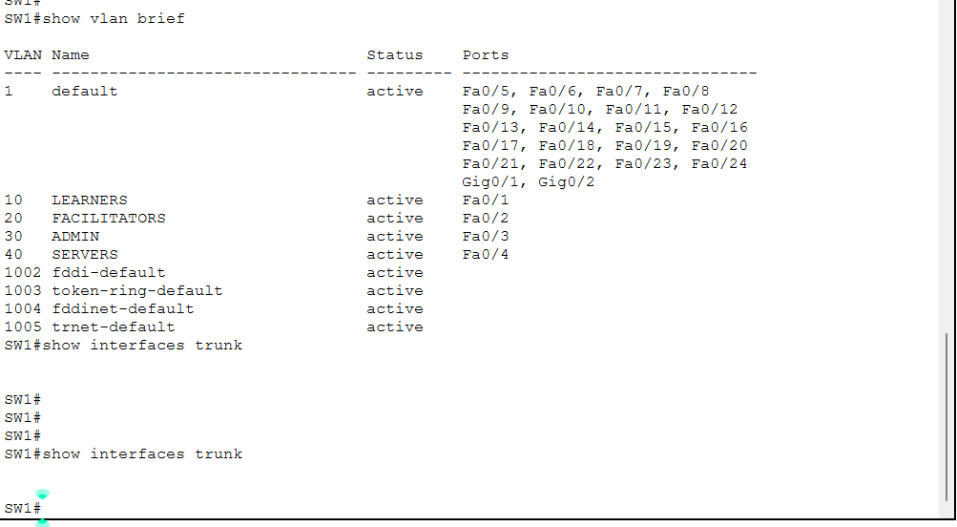
Figure 1: show vlan brief on SW1: each port is in its intended VLAN (Fa0/1 in 10, Fa0/2 in 20, Fa0/3 in 30, Fa0/4 in 40).

2.2 Devices and cabling
Device | Port | Connects to | Cable
PC-Learner | Fa0 | SW1 Fa0/1 (VLAN 10) | Copper straight-through
PC-Facilitator | Fa0 | SW1 Fa0/2 (VLAN 20) | Copper straight-through
PC-Admin | Fa0 | SW1 Fa0/3 (VLAN 30) | Copper straight-through
Server0 | Fa0 | SW1 Fa0/4 (VLAN 40) | Copper straight-through
SW1 (2960-24TT) | Gi0/1 (trunk) | R1 (1941) Gi0/0 | Copper straight-through
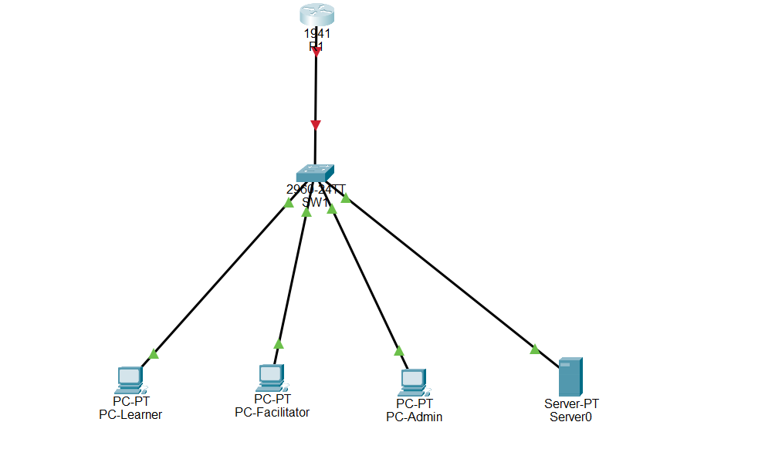
Figure 2: Packet Tracer topology: R1, SW1, three PCs and Server0. The R1 to SW1 link was red at this stage because R1 Gi0/0 had not yet been brought up.

2.3 Routing design
Devices in different VLANs cannot talk to each other without a router. The design uses router-on-a-stick: a single trunk link between SW1 and R1 carries all four VLANs, and R1 has one subinterface per VLAN. Each subinterface is that VLAN's gateway, and its encapsulation dot1Q number must match the VLAN number. This keeps the hardware to one router and one link, which suits a small school, and it places all inter-VLAN traffic through R1 where ACLs can inspect it.
Subinterface | dot1Q VLAN | IP address
Gi0/0.10 | 10 | 192.168.10.1/24
Gi0/0.20 | 20 | 192.168.20.1/24
Gi0/0.30 | 30 | 192.168.30.1/24
Gi0/0.40 | 40 | 192.168.40.1/24
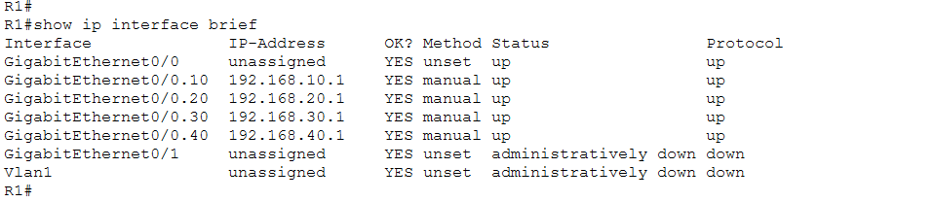
Figure 3: show ip interface brief on R1: Gi0/0 and the four subinterfaces are up/up with the correct gateway addresses.
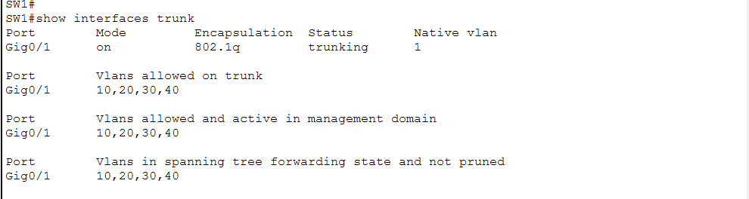
Figure 4: show interfaces trunk on SW1: Gi0/1 is trunking and carries VLANs 10, 20, 30 and 40.

3. Inter-VLAN Communication Policy
In brief: The matrix below shows which group may start a connection to which other group, with the reason for each decision. Read each row as the source and each column as the destination.
From / To | Learners | Facilitators | Admin | Server
Learners | n/a | Block | Block | Allow: HTTP + FTP
Facilitators | Allow | n/a | Block | Allow: HTTP + FTP
Admin | Allow | Allow | n/a | Allow: full access
Server | Replies only | Replies only | Replies only | n/a

3.1 Reasons
Rule | Reason
Learners to Facilitators: Block | Facilitator computers hold marking and test material. Learners reach staff through the server instead (least privilege, confidentiality).
Learners to Admin: Block | Protects records and classified information from being viewed or changed (confidentiality, integrity).
Learners to Server: HTTP + FTP | Learners need to view results and the timetable and to submit work, and nothing more (least privilege). Their FTP account is restricted on the server.
Facilitators to Learners: Allow | Facilitators give out assignments, mark work and help with projects.
Facilitators to Admin: Block | Prevents test leaks and changes to administrative data (confidentiality, integrity).
Facilitators to Server: HTTP + FTP | They view and upload the files they need. Limiting them to their own subject is a server permission, not a network rule.
Admin to Learners and Facilitators: Allow | Admin distributes information and tracks progress.
Admin to Server: Full | Admin manages classified information and keeps data accurate (integrity).
Server to anyone: Replies only | The server never starts a connection. It only answers requests, which limits the damage if it is compromised.

4. Firewall Controls (Access Control Lists)
In brief: Extended ACLs on R1 turn the matrix into enforced rules. One ACL is applied inbound on each VLAN subinterface, so unwanted traffic is dropped as close to its source as possible.
ACL (applied inbound on) | Permits | Everything else
LEARNERS_IN (Gi0/0.10) | Ping to own gateway; TCP 80 (HTTP) and TCP 21 (FTP) plus TCP above 1023 to Server0 only; echo-replies and established TCP for return traffic | Denied (deny ip any any)
FACILITATORS_IN (Gi0/0.20) | Anything to the Learners subnet; ping to own gateway; HTTP, FTP and TCP above 1023 to Server0 only; echo-replies and established TCP | Denied, including Admin
ADMIN_IN (Gi0/0.30) | All traffic from the Admin subnet | None (full access by design)
SERVER_IN (Gi0/0.40) | Only established TCP and echo-replies from Server0 | Denied, so the server cannot start connections

4.1 Return traffic
Basic extended ACLs do not track connections. Because Facilitators and Admin may start connections to Learners but not the other way round, the Learner ACL must still allow replies to come back. It does this with permit icmp ... echo-reply for pings and permit tcp ... established for TCP. The established keyword only checks TCP flags, so it is weaker than a stateful firewall; this is discussed in the limitations.

4.2 Passive FTP and the high-port rule
FTP uses two connections: a control connection on port 21 and, in passive mode, a second data connection to a high port on the server. After the first set of ACLs was applied, FTP logins worked but the dir command failed, because the data connection was blocked by the final deny rule. The fix was to add one rule to each of the Learner and Facilitator ACLs allowing TCP above port 1023 to Server0 only (sequence 35 and 45). The rule is limited to one server and one protocol, so it does not open any other VLAN.
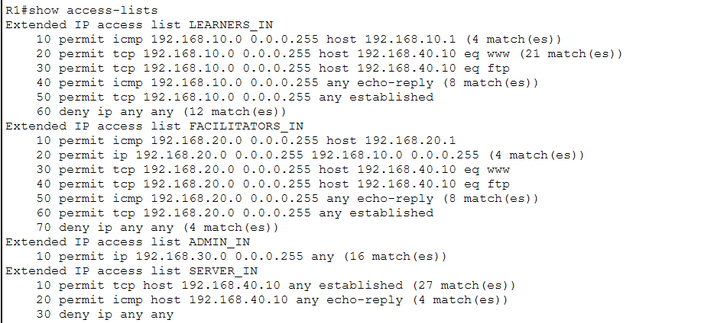
Figure 5: show access-lists before the high-port rules were added: the FTP rules and the facilitator HTTP rule show no matches.

5. Server Services and Permissions
In brief: The network decides which services each VLAN can reach. The server decides what each person can do inside those services. Both layers are needed to deliver the view, upload and edit split.
Layer | What it controls | Mechanism
Network (ACLs on R1) | Which VLANs can reach which service | Permit or deny by protocol and port
Server (user accounts) | What an authenticated user can do | FTP accounts with different permissions

FTP account | Permissions | Meaning
learner | Write, List | Can submit work and see the folder; cannot read, delete or rename files
facilitator | Read, Write, List | Can view and upload files
admin | Read, Write, Delete, Rename, List | Full control, including editing and cleaning up

HTTP is enabled for viewing results and the timetable. The default cisco FTP account, which has full permissions and a well-known password, was removed. Packet Tracer sets FTP permissions per account and not per folder, so the idea that facilitators only reach their own subject area is described here as a design goal that a real server would enforce with folder-level permissions.
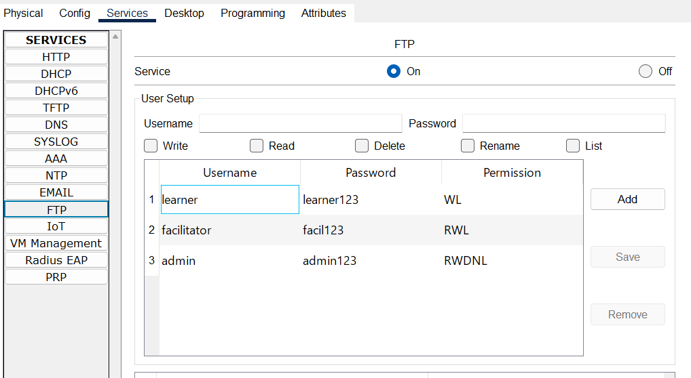
Figure 6: FTP service on Server0: the learner (WL), facilitator (RWL) and admin (RWDNL) accounts. The default cisco account was removed.
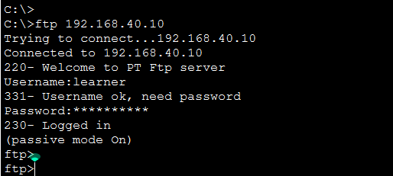
Figure 7: FTP login from PC-Learner as learner (before the ACLs were applied).
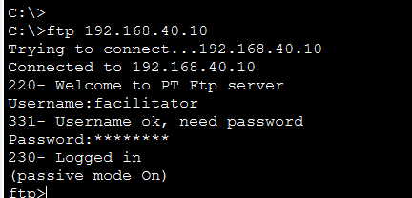
Figure 8: FTP login from PC-Facilitator as facilitator (before the ACLs were applied).
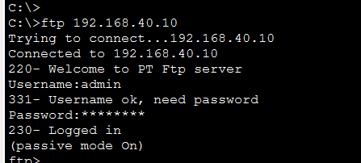
Figure 9: FTP login from PC-Admin as admin (before the ACLs were applied).

6. Testing and Results
In brief: Testing happened in two phases. First, with no ACLs, every device could reach every other, which proves the VLANs, trunk and routing are correct. Then, with the ACLs applied, the allowed traffic worked and the forbidden traffic was blocked.

6.1 Baseline test (before ACLs)
# | From | To | Result
1 | PC-Learner | 192.168.10.1 (own gateway) | Success
2 | PC-Learner | 192.168.20.10 (Facilitator) | Success
3 | PC-Learner | 192.168.30.10 (Admin) | Success
4 | PC-Learner | 192.168.40.10 (Server) | Success
5 | PC-Facilitator | 192.168.10.10 (Learner) | Success
6 | PC-Facilitator | 192.168.30.10 (Admin) | Success
7 | PC-Facilitator | 192.168.40.10 (Server) | Success
8 | PC-Admin | 192.168.10.10 (Learner) | Success
9 | PC-Admin | 192.168.20.10 (Facilitator) | Success
10 | PC-Admin | 192.168.40.10 (Server) | Success
[Insert screenshot: baseline ping results from the three PCs]

6.2 Test with ACLs applied
# | From | Test | Expected | Result
1 | PC-Learner | Ping own gateway 192.168.10.1 | Success | Success
2 | PC-Learner | Ping Facilitator 192.168.20.10 | Fail | Fail (blocked)
3 | PC-Learner | Ping Admin 192.168.30.10 | Fail | Fail (blocked)
4 | PC-Learner | Ping Server 192.168.40.10 | Fail | Fail (only HTTP and FTP allowed)
5 | PC-Learner | Web browser to http://192.168.40.10 | Success | Success
6 | PC-Learner | FTP login and dir | Success | Success after the high-port rule (dir failed before it)
7 | PC-Facilitator | Ping Learner 192.168.10.10 | Success | Success
8 | PC-Facilitator | Ping Admin 192.168.30.10 | Fail | Fail (blocked)
9 | PC-Facilitator | HTTP and FTP login and dir | Success | Success after the high-port rule
10 | PC-Admin | Ping Learner, Facilitator and Server | Success | Success
[Insert screenshot: failed pings from PC-Learner and PC-Facilitator, plus a successful FTP dir]

6.3 ACL match counters (show access-lists)
The match counters on R1 confirm which rules handled the traffic:
Rule | Matches | What it shows
LEARNERS_IN: HTTP to server (line 20) | 21 | Learner web access worked
LEARNERS_IN: FTP to server (line 30) | 27 | Learner FTP logins worked
LEARNERS_IN: high ports to server (line 35) | 5 | Learner dir/data connection worked after the fix
LEARNERS_IN: echo-reply (line 40) | 8 | Learners could answer pings from Facilitators and Admin
LEARNERS_IN: deny (line 60) | 23 | Pings to Facilitators, Admin and the server were blocked
FACILITATORS_IN: to Learners (line 20) | 4 | Facilitator to Learner traffic worked
FACILITATORS_IN: HTTP (line 30) | 5 | Facilitator web access worked
FACILITATORS_IN: FTP (line 40) | 27 | Facilitator FTP logins worked
FACILITATORS_IN: high ports (line 45) | 5 | Facilitator dir/data connection worked
FACILITATORS_IN: deny (line 70) | 15 | Traffic to Admin was blocked
ADMIN_IN: permit all (line 10) | 16 | Admin reached every destination it should
SERVER_IN: established / echo-reply (lines 10, 20) | 80 and 4 | The server only sent replies
SERVER_IN: deny (line 30) | none | The server never tried to start a connection
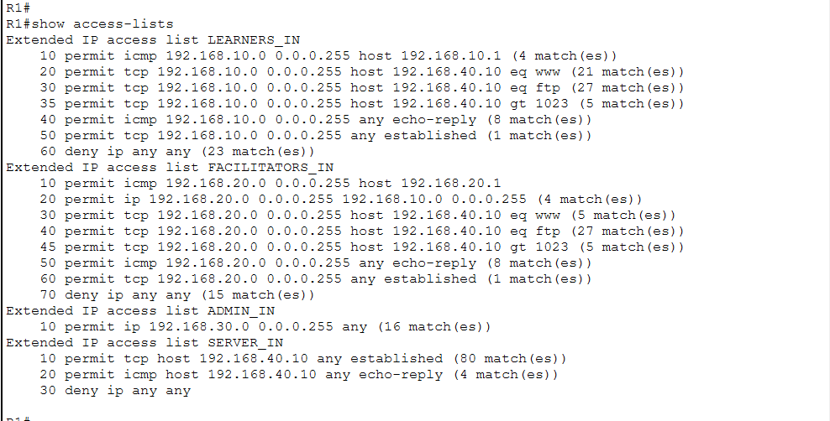
Figure 10: show access-lists after the fix: lines 35 and 45 (high ports) now match, and the FTP, HTTP and deny rules all show activity.

7. Limitations and Possible Improvements
In brief: The design meets the brief, but a few simplifications were needed for Packet Tracer. A real deployment would tighten them.
- FTP sends usernames and passwords in plain text. A real network would use SFTP or FTPS.
- The ACLs are not stateful. The established keyword only checks TCP flags, so a stateful firewall or zone-based firewall would be stronger and would also open passive FTP data ports automatically.
- The high-port rule permits any TCP port above 1023 to the server. On a real server, passive FTP would be restricted to a narrow range, for example 50000 to 50100, and only that range permitted.
- Permissions are per account, not per folder. A real server would give each facilitator access only to their own subject folders.
- Switch hardening was not covered: port security on access ports, shutting down and moving unused ports into an unused VLAN, and disabling DTP negotiation on trunks.
- Router-on-a-stick has one link and one router as a single point of failure and a bandwidth limit. A layer 3 switch or a second link would improve this in a larger school.
- Wireless access, internet access and a management VLAN were outside the scope of this design.

8. Conclusion
The network separates learners, facilitators, administration and the server into their own VLANs, routes between them through R1, and enforces a least-privilege policy with ACLs. Testing showed that allowed traffic works and forbidden traffic is blocked, and the ACL counters back this up. Splitting control between the network (which service a VLAN can reach) and the server (what a user can do there) delivers the intended view, upload and edit behaviour, and the limitations above show what a production network would add.

Appendix A: Switch Configuration (SW1)
enable
configure terminal
hostname SW1
vlan 10
name LEARNERS
vlan 20
name FACILITATORS
vlan 30
name ADMIN
vlan 40
name SERVERS
interface FastEthernet0/1
switchport mode access
switchport access vlan 10
interface FastEthernet0/2
switchport mode access
switchport access vlan 20
interface FastEthernet0/3
switchport mode access
switchport access vlan 30
interface FastEthernet0/4
switchport mode access
switchport access vlan 40
interface GigabitEthernet0/1
switchport mode trunk
switchport trunk allowed vlan 10,20,30,40
end
write memory

Appendix B: Router Configuration (R1)
enable
configure terminal
hostname R1
interface GigabitEthernet0/0
no shutdown
interface GigabitEthernet0/0.10
encapsulation dot1Q 10
ip address 192.168.10.1 255.255.255.0
interface GigabitEthernet0/0.20
encapsulation dot1Q 20
ip address 192.168.20.1 255.255.255.0
interface GigabitEthernet0/0.30
encapsulation dot1Q 30
ip address 192.168.30.1 255.255.255.0
interface GigabitEthernet0/0.40
encapsulation dot1Q 40
ip address 192.168.40.1 255.255.255.0
ip access-list extended LEARNERS_IN
10 permit icmp 192.168.10.0 0.0.0.255 host 192.168.10.1
20 permit tcp 192.168.10.0 0.0.0.255 host 192.168.40.10 eq 80
30 permit tcp 192.168.10.0 0.0.0.255 host 192.168.40.10 eq 21
35 permit tcp 192.168.10.0 0.0.0.255 host 192.168.40.10 gt 1023
40 permit icmp 192.168.10.0 0.0.0.255 any echo-reply
50 permit tcp 192.168.10.0 0.0.0.255 any established
60 deny ip any any
ip access-list extended FACILITATORS_IN
10 permit icmp 192.168.20.0 0.0.0.255 host 192.168.20.1
20 permit ip 192.168.20.0 0.0.0.255 192.168.10.0 0.0.0.255
30 permit tcp 192.168.20.0 0.0.0.255 host 192.168.40.10 eq 80
40 permit tcp 192.168.20.0 0.0.0.255 host 192.168.40.10 eq 21
45 permit tcp 192.168.20.0 0.0.0.255 host 192.168.40.10 gt 1023
50 permit icmp 192.168.20.0 0.0.0.255 any echo-reply
60 permit tcp 192.168.20.0 0.0.0.255 any established
70 deny ip any any
ip access-list extended ADMIN_IN
10 permit ip 192.168.30.0 0.0.0.255 any
ip access-list extended SERVER_IN
10 permit tcp host 192.168.40.10 any established
20 permit icmp host 192.168.40.10 any echo-reply
30 deny ip any any
interface GigabitEthernet0/0.10
ip access-group LEARNERS_IN in
interface GigabitEthernet0/0.20
ip access-group FACILITATORS_IN in
interface GigabitEthernet0/0.30
ip access-group ADMIN_IN in
interface GigabitEthernet0/0.40
ip access-group SERVER_IN in
end
write memory

