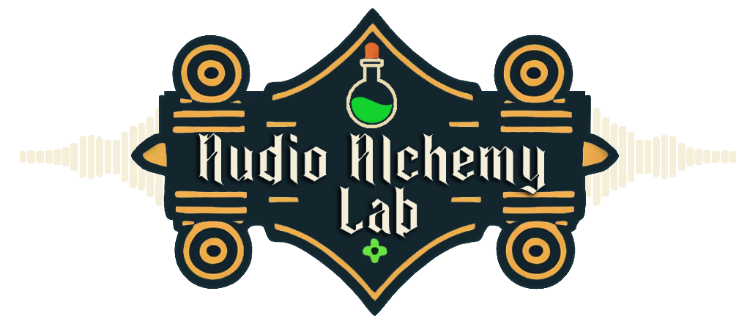

Introduction
Overview: AudioAlchemyLab is a comprehensive audio management tool designed to streamline your workflow within Unity. Whether you’re managing a small set of sound effects or a large library of music tracks, AudioAlchemyLab provides powerful features that allow for effortless playback, intuitive controls, and advanced audio management—all directly within the Unity Editor.
Key Features:
- One-click audio playback
- Intuitive interface
- Advanced volume and pitch control
- Simple looping options
- Play On Awake functionality
- Automatic audio source assignment
- Folder-specific audio loading
- Seamless navigation to audio files in your project

2. Getting Started
Installation:
- Download the AudioAlchemyLab package from the Unity Asset Store
- Open your Unity project and navigate to Assets > Import Package > Custom Package....
- Select the AudioAlchemyLab package you downloaded and click "Import".
Initial Setup:
- After importing, open the AudioAlchemyLab window by navigating to Tools > Audio Alchemy Lab.
- Set your preferred settings in the AudioAlchemyLab window. You can adjust things like volume, pitch, and loop settings according to your needs.
- To start using the tool, simply click on any audio clip within the Unity Editor, and AudioAlchemyLab will automatically load it into the interface.

3. Features and Usage
Effortless Audio Playback:
- Play any audio file in your project with a single click. Simply select the file in AudioAlchemyLab and press the play button. No need to manually assign audio sources.
Intuitive Interface:
- The interface is designed to be user-friendly, integrating seamlessly into the Unity Editor. It offers a clean layout where you can easily navigate and manage your audio assets.
Advanced Control:
- Fine-tune the volume and pitch of your audio clips directly within the tool. Adjustments are immediately reflected, allowing for precise control over how your audio sounds.
Looping Made Simple:
- Toggle looping for any audio clip with just one click. You can also customize the delay between loops to fit your needs.
Play On Awake:
- Easily enable or disable the Play On Awake feature for quick audio testing within your scenes.
Auto-Assignment:
- When you click on an audio clip, AudioAlchemyLab automatically assigns it to the selected audio source. This streamlines the process of managing sound effects and background music in your project.
Folder Functionality:
- Load all audio files from any folder within your Assets directory instantly. This makes it easy to organize and manage large audio libraries by narrowing down your selection to specific folders.
One-Click Access:
- Quickly navigate to any audio file in your project with a single click. This feature simplifies file management and helps you keep track of where your assets are stored.

4. Compatibility and Requirements
Supported Unity Versions:
- AudioAlchemyLab is compatible with Unity version 2022.3.22f1 and above.
Dependencies:
- This tool does not require any additional packages or plugins. It’s designed to work out-of-the-box with your Unity projects.

5. FAQ/Troubleshooting
Common Issues and Solutions:
- Issue: AudioAlchemyLab isn’t displaying audio files in my project.
  - Solution: Ensure that the audio files are placed within the Assets directory of your Unity project. The tool only scans the Assets folder for audio files.
- Issue: The Play On Awake feature isn’t working as expected.
  - Solution: Double-check that the audio source in your scene has the Play On Awake option enabled. Also, ensure that the correct audio clip is assigned to the audio source.
- Issue: The looping feature isn’t looping the audio as expected.
  - Solution: Verify that the loop delay setting is correctly configured in AudioAlchemyLab. If the issue persists, try resetting the loop settings to their defaults.

6. Changelog
Version 5.2:
- Complete rebuild from the ground up.
- Added Play On Awake functionality.
- Automatic loading of audio files from the Assets folder.
- GUI redesign with improved UI scaling.
- Data persistence across editor sessions and play modes.
- Audio Source detection and management.
- Audio clip file management and assignment.
- Bug fixes.
Version 4.0:
- Search functionality fixed.
- Major visual and UI improvements.

7. Credits and Acknowledgments
Contributors:
- The development of AudioAlchemyLab was led by [Tyler Bernard/Reptilian Alien Games].
AI Involvement:
- This asset’s creation benefited from AI technology, particularly ChatGPT, in multiple facets of development. ChatGPT provided valuable assistance by generating code snippets, documentation, project planning, and contributing to bug fixing efforts. This AI-powered collaboration enhanced the asset's development efficiency, quality, and functionality.

Overview Video:
- https://www.youtube.com/watch?v=DJ4LplGmHbk
Support Discord:
- https://discord.gg/DHbTV97q

