实验成绩

《数据库系统原理及应用》实验报告
实验八： 存储过程
专业班级： 软件1702 姓名 刘文博 学号201716040224完成时间： 2019/11/14
- 实验目的
理解存储过程的作用和原理，掌握过程化SQL语言编写存储过程和使用方法
- 实验内容及要求
实现一个银行转账的存储过程，并进行转账的存储过程调用

三、实验步骤
Sql语句:
DELIMITER //
CREATE PROCEDURE tc(
IN fid int,
IN tid int,
IN money double
)
BEGIN
declare balance double default 0.00;
declare state int default 0;
declare statef int default 0;
declare statet int default 0;

/* set statef = select isnull((select uid from user where uid = fid));
set statet = select isnull((select uid from user where uid = tid)); */
select count(*) into statef from user where uid =fid;
select count(*) into statet from user where uid =tid;
if
statef = 1 and statet = 1
then
select count into balance from user where uid = fid;
if
money <= balance
then
set state = 1;

else
set state = 0;

end if;
else
set state = 0;
end if;

start transaction; /* 开启事务*/
if
state = 1
then
update user set count = count-money where uid = fid;
update user set count = count+money where uid = tid;
signal sqlstate 'ERROR' set message_text = '转账成功!';
commit;
else
signal sqlstate 'ERROR' set message_text = '转账失败!';
rollback;
end if;
END;
实验截图:
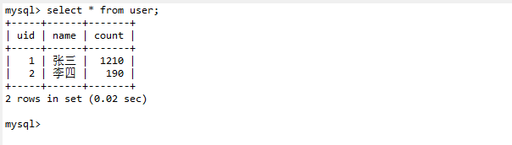

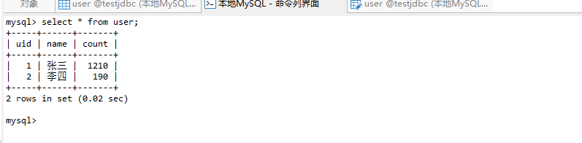
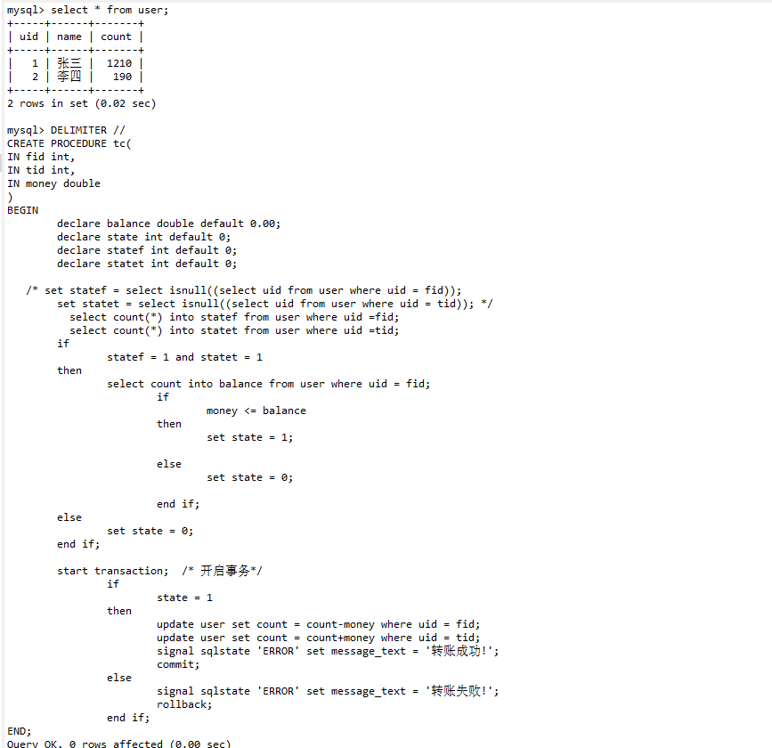

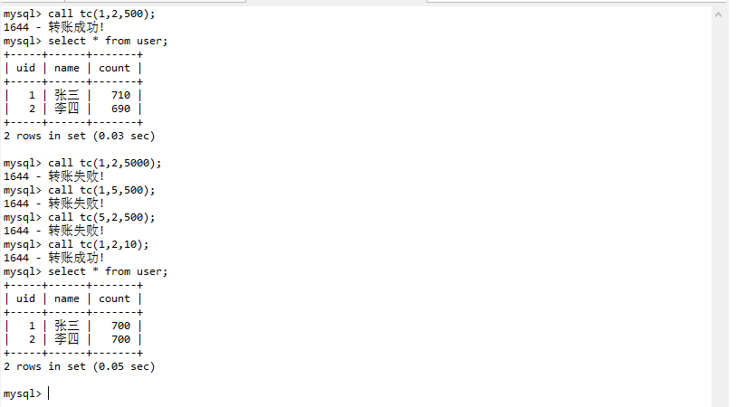
经检测,可以判断金额超出存款或者转账id不存在的情况.

四、实验中遇到的问题及解决（或未解决）的方案

在进行转账id是否存在进行赋值需要用

select count(*) into statef from user where uid =fid;

而不是set statef = statef from user where uid =fid;
避免浪费时间.

