|  |
| --- |
| Switch>enable  Switch#configure terminal  Switch(config)#hostname Switch0224a  Switch0224a(config)#enable secret 0224  Switch0224a(config)#interface vlan 1  Switch0224a(config-if)#ip address 192.168.24.1 255.255.255.0  Switch0224a(config-if)#ip default-gateway 192.168.24.1  Switch0224a(config)#end  Switch0224a#  Switch0224a#write |

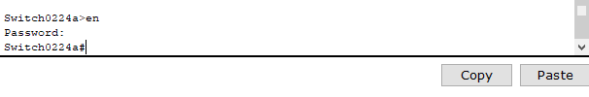

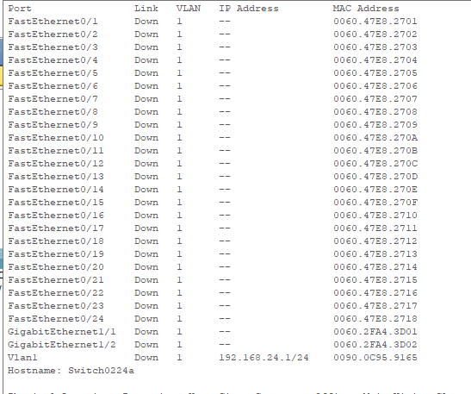

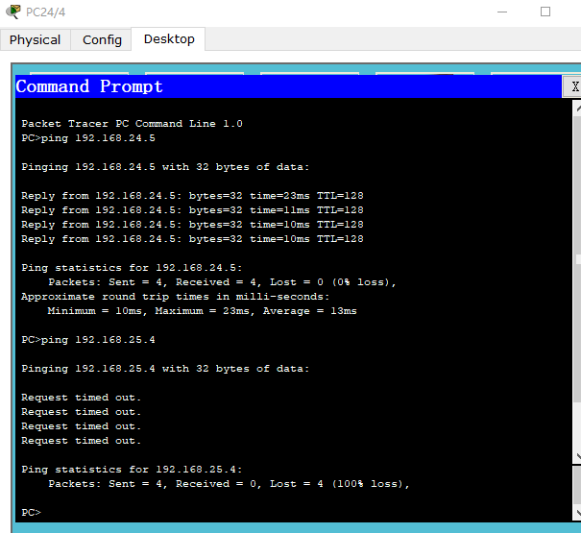

|  |
| --- |
| Switch0224b#config t  Enter configuration commands, one per line. End with CNTL/Z.  Switch0224b(config)#interface range fa03 - 5  ^  % Invalid input detected at '^' marker.    Switch0224b(config)#interface range fa0/3 - 5  Switch0224b(config-if-range)#switchport mode access  Switch0224b(config-if-range)#switchport access vlan 2  Switch0224b(config-if-range)#exit  Switch0224b(config)#interface range fa0/10 - 13  Switch0224b(config-if-range)#switchport mode access  Switch0224b(config-if-range)#switchport access vlan 3  Switch0224b(config-if-range)#exit  Switch0224b(config)#interface vlan 2  Switch0224b(config-if)#  %LINK-5-CHANGED: Interface Vlan2, changed state to up  %LINEPROTO-5-UPDOWN: Line protocol on Interface Vlan2, changed state to up  Switch0224b(config-if)#ip address 192.168.24.1 255.255.255.0  Switch0224b(config-if)#no shutdown  Switch0224b(config-if)#exit  Switch0224b(config)#interface vlan 3  Switch0224b(config-if)#  %LINK-5-CHANGED: Interface Vlan3, changed state to up  %LINEPROTO-5-UPDOWN: Line protocol on Interface Vlan3, changed state to up  Switch0224b(config-if)#ip address 192.168.25.1 255.255.255.0  Switch0224b(config-if)#no shutdown  Switch0224b(config-if)#exit |

