

UNDERGRADUATE PROJECT PROPOSAL

|  |  |
| --- | --- |
| **Project Title:** | **Hospital Management System** |
| **Surname:** | **Li** |
| **First Name:** | **WenBo(Bob)** |
| **Student Number:** | **202018010126** |
| **Supervisor Name:** | **James Blouin** |
| **Module Code:** | **CHC 6096** |
| **Module Name:** | **Project** |
| **Date Submitted:** | **2023.10.31** |

# **Declaration**

Student Conduct Regulations:

Please ensure you are familiar with the regulations in relation to Academic Integrity. The University takes this issue very seriously and students have been expelled or had their degrees withheld for cheating in assessment. It is important that students having difficulties with their work should seek help from their tutors rather than be tempted to use unfair means to gain marks. Students should not risk losing their degree and undermining all the work they have done towards it. You are expected to have familiarised yourself with these regulations. https://www.brookes.ac.uk/regulations/current/appeals-complaints-and-conduct/c1-1/

Guidance on the correct use of references can be found on www.brookes.ac.uk/services/library, and also in a handout in the Library. The full regulations may be accessed online at https://www.brookes.ac.uk/students/sirt/student-conduct/

If you do not understand what any of these terms mean, you should ask your Project Supervisor to clarify them for you.

I declare that I have read and understood Regulations C1.1.4 of the Regulations governing Academic Misconduct, and that the work I submit is fully in accordance with them.

Signature ………………Bob.Li…………………………. Date …………………………2024.3.18………………

REGULATIONS GOVERNING THE DEPOSIT AND USE OF OXFORD BROOKES UNIVERSITY MODULAR PROGRAMME PROJECTS AND DISSERTATIONS

Copies of projects/dissertations, submitted in fulfilment of Modular Programme requirements and achieving marks of 60% or above, shall normally be kept by the Oxford Brookes University Library.

I agree that this dissertation may be available for reading and photocopying in accordance with the Regulations governing the use of the Oxford Brookes University Library.

Signature ……………Bob.Li……………………………. Date ………………………2024.3.18………………

# **Acknowledgment**

Here, students are given the opportunity to thank those who have provided you with assistance and support.

**Table of Contents**

**Declaration** i

**Acknowledgment** ii

**Table of Contents** iii

**Abstract** iv

**Abbreviations** v

**Glossary** vi

**Chapter 1 Introduction** 1

**1.1** **Background** 1

**1.2** **Aim** 1

**1.3** **Objectives** 1

**1.4** **Project Overview** 1

**1.4.1** **Scope** 1

**1.4.2** **Audience** 1

**Chapter 2 Background Review** 2

**Chapter 3 Methodology** 3

**3.1** **Approach** 3

**3.2** **Technology** 3

**3.3** **Project Version Management** 3

**Chapter 4 Results** 4

**Chapter 5 Professional Issues** 5

**5.1** **Project Management** 5

**5.1.1** **Activities** 5

**5.1.2** **Schedule** 5

**5.1.3** **Project Data Management** 5

**5.1.4** **Project Deliverables** 5

**5.2** **Risk Analysis** 5

**5.3** **Professional Issues** 5

**Chapter 6 Conclusion** 6

**References** 7

**6.1** **Formatting Requirements** 7

**6.2** **Written Presentation** 7

**Appendices** 8

# Introduction

## Background

The development of computer networks has greatly improved the efficiency of units and individuals, and the development of any industry cannot do without the support of information technology. In order to help hospitals better manage and strengthen the management of the medical and health system, I have established a hospital management system for the system[1]. This system makes busy medical units more orderly, not only more efficient in managing outpatient information, but also enables patients to have a better medical experience.

Entering the new century, the arrival of the information age and the rapid development of science and technology have promoted the global exchange of interconnected information. With the continuous improvement of socio-economic development and the deepening of information exchange, a large amount of information needs to be processed. Secondly, it is necessary to establish an advanced and professional information management system to achieve management objectives[2]. A good information management system can process information in a timely and effective manner, making information management in the era of big data even better[1]. Therefore, establishing a hospital health system is not only a requirement of the times, but also a need for self-management.

## Aim

To this day, some small hospitals have not yet achieved full information management coverage and still use traditional paper documents for registration, accounting for a large amount of business data,generated every day. So, due to the large workload and limited manpower, errors will occur to some extent. Therefore, in order to improve the management status of medical institutions, it is necessary to start with information management. The government should promote the integration of intelligent hospital management systems into the healthcare system to improve the shortcomings of traditional management and address issues such as information collection errors and personnel registration errors.

## Objectives

This project will complete the registration and storage of patient data, including the classification of different patients' diseases, the allocation and appointment of doctors, time management, etc

Goals for completing the entire project include:

a) Collection of open source dataset

b) Classification of data information, storage and allocation of data

c) Design of website interface and backend

d) By testing the feasibility of different data and the correctness of the code

e) Feasibility and operability of learning different management data models

f) Complete the planned allocation operation

g) Run correctly on the compiler to test the service functionality of different types of consumers

## Project Overview

### Scope

The purpose of this study is to facilitate hospital data management, effectively improve patient operability of the system, improve medical efficiency, and provide better services for users

### Audience

If someone is sick, they hope to receive treatment. Firstly, they need to go to the hospital for consultation, but the premise is that they need to make a doctor appointment before going to the hospital because the hospital cannot always provide services for you[5]. This requires patients to register according to their own condition, and the hospital system can make appointments for them, greatly helping patients solve their medical problems.

# Background Review

1. If a hospital does not have a good hospital management system, it will lead to the loss of many patients, which means they will lose a lot of money. For example, when their management system often suffers from issues such as lag, data loss, and information confusion, these patients will go to other hospitals for treatment[2]. Therefore, in order to improve competitiveness, it is necessary to design a good system
2. Convenient. Both patients and doctors can access the appointment scheduling system and easily book the best time[1]. Hospital staff can provide the latest schedule and view new or cancelled appointments.
3. Automation. These modules provide useful tools to automate the scheduling process, thereby freeing up valuable employee time. These modules provide opportunities to synchronize contacts, automatically confirm appointments, and more. Due to all employees being busy, issues related to appointments can be minimized.
4. Reduce costs. With this module, appointments can be created in the best way to ensure the continuous workload of all hospital staff. Hospitals can save money by having fewer or no shifts between doctors, as they do not have to pay for their free time[3].
5. Patient satisfaction. The appointment management module in hospital management allows patients to easily choose the most suitable time. Non verbal interfaces, such as network access or mobile applications, are very suitable for patients who have found problems making phone calls or may have some language barriers.

# Methodology

## Approach

3.1.1: Collection of information related to hospital inpatient modules

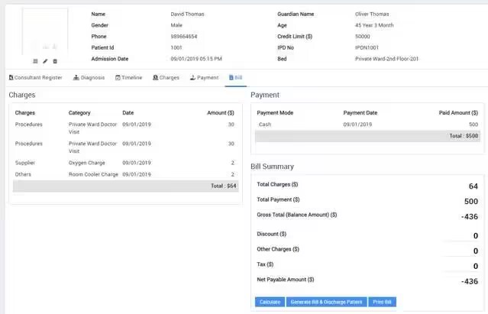

Figure 1: Hospitalization module information

When a patient needs to come to see a doctor, they need to check the doctors they need to visit, screen and classify them based on their condition. Finally, the system will arrange the required registration queue for the patient based on the doctor's available time slot[4], and make an appointment for them. If the patient needs a short visit, they can communicate through manual mode.

3.1.2: When you need to go to the hospital for medical treatment, you need to make an appointment for the doctor's free time on the same day and other related matters.

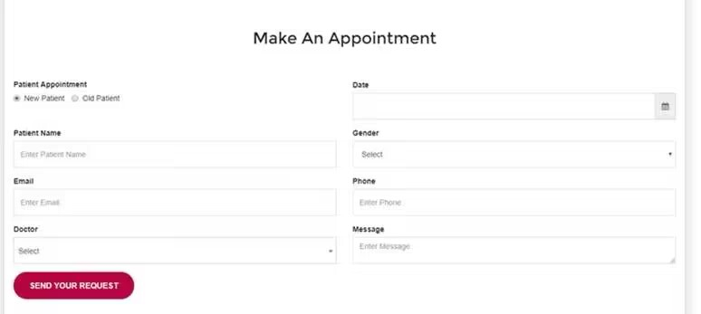

Figure 2: Appointment module

After checking the doctors you need to visit, you can schedule your favorite time in the system, which is also a free time slot provided by the system for your doctors. This module can greatly improve medical efficiency, better arrange time for patients or doctors, and prevent crowding caused by multiple patients at the same time. Of course, the implementation of this module cannot do without the support of multiple technologies, Completing this module also requires multiple feasibility tests to improve the functionality of the system[3].

3.1.3: Details of the manager's relevant work

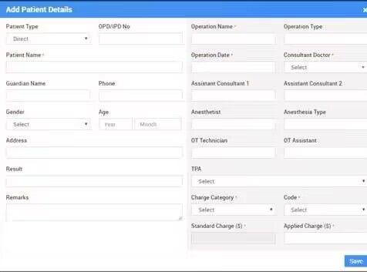

Figure 3: Hospital management personnel organize patient data

When the patient has determined that they need to seek medical treatment at this hospital, the system's management personnel need to save the patient's data to avoid providing evidence and data support in subsequent operations[8], including patient classification, patient contact information, patient appointment time, etc. If the patient wants to view their relevant information after treatmen[6]t, they can also arrange through the information saved in the background, This not only helps hospitals manage but also enhances patients' sense of safety and trust, which to some extent helps hospitals solve unnecessary troubles.

Store information about the patient's health status. Records include medical appointments, medication lists, and laboratory results[1]. They also display the date of the last visit to the doctor and their number.

The system stores personal data of patients, such as name, passport, social security number, address, mobile phone, and emai[5]l. This category includes EHR or EMR subsystems[4].

The information in the system will be automatically updated. This module is used to register patients and maintain medical history[4]. The obtained data helps healthcare professionals notify customers of appointments and automatically send discharge recommendations via email[7].

3.1.4: When doctors or managers need to view patient information or evaluate the current situation, a powerful search function is needed

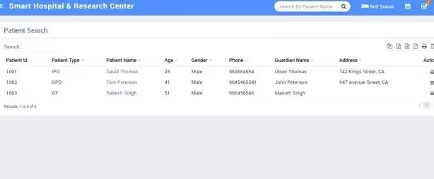

Figure 4: Patient search function

This module is designed for doctors. When doctors want to learn about their patients or contact them, they can obtain more patient details by searching for relevant patient information. This requires a powerful backend database and a powerful search engine to complete this list[7]. Of course, the most important thing is to protect patient privacy information to avoid unnecessary trouble for patients, The implementation of this module has to some extent improved the work efficiency of doctors, making it more convenient and efficient to find patients for doctors[3], thereby saving medical time. Of course, as mentioned earlier, privacy protection is also important, which involves some encryption algorithms and permissions issues. We will supplement and study this in the future to strengthen the security and efficiency of the system.

3.1.5: Online payment module for patient medical expenses

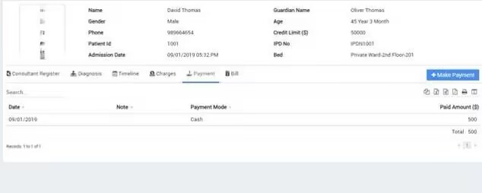

Figure 5: payment

In this module, you can view the relevant list of your hospitalization or medication, complete the final payment based on the list, perform treatment and processing, and submit the required amount[8].

3.1.6: Inventory management of hospital related drugs and other related products

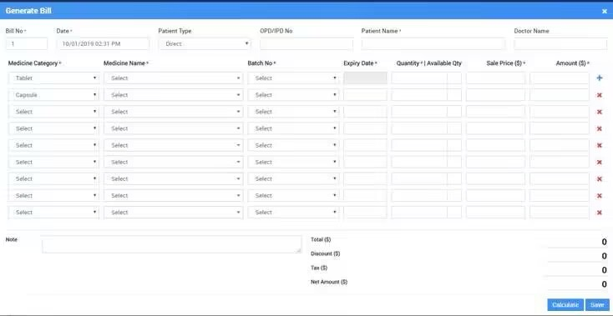

Figure 6: Inventory management

This display not only shows the inventory situation of the hospital, but also includes some hardware conditions, such as the number of ambulances, the arrangement of rescue personnel, and the situation of related drugs, so that the system can distribute and assist patients with medication and provide technical support for future medical payment[5]. If the drug inventory is insufficient[7], the system should promptly remind management personnel to supplement to prevent patients from experiencing insufficient medication during medication prescribing[8], Reduced the probability of errors occurring, thereby providing a certain degree of guarantee for the hospital's work efficiency[8].

3.1.7: Users can make appointments and complaints through email, phone, and other means

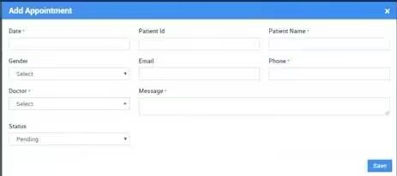

Figure 7: Used for manual customer service modules such as complaints

If the patient has some suggestions and complaints about the hospital, such as dissatisfaction with the service attitude of the hospital doctors or suggestions about the hospital's medical environment, manual interaction or specialized complaint channels can be operated through email or phone, which to some extent ensures the rights and interests of the patients[1]. The system allows integration with health insurance services[5]. The news about the hospitalization of insurance company clients arrived at their office [4]. Professional companies can bear all the costs of further treatment.

3.1.8: Statistical data and reports

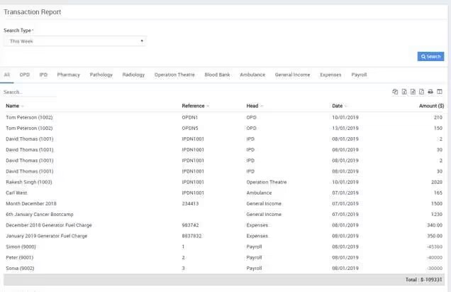

Figure 8：Statistical data and reports

Patients use their unique code to pay for specific medical services. The system issues invoices based on the time spent in the hospital and the procedures executed. It interacts with third-party tools such as payment gateways to transfer funds. Reports are automatically generated to record information about currency transactions and customer data[4].

3.1.9：Personal Module Summary

Personalized access. Medical personnel must have a personal password and log in to log in to the software. The access level is determined based on the position held and the permissions of the employee. The management department of medical institutions should have advanced functions such as changing passwords and opening confidential blocks[4], while also improving the qualifications of experts.

Clear and functional UI/UX design. Every employee of the clinic should know how to use the system's functions[1]. The interface must be tested under the supervision of medical experts. Navigation buttons, workspace organization, and data input are used daily, so you should make them as convenient as possible[4].

Fast working speed and fast response. Saving information, generating reports for users, and searching for users should be efficient and efficient[7]. In some special and emergency situations, real-time operating system features must be adopted to prioritize meeting the requirements of some patients, such as critically ill, allergic, and similar users, as this can have a significant impact on their lives[2].

International safety standards. The system must provide the highest level of protection for patient data. Introducing HMS[4], please consider three mandatory HIPAA rules: confidentiality, integrity, and availability of the entire electronic PHI, as well as preventing potential attacks or confidential information leakage.

Appropriate configuration of HMS modules[2]. It includes a list of settings, form templates, and program code itself. A module is a text file containing IT product code. Each HMS subsystem can exist as a separate component of the program. Module types include electronic recipe platforms, HER[4], etc. During the development process, the required configuration of all elements should be determined.

## Technology

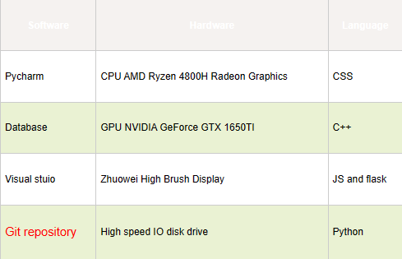

## Version management plan

Usually, I use the GitHub repository under Github and Baidu Cloud for data backup.

# Project Management

## Activities

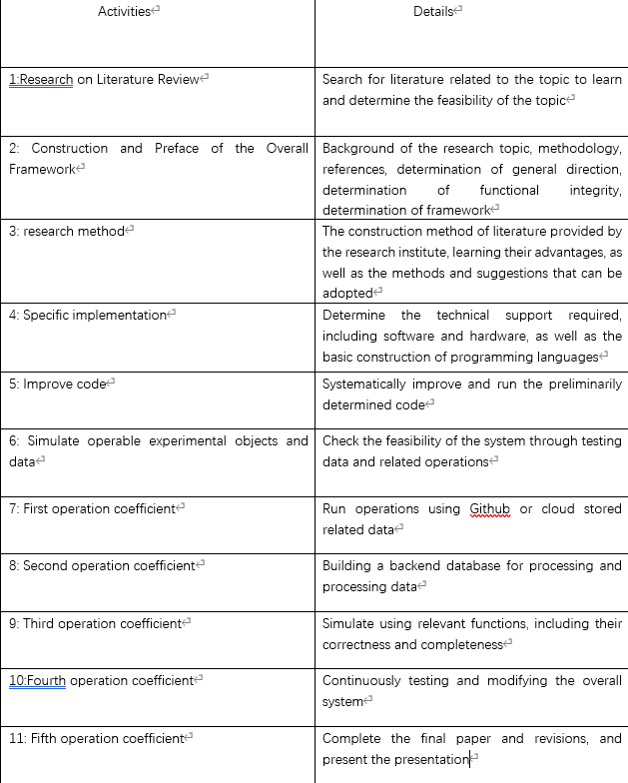

## Schedule

The progress report of my specific design is displayed through the following progress display. This progress is the relevant progress and completion status within three months, including the search and learning of relevant literature. The relevant testing of data is effective and in line with the current experimental progress, including the overall schedule arrangement for the next few months, completing all required goals given by the teacher within a limited time, and weekly reports are also essential. During the entire system construction process, I encountered many difficulties, but they were all resolved through learning and research. However, this does not mean that this situation will not occur again in future learning. Therefore, I will strive to overcome them, complete the writing of the paper, build the system, and make progress and success.

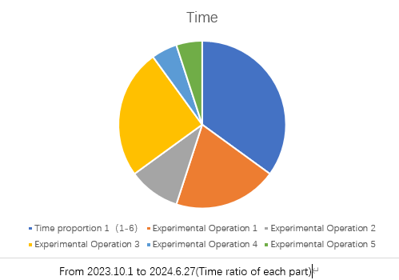

## Data management plan

a. Write your own weekly report and report progress to your supervisor

b. Upload your own code to Github to save the relevant data code for storage

c. Save weekly progress folder and data time and actions

d. Use relevant research papers as templates for learning and reference, and search through Baidu and relevant internet sites.

## Project Deliverables

a. Complete the writing of the project proposal

b. Complete and deliver weekly report content

c. Submit relevant progress folders

d. Complete and deliver the final report

e. Improve and modify the final code, and ensure it is correct after multiple tests

f. Use the PowerPoint required for presentation

g. Project Introduction and Submission.

# Reference

[1]: Detailed Introduction of Hospital Management System (HMS) (Krae,2020) available at:

[Introduction of Hospital Management System & its Features (karexpert.com)](https://www.karexpert.com/blogs/what-is-hospital-management-system/)

[2]: Features Of Hospital Management System | Efficient Scheduling & Record Management (Rising,2023) available at: [Features of Hospital Management System | Efficient Scheduling & Record Management (risingmax.com)](https://risingmax.com/blog/features-of-hospital-management-system)

[3]: ER diagram for a hospital management system (Crow’s Foot notation)(Constantine,2021) available at: [ER diagram for a hospital management system (Crow’s Foot notation) | Gleek | Gleek](https://www.gleek.io/blog/erd-hospital-management.html)

[4]: Hospital Management System: Features, Solutions, Modules (Andrei,2023) available at: [Hospital Management System: Features, Solutions, Modules - Glorium Technologies](https://gloriumtech.com/hospital-management-system-features-solutions-modules/)

[5]: Basic Components of a Hospital Management System available at:

[Hospital Management System: Modules, Features of Software Components - EffectiveSoft](https://www.effectivesoft.com/blog/basic-components-of-a-hospital-management-system.html).

[6]: How much does it cost to develop a hospital management system?(GIT,2022) available at:

[How much does it cost to develop a hospital management system? (appinventiv.com)](https://appinventiv.com/blog/how-to-build-hospital-management-system-and-its-cost/)

[7]: Use Case Diagram for Hospital Management System (Nym,2022) available at:

[Use Case Diagram for Hospital Management System (itsourcecode.com)](https://itsourcecode.com/uml/usecase/hospital-management-system-use-case-diagram/#google_vignette)

[8] How to Build a Hospital Management That Will Become a Cure Both for Your Patients and Your Organization (Sergey,2022) available at: [How to Develop a Hospital Management Software System? - XB Software](https://xbsoftware.com/blog/hospital-management-system/).