1. Introduction

The Point of Sale (POS) System is designed to manage products, sales transactions, users, inventory, and receipts. The system will provide an organized way for cashiers to process sales and for authorized users to monitor sales and stock information.

This document describes the planning and design phase of the POS system. It outlines the system requirements, scope, objectives, and the diagrams that will be used to design the system.

2. Planning Phase

The planning phase defines what the POS system will do, who will use it, and how its main components will be structured before the remaining development is completed.

2.1 Project Overview

The POS system will provide:

User authentication and role management.
Product and category management.
New sales and cart management.
Sales history and searching.
Receipt generation for paid sales.
Dashboard with sales and stock information.
2.2 Problem Statement

Manual management of sales and inventory can result in inaccurate records, difficulty tracking stock, and difficulty retrieving previous transactions. The POS system will provide a centralized system for recording sales, managing products, and monitoring business operations.

2.3 Project Objectives

The main objectives are to:

Manage users and their access.
Manage products, categories, prices, and stock.
Process sales using a shopping cart.
Store accurate sales and sale-item records.
Provide sales history and search functionality.
Generate receipts for paid sales.
Provide useful sales and inventory summaries.

2.4 Scope

The system will cover:

User registration and authentication.
Product management.
Category management.
Cart management.
Sales processing.
Sales history.
Receipt management.
Dashboard and low-stock monitoring.
2.5 Functional Requirements

The system shall:

Allow users to register and log in.
Allow authorized users to manage products and categories.
Allow cashiers to create sales.
Allow products to be added, removed, and updated in the cart.
Record sales and sale items.
Allow users to search and filter sales.
Display paid sales as receipts.
Display low-stock products and sales summaries.
2.6 Non-Functional Requirements

The system should:

Be secure — protect user accounts and restrict unauthorized access.
Be reliable — maintain accurate sales and inventory records.
Be usable — provide a simple interface for cashiers.
Be maintainable — use a structured MVC architecture.
Be efficient — retrieve and display product and sales information quickly.

- System Design

3.1 UML Class Diagram

The UML Class Diagram represents the main classes used in the POS system, including the controllers and models. It shows their attributes, methods, inheritance, and relationships with other classes.

Figure 1: UML Class Diagram of the POS System

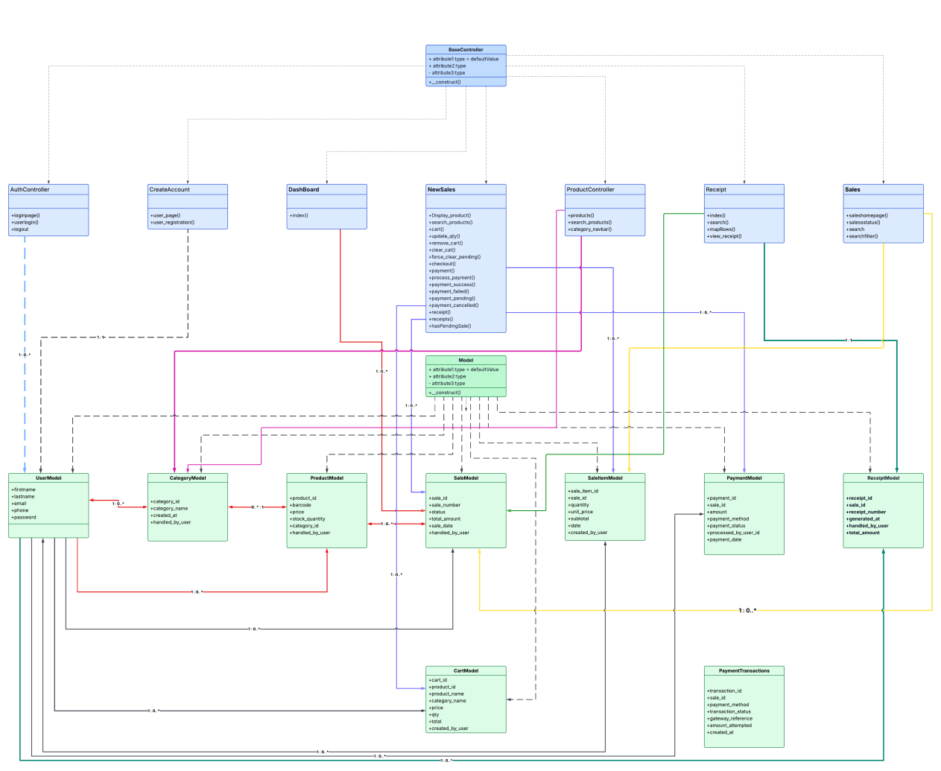

3.2 Class Diagram Explanation

The class diagram is based on the MVC structure used in the CodeIgniter application. The controllers contain the main system functions, while the models represent and manage the data used by the system.

The main controller classes include AuthController, CreateAccount, DashBoard, Newsales, Sales, Productcontroller, and Receipt. The main model classes include UserModel, ProductModel, CategoryModel, CartModel, SaleModel, SaleItemModel, PaymentModel, PaymentTransactions, and ReceiptModel.

3.3 EERD / Database Design

The Enhanced Entity-Relationship Diagram (EERD) represents the database structure of the POS system. It shows the main entities, their attributes, primary keys, foreign keys, and relationships.

The main entities include User, Category, Product, Cart, Sale, SaleItem, Payment, Payment Transaction, and Receipt. These entities work together to store user information, products, sales, payments, and receipts.

Figure 2: EERD of the POS System

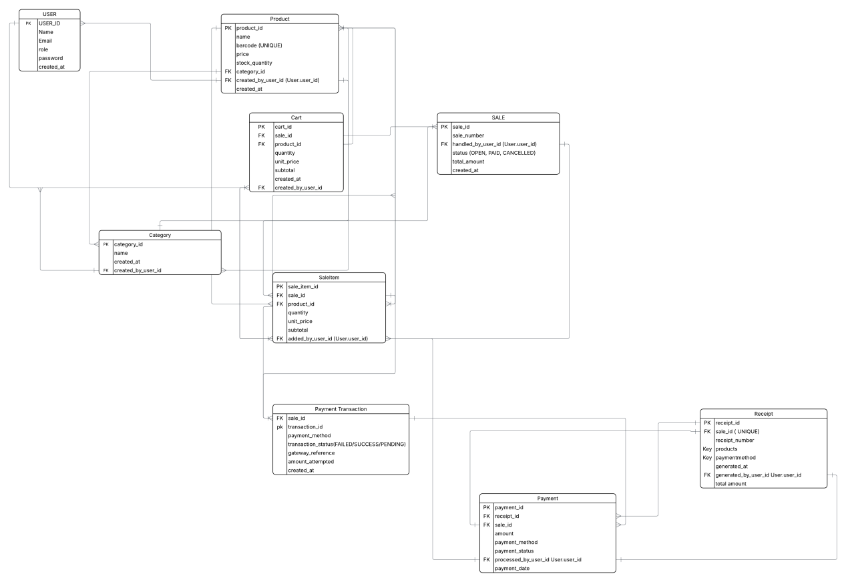

The EERD shows how the different database tables are connected. For example, a category can contain multiple products, while a sale can contain multiple sale items. A sale is also associated with payment information and can generate a receipt once the sale has been paid.

The EERD will serve as the database design reference during implementation and will help ensure that the relationships between the tables are maintained correctly

