《 数据结构IV 》
三级项目报告（终结性）
姓 名： |  | 学 号：
项目
名称

1. 查找
①给出查找代码，查找程序粘到此处
// 二分查找算法
public static int binarySearch(List<Person> list, int key) {
int low = 0;
int high = list.size() - 1;

while (low <= high) {
int mid = (low + high) >>> 1;
int midVal = list.get(mid).getId();

if (midVal < key)
low = mid + 1;
else if (midVal > key)
high = mid - 1;
else
return mid; // 键值等于中间元素
}
return -(low + 1); // 键值不存在
}

②写出每次比较对象(包括查找前的关键字序列)，程序运行截图粘到此处

Initial list:
Person [id=537515900, name=Name0, age=20, gender=Male, address=Address0]
Person [id=1173033090, name=Name1, age=21, gender=Female, address=Address1]
Person [id=121725181, name=Name2, age=22, gender=Male, address=Address2]
Person [id=428627943, name=Name3, age=23, gender=Female, address=Address3]
Person [id=757746170, name=Name4, age=24, gender=Male, address=Address4]
Person [id=1661749181, name=Name5, age=25, gender=Female, address=Address5]
Person [id=399421596, name=Name6, age=26, gender=Male, address=Address6]
Person [id=1836096670, name=Name7, age=27, gender=Female, address=Address7]
Person [id=1123860622, name=Name8, age=28, gender=Male, address=Address8]
Person [id=810682527, name=Name9, age=29, gender=Female, address=Address9]
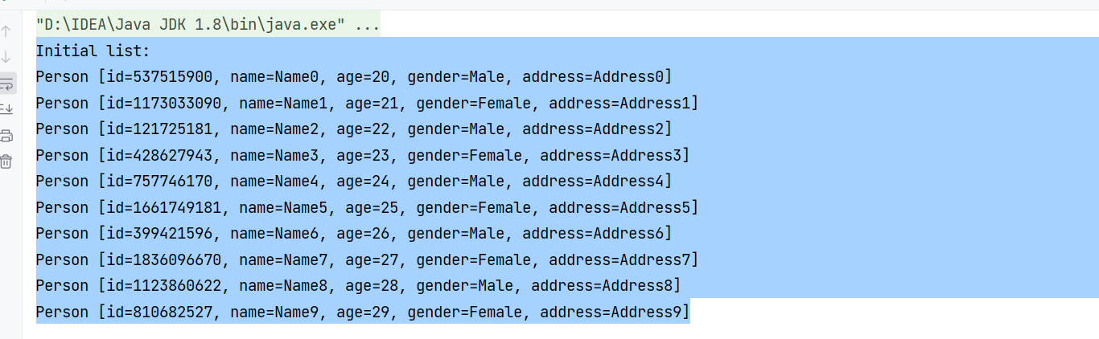

③要包括查找成功和查找失败的情况，程序运行截图粘到此处
1、查找失败
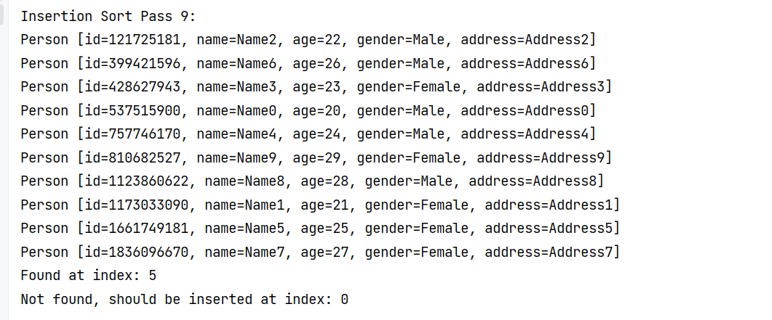

2、无运行出查找成功截图

2. 排序
利用讲过的8个排序算法选择其中2个将所有对象按关键字值从小到大排序
- 2个算法的代码实现，排序程序粘到此处

/ / 直接插入排序
public static void insertionSort(List<Person> list) {
for (int i = 1; i < list.size(); i++) {
Person current = list.get(i);
int j = i - 1;

// 将当前元素与已排序序列中的元素进行比较
while (j >= 0 && list.get(j).getId() > current.getId()) {
list.set(j + 1, list.get(j));
j--;
}
list.set(j + 1, current);

// 输出每一趟排序后的结果
System.out.println("Insertion Sort Pass " + i + ":");
list.forEach(System.out::println);
}
}

// 冒泡排序
public static void bubbleSort(List<Person> list) {
int n = list.size();
boolean swapped;
for (int i = 0; i < n - 1; i++) {
swapped = false;
for (int j = 0; j < n - 1 - i; j++) {
if (list.get(j).getId() > list.get(j + 1).getId()) {
// 交换元素
Person temp = list.get(j);
list.set(j, list.get(j + 1));
list.set(j + 1, temp);
swapped = true;
}
}
// 如果没有发生交换，说明列表已经是有序的
if (!swapped)
break;
// 输出每一趟排序后的结果
System.out.println("Bubble Sort Pass " + (i + 1) + ":");
list.forEach(System.out::println);
}
}

②分别写出2个排序算法的名称及每个算法的每一趟排序过程(包括排序前的关键字序列) ，程序运行截图粘到此处

插入排序过程：
Performing Insertion Sort:
Insertion Sort Pass 1:
Person [id=930170957, name=Name1, age=21, gender=Female, address=Address1]
Person [id=1062119338, name=Name0, age=20, gender=Male, address=Address0]
Person [id=625608127, name=Name2, age=22, gender=Male, address=Address2]
Person [id=413967991, name=Name3, age=23, gender=Female, address=Address3]
Person [id=1564006119, name=Name4, age=24, gender=Male, address=Address4]
Person [id=712375312, name=Name5, age=25, gender=Female, address=Address5]
Person [id=865821762, name=Name6, age=26, gender=Male, address=Address6]
Person [id=1301127430, name=Name7, age=27, gender=Female, address=Address7]
Person [id=17312037, name=Name8, age=28, gender=Male, address=Address8]
Person [id=1240589197, name=Name9, age=29, gender=Female, address=Address9]
Insertion Sort Pass 2:
Person [id=625608127, name=Name2, age=22, gender=Male, address=Address2]
Person [id=930170957, name=Name1, age=21, gender=Female, address=Address1]
Person [id=1062119338, name=Name0, age=20, gender=Male, address=Address0]
Person [id=413967991, name=Name3, age=23, gender=Female, address=Address3]
Person [id=1564006119, name=Name4, age=24, gender=Male, address=Address4]
Person [id=712375312, name=Name5, age=25, gender=Female, address=Address5]
Person [id=865821762, name=Name6, age=26, gender=Male, address=Address6]
Person [id=1301127430, name=Name7, age=27, gender=Female, address=Address7]
Person [id=17312037, name=Name8, age=28, gender=Male, address=Address8]
Person [id=1240589197, name=Name9, age=29, gender=Female, address=Address9]
Insertion Sort Pass 3:
Person [id=413967991, name=Name3, age=23, gender=Female, address=Address3]
Person [id=625608127, name=Name2, age=22, gender=Male, address=Address2]
Person [id=930170957, name=Name1, age=21, gender=Female, address=Address1]
Person [id=1062119338, name=Name0, age=20, gender=Male, address=Address0]
Person [id=1564006119, name=Name4, age=24, gender=Male, address=Address4]
Person [id=712375312, name=Name5, age=25, gender=Female, address=Address5]
Person [id=865821762, name=Name6, age=26, gender=Male, address=Address6]
Person [id=1301127430, name=Name7, age=27, gender=Female, address=Address7]
Person [id=17312037, name=Name8, age=28, gender=Male, address=Address8]
Person [id=1240589197, name=Name9, age=29, gender=Female, address=Address9]
Insertion Sort Pass 4:
Person [id=413967991, name=Name3, age=23, gender=Female, address=Address3]
Person [id=625608127, name=Name2, age=22, gender=Male, address=Address2]
Person [id=930170957, name=Name1, age=21, gender=Female, address=Address1]
Person [id=1062119338, name=Name0, age=20, gender=Male, address=Address0]
Person [id=1564006119, name=Name4, age=24, gender=Male, address=Address4]
Person [id=712375312, name=Name5, age=25, gender=Female, address=Address5]
Person [id=865821762, name=Name6, age=26, gender=Male, address=Address6]
Person [id=1301127430, name=Name7, age=27, gender=Female, address=Address7]
Person [id=17312037, name=Name8, age=28, gender=Male, address=Address8]
Person [id=1240589197, name=Name9, age=29, gender=Female, address=Address9]
Insertion Sort Pass 5:
Person [id=413967991, name=Name3, age=23, gender=Female, address=Address3]
Person [id=625608127, name=Name2, age=22, gender=Male, address=Address2]
Person [id=712375312, name=Name5, age=25, gender=Female, address=Address5]
Person [id=930170957, name=Name1, age=21, gender=Female, address=Address1]
Person [id=1062119338, name=Name0, age=20, gender=Male, address=Address0]
Person [id=1564006119, name=Name4, age=24, gender=Male, address=Address4]
Person [id=865821762, name=Name6, age=26, gender=Male, address=Address6]
Person [id=1301127430, name=Name7, age=27, gender=Female, address=Address7]
Person [id=17312037, name=Name8, age=28, gender=Male, address=Address8]
Person [id=1240589197, name=Name9, age=29, gender=Female, address=Address9]
Insertion Sort Pass 6:
Person [id=413967991, name=Name3, age=23, gender=Female, address=Address3]
Person [id=625608127, name=Name2, age=22, gender=Male, address=Address2]
Person [id=712375312, name=Name5, age=25, gender=Female, address=Address5]
Person [id=865821762, name=Name6, age=26, gender=Male, address=Address6]
Person [id=930170957, name=Name1, age=21, gender=Female, address=Address1]
Person [id=1062119338, name=Name0, age=20, gender=Male, address=Address0]
Person [id=1564006119, name=Name4, age=24, gender=Male, address=Address4]
Person [id=1301127430, name=Name7, age=27, gender=Female, address=Address7]
Person [id=17312037, name=Name8, age=28, gender=Male, address=Address8]
Person [id=1240589197, name=Name9, age=29, gender=Female, address=Address9]
Insertion Sort Pass 7:
Person [id=413967991, name=Name3, age=23, gender=Female, address=Address3]
Person [id=625608127, name=Name2, age=22, gender=Male, address=Address2]
Person [id=712375312, name=Name5, age=25, gender=Female, address=Address5]
Person [id=865821762, name=Name6, age=26, gender=Male, address=Address6]
Person [id=930170957, name=Name1, age=21, gender=Female, address=Address1]
Person [id=1062119338, name=Name0, age=20, gender=Male, address=Address0]
Person [id=1301127430, name=Name7, age=27, gender=Female, address=Address7]
Person [id=1564006119, name=Name4, age=24, gender=Male, address=Address4]
Person [id=17312037, name=Name8, age=28, gender=Male, address=Address8]
Person [id=1240589197, name=Name9, age=29, gender=Female, address=Address9]
Insertion Sort Pass 8:
Person [id=17312037, name=Name8, age=28, gender=Male, address=Address8]
Person [id=413967991, name=Name3, age=23, gender=Female, address=Address3]
Person [id=625608127, name=Name2, age=22, gender=Male, address=Address2]
Person [id=712375312, name=Name5, age=25, gender=Female, address=Address5]
Person [id=865821762, name=Name6, age=26, gender=Male, address=Address6]
Person [id=930170957, name=Name1, age=21, gender=Female, address=Address1]
Person [id=1062119338, name=Name0, age=20, gender=Male, address=Address0]
Person [id=1301127430, name=Name7, age=27, gender=Female, address=Address7]
Person [id=1564006119, name=Name4, age=24, gender=Male, address=Address4]
Person [id=1240589197, name=Name9, age=29, gender=Female, address=Address9]
Insertion Sort Pass 9:
Person [id=17312037, name=Name8, age=28, gender=Male, address=Address8]
Person [id=413967991, name=Name3, age=23, gender=Female, address=Address3]
Person [id=625608127, name=Name2, age=22, gender=Male, address=Address2]
Person [id=712375312, name=Name5, age=25, gender=Female, address=Address5]
Person [id=865821762, name=Name6, age=26, gender=Male, address=Address6]
Person [id=930170957, name=Name1, age=21, gender=Female, address=Address1]
Person [id=1062119338, name=Name0, age=20, gender=Male, address=Address0]
Person [id=1240589197, name=Name9, age=29, gender=Female, address=Address9]
Person [id=1301127430, name=Name7, age=27, gender=Female, address=Address7]
Person [id=1564006119, name=Name4, age=24, gender=Male, address=Address4]
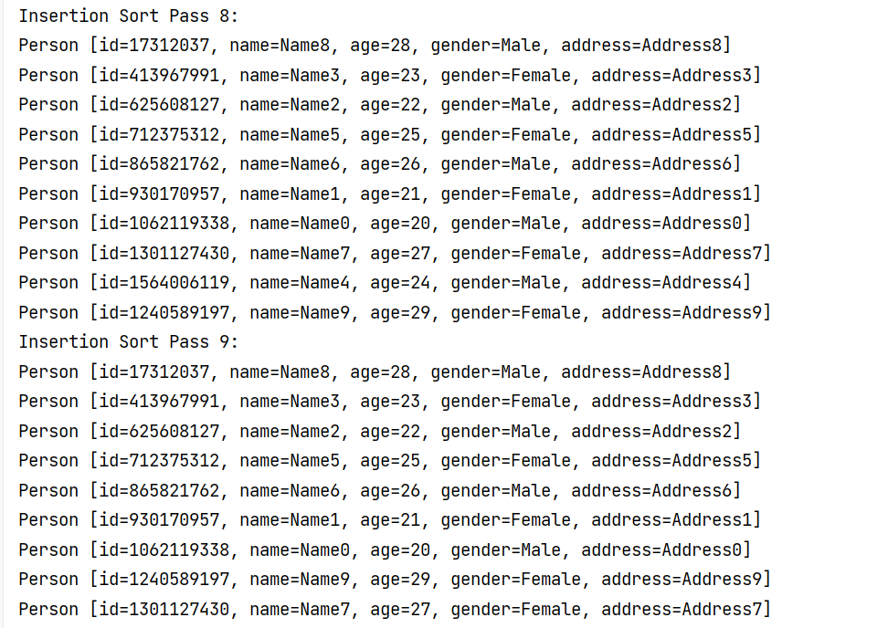

冒泡排序过程：
Performing Bubble Sort:
Bubble Sort Pass 1:
Person [id=1914890612, name=Name1, age=21, gender=Female, address=Address1]
Person [id=1729019514, name=Name2, age=22, gender=Male, address=Address2]
Person [id=1437029736, name=Name3, age=23, gender=Female, address=Address3]
Person [id=1583209262, name=Name4, age=24, gender=Male, address=Address4]
Person [id=746723721, name=Name5, age=25, gender=Female, address=Address5]
Person [id=2047219237, name=Name0, age=20, gender=Male, address=Address0]
Person [id=1911905822, name=Name7, age=27, gender=Female, address=Address7]
Person [id=2976910, name=Name8, age=28, gender=Male, address=Address8]
Person [id=801015455, name=Name9, age=29, gender=Female, address=Address9]
Person [id=2048882795, name=Name6, age=26, gender=Male, address=Address6]
Bubble Sort Pass 2:
Person [id=1729019514, name=Name2, age=22, gender=Male, address=Address2]
Person [id=1437029736, name=Name3, age=23, gender=Female, address=Address3]
Person [id=1583209262, name=Name4, age=24, gender=Male, address=Address4]
Person [id=746723721, name=Name5, age=25, gender=Female, address=Address5]
Person [id=1914890612, name=Name1, age=21, gender=Female, address=Address1]
Person [id=1911905822, name=Name7, age=27, gender=Female, address=Address7]
Person [id=2976910, name=Name8, age=28, gender=Male, address=Address8]
Person [id=801015455, name=Name9, age=29, gender=Female, address=Address9]
Person [id=2047219237, name=Name0, age=20, gender=Male, address=Address0]
Person [id=2048882795, name=Name6, age=26, gender=Male, address=Address6]
Bubble Sort Pass 3:
Person [id=1437029736, name=Name3, age=23, gender=Female, address=Address3]
Person [id=1583209262, name=Name4, age=24, gender=Male, address=Address4]
Person [id=746723721, name=Name5, age=25, gender=Female, address=Address5]
Person [id=1729019514, name=Name2, age=22, gender=Male, address=Address2]
Person [id=1911905822, name=Name7, age=27, gender=Female, address=Address7]
Person [id=2976910, name=Name8, age=28, gender=Male, address=Address8]
Person [id=801015455, name=Name9, age=29, gender=Female, address=Address9]
Person [id=1914890612, name=Name1, age=21, gender=Female, address=Address1]
Person [id=2047219237, name=Name0, age=20, gender=Male, address=Address0]
Person [id=2048882795, name=Name6, age=26, gender=Male, address=Address6]
Bubble Sort Pass 4:
Person [id=1437029736, name=Name3, age=23, gender=Female, address=Address3]
Person [id=746723721, name=Name5, age=25, gender=Female, address=Address5]
Person [id=1583209262, name=Name4, age=24, gender=Male, address=Address4]
Person [id=1729019514, name=Name2, age=22, gender=Male, address=Address2]
Person [id=2976910, name=Name8, age=28, gender=Male, address=Address8]
Person [id=801015455, name=Name9, age=29, gender=Female, address=Address9]
Person [id=1911905822, name=Name7, age=27, gender=Female, address=Address7]
Person [id=1914890612, name=Name1, age=21, gender=Female, address=Address1]
Person [id=2047219237, name=Name0, age=20, gender=Male, address=Address0]
Person [id=2048882795, name=Name6, age=26, gender=Male, address=Address6]
Bubble Sort Pass 5:
Person [id=746723721, name=Name5, age=25, gender=Female, address=Address5]
Person [id=1437029736, name=Name3, age=23, gender=Female, address=Address3]
Person [id=1583209262, name=Name4, age=24, gender=Male, address=Address4]
Person [id=2976910, name=Name8, age=28, gender=Male, address=Address8]
Person [id=801015455, name=Name9, age=29, gender=Female, address=Address9]
Person [id=1729019514, name=Name2, age=22, gender=Male, address=Address2]
Person [id=1911905822, name=Name7, age=27, gender=Female, address=Address7]
Person [id=1914890612, name=Name1, age=21, gender=Female, address=Address1]
Person [id=2047219237, name=Name0, age=20, gender=Male, address=Address0]
Person [id=2048882795, name=Name6, age=26, gender=Male, address=Address6]
Bubble Sort Pass 6:
Person [id=746723721, name=Name5, age=25, gender=Female, address=Address5]
Person [id=1437029736, name=Name3, age=23, gender=Female, address=Address3]
Person [id=2976910, name=Name8, age=28, gender=Male, address=Address8]
Person [id=801015455, name=Name9, age=29, gender=Female, address=Address9]
Person [id=1583209262, name=Name4, age=24, gender=Male, address=Address4]
Person [id=1729019514, name=Name2, age=22, gender=Male, address=Address2]
Person [id=1911905822, name=Name7, age=27, gender=Female, address=Address7]
Person [id=1914890612, name=Name1, age=21, gender=Female, address=Address1]
Person [id=2047219237, name=Name0, age=20, gender=Male, address=Address0]
Person [id=2048882795, name=Name6, age=26, gender=Male, address=Address6]
Bubble Sort Pass 7:
Person [id=746723721, name=Name5, age=25, gender=Female, address=Address5]
Person [id=2976910, name=Name8, age=28, gender=Male, address=Address8]
Person [id=801015455, name=Name9, age=29, gender=Female, address=Address9]
Person [id=1437029736, name=Name3, age=23, gender=Female, address=Address3]
Person [id=1583209262, name=Name4, age=24, gender=Male, address=Address4]
Person [id=1729019514, name=Name2, age=22, gender=Male, address=Address2]
Person [id=1911905822, name=Name7, age=27, gender=Female, address=Address7]
Person [id=1914890612, name=Name1, age=21, gender=Female, address=Address1]
Person [id=2047219237, name=Name0, age=20, gender=Male, address=Address0]
Person [id=2048882795, name=Name6, age=26, gender=Male, address=Address6]
Bubble Sort Pass 8:
Person [id=2976910, name=Name8, age=28, gender=Male, address=Address8]
Person [id=746723721, name=Name5, age=25, gender=Female, address=Address5]
Person [id=801015455, name=Name9, age=29, gender=Female, address=Address9]
Person [id=1437029736, name=Name3, age=23, gender=Female, address=Address3]
Person [id=1583209262, name=Name4, age=24, gender=Male, address=Address4]
Person [id=1729019514, name=Name2, age=22, gender=Male, address=Address2]
Person [id=1911905822, name=Name7, age=27, gender=Female, address=Address7]
Person [id=1914890612, name=Name1, age=21, gender=Female, address=Address1]
Person [id=2047219237, name=Name0, age=20, gender=Male, address=Address0]
