《 数据结构IV 》
三级项目报告（终结性）
姓 名： |  | 学 号：
项目
名称

1. 查找
①给出查找代码，查找程序粘到此处

List<Entity> entities = new ArrayList<>();
Random random = new Random();

// 随机生成10个Entity对象
for (int i = 0; i < 10; i++) {
entities.add(new Entity(random.nextInt(100), // id作为主关键字
"Name" + i,
random.nextInt(50) + 20, // 年龄20-70
random.nextDouble() * 10000, // 薪水0-10000
"Dept" + (i % 3 + 1))); // 部门
}

System.out.println("\n初始数据:");
printEntities(entities);

// 排序操作
System.out.println("\n冒泡排序 (按主关键字id从小到大排序):");
bubbleSort(entities);

System.out.println("\n直接选择排序 (按主关键字id从小到大排序):");
selectionSort(entities);

// 查找操作
System.out.println("\n二分查找 (按id查找):");
binarySearch(entities, entities.get(5).getId()); // 查找成功
binarySearch(entities, 999); // 查找失败
}

②写出每次比较对象(包括查找前的关键字序列)，程序运行截图粘到此处
初始数据:
Entity{id=71, name='Name0', age=64, salary=5359.254808351375, department='Dept1'}
Entity{id=16, name='Name1', age=22, salary=5429.774674639523, department='Dept2'}
Entity{id=60, name='Name2', age=62, salary=5601.063126970645, department='Dept3'}
Entity{id=67, name='Name3', age=25, salary=856.0590558689352, department='Dept1'}
Entity{id=1, name='Name4', age=28, salary=9215.280836740385, department='Dept2'}
Entity{id=11, name='Name5', age=56, salary=2818.359193816492, department='Dept3'}
Entity{id=49, name='Name6', age=63, salary=7223.976148095417, department='Dept1'}
Entity{id=36, name='Name7', age=65, salary=8380.093622709615, department='Dept2'}
Entity{id=1, name='Name8', age=51, salary=9728.181319416904, department='Dept3'}
Entity{id=39, name='Name9', age=32, salary=518.1601476435316, department='Dept1'}
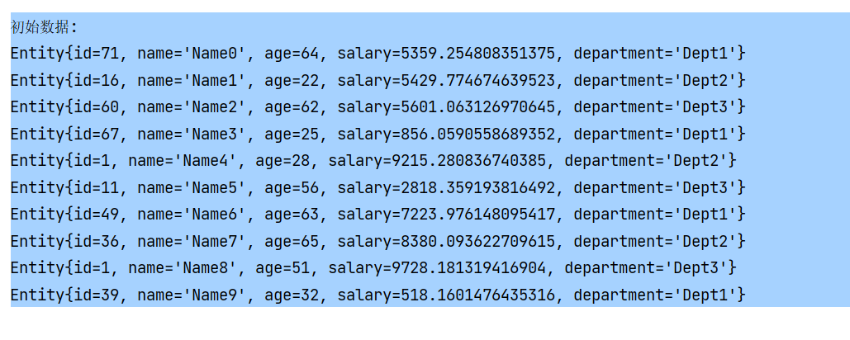

③要包括查找成功和查找失败的情况，程序运行截图粘到此处
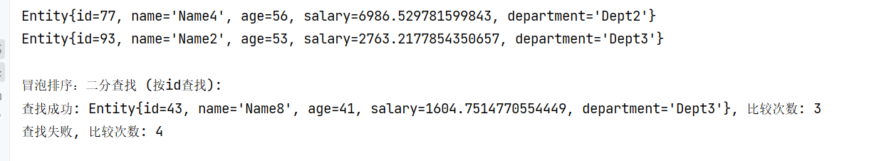

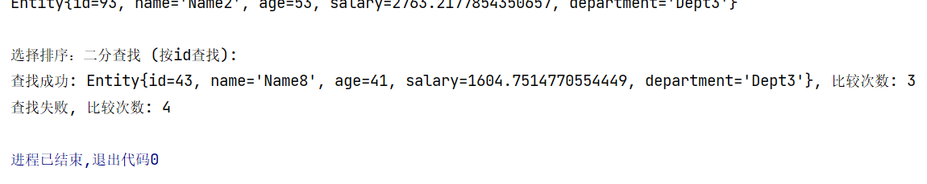

2. 排序
利用讲过的8个排序算法选择其中2个将所有对象按关键字值从小到大排序
①2个算法的代码实现，排序程序粘到此处

// 冒泡排序
public static void bubbleSort(List<Entity> entities) {
int n = entities.size();
for (int i = 0; i < n - 1; i++) {
for (int j = 0; j < n - i - 1; j++) {
if (entities.get(j).getId() > entities.get(j + 1).getId()) {
Collections.swap(entities, j, j + 1);
}
}
System.out.println("第" + (i + 1) + "趟排序结果: ");
printEntities(entities);
}
}

// 直接选择排序
public static void selectionSort(List<Entity> entities) {
int n = entities.size();
for (int i = 0; i < n - 1; i++) {
int minIndex = i;
for (int j = i + 1; j < n; j++) {
if (entities.get(j).getId() < entities.get(minIndex).getId()) {
minIndex = j;
}
}
Collections.swap(entities, i, minIndex);
System.out.println("第" + (i + 1) + "趟排序结果: ");
printEntities(entities);
}
}

②分别写出2个排序算法的名称及每个算法的每一趟排序过程(包括排序前的关键字序列) ，程序运行截图粘到此处

冒泡排序 (按主关键字id从小到大排序):
第1趟排序结果:
Entity{id=5, name='Name1', age=49, salary=5768.668964041741, department='Dept2'}
Entity{id=17, name='Name0', age=30, salary=1396.3866312296736, department='Dept1'}
Entity{id=17, name='Name3', age=31, salary=5113.109468352661, department='Dept1'}
Entity{id=77, name='Name4', age=56, salary=6986.529781599843, department='Dept2'}
Entity{id=27, name='Name5', age=33, salary=7970.360261636724, department='Dept3'}
Entity{id=46, name='Name6', age=69, salary=827.5766810809627, department='Dept1'}
Entity{id=18, name='Name7', age=41, salary=7581.432637577887, department='Dept2'}
Entity{id=43, name='Name8', age=41, salary=1604.7514770554449, department='Dept3'}
Entity{id=53, name='Name9', age=28, salary=4873.091008149911, department='Dept1'}
Entity{id=93, name='Name2', age=53, salary=2763.2177854350657, department='Dept3'}
第2趟排序结果:
Entity{id=5, name='Name1', age=49, salary=5768.668964041741, department='Dept2'}
Entity{id=17, name='Name0', age=30, salary=1396.3866312296736, department='Dept1'}
Entity{id=17, name='Name3', age=31, salary=5113.109468352661, department='Dept1'}
Entity{id=27, name='Name5', age=33, salary=7970.360261636724, department='Dept3'}
Entity{id=46, name='Name6', age=69, salary=827.5766810809627, department='Dept1'}
Entity{id=18, name='Name7', age=41, salary=7581.432637577887, department='Dept2'}
Entity{id=43, name='Name8', age=41, salary=1604.7514770554449, department='Dept3'}
Entity{id=53, name='Name9', age=28, salary=4873.091008149911, department='Dept1'}
Entity{id=77, name='Name4', age=56, salary=6986.529781599843, department='Dept2'}
Entity{id=93, name='Name2', age=53, salary=2763.2177854350657, department='Dept3'}
第3趟排序结果:
Entity{id=5, name='Name1', age=49, salary=5768.668964041741, department='Dept2'}
Entity{id=17, name='Name0', age=30, salary=1396.3866312296736, department='Dept1'}
Entity{id=17, name='Name3', age=31, salary=5113.109468352661, department='Dept1'}
Entity{id=27, name='Name5', age=33, salary=7970.360261636724, department='Dept3'}
Entity{id=18, name='Name7', age=41, salary=7581.432637577887, department='Dept2'}
Entity{id=43, name='Name8', age=41, salary=1604.7514770554449, department='Dept3'}
Entity{id=46, name='Name6', age=69, salary=827.5766810809627, department='Dept1'}
Entity{id=53, name='Name9', age=28, salary=4873.091008149911, department='Dept1'}
Entity{id=77, name='Name4', age=56, salary=6986.529781599843, department='Dept2'}
Entity{id=93, name='Name2', age=53, salary=2763.2177854350657, department='Dept3'}
第4趟排序结果:
Entity{id=5, name='Name1', age=49, salary=5768.668964041741, department='Dept2'}
Entity{id=17, name='Name0', age=30, salary=1396.3866312296736, department='Dept1'}
Entity{id=17, name='Name3', age=31, salary=5113.109468352661, department='Dept1'}
Entity{id=18, name='Name7', age=41, salary=7581.432637577887, department='Dept2'}
Entity{id=27, name='Name5', age=33, salary=7970.360261636724, department='Dept3'}
Entity{id=43, name='Name8', age=41, salary=1604.7514770554449, department='Dept3'}
Entity{id=46, name='Name6', age=69, salary=827.5766810809627, department='Dept1'}
Entity{id=53, name='Name9', age=28, salary=4873.091008149911, department='Dept1'}
Entity{id=77, name='Name4', age=56, salary=6986.529781599843, department='Dept2'}
Entity{id=93, name='Name2', age=53, salary=2763.2177854350657, department='Dept3'}
第5趟排序结果:
Entity{id=5, name='Name1', age=49, salary=5768.668964041741, department='Dept2'}
Entity{id=17, name='Name0', age=30, salary=1396.3866312296736, department='Dept1'}
Entity{id=17, name='Name3', age=31, salary=5113.109468352661, department='Dept1'}
Entity{id=18, name='Name7', age=41, salary=7581.432637577887, department='Dept2'}
Entity{id=27, name='Name5', age=33, salary=7970.360261636724, department='Dept3'}
Entity{id=43, name='Name8', age=41, salary=1604.7514770554449, department='Dept3'}
Entity{id=46, name='Name6', age=69, salary=827.5766810809627, department='Dept1'}
Entity{id=53, name='Name9', age=28, salary=4873.091008149911, department='Dept1'}
Entity{id=77, name='Name4', age=56, salary=6986.529781599843, department='Dept2'}
Entity{id=93, name='Name2', age=53, salary=2763.2177854350657, department='Dept3'}
第6趟排序结果:
Entity{id=5, name='Name1', age=49, salary=5768.668964041741, department='Dept2'}
Entity{id=17, name='Name0', age=30, salary=1396.3866312296736, department='Dept1'}
Entity{id=17, name='Name3', age=31, salary=5113.109468352661, department='Dept1'}
Entity{id=18, name='Name7', age=41, salary=7581.432637577887, department='Dept2'}
Entity{id=27, name='Name5', age=33, salary=7970.360261636724, department='Dept3'}
Entity{id=43, name='Name8', age=41, salary=1604.7514770554449, department='Dept3'}
Entity{id=46, name='Name6', age=69, salary=827.5766810809627, department='Dept1'}
Entity{id=53, name='Name9', age=28, salary=4873.091008149911, department='Dept1'}
Entity{id=77, name='Name4', age=56, salary=6986.529781599843, department='Dept2'}
Entity{id=93, name='Name2', age=53, salary=2763.2177854350657, department='Dept3'}
第7趟排序结果:
Entity{id=5, name='Name1', age=49, salary=5768.668964041741, department='Dept2'}
Entity{id=17, name='Name0', age=30, salary=1396.3866312296736, department='Dept1'}
Entity{id=17, name='Name3', age=31, salary=5113.109468352661, department='Dept1'}
Entity{id=18, name='Name7', age=41, salary=7581.432637577887, department='Dept2'}
Entity{id=27, name='Name5', age=33, salary=7970.360261636724, department='Dept3'}
Entity{id=43, name='Name8', age=41, salary=1604.7514770554449, department='Dept3'}
Entity{id=46, name='Name6', age=69, salary=827.5766810809627, department='Dept1'}
Entity{id=53, name='Name9', age=28, salary=4873.091008149911, department='Dept1'}
Entity{id=77, name='Name4', age=56, salary=6986.529781599843, department='Dept2'}
Entity{id=93, name='Name2', age=53, salary=2763.2177854350657, department='Dept3'}
第8趟排序结果:
Entity{id=5, name='Name1', age=49, salary=5768.668964041741, department='Dept2'}
Entity{id=17, name='Name0', age=30, salary=1396.3866312296736, department='Dept1'}
Entity{id=17, name='Name3', age=31, salary=5113.109468352661, department='Dept1'}
Entity{id=18, name='Name7', age=41, salary=7581.432637577887, department='Dept2'}
Entity{id=27, name='Name5', age=33, salary=7970.360261636724, department='Dept3'}
Entity{id=43, name='Name8', age=41, salary=1604.7514770554449, department='Dept3'}
Entity{id=46, name='Name6', age=69, salary=827.5766810809627, department='Dept1'}
Entity{id=53, name='Name9', age=28, salary=4873.091008149911, department='Dept1'}
Entity{id=77, name='Name4', age=56, salary=6986.529781599843, department='Dept2'}
Entity{id=93, name='Name2', age=53, salary=2763.2177854350657, department='Dept3'}
第9趟排序结果:
Entity{id=5, name='Name1', age=49, salary=5768.668964041741, department='Dept2'}
Entity{id=17, name='Name0', age=30, salary=1396.3866312296736, department='Dept1'}
Entity{id=17, name='Name3', age=31, salary=5113.109468352661, department='Dept1'}
Entity{id=18, name='Name7', age=41, salary=7581.432637577887, department='Dept2'}
Entity{id=27, name='Name5', age=33, salary=7970.360261636724, department='Dept3'}
Entity{id=43, name='Name8', age=41, salary=1604.7514770554449, department='Dept3'}
Entity{id=46, name='Name6', age=69, salary=827.5766810809627, department='Dept1'}
Entity{id=53, name='Name9', age=28, salary=4873.091008149911, department='Dept1'}
Entity{id=77, name='Name4', age=56, salary=6986.529781599843, department='Dept2'}
Entity{id=93, name='Name2', age=53, salary=2763.2177854350657, department='Dept3'}

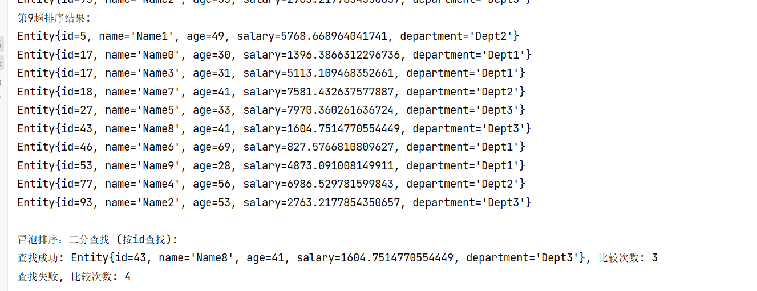
直接选择排序 (按主关键字id从小到大排序):
第1趟排序结果:
Entity{id=5, name='Name1', age=49, salary=5768.668964041741, department='Dept2'}
Entity{id=17, name='Name0', age=30, salary=1396.3866312296736, department='Dept1'}
Entity{id=17, name='Name3', age=31, salary=5113.109468352661, department='Dept1'}
Entity{id=18, name='Name7', age=41, salary=7581.432637577887, department='Dept2'}
Entity{id=27, name='Name5', age=33, salary=7970.360261636724, department='Dept3'}
Entity{id=43, name='Name8', age=41, salary=1604.7514770554449, department='Dept3'}
Entity{id=46, name='Name6', age=69, salary=827.5766810809627, department='Dept1'}
Entity{id=53, name='Name9', age=28, salary=4873.091008149911, department='Dept1'}
Entity{id=77, name='Name4', age=56, salary=6986.529781599843, department='Dept2'}
Entity{id=93, name='Name2', age=53, salary=2763.2177854350657, department='Dept3'}
第2趟排序结果:
Entity{id=5, name='Name1', age=49, salary=5768.668964041741, department='Dept2'}
Entity{id=17, name='Name0', age=30, salary=1396.3866312296736, department='Dept1'}
Entity{id=17, name='Name3', age=31, salary=5113.109468352661, department='Dept1'}
Entity{id=18, name='Name7', age=41, salary=7581.432637577887, department='Dept2'}
Entity{id=27, name='Name5', age=33, salary=7970.360261636724, department='Dept3'}
Entity{id=43, name='Name8', age=41, salary=1604.7514770554449, department='Dept3'}
Entity{id=46, name='Name6', age=69, salary=827.5766810809627, department='Dept1'}
Entity{id=53, name='Name9', age=28, salary=4873.091008149911, department='Dept1'}
Entity{id=77, name='Name4', age=56, salary=6986.529781599843, department='Dept2'}
Entity{id=93, name='Name2', age=53, salary=2763.2177854350657, department='Dept3'}
第3趟排序结果:
Entity{id=5, name='Name1', age=49, salary=5768.668964041741, department='Dept2'}
Entity{id=17, name='Name0', age=30, salary=1396.3866312296736, department='Dept1'}
Entity{id=17, name='Name3', age=31, salary=5113.109468352661, department='Dept1'}
Entity{id=18, name='Name7', age=41, salary=7581.432637577887, department='Dept2'}
Entity{id=27, name='Name5', age=33, salary=7970.360261636724, department='Dept3'}
Entity{id=43, name='Name8', age=41, salary=1604.7514770554449, department='Dept3'}
Entity{id=46, name='Name6', age=69, salary=827.5766810809627, department='Dept1'}
Entity{id=53, name='Name9', age=28, salary=4873.091008149911, department='Dept1'}
Entity{id=77, name='Name4', age=56, salary=6986.529781599843, department='Dept2'}
Entity{id=93, name='Name2', age=53, salary=2763.2177854350657, department='Dept3'}
第4趟排序结果:
Entity{id=5, name='Name1', age=49, salary=5768.668964041741, department='Dept2'}
Entity{id=17, name='Name0', age=30, salary=1396.3866312296736, department='Dept1'}
Entity{id=17, name='Name3', age=31, salary=5113.109468352661, department='Dept1'}
Entity{id=18, name='Name7', age=41, salary=7581.432637577887, department='Dept2'}
Entity{id=27, name='Name5', age=33, salary=7970.360261636724, department='Dept3'}
Entity{id=43, name='Name8', age=41, salary=1604.7514770554449, department='Dept3'}
Entity{id=46, name='Name6', age=69, salary=827.5766810809627, department='Dept1'}
Entity{id=53, name='Name9', age=28, salary=4873.091008149911, department='Dept1'}
Entity{id=77, name='Name4', age=56, salary=6986.529781599843, department='Dept2'}
Entity{id=93, name='Name2', age=53, salary=2763.2177854350657, department='Dept3'}
第5趟排序结果:
Entity{id=5, name='Name1', age=49, salary=5768.668964041741, department='Dept2'}
Entity{id=17, name='Name0', age=30, salary=1396.3866312296736, department='Dept1'}
Entity{id=17, name='Name3', age=31, salary=5113.109468352661, department='Dept1'}
Entity{id=18, name='Name7', age=41, salary=7581.432637577887, department='Dept2'}
Entity{id=27, name='Name5', age=33, salary=7970.360261636724, department='Dept3'}
Entity{id=43, name='Name8', age=41, salary=1604.7514770554449, department='Dept3'}
Entity{id=46, name='Name6', age=69, salary=827.5766810809627, department='Dept1'}
Entity{id=53, name='Name9', age=28, salary=4873.091008149911, department='Dept1'}
Entity{id=77, name='Name4', age=56, salary=6986.529781599843, department='Dept2'}
Entity{id=93, name='Name2', age=53, salary=2763.2177854350657, department='Dept3'}
第6趟排序结果:
Entity{id=5, name='Name1', age=49, salary=5768.668964041741, department='Dept2'}
Entity{id=17, name='Name0', age=30, salary=1396.3866312296736, department='Dept1'}
Entity{id=17, name='Name3', age=31, salary=5113.109468352661, department='Dept1'}
Entity{id=18, name='Name7', age=41, salary=7581.432637577887, department='Dept2'}
Entity{id=27, name='Name5', age=33, salary=7970.360261636724, department='Dept3'}
Entity{id=43, name='Name8', age=41, salary=1604.7514770554449, department='Dept3'}
Entity{id=46, name='Name6', age=69, salary=827.5766810809627, department='Dept1'}
Entity{id=53, name='Name9', age=28, salary=4873.091008149911, department='Dept1'}
Entity{id=77, name='Name4', age=56, salary=6986.529781599843, department='Dept2'}
Entity{id=93, name='Name2', age=53, salary=2763.2177854350657, department='Dept3'}
第7趟排序结果:
Entity{id=5, name='Name1', age=49, salary=5768.668964041741, department='Dept2'}
Entity{id=17, name='Name0', age=30, salary=1396.3866312296736, department='Dept1'}
Entity{id=17, name='Name3', age=31, salary=5113.109468352661, department='Dept1'}
Entity{id=18, name='Name7', age=41, salary=7581.432637577887, department='Dept2'}
Entity{id=27, name='Name5', age=33, salary=7970.360261636724, department='Dept3'}
Entity{id=43, name='Name8', age=41, salary=1604.7514770554449, department='Dept3'}
Entity{id=46, name='Name6', age=69, salary=827.5766810809627, department='Dept1'}
Entity{id=53, name='Name9', age=28, salary=4873.091008149911, department='Dept1'}
Entity{id=77, name='Name4', age=56, salary=6986.529781599843, department='Dept2'}
Entity{id=93, name='Name2', age=53, salary=2763.2177854350657, department='Dept3'}
第8趟排序结果:
Entity{id=5, name='Name1', age=49, salary=5768.668964041741, department='Dept2'}
Entity{id=17, name='Name0', age=30, salary=1396.3866312296736, department='Dept1'}
Entity{id=17, name='Name3', age=31, salary=5113.109468352661, department='Dept1'}
Entity{id=18, name='Name7', age=41, salary=7581.432637577887, department='Dept2'}
Entity{id=27, name='Name5', age=33, salary=7970.360261636724, department='Dept3'}
Entity{id=43, name='Name8', age=41, salary=1604.7514770554449, department='Dept3'}
Entity{id=46, name='Name6', age=69, salary=827.5766810809627, department='Dept1'}
Entity{id=53, name='Name9', age=28, salary=4873.091008149911, department='Dept1'}
Entity{id=77, name='Name4', age=56, salary=6986.529781599843, department='Dept2'}
Entity{id=93, name='Name2', age=53, salary=2763.2177854350657, department='Dept3'}
第9趟排序结果:
Entity{id=5, name='Name1', age=49, salary=5768.668964041741, department='Dept2'}
Entity{id=17, name='Name0', age=30, salary=1396.3866312296736, department='Dept1'}
Entity{id=17, name='Name3', age=31, salary=5113.109468352661, department='Dept1'}
Entity{id=18, name='Name7', age=41, salary=7581.432637577887, department='Dept2'}
Entity{id=27, name='Name5', age=33, salary=7970.360261636724, department='Dept3'}
Entity{id=43, name='Name8', age=41, salary=1604.7514770554449, department='Dept3'}
Entity{id=46, name='Name6', age=69, salary=827.5766810809627, department='Dept1'}
Entity{id=53, name='Name9', age=28, salary=4873.091008149911, department='Dept1'}
Entity{id=77, name='Name4', age=56, salary=6986.529781599843, department='Dept2'}
Entity{id=93, name='Name2', age=53, salary=2763.2177854350657, department='Dept3'}

