《 数据结构IV 》
三级项目报告（终结性）
姓 名： |  | 学 号：
项目
名称

1. 查找
①给出查找代码，查找程序粘到此处
// 二分查找
public static void binarySearch(List<Product> products, int key) {
int left = 0, right = products.size() - 1;
int comparisons = 0;
while (left <= right) {
int mid = left + (right - left) / 2;
comparisons++;
if (products.get(mid).getProductId() == key) {
System.out.println("查找成功: " + products.get(mid) + ", 比较次数: " + comparisons);
return;
} else if (products.get(mid).getProductId() < key) {
left = mid + 1;
} else {
right = mid - 1;
}
}
System.out.println("查找失败, 比较次数: " + comparisons);
}

②写出每次比较对象(包括查找前的关键字序列)，程序运行截图粘到此处
初始数据:
Product{productId=12, productName='Product0', price=209.49779294551251, stock=30, category='Category1'}
Product{productId=91, productName='Product1', price=717.8887336044988, stock=435, category='Category2'}
Product{productId=38, productName='Product2', price=698.5078102997684, stock=330, category='Category3'}
Product{productId=47, productName='Product3', price=546.7268552162074, stock=288, category='Category1'}
Product{productId=64, productName='Product4', price=447.1931240127397, stock=115, category='Category2'}
Product{productId=91, productName='Product5', price=536.1137885525749, stock=342, category='Category3'}
Product{productId=42, productName='Product6', price=249.80618391054864, stock=369, category='Category1'}
Product{productId=53, productName='Product7', price=427.5910758868431, stock=15, category='Category2'}
Product{productId=69, productName='Product8', price=154.4073810038291, stock=378, category='Category3'}
Product{productId=31, productName='Product9', price=187.29560503024078, stock=24, category='Category1'}
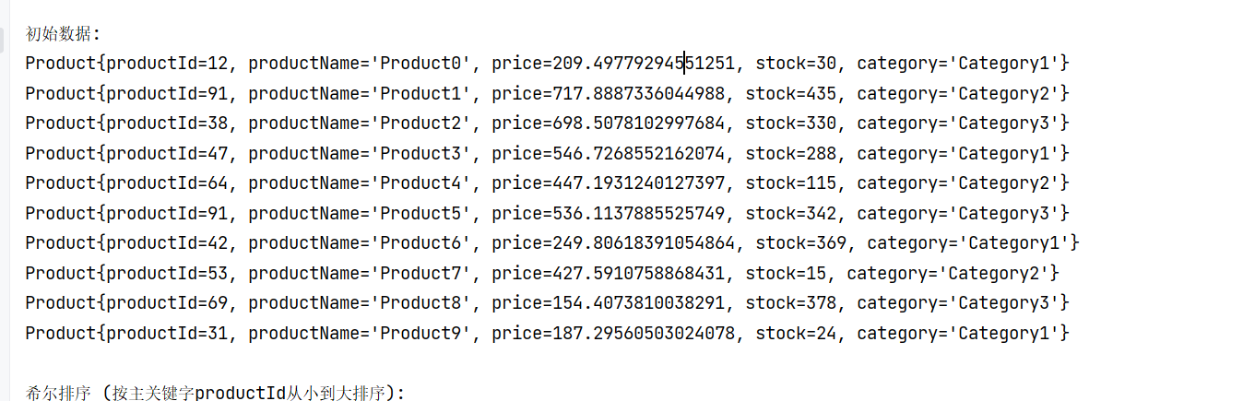

③要包括查找成功和查找失败的情况，程序运行截图粘到此处
1、
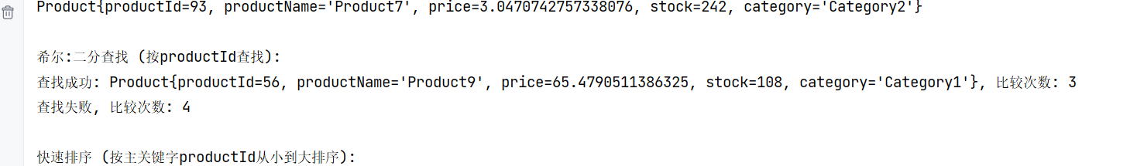
2、
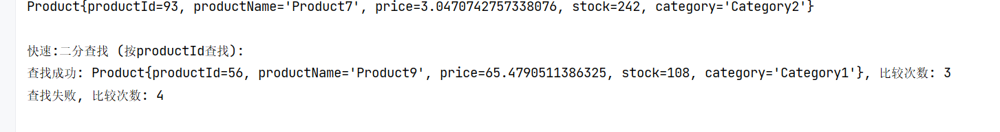

2. 排序
利用讲过的8个排序算法选择其中2个将所有对象按关键字值从小到大排序
①2个算法的代码实现，排序程序粘到此处

// 希尔排序
public static void shellSort(List<Product> products) {
int n = products.size();
for (int gap = n / 2; gap > 0; gap /= 2) {
for (int i = gap; i < n; i++) {
Product temp = products.get(i);
int j;
for (j = i; j >= gap && products.get(j - gap).getProductId() > temp.getProductId(); j -= gap) {
products.set(j, products.get(j - gap));
}
products.set(j, temp);
}
System.out.println("当前间隔" + gap + "排序结果:");
printProducts(products);
}
}

// 快速排序
public static void quickSort(List<Product> products, int low, int high) {
if (low < high) {
int pi = partition(products, low, high);
quickSort(products, low, pi - 1);
quickSort(products, pi + 1, high);
}
}

②分别写出2个排序算法的名称及每个算法的每一趟排序过程(包括排序前的关键字序列) ，程序运行截图粘到此处

希尔排序 (按主关键字productId从小到大排序):
当前间隔5排序结果:
Product{productId=19, productName='Product0', price=682.5666070310177, stock=76, category='Category1'}
Product{productId=57, productName='Product1', price=881.9599254638392, stock=471, category='Category2'}
Product{productId=83, productName='Product2', price=414.2658461709716, stock=335, category='Category3'}
Product{productId=6, productName='Product8', price=81.19047585669348, stock=307, category='Category3'}
Product{productId=51, productName='Product4', price=53.76740271338632, stock=442, category='Category2'}
Product{productId=29, productName='Product5', price=945.3829183899254, stock=380, category='Category3'}
Product{productId=75, productName='Product6', price=161.54488989993254, stock=396, category='Category1'}
Product{productId=93, productName='Product7', price=3.0470742757338076, stock=242, category='Category2'}
Product{productId=26, productName='Product3', price=677.090715697015, stock=244, category='Category1'}
Product{productId=56, productName='Product9', price=65.4790511386325, stock=108, category='Category1'}
当前间隔2排序结果:
Product{productId=19, productName='Product0', price=682.5666070310177, stock=76, category='Category1'}
Product{productId=6, productName='Product8', price=81.19047585669348, stock=307, category='Category3'}
Product{productId=26, productName='Product3', price=677.090715697015, stock=244, category='Category1'}
Product{productId=29, productName='Product5', price=945.3829183899254, stock=380, category='Category3'}
Product{productId=51, productName='Product4', price=53.76740271338632, stock=442, category='Category2'}
Product{productId=56, productName='Product9', price=65.4790511386325, stock=108, category='Category1'}
Product{productId=75, productName='Product6', price=161.54488989993254, stock=396, category='Category1'}
Product{productId=57, productName='Product1', price=881.9599254638392, stock=471, category='Category2'}
Product{productId=83, productName='Product2', price=414.2658461709716, stock=335, category='Category3'}
Product{productId=93, productName='Product7', price=3.0470742757338076, stock=242, category='Category2'}
当前间隔1排序结果:
Product{productId=6, productName='Product8', price=81.19047585669348, stock=307, category='Category3'}
Product{productId=19, productName='Product0', price=682.5666070310177, stock=76, category='Category1'}
Product{productId=26, productName='Product3', price=677.090715697015, stock=244, category='Category1'}
Product{productId=29, productName='Product5', price=945.3829183899254, stock=380, category='Category3'}
Product{productId=51, productName='Product4', price=53.76740271338632, stock=442, category='Category2'}
Product{productId=56, productName='Product9', price=65.4790511386325, stock=108, category='Category1'}
Product{productId=57, productName='Product1', price=881.9599254638392, stock=471, category='Category2'}
Product{productId=75, productName='Product6', price=161.54488989993254, stock=396, category='Category1'}
Product{productId=83, productName='Product2', price=414.2658461709716, stock=335, category='Category3'}
Product{productId=93, productName='Product7', price=3.0470742757338076, stock=242, category='Category2'}

希尔:二分查找 (按productId查找):
查找成功: Product{productId=56, productName='Product9', price=65.4790511386325, stock=108, category='Category1'}, 比较次数: 3
查找失败, 比较次数: 4

快速排序 (按主关键字productId从小到大排序):
Product{productId=6, productName='Product8', price=81.19047585669348, stock=307, category='Category3'}
Product{productId=19, productName='Product0', price=682.5666070310177, stock=76, category='Category1'}
Product{productId=26, productName='Product3', price=677.090715697015, stock=244, category='Category1'}
Product{productId=29, productName='Product5', price=945.3829183899254, stock=380, category='Category3'}
Product{productId=51, productName='Product4', price=53.76740271338632, stock=442, category='Category2'}
Product{productId=56, productName='Product9', price=65.4790511386325, stock=108, category='Category1'}
Product{productId=57, productName='Product1', price=881.9599254638392, stock=471, category='Category2'}
Product{productId=75, productName='Product6', price=161.54488989993254, stock=396, category='Category1'}
Product{productId=83, productName='Product2', price=414.2658461709716, stock=335, category='Category3'}
Product{productId=93, productName='Product7', price=3.0470742757338076, stock=242, category='Category2'}

快速:二分查找 (按productId查找):
查找成功: Product{productId=56, productName='Product9', price=65.4790511386325, stock=108, category='Category1'}, 比较次数: 3
查找失败, 比较次数: 4

进程已结束,退出代码0

