《数据库原理》大作业

班 级：

学 号：

姓 名：

教 师：

学 期：

1数据库操作：建立数据库，删除数据库，备份数据库，还原数据库

* 删除数据库

DROP DATABASE room;

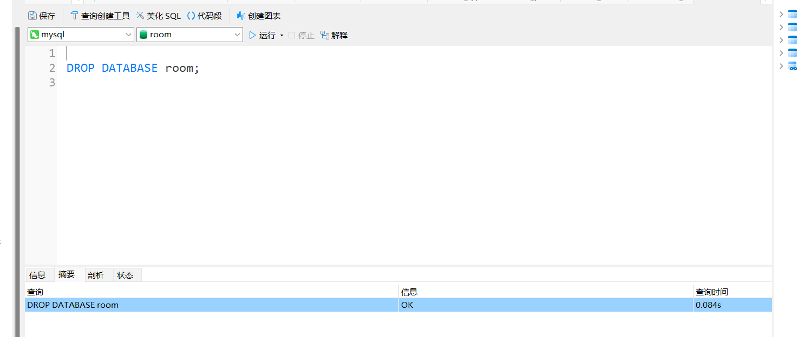

建立数据库

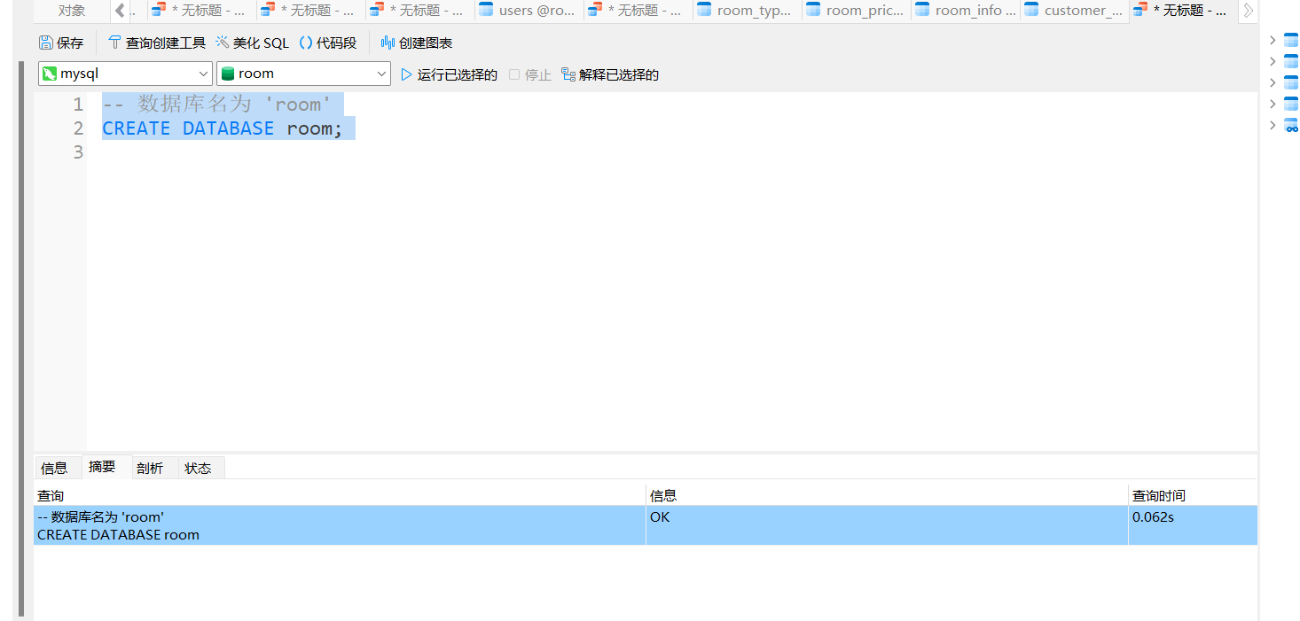

-- 备份数据库

mysqldump -u username -p room > backup.sql

--还原数据库

mysql -u username -p room < backup.sql

2 表的操作：建表，修改表，删除表，添加约束（每种约束都要添加）

-- 创建表（根据 `customer_info` 表结构）

CREATE TABLE customer_info (

customer_id INT NOT NULL,

room_id INT NOT NULL,

check_in_date DATE NOT NULL,

check_out_date DATE DEFAULT NULL,

total_cost DECIMAL(10, 2) DEFAULT NULL,

username VARCHAR(50) NOT NULL,

PRIMARY KEY (customer_id),

INDEX room_id (room_id),

CONSTRAINT customer_info_ibfk_1 FOREIGN KEY (room_id) REFERENCES room_info (room_id)

);

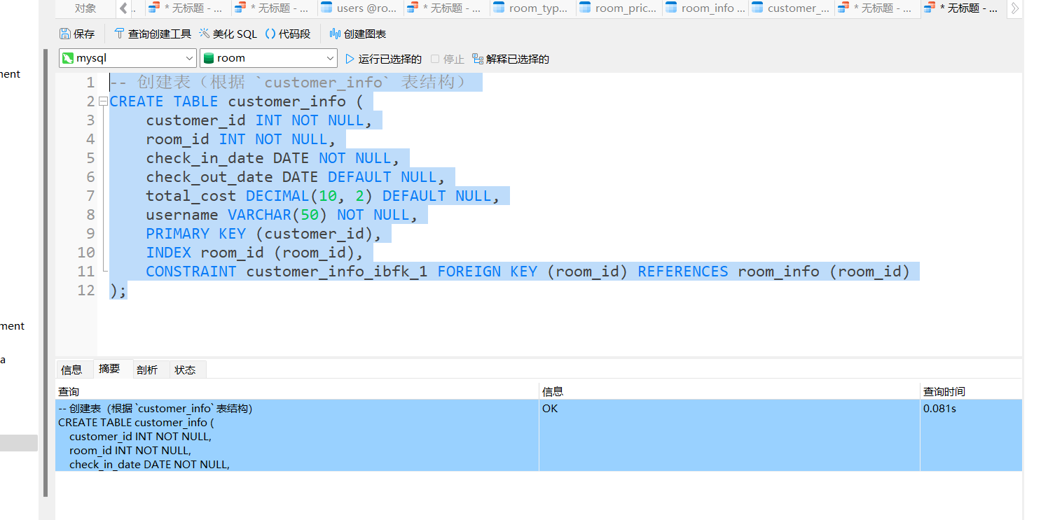

-- 修改表（添加列）

ALTER TABLE customer_info ADD phone_number VARCHAR(15);

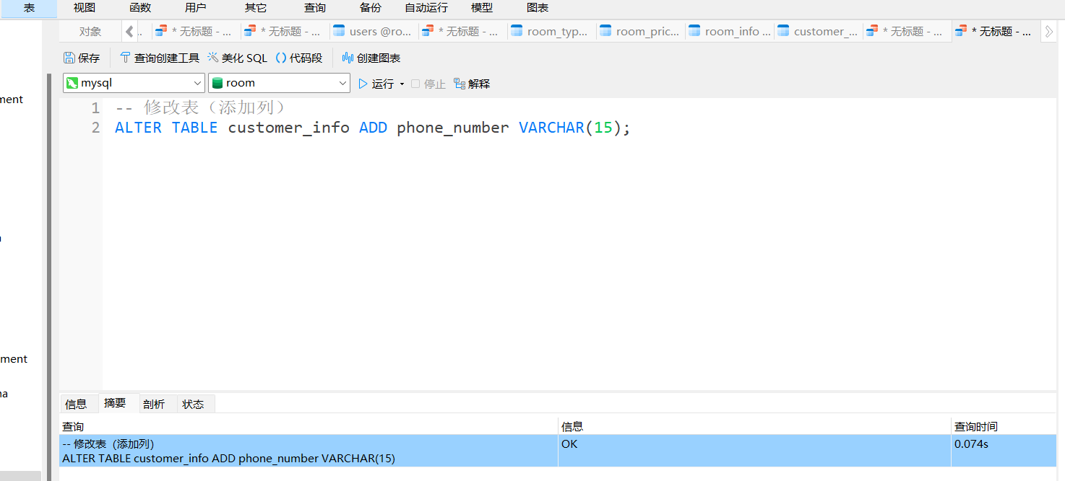

-- 添加约束示例

-- 唯一约束

ALTER TABLE customer_info ADD CONSTRAINT UQ_username UNIQUE (username); 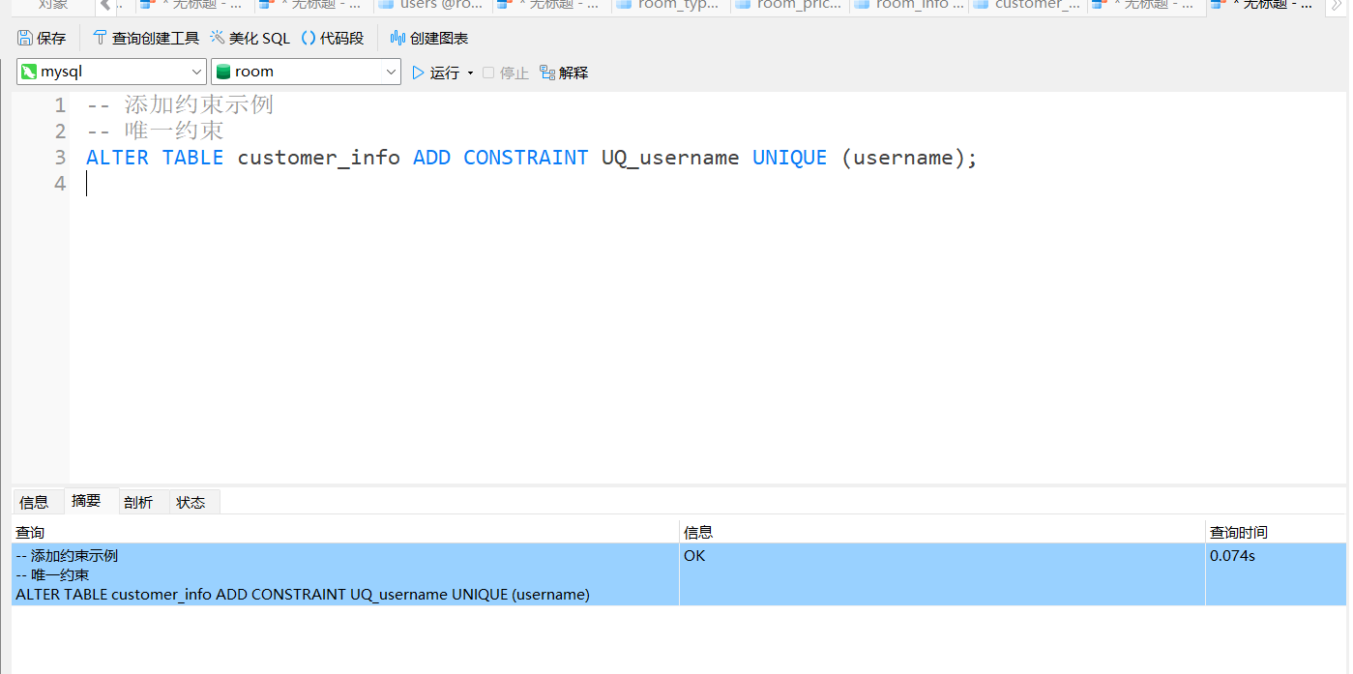

-- 检查约束（如 MySQL 不支持，可改为触发器实现） ALTER TABLE customer_info ADD CONSTRAINT CK_total_cost CHECK (total_cost >= 0);

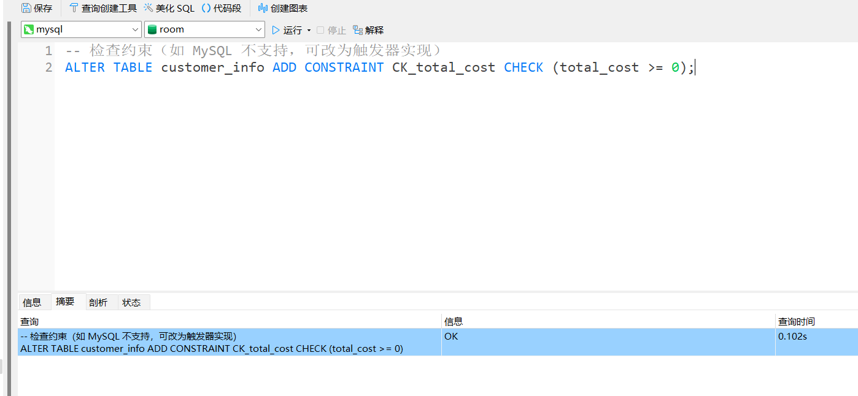

-- 删除表 DROP TABLE customer_info;

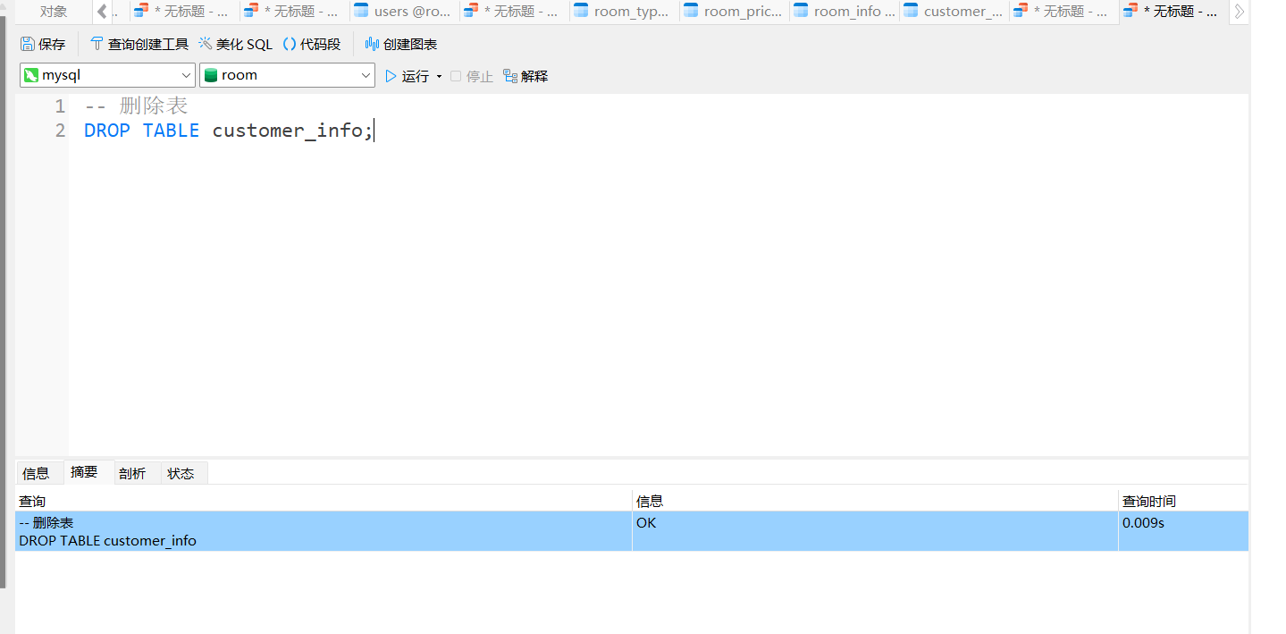

3 数据操作：插入数据，修改数据和删除数据（有条件无条件各一个）

-- 插入数据

INSERT INTO `customer_info` VALUES (1, 1, '2023-06-21', '2023-06-23', 200.00, '张三');

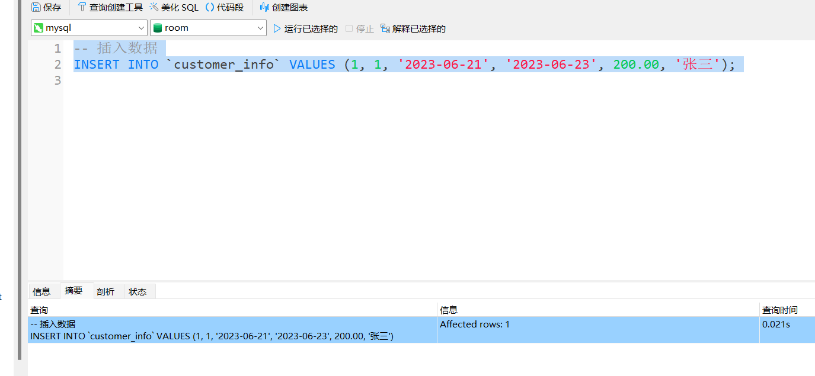

-- 修改数据（有条件） UPDATE customer_info SET total_cost = 500.00 WHERE customer_id = 1;

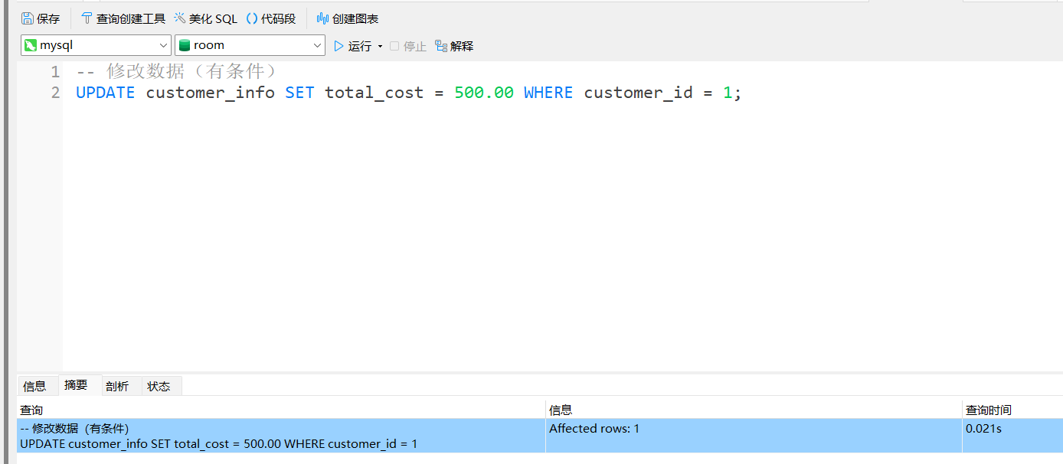

-- 修改数据（无条件） UPDATE customer_info SET total_cost = 600.00; 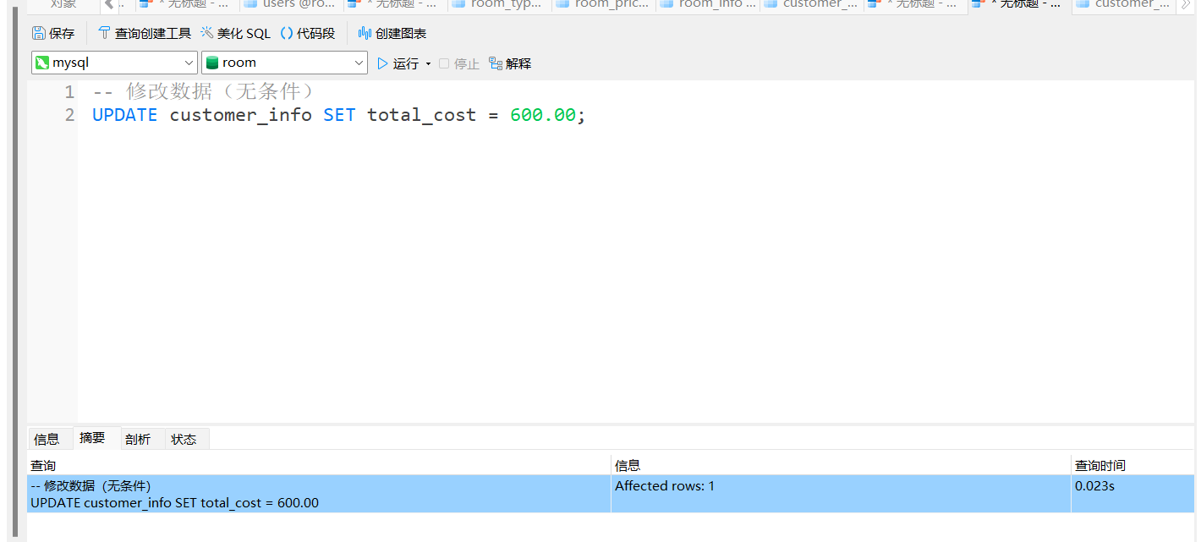-- 删除数据（有条件） DELETE FROM customer_info WHERE customer_id = 1; 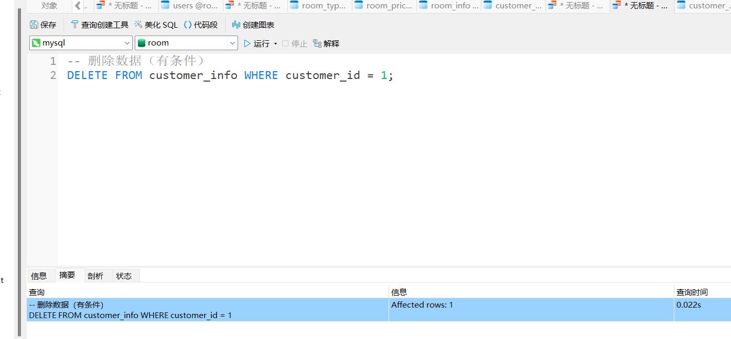-- 删除数据（无条件） DELETE FROM customer_info; 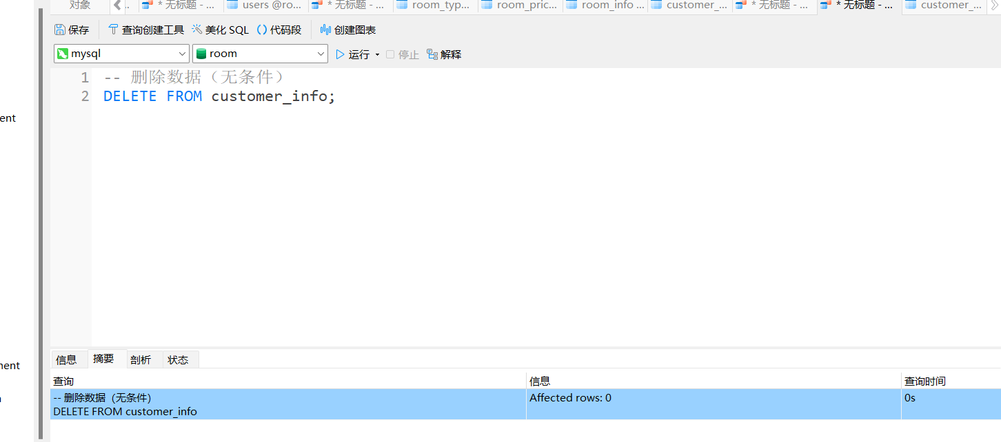

4 数据查询（1）：简单查询，条件查询（每种条件一个查询）

-- 简单查询

SELECT * FROM customer_info;

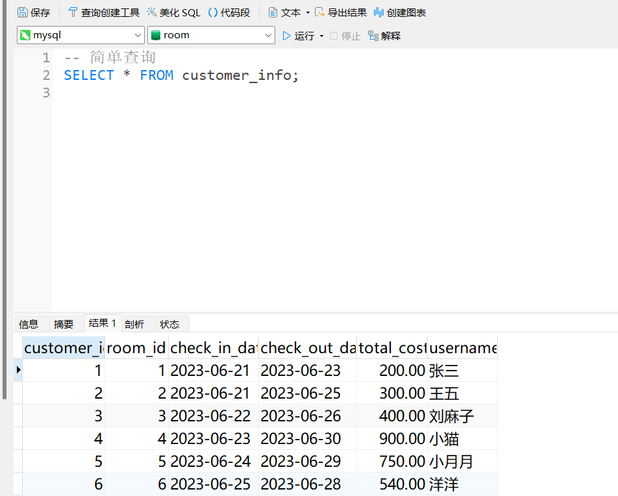

-- 条件查询

-- 比较运算符

SELECT * FROM customer_info WHERE total_cost > 100; 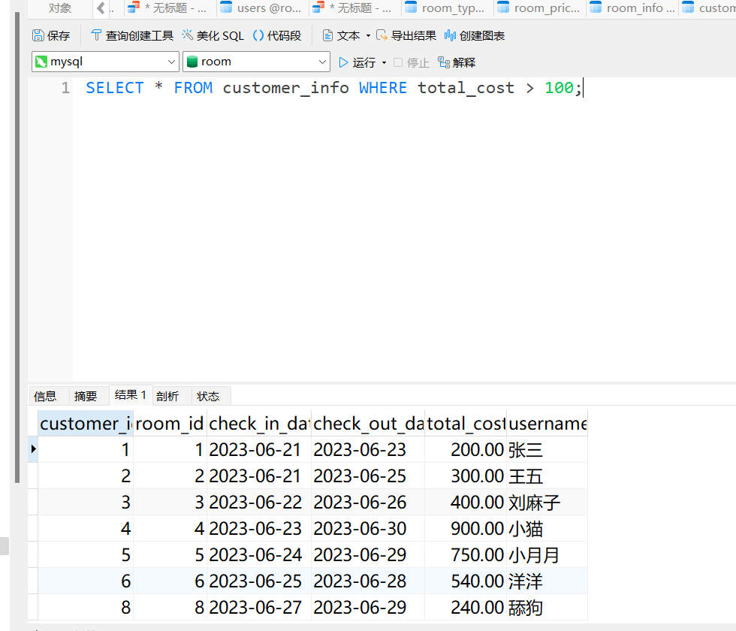

-- 逻辑运算符

SELECT * FROM customer_info WHERE total_cost > 100 AND check_out_date IS NOT NULL;

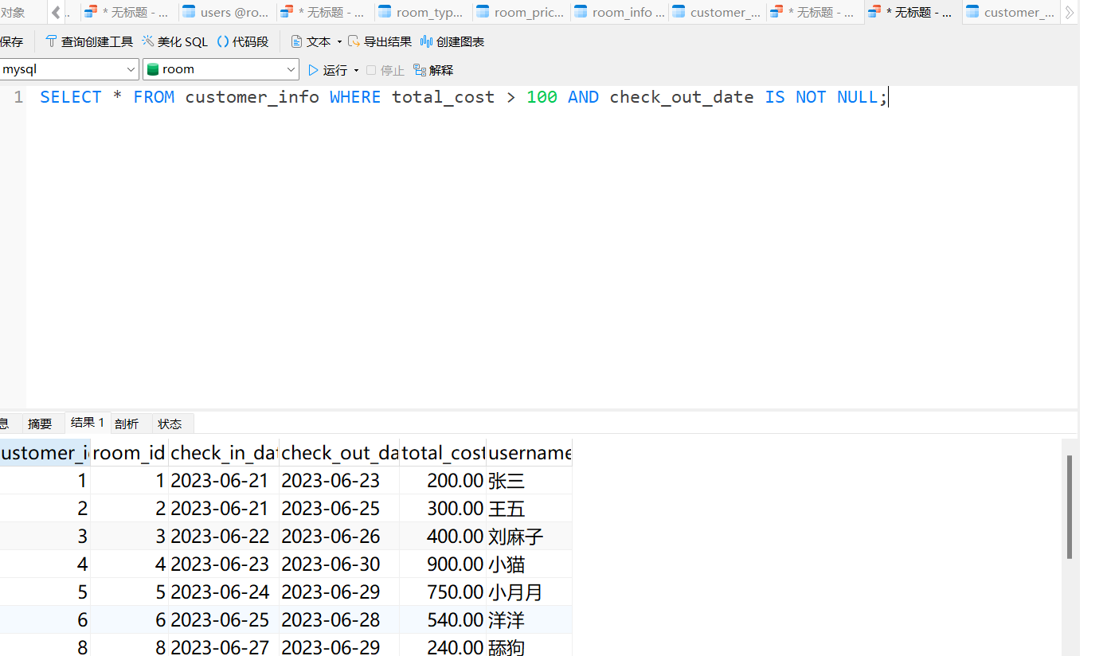

-- 模糊查询

SELECT * FROM customer_info WHERE username LIKE 'J%';

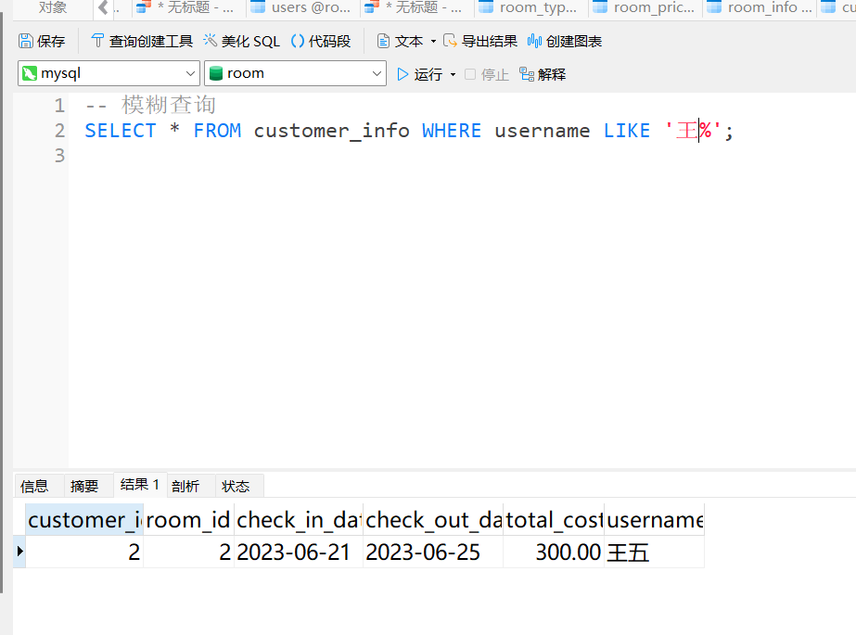

-- 空值查询

SELECT * FROM customer_info WHERE check_out_date IS NULL;

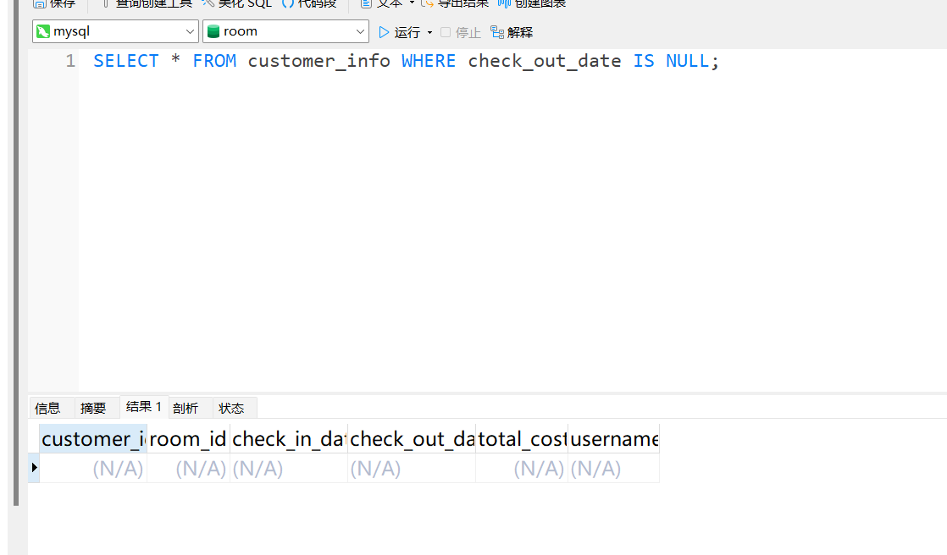

5数据查询（2）：高级查询（分组，排序，聚合函数的使用，每种至少一个），多表查询（自然连接，外连接各一个），嵌套查询（in,>any,>all 各一个）

-- 分组查询

SELECT room_id, COUNT(*) AS bookings FROM customer_info GROUP BY room_id;

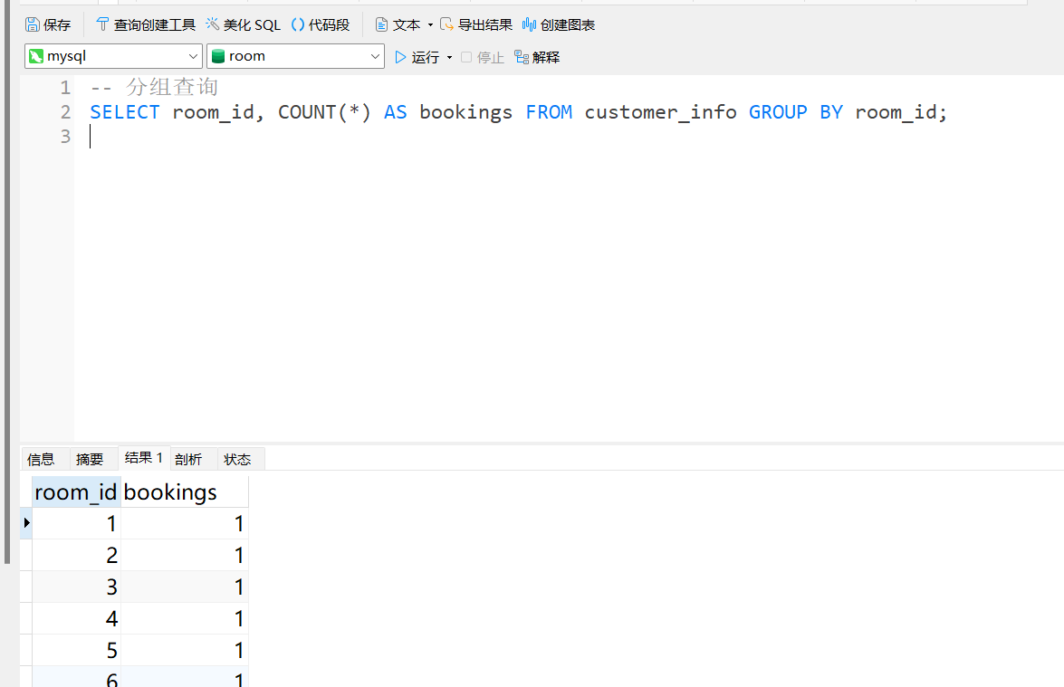

-- 排序查询

SELECT * FROM customer_info ORDER BY check_in_date ASC;

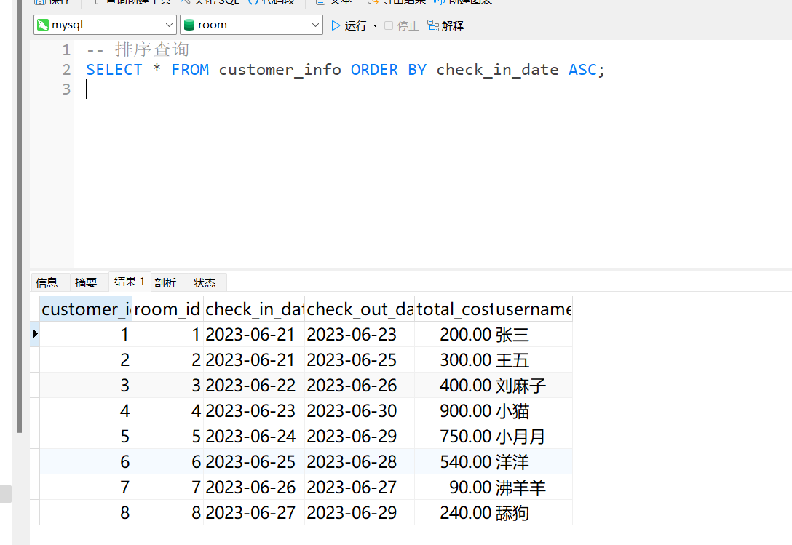

-- 聚合函数

SELECT AVG(total_cost) AS AverageCost FROM customer_info;

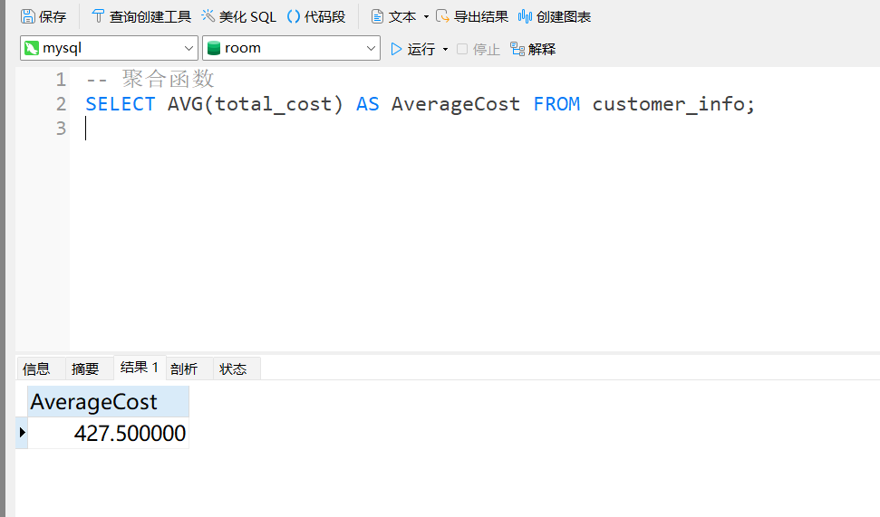

-- 自然连接

SELECT customer_info.room_id, room_info.room_id

FROM customer_info

NATURAL JOIN room_info;

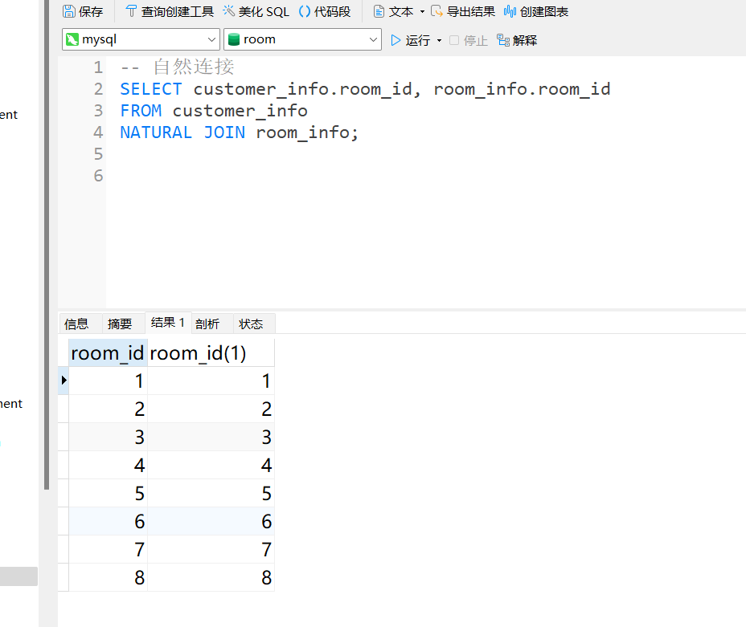s

-- 外连接

SELECT customer_info.room_id, room_info.room_id

FROM customer_info

LEFT JOIN room_info ON customer_info.room_id = room_info.room_id;

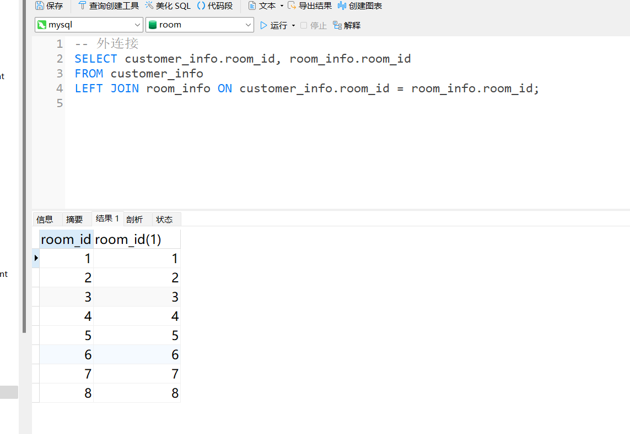

-- 嵌套查询

-- IN

SELECT * FROM customer_info WHERE room_id IN (SELECT room_id FROM room_info WHERE room_id = 1);

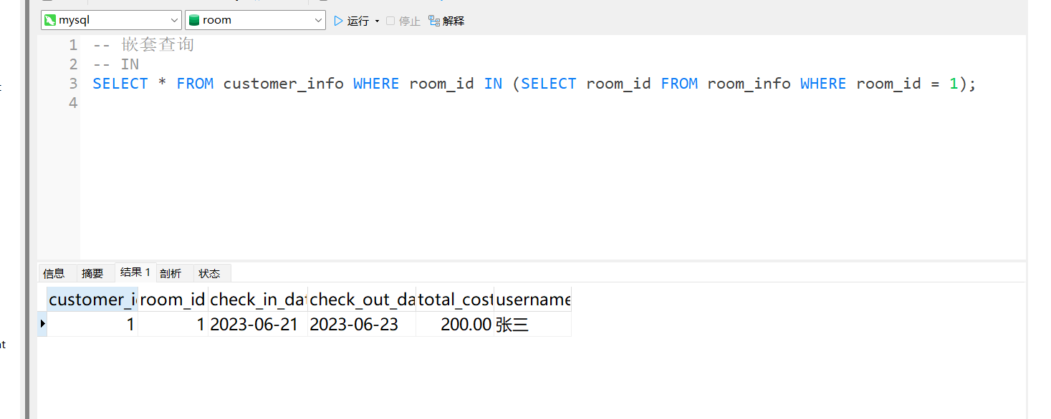

-- >ANY

SELECT * FROM customer_info WHERE total_cost > ANY (SELECT total_cost FROM customer_info WHERE total_cost < 500);

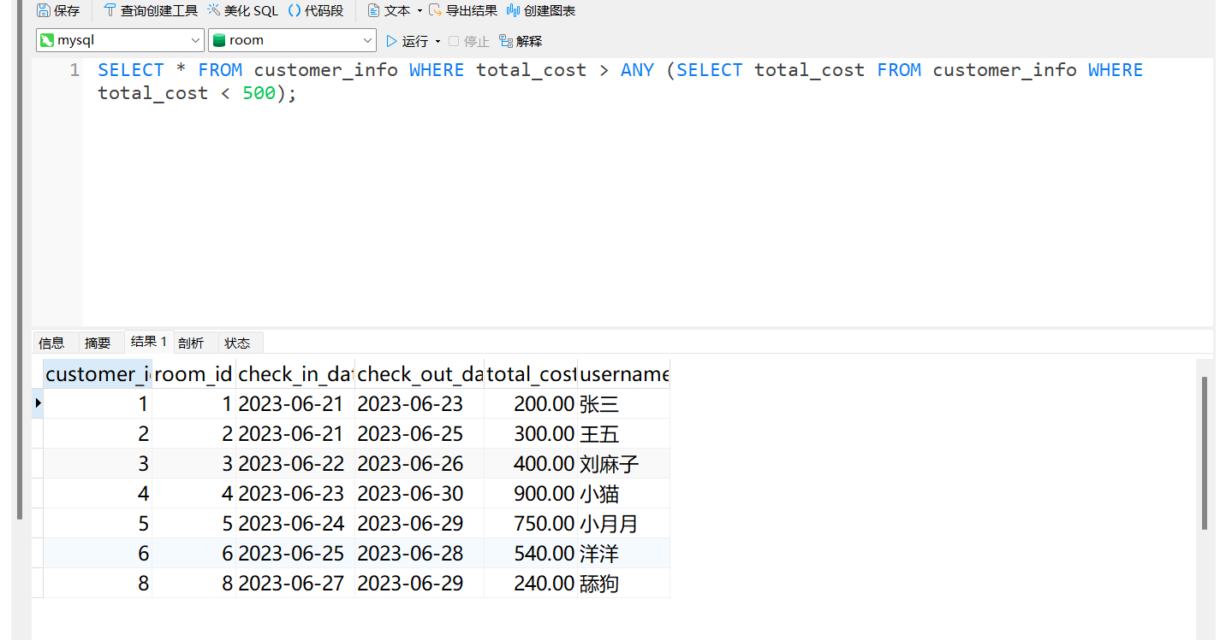

-- >ALL

SELECT * FROM customer_info WHERE total_cost > ALL (SELECT total_cost FROM customer_info WHERE total_cost < 500);

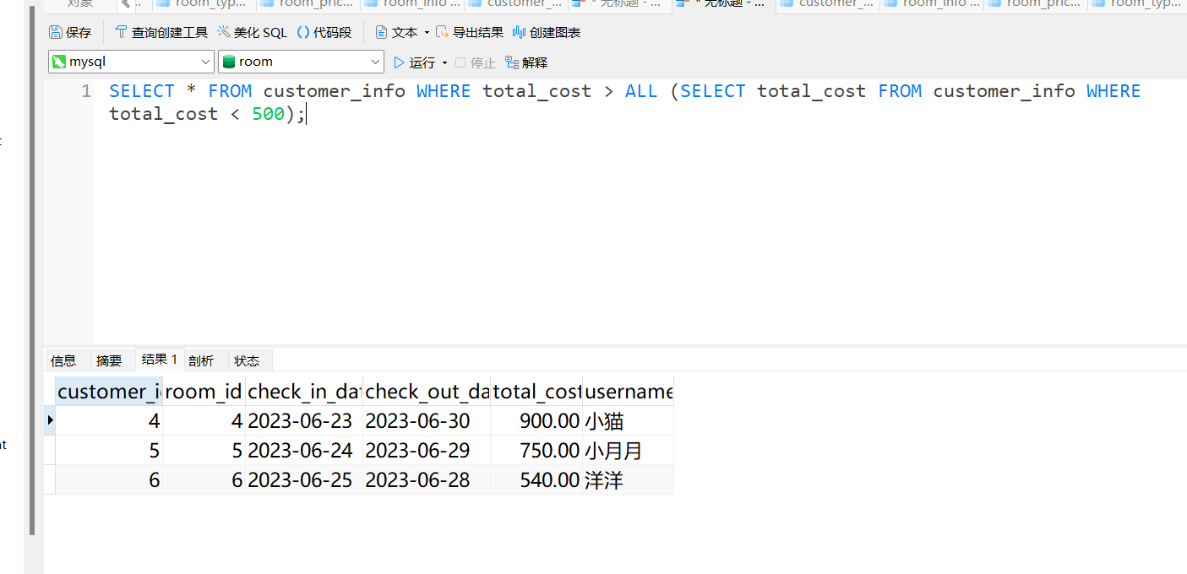

6索引操作：建立和删除索引

-- 创建索引

CREATE INDEX IDX_check_in_date ON customer_info (check_in_date);

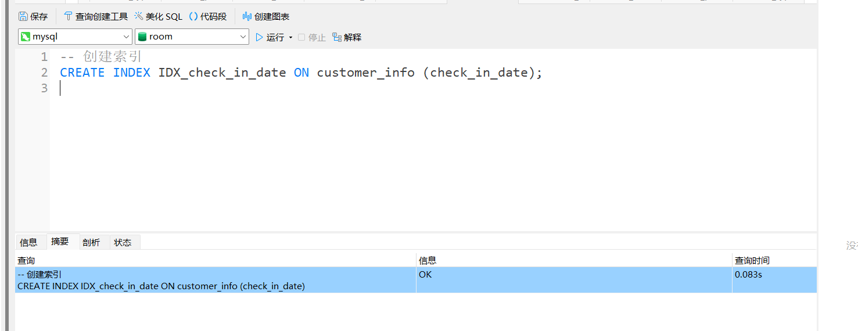

-- 删除索引

DROP INDEX IDX_check_in_date ON customer_info;

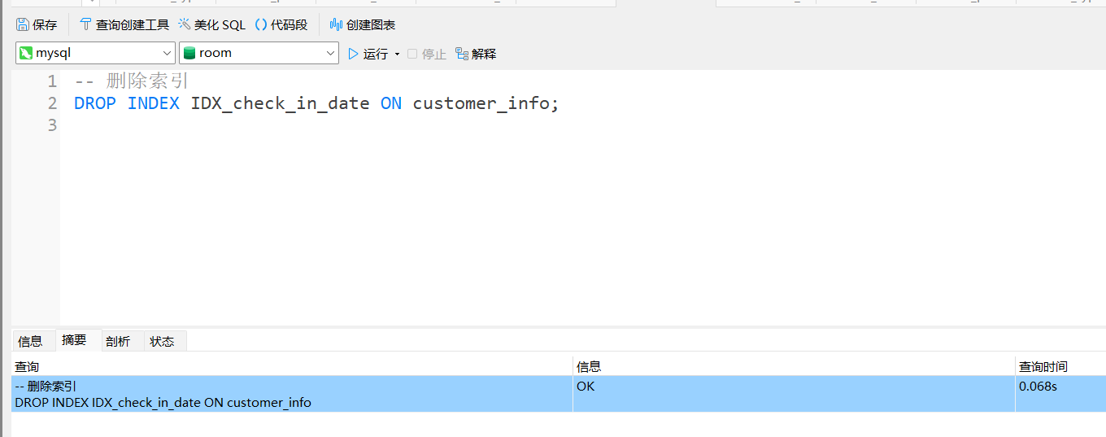

7 视图操作：视图的建立（行列子集一个，非行列子集一个），查询和删除

-- 行列子集视图

CREATE VIEW ActiveBookings AS

SELECT customer_id, room_id, check_in_date

FROM customer_info WHERE check_out_date IS NULL;

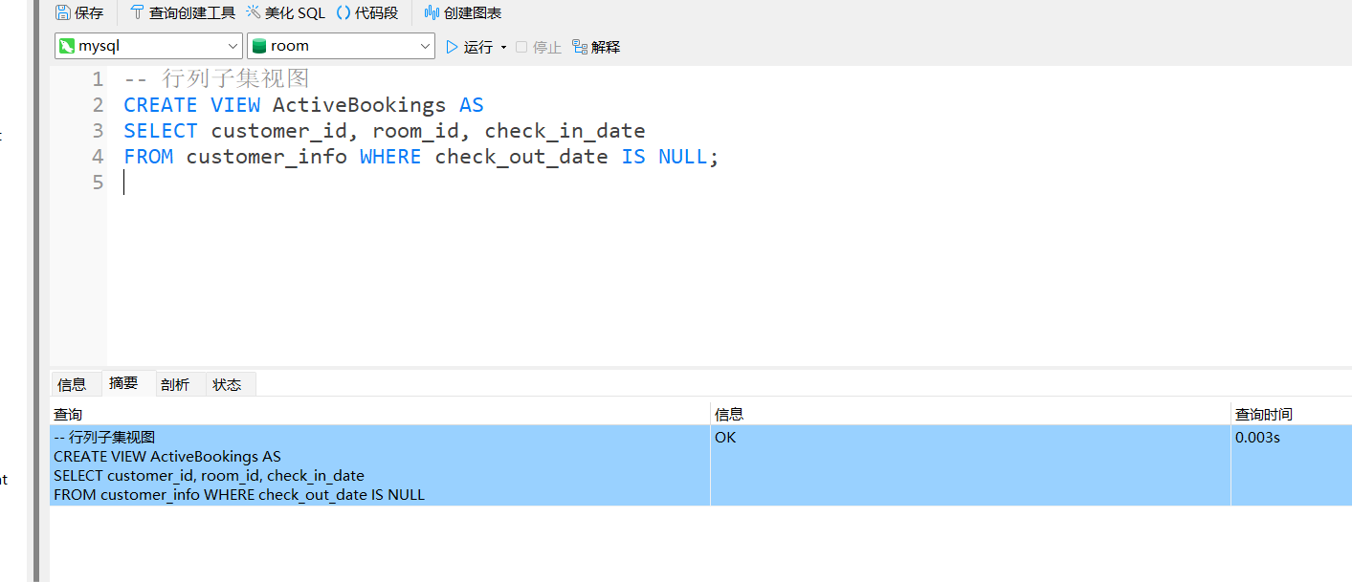

-- 非行列子集视图

CREATE VIEW FullCustomerInfo AS

SELECT * FROM customer_info;

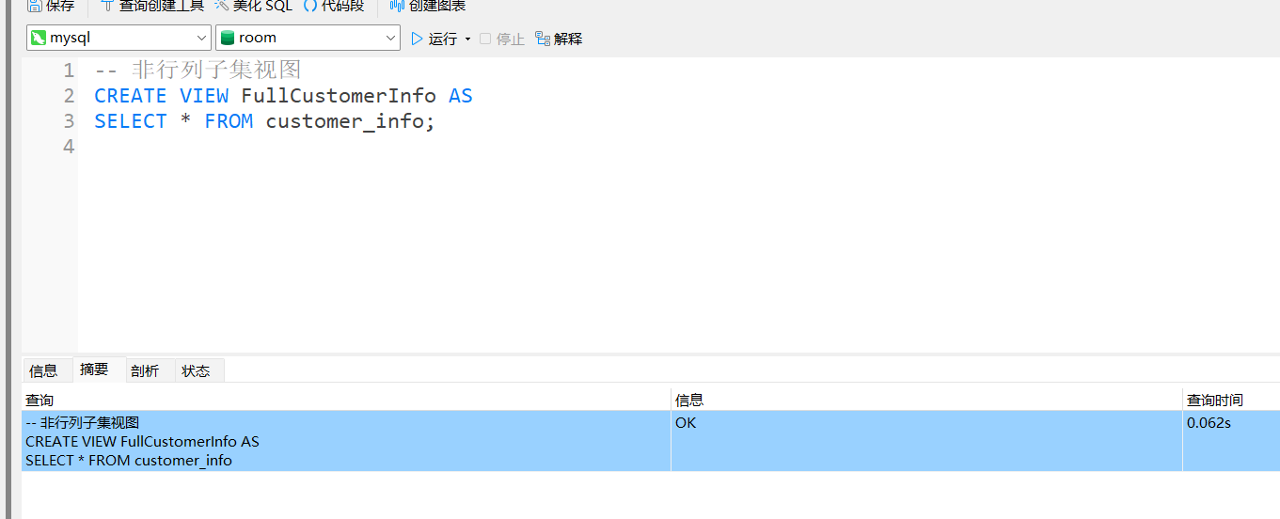

-- 查询视图

SELECT * FROM ActiveBookings;

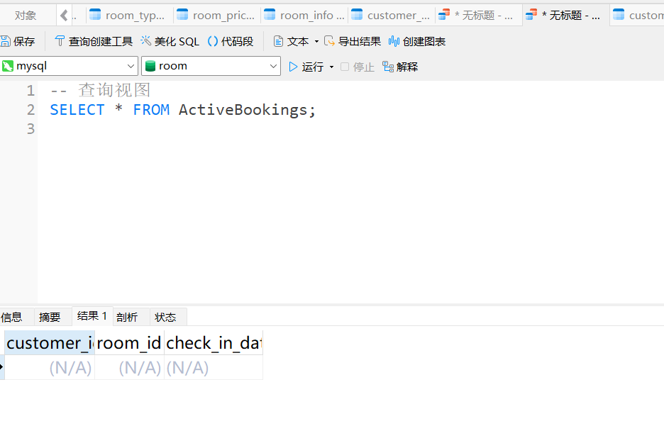

-- 删除视图

DROP VIEW ActiveBookings;

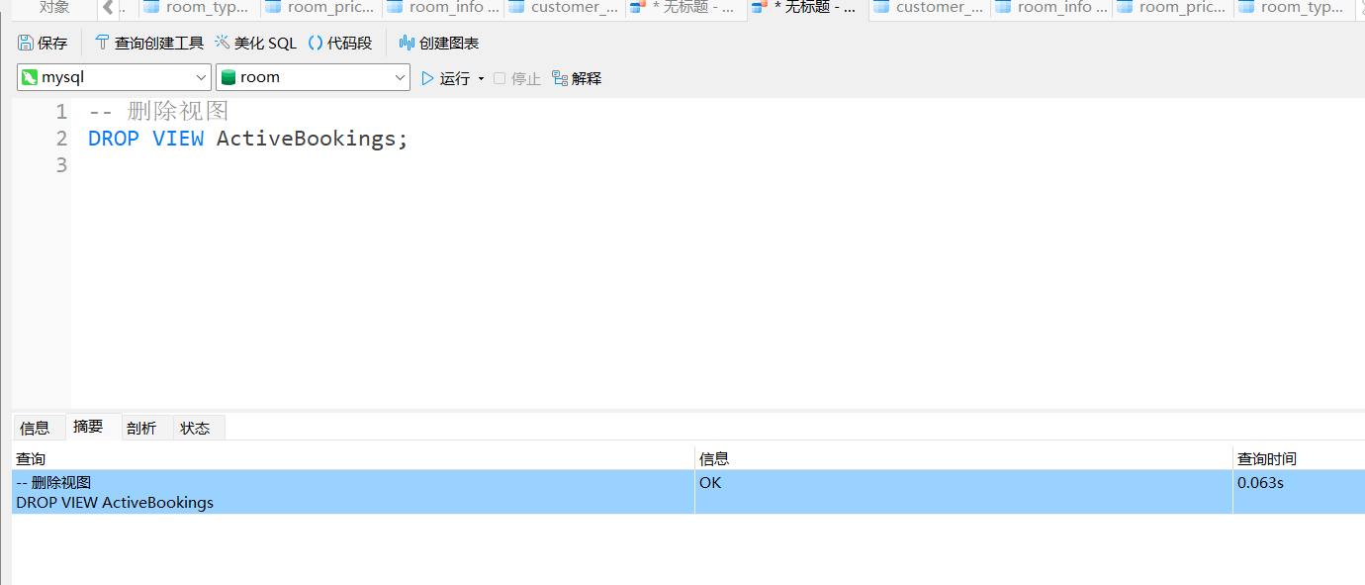

8存储过程操作：存储过程的建立和调用（有参无参各一个）和删除

-- 创建存储过程（无参）

CREATE PROCEDURE GetAllCustomers()

BEGIN

SELECT * FROM customer_info;

END;

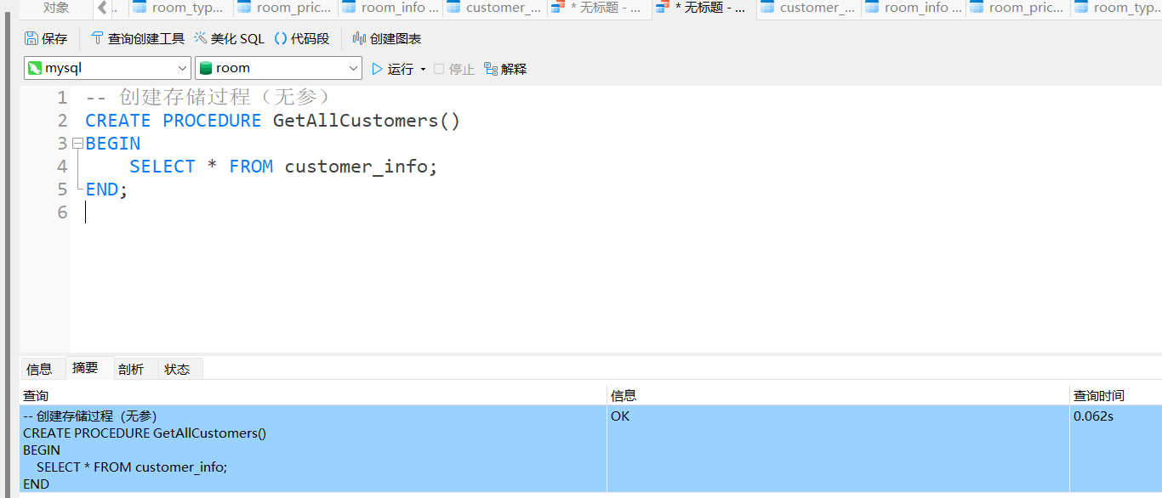

-- 创建存储过程（有参）

CREATE PROCEDURE GetCustomerByID(IN cid INT)

BEGIN

SELECT * FROM customer_info WHERE customer_id = cid;

END;

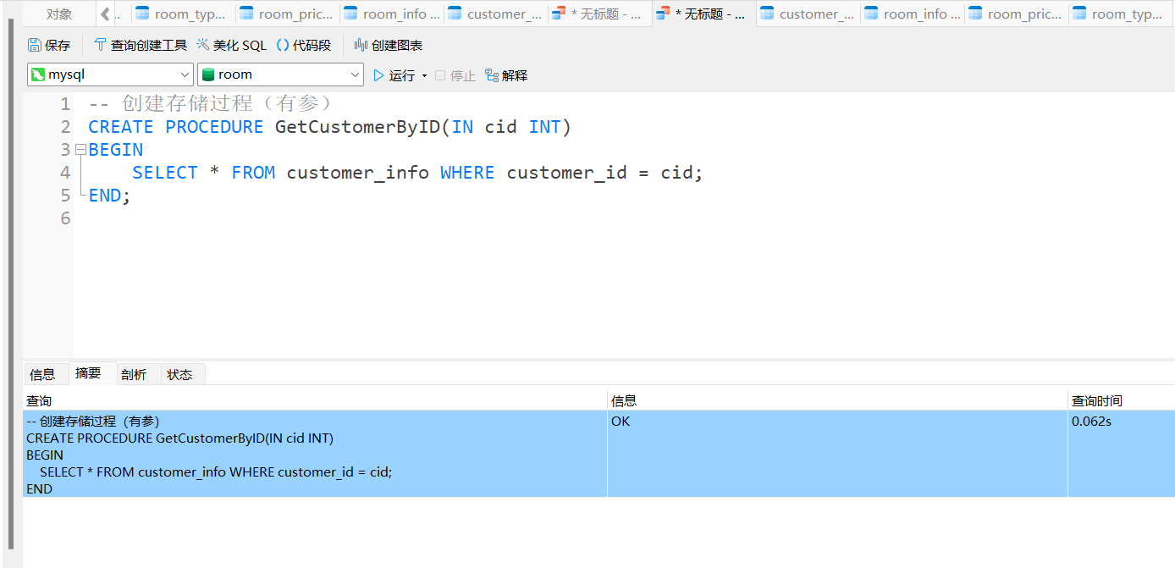

-- 调用存储过程

CALL GetAllCustomers();

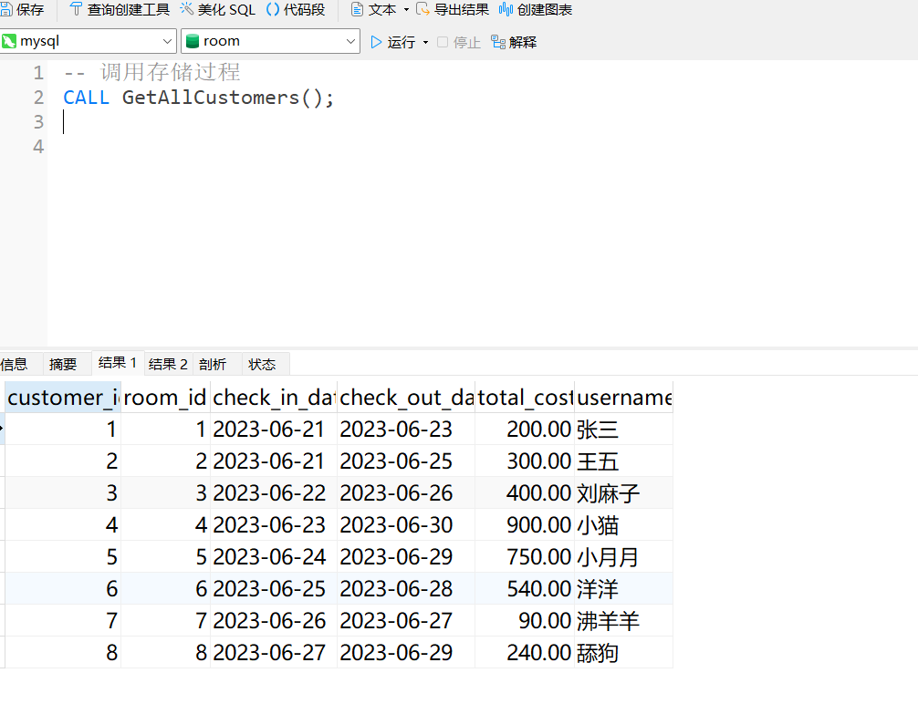

CALL GetCustomerByID(1);

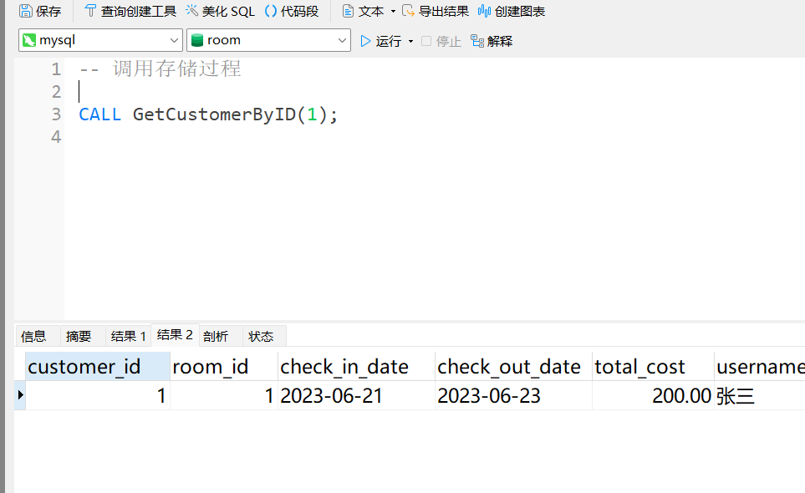

-- 删除存储过程

DROP PROCEDURE GetAllCustomers;

DROP PROCEDURE GetCustomerByID;

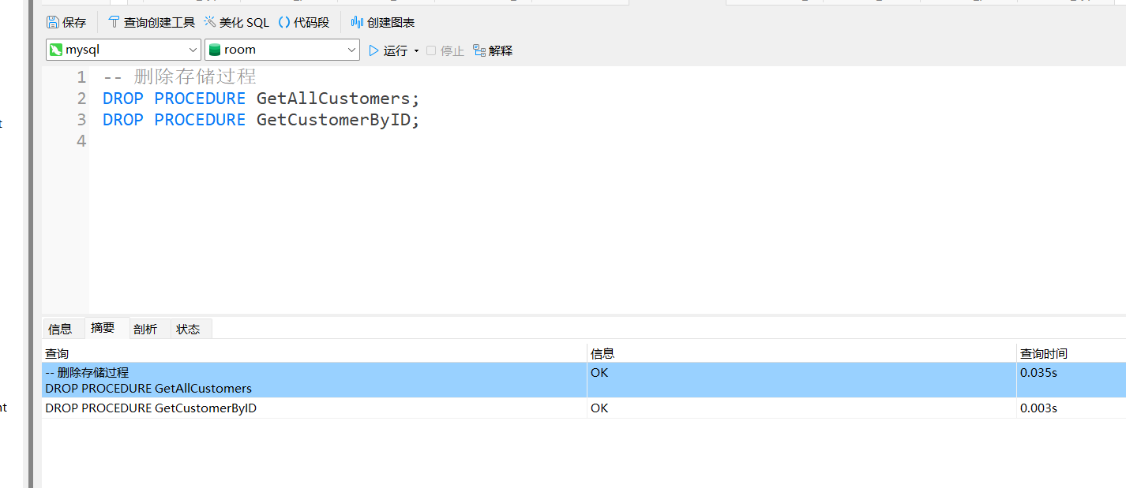

9 触发器的操作：建立（insert，update，delete事件各写一个）和删除

-- 插入触发器

CREATE TRIGGER AfterCustomerInsert

AFTER INSERT ON customer_info

FOR EACH ROW

BEGIN

INSERT INTO logs (action, timestamp) VALUES ('Insert', NOW());

END;

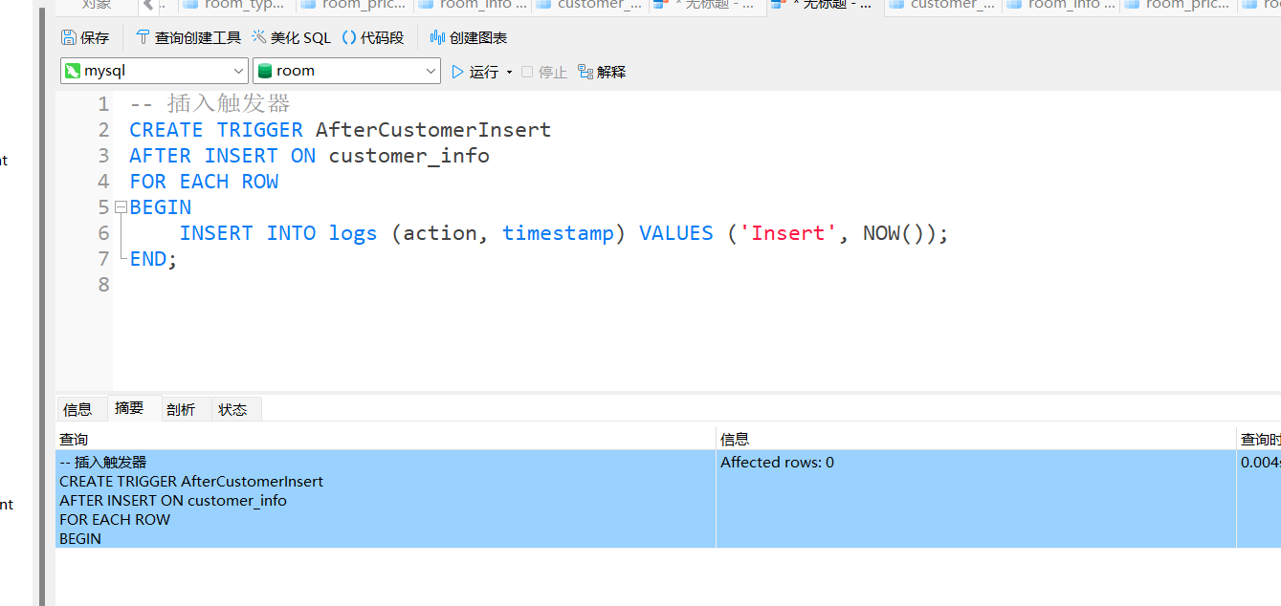

-- 更新触发器

CREATE TRIGGER BeforeCustomerUpdate

BEFORE UPDATE ON customer_info

FOR EACH ROW

BEGIN

INSERT INTO logs (action, timestamp) VALUES ('Update', NOW());

END;

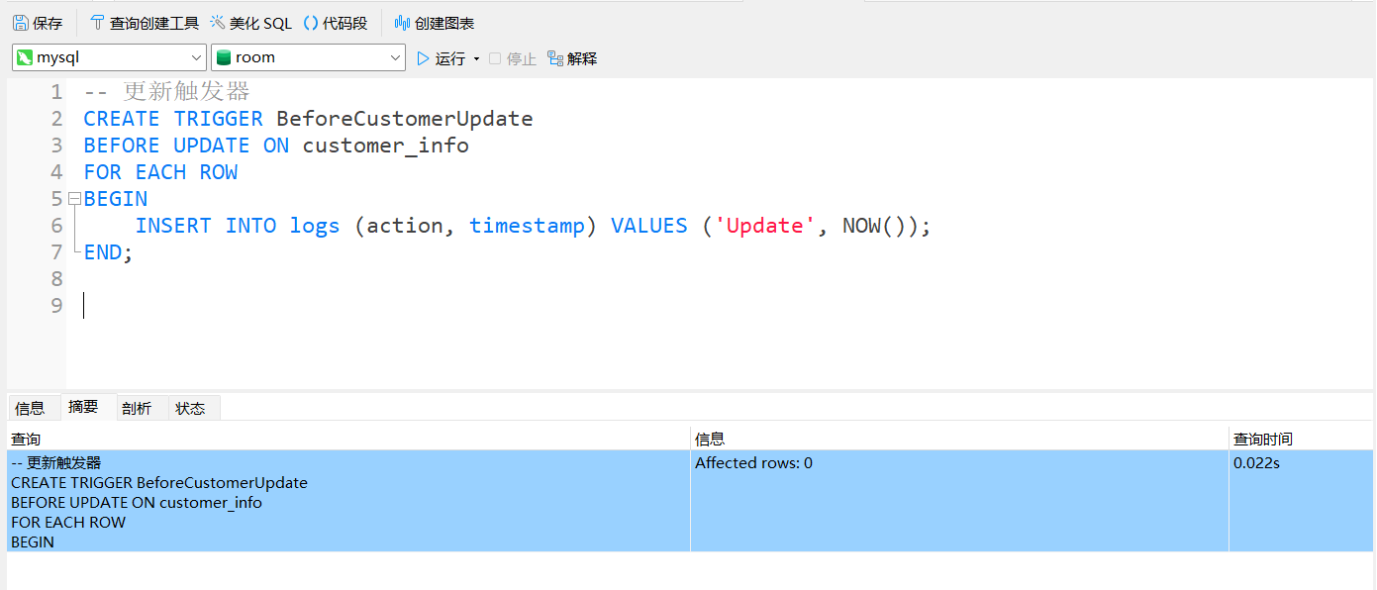

-- 删除触发器

DROP TRIGGER AfterCustomerInsert;

DROP TRIGGER BeforeCustomerUpdate;

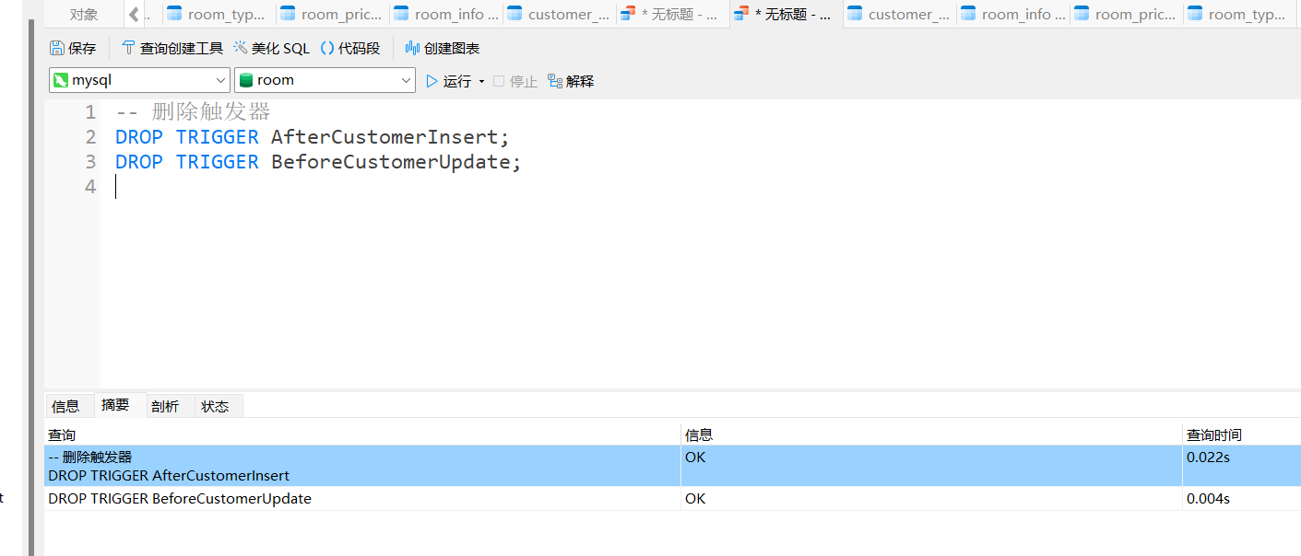

10 权限管理：用户的添加和修改（用户名和密码都要修改），权限的授予和撤销

-- 创建用户

CREATE USER 'booking_user'@'localhost' IDENTIFIED BY 'securepassword';

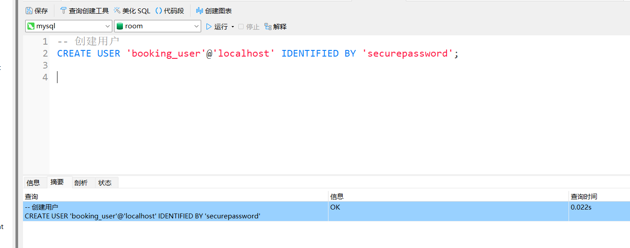

-- 修改用户

RENAME USER 'booking_user'@'localhost' TO 'updated_user'@'localhost';

SET PASSWORD FOR 'updated_user'@'localhost' = PASSWORD('newpassword');

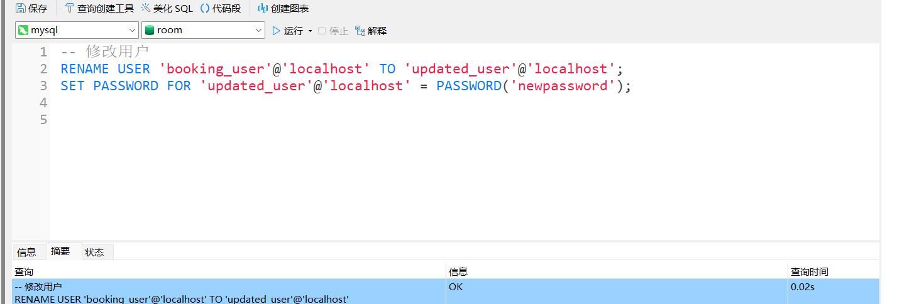

-- 授予权限

GRANT SELECT, INSERT ON room.* TO 'updated_user'@'localhost';

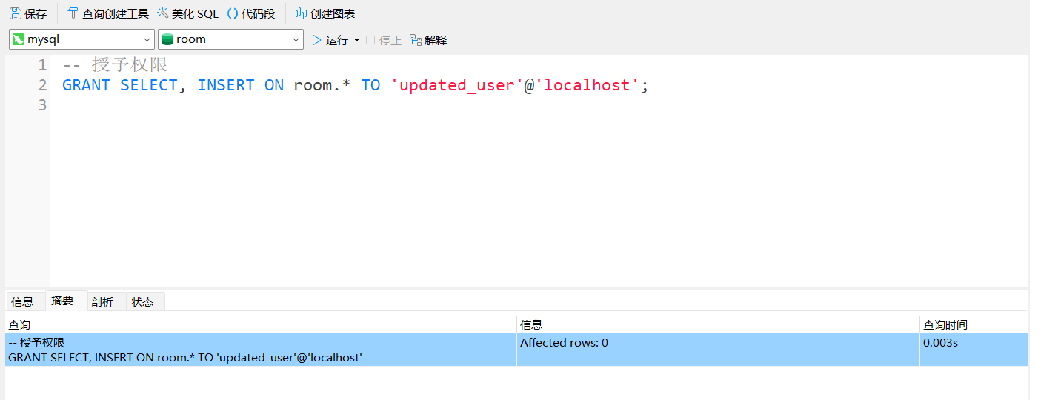

-- 撤销权限

REVOKE INSERT ON room.* FROM 'updated_user'@'localhost';

