题目如下：

第一题：

关于商品（你的可以买的任意东西即可）

1：按分类展示商品：类别、图片名称、商品描述、价格

SELECT

c.category_name AS 类别,

p.image_name AS 图片名称,

p.description AS 商品描述,

p.price AS 价格

FROM

products p

JOIN

categories c ON p.category_id = c.category_id;

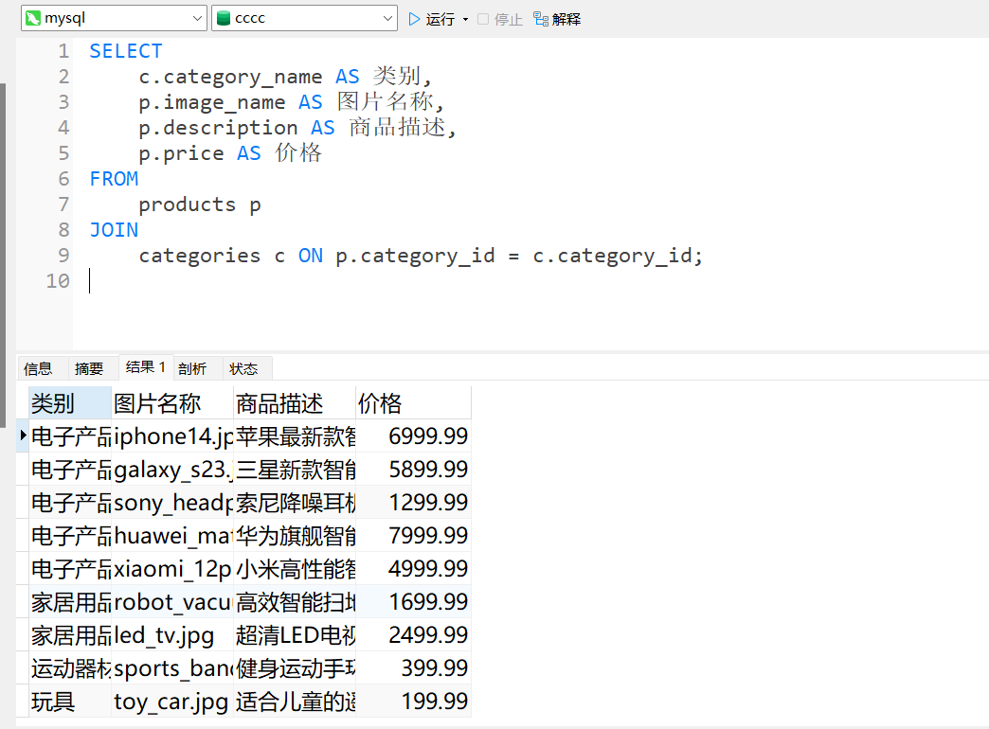

2：查询一个商品（按商品的唯一标识），展示如下信息：

图片名称、商品详细描述、价格、供应商名字；

SELECT

p.image_name AS 图片名称,

p.description AS 商品详细描述,

p.price AS 价格,

s.supplier_name AS 供应商名字

FROM

products p

JOIN

suppliers s ON p.supplier_id = s.supplier_id

WHERE

p.product_id = 1; -- ? 用于绑定商品的唯一标识（产品ID）

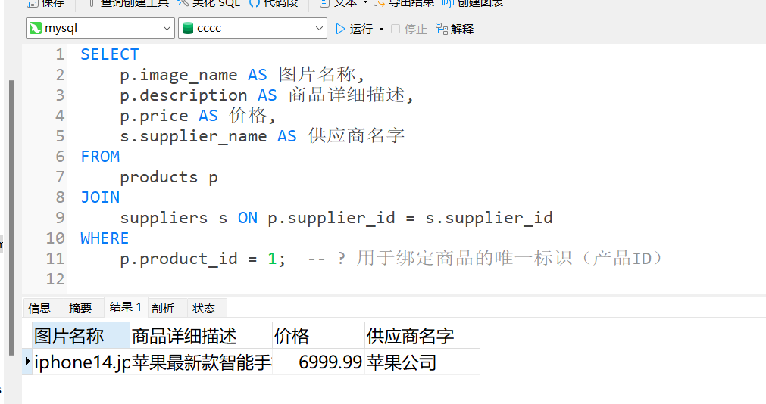

3：查询邮寄地址（按照登录的那个人的对应的多个地址），

展示收件人姓名、手机号、详细地址；

SELECT

a.receiver_name AS 收件人姓名,

a.receiver_phone AS 手机号,

a.address_details AS 详细地址

FROM

addresses a

WHERE

a.user_id = ?; -- ? 用于绑定当前登录用户的ID

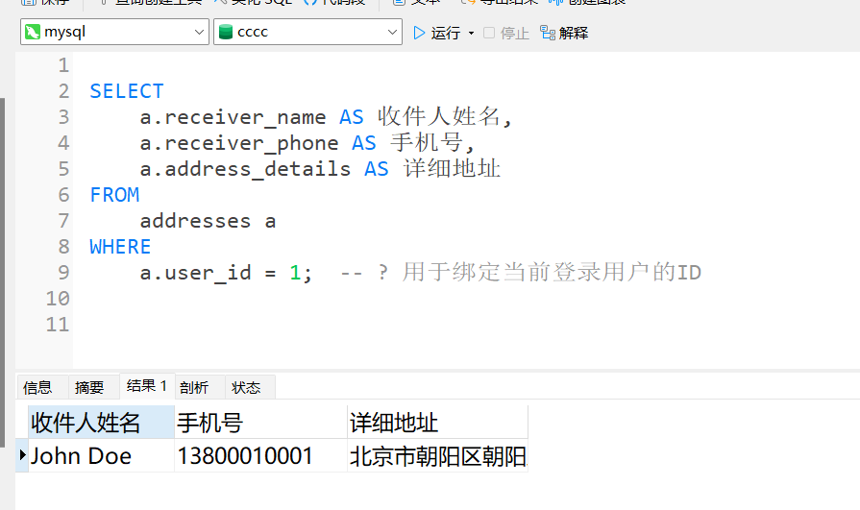

第二题：

关于购物车：按照登录用户来查询这个人的购物车：

1： 查询购物车所有的信息，展示：商品图片名称、商品详细描述、单价、数量

SELECT

p.image_name AS 商品图片名称,

p.description AS 商品详细描述,

p.price AS 单价,

c.quantity AS 数量

FROM

cart c

JOIN

products p ON c.product_id = p.product_id

WHERE

c.user_id = ?; -- ? 用于绑定当前登录用户的ID

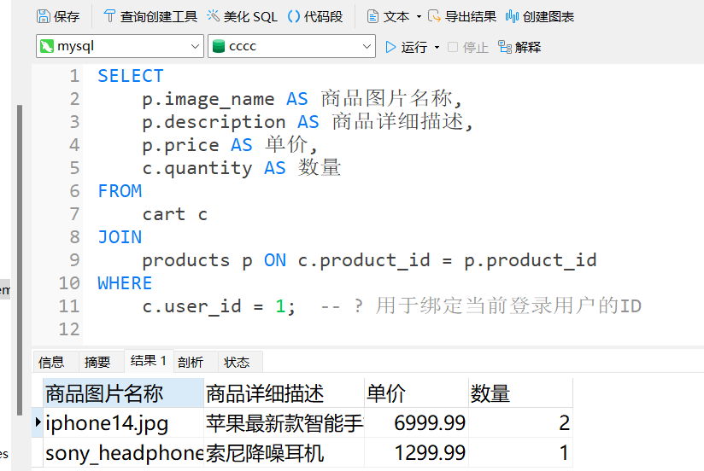

第三题：

关于订单：按照登录用户ID来查询这个人的订单

1：查询近7天的所有订单：展示订单时间、订单编号、

商品图片名称、商品描述、供应商名字、数量、邮寄的收件人姓名、单价、订单状态

SELECT

o.order_date AS 订单时间,

o.order_number AS 订单编号,

p.image_name AS 商品图片名称,

p.description AS 商品描述,

s.supplier_name AS 供应商名字,

od.quantity AS 数量,

a.receiver_name AS 收件人姓名,

p.price AS 单价,

o.order_status AS 订单状态

FROM

orders o

JOIN

order_details od ON o.order_id = od.order_id

JOIN

products p ON od.product_id = p.product_id

JOIN

suppliers s ON p.supplier_id = s.supplier_id

JOIN

addresses a ON o.shipping_address_id = a.address_id

WHERE

o.user_id = ? AND -- ? 用于绑定需要查询用户的ID

o.order_date >= CURDATE() - INTERVAL 7 DAY; -- 查询近7天的订单

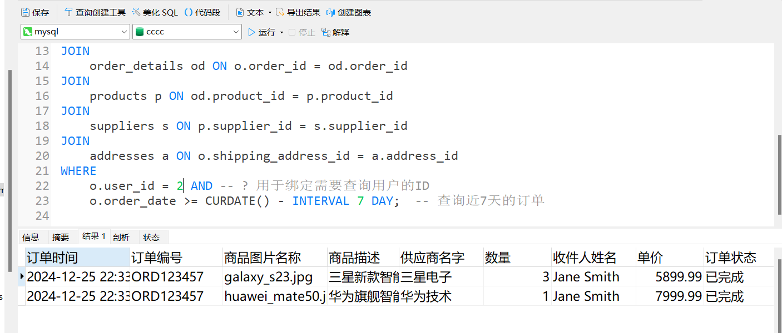

2：查询已经完成的订单有哪些：

展示订单时间、订单编号、商品图片名称、商品描述、供应商名字、数量、邮寄的收件人姓名、单价、订单状态

SELECT

o.order_date AS 订单时间,

o.order_number AS 订单编号,

p.image_name AS 商品图片名称,

p.description AS 商品描述,

s.supplier_name AS 供应商名字,

od.quantity AS 数量,

a.receiver_name AS 收件人姓名,

p.price AS 单价,

o.order_status AS 订单状态

FROM

orders o

JOIN

order_details od ON o.order_id = od.order_id

JOIN

products p ON od.product_id = p.product_id

JOIN

suppliers s ON p.supplier_id = s.supplier_id

JOIN

addresses a ON o.shipping_address_id = a.address_id

WHERE

o.user_id = ? AND -- ? 用于绑定需要查询用户的ID

o.order_status = '完成'; -- 查询已经完成的订单

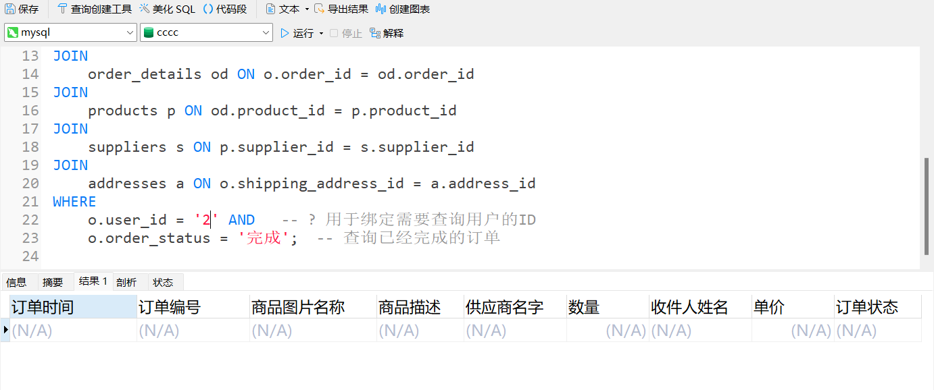

3：查询某个商品名字（模糊匹配）的订单信息：

展示订单时间、订单编号、商品图片名称、商品描述、供应商名字、数量、邮寄的收件人姓名、单价、订单状态

SELECT

o.order_date AS 订单时间,

o.order_number AS 订单编号,

p.image_name AS 商品图片名称,

p.description AS 商品描述,

s.supplier_name AS 供应商名字,

od.quantity AS 数量,

a.receiver_name AS 收件人姓名,

p.price AS 单价,

o.order_status AS 订单状态

FROM

orders o

JOIN

order_details od ON o.order_id = od.order_id

JOIN

products p ON od.product_id = p.product_id

JOIN

suppliers s ON p.supplier_id = s.supplier_id

JOIN

addresses a ON o.shipping_address_id = a.address_id

WHERE

o.user_id = ? AND -- ? 用于绑定需要查询用户的ID

p.product_name LIKE CONCAT('%', '?', '%'); -- ? 用于绑定当前商品名称（模糊匹配）

