* 描述

该实例是一个客房管理系统，用于管理酒店客房的类型、价格、客房信息以及客户信息。以下是对该系统的描述和回答问题：

* 实体和联系：

- 实体：room_type（客房类型）、room_price（价目信息）、room_info（客房信息）、customer_info（客户信息）

- 联系：room_price与room_type之间的外键联系、customer_info与room_info之间的外键联系

* 实体和联系的属性：

- room_type：type_id（主键），type_name，price

- room_price：price_id（主键），type_id（外键），start_date，end_date，price

- room_info：room_id（主键），type_id（外键），room_number，status

- customer_info：customer_id（主键），room_id（外键），check_in_date，check_out_date，total_cost

* E-R图：

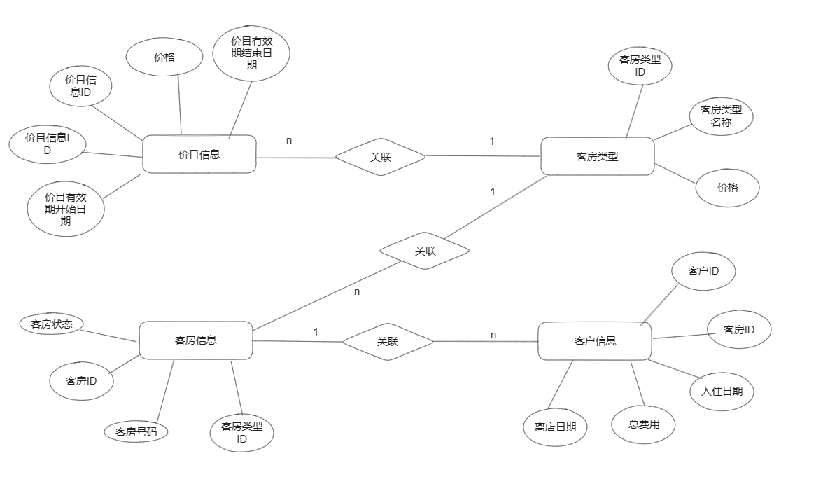

* 关系模式：

room_type (type_id [PK], type_name, price)

room_price (price_id [PK], type_id [FK], start_date, end_date, price)

room_info (room_id [PK], type_id [FK], room_number, status)

customer_info (customer_id [PK], room_id [FK], check_in_date, check_out_date, total_cost)

其中，[PK]表示主键，[FK]表示外键。

* Sql语句：

1. 客房类型表（room_type）：

```

CREATE TABLE room_type (

type_id INT PRIMARY KEY,

type_name VARCHAR(50) NOT NULL,

price DECIMAL(10,2) NOT NULL

);

```

2. 价目信息表（room_price）：

```

CREATE TABLE room_price (

price_id INT PRIMARY KEY,

type_id INT NOT NULL,

start_date DATE NOT NULL,

end_date DATE NOT NULL,

price DECIMAL(10,2) NOT NULL,

FOREIGN KEY (type_id) REFERENCES room_type(type_id)

);

```

3. 客房信息表（room_info）：

```

CREATE TABLE room_info (

room_id INT PRIMARY KEY,

type_id INT NOT NULL,

room_number VARCHAR(20) UNIQUE NOT NULL,

status VARCHAR(10) NOT NULL DEFAULT 'Vacant',

FOREIGN KEY (type_id) REFERENCES room_type(type_id)

);

```

4. 客户信息表（customer_info）：

```

CREATE TABLE customer_info (

customer_id INT PRIMARY KEY,

room_id INT NOT NULL,

check_in_date DATE NOT NULL,

check_out_date DATE,

total_cost DECIMAL(10,2),

FOREIGN KEY (room_id) REFERENCES room_info(room_id)

);

```

以下是触发器的SQL语句：

1. 入住触发器（check_in_trigger）：

CREATE TRIGGER check_in_trigger AFTER INSERT ON customer_info

FOR EACH ROW

BEGIN

UPDATE room_info SET status = 'Occupied' WHERE room_id = NEW.room_id;

END;

2. 退房触发器（check_out_trigger）：

```

CREATE TRIGGER check_out_trigger AFTER UPDATE ON customer_info

FOR EACH ROW

BEGIN

IF NEW.check_out_date IS NOT NULL THEN

UPDATE room_info SET status = 'Vacant' WHERE room_id = NEW.room_id;

END IF;

END;

以下是存储过程的SQL语句：

CREATE PROCEDURE calculate_cost(IN start_date DATE, IN end_date DATE)

BEGIN

SELECT rt.type_name, SUM(DATEDIFF(ci.check_out_date, ci.check_in_date)) AS total_days, SUM(rp.price * DATEDIFF(ci.check_out_date, ci.check_in_date)) AS total_cost

FROM customer_info ci

JOIN room_info ri ON ci.room_id = ri.room_id

JOIN room_type rt ON ri.type_id = rt.type_id

JOIN room_price rp ON rt.type_id = rp.type_id AND ci.check_in_date >= rp.start_date AND ci.check_out_date <= rp.end_date

WHERE (ci.check_in_date BETWEEN start_date AND end_date) OR (ci.check_out_date BETWEEN start_date AND end_date)

GROUP BY rt.type_name;

END;

以下是视图的SQL语句：

CREATE VIEW vacant_rooms_view AS

SELECT ri.room_id, ri.room_number, rt.type_name

FROM room_info ri

JOIN room_type rt ON ri.type_id = rt.type_id

WHERE ri.status = 'Vacant';