**2022级计算机网络技术专业**

**期末项目考试题**

**学号： 22652200036 姓名： 王俊 得分：**

1. e-r图，不画属性

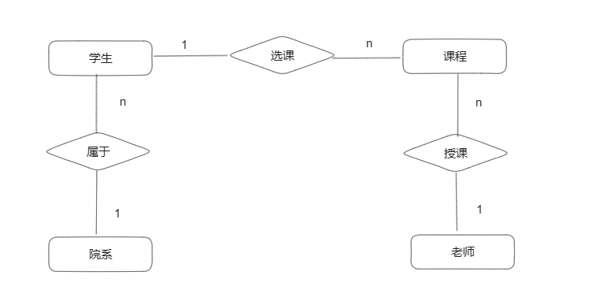

2.

（1）

Create database edu;

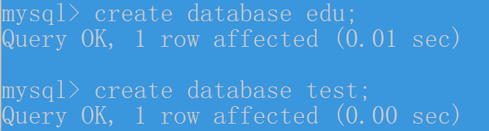

（2）

Create database test;



3.

（1）

系表

DROP TABLE IF EXISTS `dept`;

/*!40101 SET @saved_cs_client = @@character_set_client */;

/*!50503 SET character_set_client = utf8mb4 */;

CREATE TABLE `dept` (

`dname` varchar(20) NOT NULL,

`location` varchar(20) NOT NULL DEFAULT '自强楼',

PRIMARY KEY (`dname`)

) ENGINE=InnoDB DEFAULT CHARSET=utf8mb3;

/*!40101 SET character_set_client = @saved_cs_client */;

--

-- Dumping data for table `dept`

--

LOCK TABLES `dept` WRITE;

/*!40000 ALTER TABLE `dept` DISABLE KEYS */;

INSERT INTO `dept` VALUES ('会计系','C楼'),('信息系','D楼'),('化工系','B楼'),('数学系','A楼'),('机械系','D楼'),('材料系','B楼'),('英语系','C楼'),('计算机系','A楼');

/*!40000 ALTER TABLE `dept` ENABLE KEYS */;

UNLOCK TABLES;

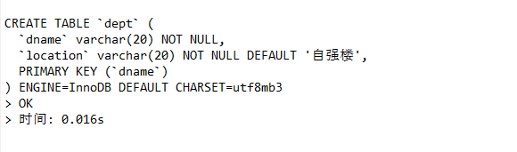



学生表

DROP TABLE IF EXISTS `student`;

/*!40101 SET @saved_cs_client = @@character_set_client */;

/*!50503 SET character_set_client = utf8mb4 */;

CREATE TABLE `student` (

`sno` char(9) NOT NULL,

`sname` varchar(10) NOT NULL,

`sage` int NOT NULL,

`ssex` char(2) NOT NULL,

`sdept` varchar(20) DEFAULT NULL,

PRIMARY KEY (`sno`),

CONSTRAINT `student_chk_1` CHECK ((`ssex` in (_utf8mb4'男',_utf8mb4'女')))

) ENGINE=InnoDB DEFAULT CHARSET=utf8mb3;

/*!40101 SET character_set_client = @saved_cs_client */;

--

-- Dumping data for table `student`

--

LOCK TABLES `student` WRITE;

/*!40000 ALTER TABLE `student` DISABLE KEYS */;

INSERT INTO `student` VALUES ('202201121','李勇',20,'男','计算机系'),('202201122','刘晨',19,'女','计算机系'),('202204123','王敏',18,'女','数学'),('202207225','张立',19,'男','信息');

/*!40000 ALTER TABLE `student` ENABLE KEYS */;

UNLOCK TABLES;

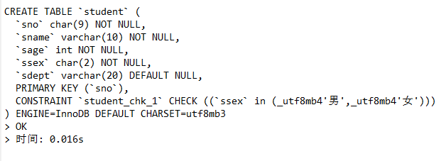



教师表

DROP TABLE IF EXISTS `teacher`;

/*!40101 SET @saved_cs_client = @@character_set_client */;

/*!50503 SET character_set_client = utf8mb4 */;

CREATE TABLE `teacher` (

`tno` char(2) NOT NULL,

`tname` varchar(10) NOT NULL,

`tsex` char(2) NOT NULL,

`ttechnical` varchar(10) NOT NULL,

`tdept` varchar(20) DEFAULT NULL,

PRIMARY KEY (`tno`),

CONSTRAINT `teacher_chk_1` CHECK ((`tsex` in (_utf8mb4'男',_utf8mb4'女')))

) ENGINE=InnoDB DEFAULT CHARSET=utf8mb3;

/*!40101 SET character_set_client = @saved_cs_client */;

--

-- Dumping data for table `teacher`

--

LOCK TABLES `teacher` WRITE;

/*!40000 ALTER TABLE `teacher` DISABLE KEYS */;

INSERT INTO `teacher` VALUES ('01','李丹','女','讲师','计算机'),('02','陈诚','女','讲师','计算机'),('03','李文','男','副教授','计算机'),('04','刘逸','男','讲师','材料');

/*!40000 ALTER TABLE `teacher` ENABLE KEYS */;

UNLOCK TABLES;

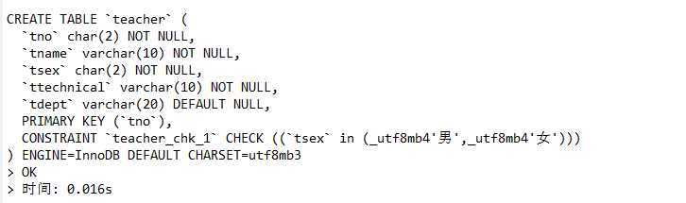



课程表

DROP TABLE IF EXISTS `course`;

/*!40101 SET @saved_cs_client = @@character_set_client */;

/*!50503 SET character_set_client = utf8mb4 */;

CREATE TABLE `course` (

`cno` char(2) NOT NULL,

`cname` varchar(10) NOT NULL,

`cpno` char(2) DEFAULT NULL,

`ccredit` int NOT NULL,

PRIMARY KEY (`cno`)

) ENGINE=InnoDB DEFAULT CHARSET=utf8mb3;

/*!40101 SET character_set_client = @saved_cs_client */;

--

-- Dumping data for table `course`

--

LOCK TABLES `course` WRITE;

/*!40000 ALTER TABLE `course` DISABLE KEYS */;

INSERT INTO `course` VALUES ('1','数据库','5',4),('2','数学',NULL,2),('3','信息系统','1',4),('4','操作系统','6',3),('5','数据结构','7',4),('6','数据处理',NULL,2),('7','C语言','6',4);

/*!40000 ALTER TABLE `course` ENABLE KEYS */;

UNLOCK TABLES;

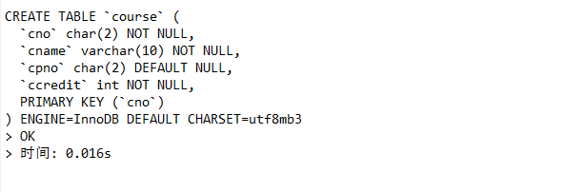



选课表

DROP TABLE IF EXISTS `sc`;

/*!40101 SET @saved_cs_client = @@character_set_client */;

/*!50503 SET character_set_client = utf8mb4 */;

CREATE TABLE `sc` (

`sno` char(9) NOT NULL,

`cno` char(2) NOT NULL,

`grade` float DEFAULT NULL,

PRIMARY KEY (`sno`,`cno`)

) ENGINE=InnoDB DEFAULT CHARSET=utf8mb3;

/*!40101 SET character_set_client = @saved_cs_client */;

--

-- Dumping data for table `sc`

--

LOCK TABLES `sc` WRITE;

/*!40000 ALTER TABLE `sc` DISABLE KEYS */;

INSERT INTO `sc` VALUES ('202201121','1',92),('202201121','2',85),('202201121','3',88),('202201122','2',90),('202201122','3',80);

/*!40000 ALTER TABLE `sc` ENABLE KEYS */;

UNLOCK TABLES;

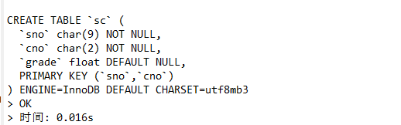



讲授表

DROP TABLE IF EXISTS `tc`;

/*!40101 SET @saved_cs_client = @@character_set_client */;

/*!50503 SET character_set_client = utf8mb4 */;

CREATE TABLE `tc` (

`tno` char(2) NOT NULL,

`cno` char(2) NOT NULL,

`start_date` date NOT NULL,

PRIMARY KEY (`tno`,`cno`,`start_date`)

) ENGINE=InnoDB DEFAULT CHARSET=utf8mb3;

/*!40101 SET character_set_client = @saved_cs_client */;

--

-- Dumping data for table `tc`

--

LOCK TABLES `tc` WRITE;

/*!40000 ALTER TABLE `tc` DISABLE KEYS */;

INSERT INTO `tc` VALUES ('01','1','2023-02-27'),('02','4','2023-02-27'),('03','5','2023-04-10');

/*!40000 ALTER TABLE `tc` ENABLE KEYS */;

UNLOCK TABLES;

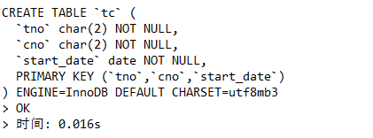

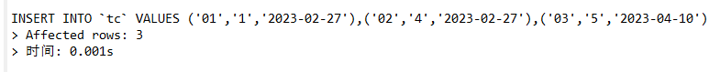

（2）查看student表的定义语句

SHOW CREATE TABLE student;

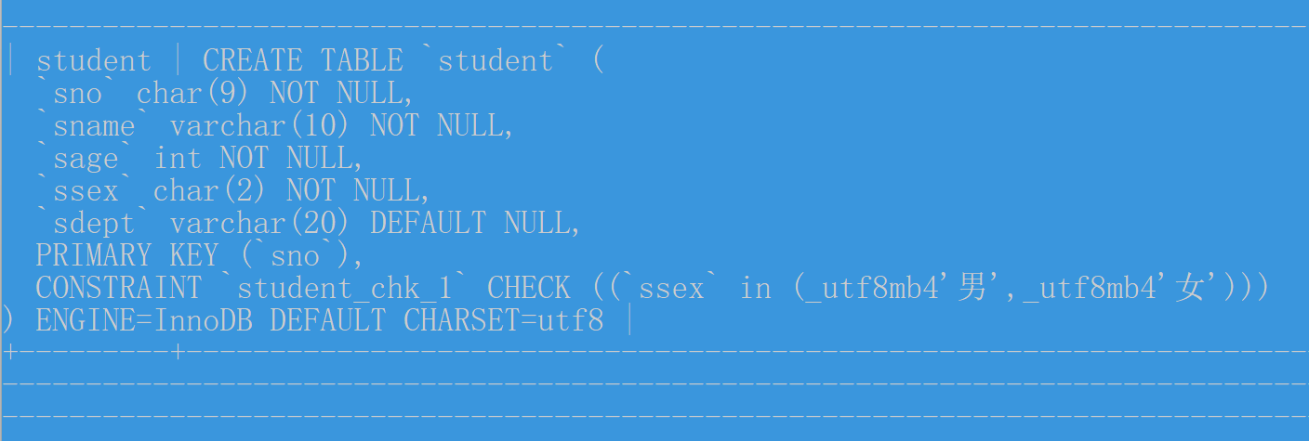

（3）查看student表各属性信息

DESCRIBE student;

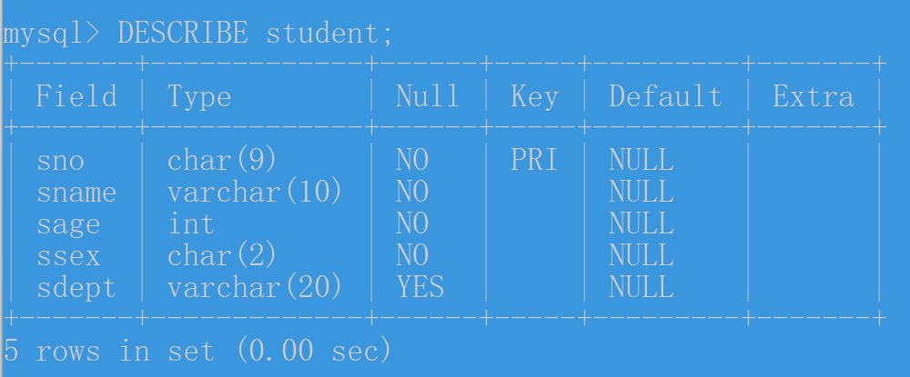

4. 数据更新操作

（1）INSERT INTO `student` VALUES ('202201121','李勇',20,'男','计算机系'),('202201122','刘晨',19,'女','计算机系'),('202204123','王敏',18,'女','数学'),('202207225','张立',19,'男','信息');



(2) UPDATE student SET sage = 18 WHERE sname = '张立';



(3) UPDATE student SET sage = sage + 1 WHERE ssex= '男';

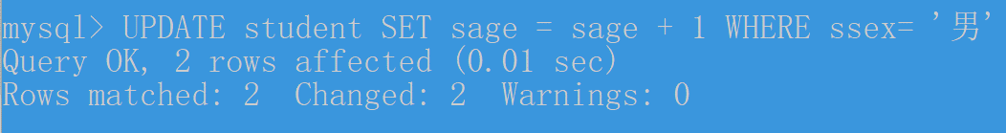

(4) DELETE FROM student WHERE sdept = '机械系';



5.

(1) mysqldump -u root -p123456 edu > C:\backup.sql



文件内容

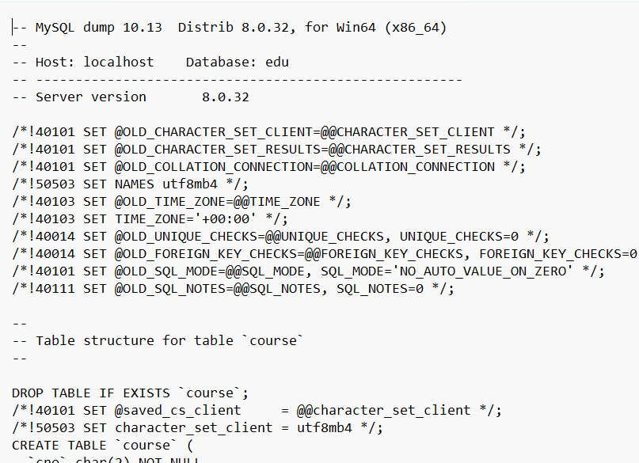

(2) DROP DATABASE edu;

mysqldump -u root -p123456 edu < C:\backup.sql



6.

(1) CREATE USER 'user1'@'localhost' IDENTIFIED BY '54321';



(2) ALTER USER 'user1'@'localhost' IDENTIFIED BY '98765';



(3) GRANT SELECT, INSERT ON teacher TO 'user1'@'localhost';

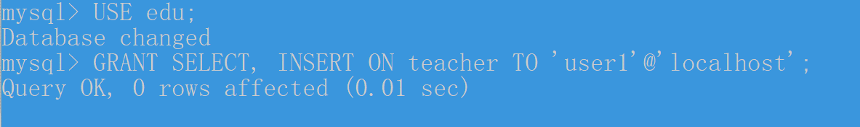

(4) SHOW GRANTS FOR 'user1'@'localhost';



(5) REVOKE ALL PRIVILEGES ON *.* FROM 'user1'@'localhost';

FLUSH PRIVILEGES;

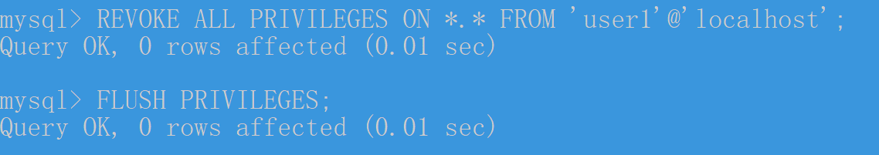

7.

（1）SELECT sno, sname, sage, ssex, sdept

FROM student

WHERE sdept = '计算机系';

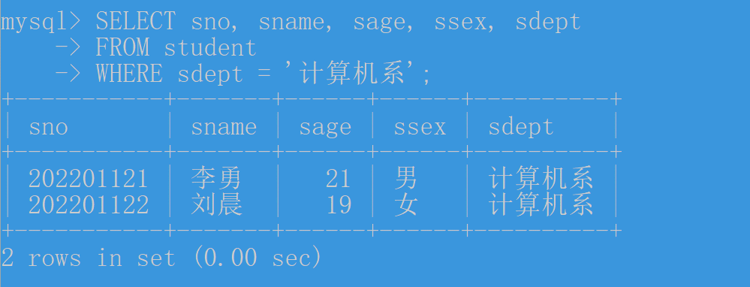

SELECT sno, sname, sage, ssex, sdept

FROM student

WHERE sdept = '机械系';



（2）SELECT s.sno, s.sname, c.cname, sc.grade

FROM student AS s

JOIN sc ON s.sno = sc.sno

JOIN course AS c ON sc.cno = c.cno

WHERE sc.grade IS NOT NULL;

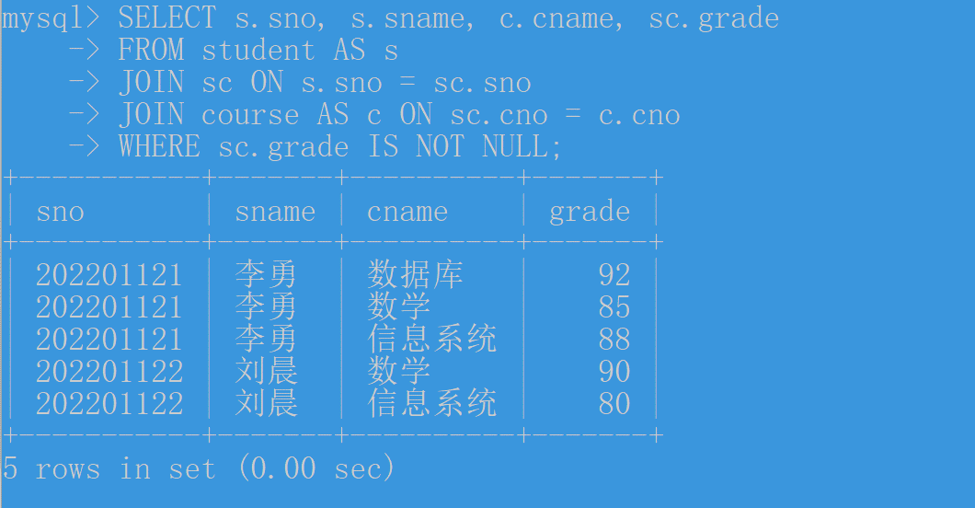

（3）SELECT * FROM teacher WHERE tname LIKE '李%';



（4）SELECT sname, YEAR(CURRENT_DATE) - sage AS birth_year FROM student;

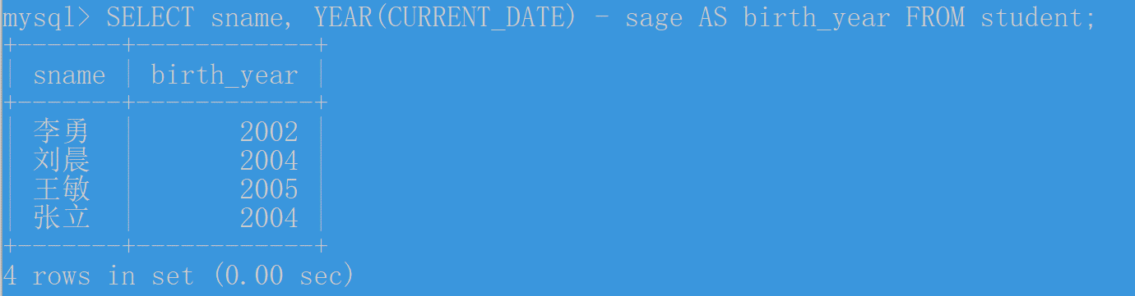

（5）SELECT sno, grade FROM sc WHERE cno = '3' ORDER BY grade DESC; 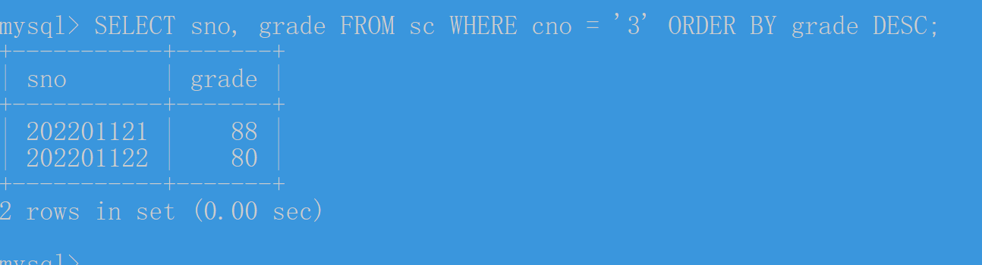

（6）SELECT ssex, COUNT(*) AS count FROM student GROUP BY ssex;

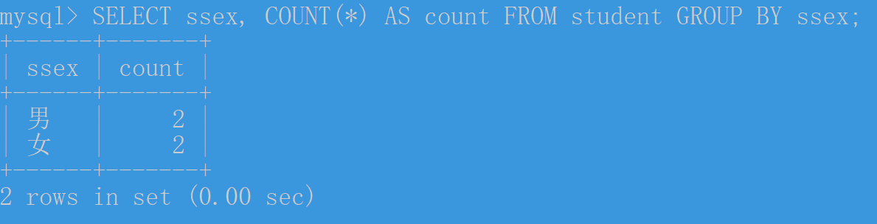

（7）SELECT AVG(grade) AS avg_grade FROM sc WHERE sno = '202201121';



（8）SELECT sno, SUM(grade) AS total_grade

FROM sc

GROUP BY sno

HAVING COUNT(*) > 3 AND MIN(grade) >= 60

ORDER BY total_grade DESC;

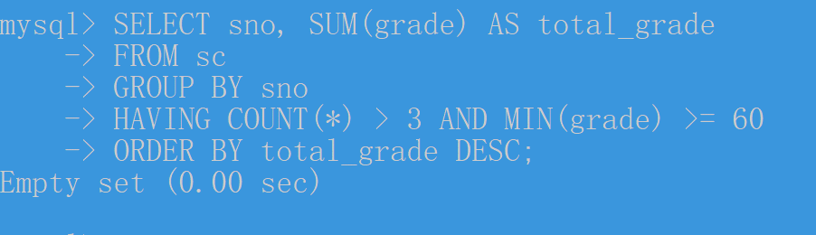

（9）SELECT cpno AS prerequisite_of_prerequisite

FROM course

WHERE cno = (

SELECT cpno

FROM course

WHERE cno = '3'

);

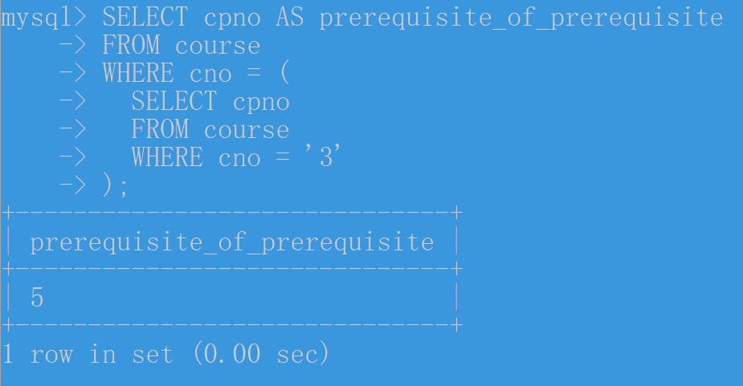

（10）SELECT s.sno, s.sname

FROM student s

JOIN sc ON s.sno = sc.sno

JOIN course c ON sc.cno = c.cno

WHERE c.cname = '信息系统';

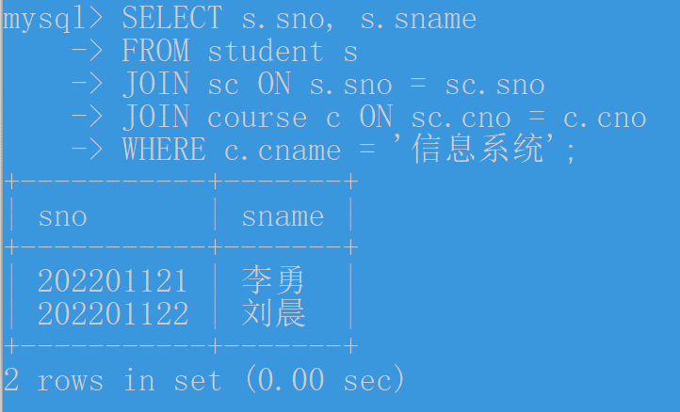

（11）SELECT sc1.sno, sc2.cno

FROM sc sc1

JOIN sc sc2 ON sc1.sno = sc2.sno

GROUP BY sc1.sno, sc2.cno

HAVING AVG(sc2.grade) > (

SELECT AVG(grade)

FROM sc

WHERE sno = sc1.sno

)

ORDER BY sc1.sno;

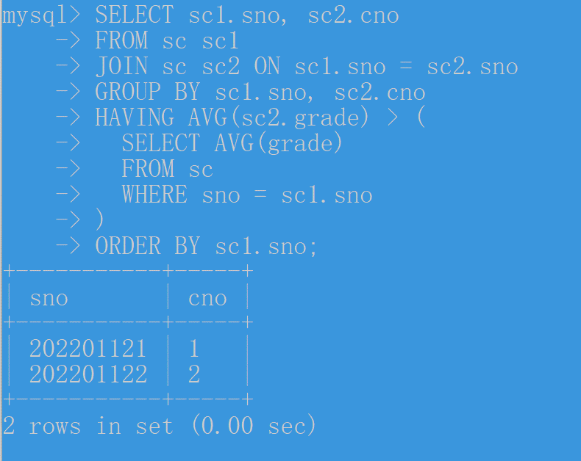

（12） SELECT s.sname

FROM student s

WHERE NOT EXISTS (

SELECT cno

FROM course

WHERE NOT EXISTS (

SELECT *

FROM sc

WHERE sno = s.sno AND cno = course.cno

)

);

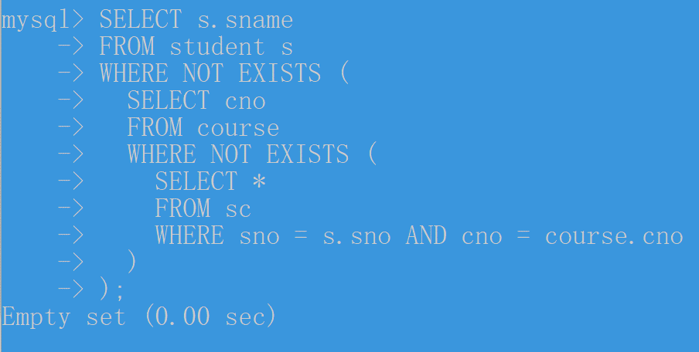

8.

（1）CREATE VIEW information_students AS

SELECT s.sno, s.sname, s.sage, s.ssex, s.sdept

FROM student s INNER JOIN dept d ON s.sdept = d.dname

WHERE d.dname = '信息系';

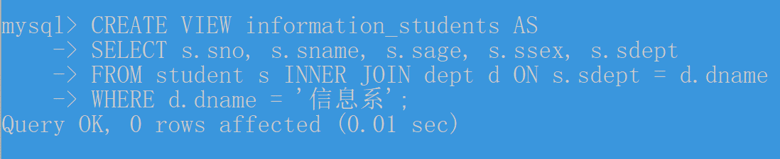

（2）CREATE VIEW information_course1_students AS

SELECT s.sno, s.sname, sc.grade

FROM student s

INNER JOIN dept d ON s.sdept = d.dname

INNER JOIN sc ON s.sno = sc.sno

WHERE d.dname = '信息系' AND sc.cno = '1';

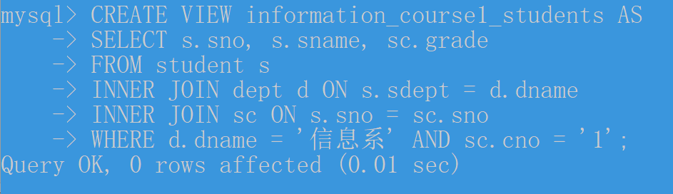

9.

（1）DELIMITER //

CREATE PROCEDURE proc_gender_count(IN gender VARCHAR(2), OUT count INT)

BEGIN

SELECT COUNT(*) INTO count FROM student WHERE ssex = gender;

END //

DELIMITER ;

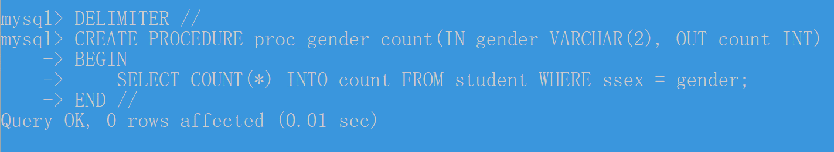

（2）DELIMITER //

CREATE FUNCTION func_get_name(sno CHAR(9)) RETURNS VARCHAR(10)

BEGIN

DECLARE name VARCHAR(10);

SELECT sname INTO name FROM student WHERE sno = sno;

RETURN name;

END //

DELIMITER ;

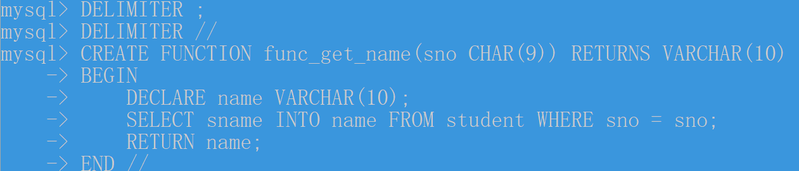

（3）CREATE TABLE trigger_test (

id INT AUTO_INCREMENT,

mark VARCHAR(10),

PRIMARY KEY (id)

);

DELIMITER //

CREATE TRIGGER tri_insert_student

BEFORE INSERT ON student

FOR EACH ROW

BEGIN

INSERT INTO trigger_test (mark) VALUES ('mark');

END //

DELIMITER ;

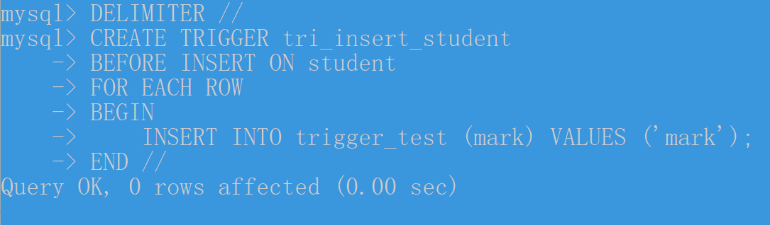

（4）DELIMITER //

CREATE FUNCTION func_calculate_total_grade(sno CHAR(9)) RETURNS FLOAT

BEGIN

DECLARE total_grade FLOAT;

SET total_grade = 0;

DECLARE done INT DEFAULT FALSE;

DECLARE cur CURSOR FOR SELECT grade FROM sc WHERE sno = sno;

DECLARE CONTINUE HANDLER FOR NOT FOUND SET done = TRUE;

OPEN cur;

read_loop: LOOP

FETCH cur INTO total_grade;

IF done THEN

LEAVE read_loop;

END IF;

SET total_grade = total_grade + total_grade;

END LOOP;

CLOSE cur;

RETURN total_grade;

END //

DELIMITER ;

