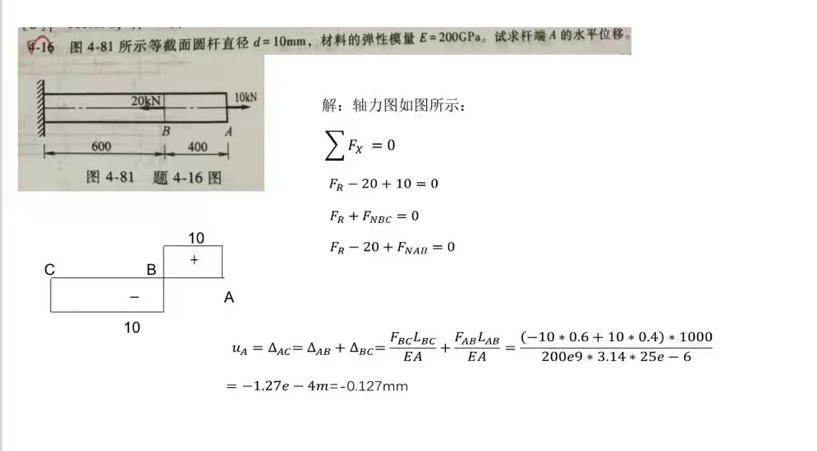

**Matlab程序：**

clear

%% 列x方向的平衡方程

% F_R=10;

% F_R+F_NBC=0;

% F_R+F_NAB=20;

A=[ 1 0 0;

1 0 1;

1 1 0];

b=[10 0 20]';

F=A\b;

F_R = F(1); % kN

F_AB = F(2); % kN

F_BC = F(3); % kN

%% 绘制轴力图

figure(1)

clf

F_N = [0 F_BC F_BC F_AB F_AB 0];

x = [0 0 6 6 10 10];

% 绘制坐标轴

plot(x,F_N ,'k');hold on

text(-1,0,'0');

text(-1,10,'10');

text(-1,-10,'-10');

text(0,-2,'C');

text(6,-2,'B');

text(10,-2,'A');

text(3,-5,'-');

text(8,5,'+');

axx=12;

ayy=max(F)*2;

plot([0 0],[-ayy ayy],'k',[0 axx],[0 0],'k');hold on

% Draw arrows

ax=[axx+0.3,axx,axx; 0,0.3,-0.3];

fill(ax(1,:),ax(2,:),'k');

ay=[0,0.1,-0.1; ayy+0.6,ayy-0.4,ayy-0.4];

fill(ay(1,:),ay(2,:),'k');

text(0.2, ay(end)+0.2, 'F_{N}(KN)', 'FontName','Times New Roman',...

'FontAngle','Italic','FontSize',12, 'HorizontalAlignment','left')

text(ax(1), -0.1, 'x','FontName','Times New Roman',...

'FontAngle','Italic','FontSize',18, 'VerticalAlignment','top')

axis off

%% 求A端的水平位移

% u_A = Delta_AC

% = Delta_AB + Delta_BC

% = (F_AB*L_AB + F_BC*L_BC)/(E*A)

L_AB = 0.4; % m

L_BC = 0.6; % m

d = 10*1e-3; % m

A = pi*(d/2)^2; % m^2

E =200*1e9; % Pa

u_A = 1000*(F_AB*L_AB + F_BC*L_BC)/(E*A); % 单位：m

U_A=['u_A=' num2str(u_A*1e3) 'mm'];

disp('杆端A的水平位移为：')

disp(U_A)

**输出结果：**

杆端A的水平位移为：

u_A=-0.12732mm

**轴力图：**

