E_Lecture5_W1
Name:
ID:

Q1 | [30 pts, 10 pts for each]  (1)  Xavier opens up a lemonade stand for two hours. He spends $10 for ingredients and sells $60 worth of lemonade. In the same two hours, he could have mowed his neighbor’s lawn for $40. Xavier has an accounting profit of and an economic profit of  Answer:  (a) $50, $10.  (b) $90, $50.  (c) $10, $50.  (d) $50, $90.  (2)  Diminishing marginal product explains why, as a firm’s output increase,  (a) the production function and total-cost curve both get steeper.  (b) the production function and total-cost curve both get flatter.  (c) the production function gets steeper, while the total-cost curve gets flatter.  (d) the production function gets flatter, while the total-cost curve gets steeper.  Answer:  (3)  Economists normally assume that the goal of a firm is to  (i) earn profits as large as possible, even if it means reducing output.  (ii) earn revenues as large as possible, even if it means reducing profits.  (iii) minimize costs, regardless of profits.  Answer:  (a) (i) only  (b) (i) and (ii) only  (c) (ii) and (iii) only  (d) (i), (ii), and (iii)

Q2 | [40 pts, 20 pts for each]  Labor Short-Run Total Product Short-Run Marginal Product Short-Run Average Product Short-Run Variable Cost Short-Run Fixed Cost  0 0 ---- --- $0 $10  1 200 200 20 10  2 350 40 10  3 450 60 10  4 50 80 10  5 25 100 10  6 530 120 10  (1)  What is the short-run marginal product (SMP) of the second, third, and sixth workers?  What is the short-run total product when the total workers are 4 and 5, respectively?  (2)  Please fill in the column of Short-Run Average Product (SAP).

Q3 | [30 pts, 10 pts for each]  In the figure below, we know that plant setting machines and operators are two inputs that are perfect complements. Suppose that the number of plant setting machines is K, and the number of operators is L, and the producer’s long-run total product is LTP; one machine needs one operator. Suppose that the cost of hiring one operator is $200 per hour and the cost of renting a machine is $1000 per hour.  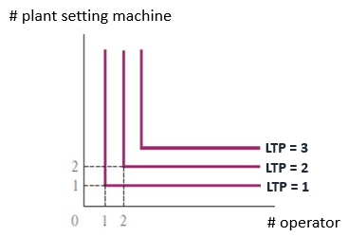  (a) If the Total Production function is $LTP=\text{g}\left(L,K\right),$ what’s the form of g.  (b) Find the input bundle $(L,K)$ having lowest costs when $LTP=1,2,3,4$  (c) Find the corresponding Long-Term Cost, LTC, when $LTP=0, 1,…, 8.$

