E_Lecture3_W2
Name:
ID:

Q1 | [20 pts, 5 pts for each]  (1)  下列何者敘述正確?  a) 期間越短供給曲線的供給價格彈性越大  b) 供給價格彈性與期間長短無關  c) 期間越短供給曲線越趨近於垂直線  d) 期間越短供給曲線越趨近於水平線  Which one of the following descriptions is right?  a) The shorter the time period, the larger the price elasticity of supply.  b) The price elasticity of supply is indifferent to the length of time interval.  c) The shorter the time period, the more the supply curve approaches a vertical line.  d) The shorter the time period, the more the supply curve approaches a horizontal line.  Answer:  (2)  台灣有多家航空公司競爭北高航線，某家航空公司在生存不易下仍決定  降低票價，其根據之理由可能為  a) 供給價格彈性很大  b) 供給價格彈性很小  c) 需求價格彈性很小  d) 需求價格彈性很大  There are several airline companies in Taiwan, and they compete for the air route from Taipei to Kaohsiung. For the companies hard to survive in such intensively competitive market, they decide to lower the price of the ticket from Taipei to Kaohsiung. The reason could be  a) the ticket has large price elasticity of supply.  b) the ticket has small elasticity of supply.  c) the ticket has small price elasticity of demand.  d) the ticket has large price elasticity of demand.  Answer:  (3)  政府對某物進行數量管制，則消費者願付價格與供給者願受價格差距越大，可能表示  a) 供需價格彈性越大  b) 政府政策越有效  c) 供需價格彈性越近似  d) 供需價格彈性越小  The government imposes some restriction on the quantity of a product in the market. The greater the difference between the prices the buyers are willing to pay and the prices the sellers are willing to offer  a) the greater the price elasticity of demand and supply.  b) this policy can easily lower the transaction volume in the market.  c) the more similar the price elasticity of demand and supply.  d) the smaller the price elasticity of demand and supply.  Answer:  (4)  一般而言若某物品之支出佔所得之比例很大，則  a) 該物品之需求價格彈性很小  b) 難以推測該物品需求價格彈性之大小  c) 該物品之需求價格彈性很大  d) 該物品之需求價格彈性與所得無關  In general, if the consumption on a given product accounts for a great part of the total income, then  a) the product has small price elasticity of demand.  b) it is hard to estimate the price elasticity of demand for the product.  c) the product has large price elasticity of demand.  d) it has no relation between the price elasticity of demand and income.  Answer:

Q2 | [40 pts, 8 pts for each]  You own a small town movie theatre. You currently charge $5 per ticket for everyone who comes to your movies. Your friend who took an economics course in college tells you that there may be a way to increase your total revenue. Given the demand curves shown, answer the following questions.  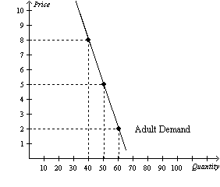  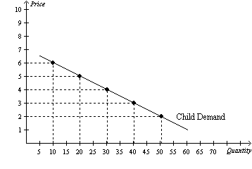  (a) What is your current total revenue for both groups?  (b) The elasticity of demand is more elastic in which market?  (c) What is the elasticity of demand between the prices of $5 and $2 in the adult market? Is this elastic or inelastic?  (d) What is the elasticity of demand between $5 and $2 in the children's market? Is this elastic or inelastic?  (e) Given the graphs and what your friend knows about economics, he recommends you increase the price of adult tickets to $8 each and lower the price of a child's ticket to $3. How much could you increase total revenue if you take his advice?

Q3 | [40 pts, 20 pts for each]  (1)  假設X商品的需求曲線為$Q_{X}^{D}=100-P_{X}$，供給曲線為 $Q_{X}^{S}=P_{X}$；若政府訂定價格管制，規定 $P_{X}$ 不得低於70，則市場成交量是多少?  Suppose that the demand curve for the product X is$Q_{X}^{D}=100-P_{X}$, and the supply curve is $Q_{X}^{S}=P_{X}$. What is the final transaction volume if the government set $70 as the price floor of the product?  (2)  承上題，如果政府定下的是數量管制，規定成交量$Q_{X}$不能超過30，則市場上的願付與願受價格差距會是多少?  Following the aforementioned question, if the government imposes a restriction on quantity and set 30 as the quantity ceiling, what is the difference between price buyers willing to pay and the price sellers willing to offer?

