E_Lecture5_W2
Name:
ID:

Q1 | [20 pts, 10 pts for each]  亮亮在釣魚台島上釣魚，在使用一套漁具之下，其釣魚時數(L)與漁獲量(STP) 之間關係如下表所示:  Alex went fishing on the island. He used a fishing tackle. The time he took is L and the corresponding yield of catch is TP. The relation between L and STP is as follows.  L(hr) 1 2 3 4 5 6  STP 5 15 22 28 32 33  (1)  試由表中的數據，推導亮亮勞動力投入的平均產量、邊際產量  Calculate the $S{AP}_{L}$ and $S{MP}_{L}$ according to the table.  (2)  假設每套漁具每6個小時的租金為100元，而亮亮每小時可賺得的最高  薪資為300元。試由上表所給的數據推導總成本、總固定成本、總變動  成本  If the rent of the fishing tackle is $100 per 6hrs, and the highest salary Alex can obtain per hours is $300. Calculate the TC, TFC, and TVC according to the table.

Q2 | [20 pts, 10 pts for each]  健荃在街上賣枝仔冰，其固定成本為20元，冰棒的數量(STP)與總成本(STC) 的關係如下表  Wendy is the seller of ice cream. In the short run, her fixed cost of selling ice cream is $20. The relation between her quantity supplied (STP) and the corresponding total cost (STC) is as follows.  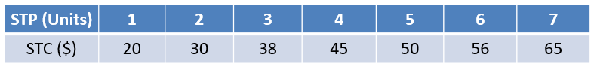  (1)  試由表中的數據推估短期之內各產量對應的總固定成本(STFC)、總變動成本(STVC)、平均固定成本(SAFC)、平均變動成本(SAVC)、短期平均成本(SAC)、邊際成本(SMC)  With the information above, calculate the STFC, STVC, SAFC, SAVC, SAC and SMC  (2)  如果每一枝枝仔冰賣10元，在健荃賣出3枝冰棒的情況下，利潤為多少?  Suppose that the price of a ice cream is $10. What is her profit if she sells three ice cream?

Q3 | [30 pts]  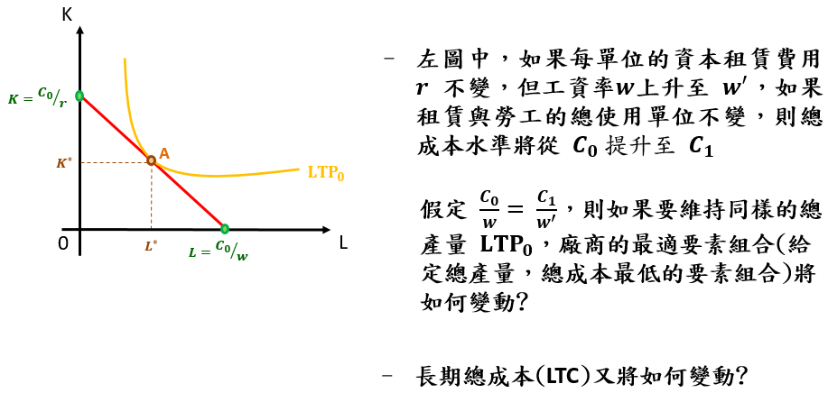  - In the above figure, we suppose that the cost of using one unit of fixed factor is $r$ and the cost of using one unit of variable cost is $w$. Once the $w$ rises to $w^{'}$ and the $r$ is unchanged so that the total cost increases from $C_{0}$ to $C_{1}.$ If $\frac{C_{0}}{w}=$ $\frac{C_{1}}{w^{'}}$, what is the producer’s input bundle having the lowest Long-Term Cost (LTC) given that the its total product ${LTP}_{0}$ is unchanged.  - What’s the corresponding LTC if the producer chooses the optimal input  bundle?

Q4 | [30 pts, 10 pts for each]  (1)  A firm is producing 20 units with an average cost (SAC or LAC) of $25  and a marginal cost (SMC or LMC) of $15. If it were to increase production to  21 units, which of the following must occur?  (a) Marginal cost would decrease.  (b) Marginal cost would increase.  (c) Average cost would be decrease.  (d) Average cost would be increase.  Answer: _______  (2)  The government imposes a $1000 per year license fee on all pizza  restaurants. As a result, which cost curves shift?  (a) average cost (SAC or LAC) and marginal cost (SMC or LMC)  (b) average cost and average fixed cost (SAFC or LAFC).  (c) average variable cost (SVAC or LAVC) and marginal cost  (d) average variable cost and average fixed cost.  Answer: _______  (3)  If a higher level of production allows workers to specialize in particular tasks, a firm will likely exhibit of scale and average cost (LAC).  (a) economies, falling  (b) economies, rising.  (c) diseconomies, falling.  (d) diseconomies, rising.  Answer: _______

