CSC59866-E: Bi-weekly Research Progress Update 2
Topic: AI Agents for Distributed Chip Design
Team: Johir Hossain & Linwei Zheng
Date: April 20, 2026
GitHub Repository
- https://github.com/LWZ459/ai-chip-design-agent
- Account created: Yes. Both team members have access.
Research Question (Revised from Week 1 Feedback)
- How can AI agents collaborate in a distributed system to optimize different stages of chip design?
- Justification of Impact: Chip design is a multi-billion dollar industry where manual optimization takes months. If AI agents can collaborate to place macros on a chip and route wires between them, design time may be reduced from weeks to hours. Faster chip design can enable faster, cheaper, and more energy-efficient processors for devices ranging from smartphones to AI data centers.
Input Datasets, Benchmarks, Models, Environments
- ISPD2005 Benchmark Suite: Industry-standard floorplanning benchmarks with 100-500 macros per chip.
- MCNC Benchmark Suite: Smaller benchmarks (10-50 macros) suitable for prototyping.
- Feasibility Check: Both datasets were downloaded and tested locally and in Google Colab. MCNC will be used for initial prototyping.
- Models/Algorithms: AlphaChip (Google DeepMind) for RL-based floorplanning; FD-MAGRPO for multi-agent RL circuit sizing.
- Environment: Custom Gymnasium environment (SimpleChipEnv), grid size 10x10 prototype scaling to 32x32, 5-10 macros initially scaling to 50.
Output and Metrics
- Expected outputs include final macro positions on a grid, coordinate list, and wirelength value.
- Metrics: Wirelength, Congestion, Runtime, Reward, and Sample Efficiency.
- Baseline comparison: Random agent already implemented; learning agents should outperform it.
Coding Updates
- GitHub repository created.
- Google Colab environment set up.
- SimpleChipEnv class implemented.
- Random agent implemented and tested.
- Prototype executed successfully.
- Prototype result: 5 macros placed in 5 steps with total reward of -25.
1. Environment Setup
!pip install gymnasium numpy matplotlib

import numpy as np
print("Setup complete!")
print(f"NumPy version: {np.__version__}")
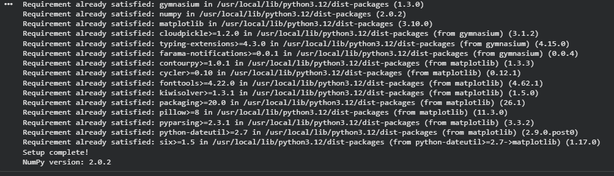
2. Simple Environment Class
class SimpleChipEnv:
def __init__(self, grid_size=10):
self.grid_size = grid_size
self.grid = np.zeros((grid_size, grid_size))
self.macros_placed = []

def reset(self):
self.grid = np.zeros((self.grid_size, self.grid_size))
self.macros_placed = []
return self.grid

def step(self, action):
x, y = action
if self.grid[x, y] == 0:
self.grid[x, y] = 1
self.macros_placed.append((x, y))
reward = -len(self.macros_placed) # Simple reward
done = len(self.macros_placed) >= 5
return self.grid, reward, done
else:
return self.grid, -10, False

3. Random Agent
def random_action(env):
x = np.random.randint(0, env.grid_size)
y = np.random.randint(0, env.grid_size)
return (x, y)
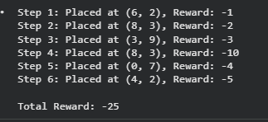
Report Writing Updates
- Project abstract started using Overleaf LaTeX template.
- Methodology outlined: environment design, random baseline, tabular Q-learning, Deep Q-Network, and multi-agent extension.
Plan for Running Code
- Google Colab will be used for experiments due to free GPU access, easy sharing, and minimal setup.
- Python files will be stored in GitHub and imported into Colab notebooks.
Timeline
- Week 2: Random agent prototype (Completed).
- Week 3: Wirelength reward function and Tabular Q-learning.
- Week 4: Deep Q-Network and comparison against random baseline.
- Week 5: Multi-agent extension.
Challenges and Solutions
- Neural networks are new: complete introductory tutorials.
- PyTorch syntax unfamiliar: follow beginner tutorials.
- Partner communication needs improvement: weekly Zoom meetings scheduled Mondays at 5 PM.
Individual Tasks (Week 2)
- Johir Hossain: Repository setup, environment implementation, random agent, dataset downloads, weekly update.
- Linwei Zheng: Review code, draft wirelength pseudocode, study Gymnasium tutorials.
Joint Group Tasks
- Discussed MDP formulation.
- Agreed to start with single-agent design.
- Agreed to use Manhattan distance for wirelength.
Next Week Goals (Week 3)
- Implement wirelength function.
- Add wirelength to reward.
- Run random agent with new reward.
- Start tabular Q-learning.
- Submit next progress update.

Codes we can try:
- AlphaChip: https://github.com/google-research/circuit_training

