**Groups 12-22 optimizer choice tf.train.AdamOptimizer**

**Groups 18-20 size of memory matrix 128×32**

**Group 18: number of read heads R = 2**

1. Testing DNC performance under iterations 20,000 and w/ clipping gradients with ranges: 10.

When change some name and noun to she/he and it:

1. Testing DNC performance under iterations 80,000 and w/ clipping gradients with ranges: 10.

When change some name and noun to she/he and it:

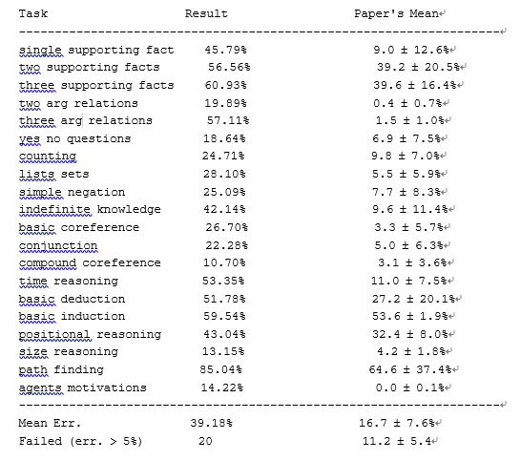

1. Testing DNC performance under iterations 20,000 and w/ clipping gradients with ranges: 6.

When change some name and noun to she/he and it:

1. Testing DNC performance under iterations 80,000 and w/ clipping gradients with ranges: 6.

When change some name and noun to she/he and it:

1. Testing DNC performance under iterations 20,000, w/o clipping gradients.

When change some name and noun to she/he and it:

1. Testing DNC performance under iterations 80,000, w/o clipping gradients.

When change some name and noun to she/he and it:

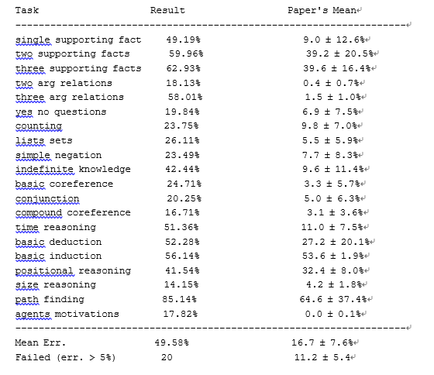

During testing for each scenario, do on both the original data and the manipulated data. I.e. replacing the name of the object by it (e.g. replacing football by it in few places as discussed during the lecture)

After running the 12 cases above, we can see that the average error rate of 20000-training is higher than 80000-training. When we change some names and noun to she/he and it, the error rate will raise as well.