DFO Multispecies Survey Trip Report

Newfoundland and Labrador Region

Science Branch

## TRIP SUMMARY

**Vessel:** Teleost | **Trip number:** TEL190

**Sailed from:** St. Anthony, NL | **Returned to:** St. John’s, NL

**Start Date:** October 24, 2018 **End Date:** November 6, 2018

**Scientific Staff:** Laura Wheeland(SIC), F. Dawson, K. Rideout, M. Terry, B. Vaters, P. Higdon, J. Croft, F. Tulk, T. Bungay

This report has been prepared by Laura Wheeland(SIC).

**Area of Operation:** NAFO Divisions 2H and 2J fishing in depths to a maximum of 1334 meters.

**Purpose:**

**Fishing Methods:**

## Catch Summary

This trip completed 35 sets in NAFO divisions 2J, 2H. Total catch was 6961kg, with 167 taxa recorded. Fishing occurred from 129m to 1334m.  
 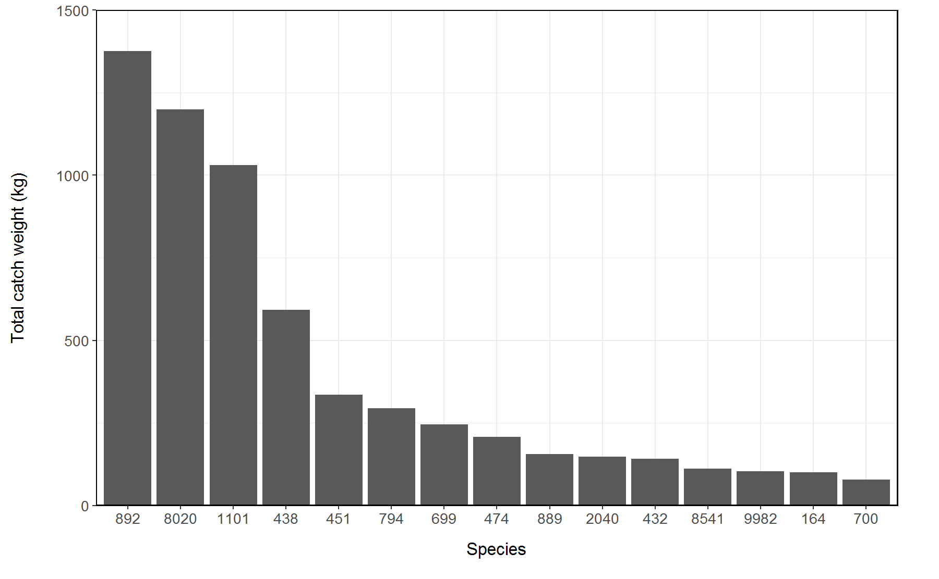

*Figure 1: Total catch weight of the fifteen most commonly encountered taxa during trip TEL190*

# 

# {r Sets.Table, echo=FALSE} # #n_sets <- RV.SET %>% # group_by(depth.bin) %>% # summarize(N=n()) # # #

# kable(n_sets, format=“markdown”)