Homework 1

1. A router processes the Network, Link, and Physical layers. A link-layer switch processes the Link and Physical layers. A host processes all layers of an IP Stack.
2. a. Over 30 hops maximum from home to mail.uwf.edu it times out after 12

b. Over 30 hops maximum for www.amazon.com it times out after 8

1. 
2. The maximum number of connections is 16. There are 8 possible simultaneous connections from A to C. Yes it is possible.
3. 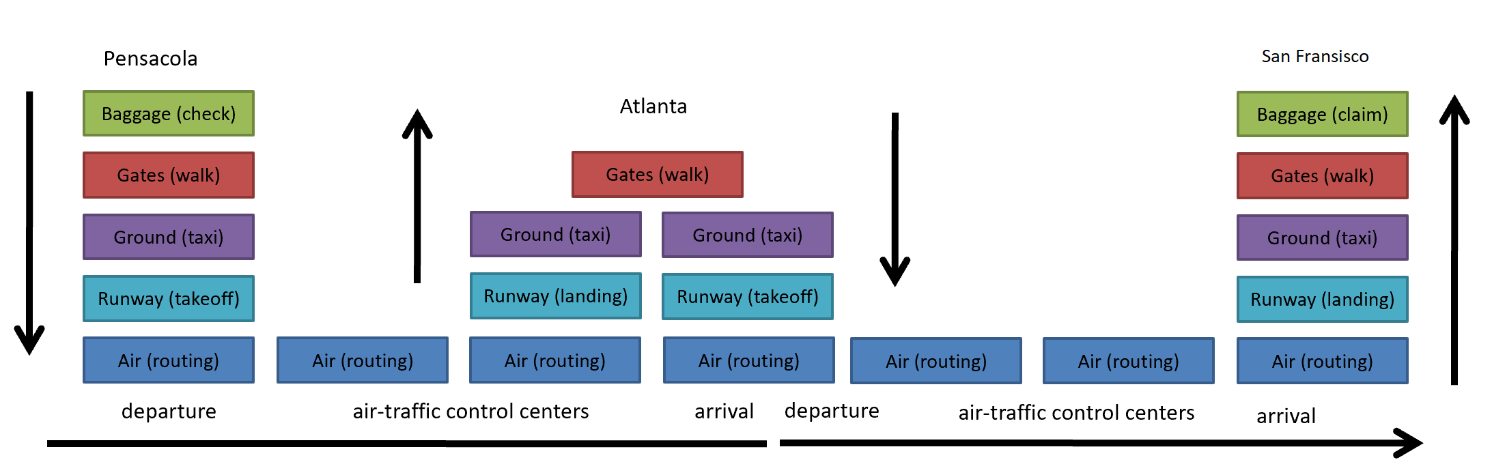
4. a. T = L/R, 8ooo kbps / 2000 kbps = 4 seconds from host to first switch. 3 hops x 4 sec/hop = total 12 seconds

b. 10 kbps per packet / 2000 kbps = .005 seconds from hos to first switch. (.005) seconds x 2 for the second packet to reach the first switch = .01 seconds or 10msec.

c. # of hops x time per hop = 3 hops x .005 sec/hop = .015 seconds or 15 msec.

1. a. dprop = Distance / Prop Speed, so 150 km / 100 km per hour = 1.5 hrs.

dtrans = # of cars x seconds per car = 10 x 12 = 120 seconds. Then, 3 tollbooths x 2 mins per car (120 sec.) = 6 minutes.

dend-to-end = dprop + dtrans = 1.5 hrs + 6 mins = 1 hr. 36 mins

b. 8 cars x 12 sec per car = 96 sec. 3 tollbooths x 96 sec = 288 sec (4 min 48 sec.). dend-to-end = 1.5 hrs + 4 mins 48 secs = 1 hr 34 mins 48 sec.

1. a. dprop = distance / speed = m/s seconds

b. dtrans = Length / Rate = L/R

c. dend-to-end = (L/R)+(m/s) seconds

d. transmitted or pushed onto the link

e. on the first packet

f. the first bit has reached destination B

g. dprop = dtrans so (m/s) = (L/R) = (m/2.5 x 108) = (120 bits / 56 kbps)

m = (120 bits / 56 kbps) x 2.5 x 108 = 30 x 109 / 56 x 103 = 535.714 km

1. LAB:
   1. Internet Protocol, Transmission Control Protocol, and Hypertext Transfer Protocol
   2. Roughly 4 seconds
   3. 128.119.245.12 and 192.168.0.67