1. 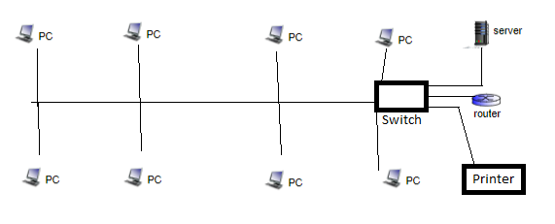

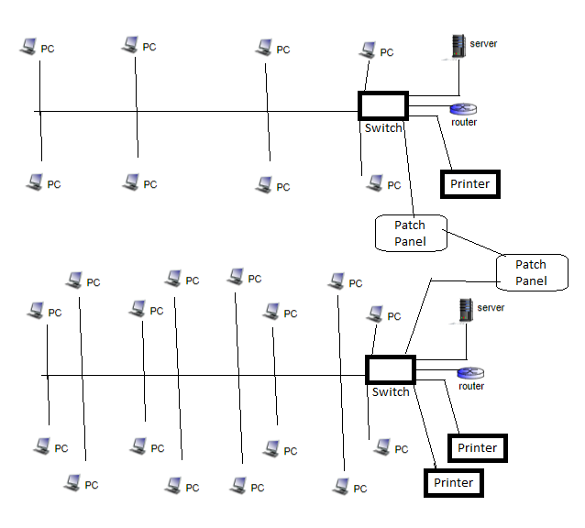

Plan 1:

* 1. 12-port switch - $49.99
  2. Router - $49.99
  3. Network printer - $349
  4. Server - $399
  5. Patch cables - $40

Plan 2:

1. 24-port switch - $78.99
2. Router - $ 49.99
3. 2 network printers - $698
4. Server - $399
5. 2 patch panels - $40
6. Patch cables - $40
7. Fiber has a higher bandwidth capability, so it can handle more ‘traffic’ and creates room for more growth.
8. Physical v. Logical:
   1. Logical topology is how devices appear to connect to users; whereas, physical topology is the actual connection with cables within a network.

Bus:

1. A topology that uses a ‘backbone’ setup. All the nodes of a LAN are connected to a single cable.

Star:

1. All nodes of a LAN are connected to a central point via individual cables. This setup prevents the entire network from collapsing if there is a failure in one area.

Ring:

1. A network configuration where the nodes of the LAN are each connected to two other nodes creating a circle pattern across the network.

Mesh:

1. All nodes of the network are connected to each other to distribute information among the network. A full mesh network is any given node has a direct connection to all other nodes; whereas, a partial mesh network means any given node may have a connection to any number of other nodes in the network.