# CNT 4007C - Theory and Fundamentals of Computer Networks Homework Assignment 3

### Problem 1 – 4 Points

### a. Suppose the information content of a packet is the bit pattern 1110101010101111 and an even parity scheme is being used. What would the value of the checksum field (sequence of parity bits) be for the case of a two-dimensional parity scheme? Your answer should be such that a minimum-length checksum field is used. (2 pts)

|  |  |  |  |  |
| --- | --- | --- | --- | --- |
| 1 | 1 | 1 | 0 | 1 |
| 1 | 0 | 1 | 0 | 0 |
| 1 | 0 | 1 | 0 | 0 |
| 1 | 1 | 1 | 1 | 0 |
| 0 | 0 | 0 | 1 | 1 |

### 1110 1010 1010 1111 1000 0001

### b. With the same bit-pattern and your derived checksum, prove that the 2D scheme will not be able to detect all burst errors? (2 pts)

|  |  |  |  |  |
| --- | --- | --- | --- | --- |
| 1 | 1 | 1 | 0 | 1 |
| 1 | 1 | 0 | 0 | 0 |
| 1 | 1 | 0 | 0 | 0 |
| 1 | 1 | 1 | 1 | 0 |
| 0 | 0 | 0 | 1 | 1 |

### Problem 2 – 3 Points

Consider the 5-bit generator, G=10011, and suppose that D has the value 1010101010. What is the value of R?

101101

|  |  |
| --- | --- |
| 10011 | 1010101010 |

10011

0011001

10011

010100

10011

0011110

10011

01101 => R: 1101

### Problem 3 – 10 Points

Given the data-bits **m = 11010110**, determine the number of k (parity-bits) by using Hamming Code requirements. Illustrate the error detection and correction scheme using Hamming code method, for both the sender and receiver to detect an error at the following positions:

2k >= m+k+1 : 24 > 8 + 4 + 1 : parity bits = 4

1. **6th bit position**.
2. **11th bit position**.

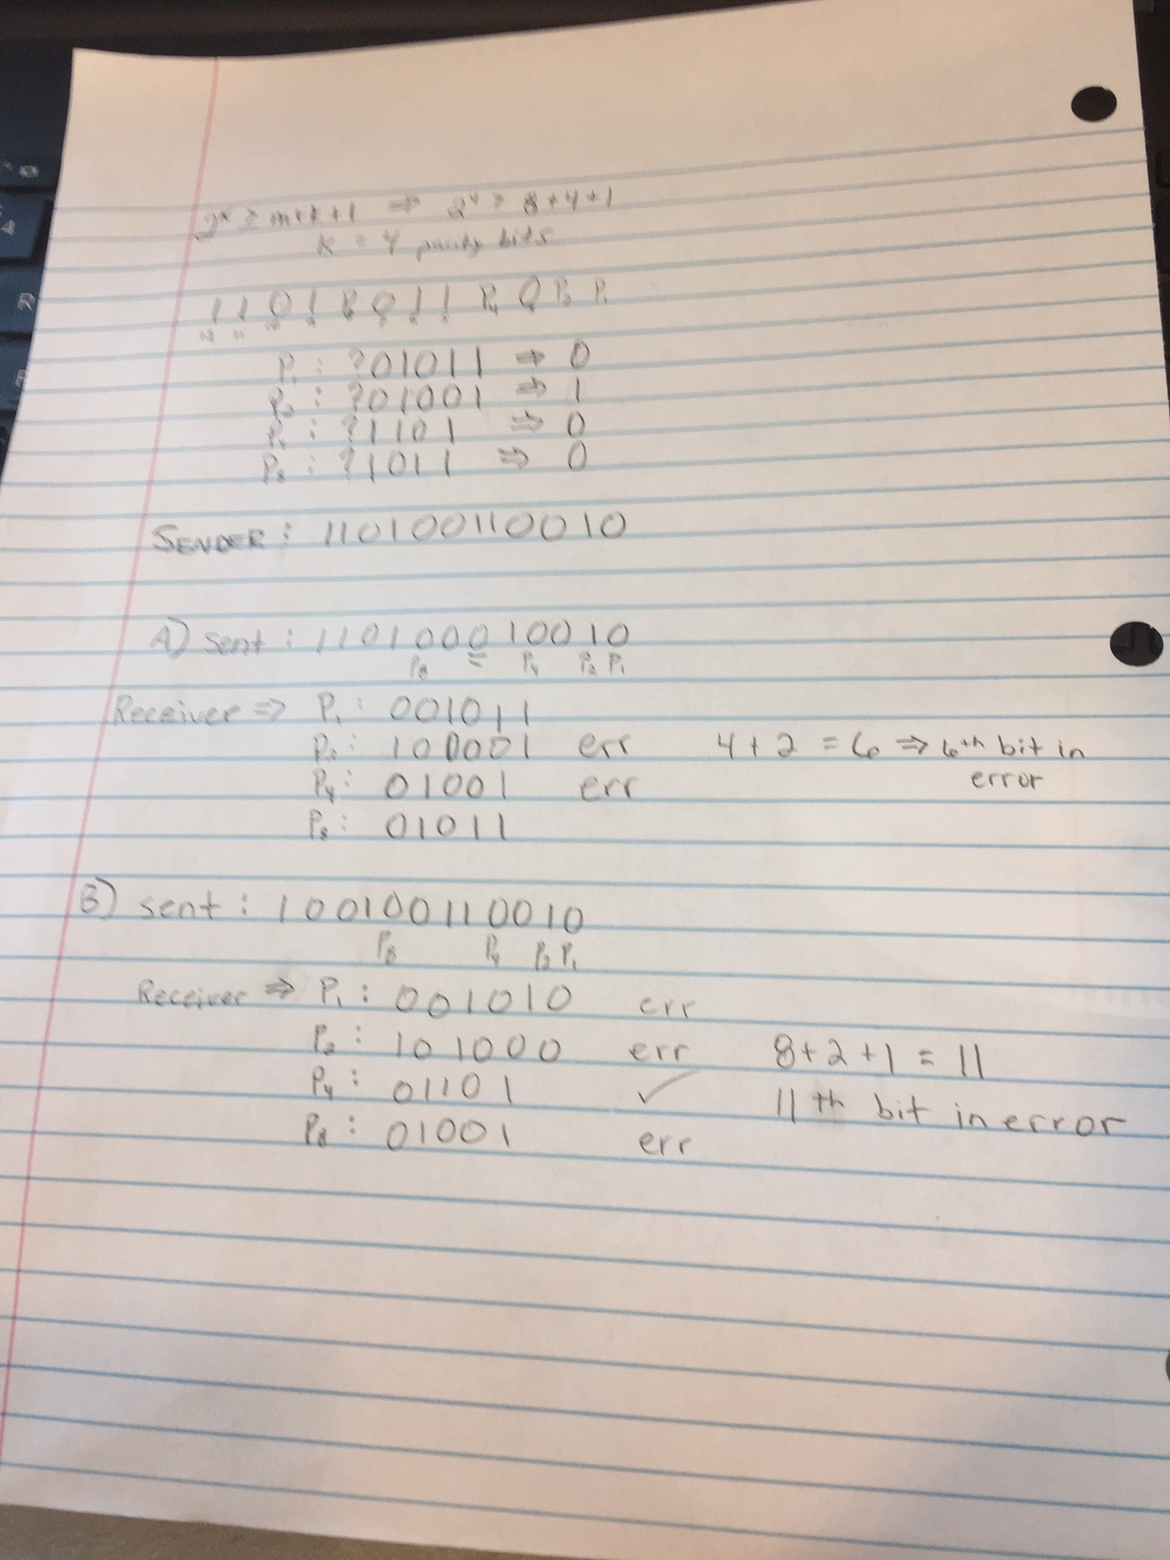

Assume an **odd-parity** scheme for this problem. You must show detailed calculations to receive full-credit.

### Problem 4 – 3 Points

### Draw the waveforms for line encoding of the bit pattern 1010111110

### 1. Using Manchester scheme

### 2. Using RZ scheme

### 

### 3. Using Bipolar AMI scheme

### A close up of an object Description automatically generatedProblem 5 – 2 Points

### Consider the single-sender CDMA example in the following figure: Screen Shot 2017-02-14 at 9.35.51 AM.png

### What would be the sender’s output (for the 2 data bits shown) if the sender’s CDMA code were (1, –1, 1, –1, 1, –1, 1, –1)? Output = d * cdma

|  |  |  |  |  |  |  |  |  |
| --- | --- | --- | --- | --- | --- | --- | --- | --- |
| d0 | 1 |  |  |  |  |  |  |  |
| CDMA | 1 | -1 | 1 | -1 | 1 | -1 | 1 | -1 |
| Output | 1 | -1 | 1 | -1 | 1 | -1 | 1 | -1 |
| d1 | -1 |  |  |  |  |  |  |  |
| CDMA | 1 | -1 | 1 | -1 | 1 | -1 | 1 | -1 |
| Output | -1 | 1 | -1 | 1 | -1 | 1 | -1 | 1 |

**Problem 6 – 2 Points**

Describe the process of Active and Passive scanning in 802.11 networks?

Active scan: The client sends a probe request and listens for a probe response from an AP.

Passive scan: The client radio listens on each channel for beacons sent periodically by an AP.

Submission Instructions:

1. Submit a single pdf document for your solution to all problems. Submitting multiple files may result in deduction of points.
2. Your submission must list your name, major, date of submission and course prefix [CNT 4007C] on the header area.