实验八 PDO操作数据库
实验目的：
1、掌握MySQLi访问数据库的方法
2、掌握PDO操作数据库的方法；
2、掌握事务、存储过程的实现；
实验内容：
分别使用MySQLi库和PDO连接MySQL（或其他数据库服务器）的TestDB数据库，通过浏览器客户端程序实现以下功能：
- 创建Student学生表，包含:学号、姓名、性别、年龄、籍贯、手机号码。其中，学号为主键，姓名不超过10个汉字（只能为汉字），年龄5~50岁，性别只能为男或女；
- 用户通过页面中的表格向表中插入3条记录；
- 根据用户输入的籍贯/姓名/学号查询学生信息并在页面显示；
- 根据用户选择/输入的学号/姓名修改其手机号码；
- 根据用户选择/输入的学号/姓名删除学生信息。删除以要用户进行确认；
- 在数据库中定义存储过程pro_sel实现根据学号查询学生信息。在客户端通过该存储过程进行查询。
创建Student学生表：
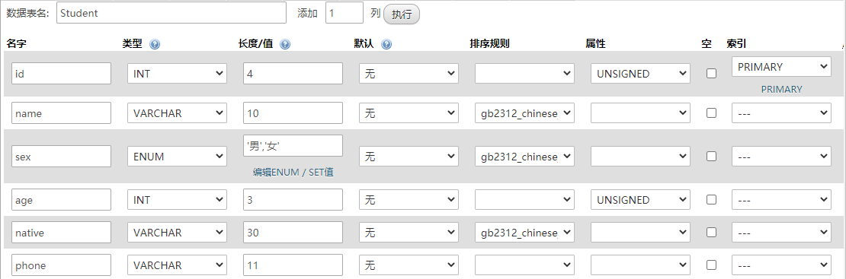
图1 Student表的创建
创建存储过程：
图2 存储过程的创建
（1）使用MySQLi库连接MySQL
conn.php：连接数据库
<?php
header("content-type:text/html;charset=utf-8");
$host = "127.0.0.1";
$username = "root";
$password = "123456";
$db = "TestDB";
$conn = mysqli_connect($host,$username,$password,$db);
// if($conn){
// echo "数据库连接成功！";
// }
// else{
// echo "数据库连接失败！";
// }
?>
insert.php：添加3条学生记录
<!DOCTYPE HTML>
<html>
<meta http-equiv="Content-Type" content="text/html; charset=utf-8" />
<title>添加学生</title>
</head>

<body>
<script language="javascript">
function check(){
var ids = document.getElementsByName("id[]");
var names = document.getElementsByName("name[]");
var ages = document.getElementsByName("age[]");
var natives = document.getElementsByName("native[]");
var phones = document.getElementsByName("phone[]");
for(var i = 0; i < 3; i++){
//检查学号
if(ids[i].value == ""){
alert("学号不能为空！");
ids[i].focus();
return false;
}
else{
var patt = /^[0-9]*$/;
if(!patt.test(ids[i].value)){
alert("学号只能是数字！");
ids[i].focus();
return false;
}
}
//检查姓名
if(names[i].value == ""){
alert("姓名不能为空！");
names[i].focus();
return false;
}
else{
var patt = /^[\u4e00-\u9fa5]{1,10}$/;
if(!patt.test(names[i].value)){
alert("姓名只能是不超过10个的汉字！");
names[i].focus();
return false;
}
}
//检查年龄
if(ages[i].value == ""){
alert("年龄不能为空！");
ages[i].focus();
return false;
}
else{
if(ages[i].value < 5 || ages[i].value > 50){
alert("年龄只能是5~50岁！");
ages[i].focus();
return false;
}
}
//检查籍贯
if(natives[i].value == ""){
alert("籍贯不能为空！");
natives[i].focus();
return false;
}
//检查手机号码
if(phones[i].value == ""){
alert("手机号码不能为空！");
phones[i].focus();
return false;
}
}
}
</script>

<div align="center"><h3>添加学生记录</h3><div>
<form method="post" action="<?php echo htmlspecialchars($_SERVER["PHP_SELF"]);?>">
<table border="1" cellspacing="0" align="center">
<tr>
<th>学号</th><th>姓名</th><th>性别</th><th>年龄</th><th>籍贯</th><th>手机号码</th>
</tr>
<?php
for($i = 0; $i < 3; $i++){
?>
<tr>
<td><input type="text" name="id[]" size="4" /></td>
<td><input type="text" name="name[]" size="10" /></td>
<td width="60" align="center">
<select name="sex[]">
<option selected>男</option>
<option>女</option>
</select>
</td>
<td><input type="text" name="age[]" size="3" /></td>
<td><input type="text" name="native[]" /></td>
<td><input type="text" name="phone[]" /></td>
</tr>
<?php
}
?>
</table>
<br />
<div align="center">
<input type="submit" value="添加" onClick="return check();" />
<div>
</form>

<?php
if($_SERVER["REQUEST_METHOD"] == "POST"){
include_once("conn.php");
$id = $_POST['id'];
$name = $_POST['name'];
$sex = $_POST['sex'];
$age = $_POST['age'];
$native = $_POST['native'];
$phone = $_POST['phone'];
$sql = "insert into Student values ";
for($i = 0; $i < 3; $i++){
$sql.= "('".$id[$i]."','".$name[$i]."','".$sex[$i]."','".$age[$i]."','".$native[$i]."','".$phone[$i]."')";
if($i < 2){
$sql.= ",";
}
}
$result = mysqli_query($conn,$sql);
if($result){
echo "<script language='javascript'>alert('添加成功！');location.href='query.php';</script>";
}
else{
echo "<script language='javascript'>alert('添加失败！');location.href='insert.php';</script>";
}
}
?>
</body>
</html>
query.php：查询学生信息
<!DOCTYPE HTML>
<html>
<meta http-equiv="Content-Type" content="text/html; charset=utf-8" />
<title>查询学生</title>
</head>

<body>
<script language="javascript">
function isDelete(){
return confirm("是否删除？");
}
</script>
<div align="center"><h3>查询学生信息</h3><div>
<form method="post" action="<?php echo htmlspecialchars($_SERVER["PHP_SELF"]);?>">
<table align="center">
<tr>
<td>学号：<input type="text" name="id" /></td>
<td>姓名：<input type="text" name="name" /></td>
<td>籍贯：<input type="text" name="native" /></td>
<td><input type="submit" value="查询" /></td>
</tr>
</table>
</form>
<br>
<table align="center" border="1" cellspacing="0" width="730">
<tr>
<th>学号</th><th>姓名</th><th>性别</th><th>年龄</th><th>籍贯</th><th>手机号码</th><th>操作</th>
</tr>
<?php
header("content-type:text/html;charset=utf-8");
include_once("conn.php");
$sql = "select * from Student ";
if($_SERVER["REQUEST_METHOD"] == "POST"){
$id = $_POST['id'];
$name = $_POST['name'];
$native = $_POST['native'];
$flag = true;
if($id){
if($flag){
$sql.= "where id = '".$id."' ";
$flag = false;
}
else{
$sql.= "and id = '".$id."' ";
}
}
if($name){
if($flag){
$sql.= "where name = '".$name."' ";
$flag = false;
}
else{
$sql.= "and name = '".$name."' ";
}
}
if($native){
if($flag){
$sql.= "where native = '".$native."' ";
$flag = false;
}
else{
$sql.= "and native = '".$native."' ";
}
}
}
$result = mysqli_query($conn,$sql);
while($myrow = mysqli_fetch_row($result)){
?>
<tr align="center">
<td><?php echo $myrow[0]; ?></td>
<td><?php echo $myrow[1]; ?></td>
<td><?php echo $myrow[2]; ?></td>
<td><?php echo $myrow[3]; ?></td>
<td><?php echo $myrow[4]; ?></td>
<td><?php echo $myrow[5]; ?></td>
<td>
<a href="update.php?id=<?php echo $myrow[0]; ?>">修改</a>|
<a href="delete.php?id=<?php echo $myrow[0]; ?>" onClick="return isDelete();">删除</a>
</td>
</tr>
<?php
}
?>
</table>
</body>
</html>
update.php：修改学生手机号页面
<!DOCTYPE HTML>
<html>
<meta http-equiv="Content-Type" content="text/html; charset=utf-8" />
<title>修改学生</title>
</head>

<body>

<form method="post" action="update_ok.php">
<div align="center">
请输入新的手机号码：<input type="text" name="phone" />
<input type="hidden" name="id" value="<?php echo $_GET['id']; ?>">
<input type="submit" value="完成">
</div>
</form>

</body>
</html>
update_ok.php：更新学生信息
<?php
header("content-type:text/html;charset=utf-8");
include_once("conn.php");
$id = $_POST['id'];
$phone = $_POST['phone'];
$sql = "update Student set phone = '".$phone."' where id = '".$id."'";
if($result = mysqli_query($conn,$sql)){
echo "<script language='javascript'>alert('修改成功！');location.href='query.php';</script>";
}
else{
echo "<script language='javascript'>alert('修改失败！');location.href='update.php?id=".$id."';</script>";
}
?>
delete.php：删除学生信息
<?php
header("content-type:text/html;charset=utf-8");
include_once("conn.php");
$id = $_GET['id'];
$sql = "delete from Student where id = '".$id."'";
if($result = mysqli_query($conn,$sql)){
echo "<script language='javascript'>alert('删除成功！');location.href='query.php';</script>";
}
else{
echo "<script language='javascript'>alert('删除失败！');location.href='query.php';</script>";
}
?>
querybyid.php：调用存储过程根据学号查询学生信息
<!DOCTYPE HTML>
<html>
<meta http-equiv="Content-Type" content="text/html; charset=utf-8" />
<title>查询学生</title>
</head>

<body>
<div align="center"><h3>根据学号查询学生信息</h3><div>
<form method="post" action="<?php echo htmlspecialchars($_SERVER["PHP_SELF"]);?>">
<table align="center">
<tr>
<td>学号：<input type="text" name="id" /></td>
<td><input type="submit" value="查询" /></td>
</tr>
</table>
</form>
<br>
<table align="center" border="1" cellspacing="0" width="730">
<tr>
<th>学号</th><th>姓名</th><th>性别</th><th>年龄</th><th>籍贯</th><th>手机号码</th>
</tr>
<?php
header("content-type:text/html;charset=utf-8");
if($_SERVER["REQUEST_METHOD"] == "POST"){
include_once("conn.php");
$sql = "call pro_sel('".$_POST['id']."')";
$result = mysqli_query($conn,$sql);
while($myrow = mysqli_fetch_row($result)){
?>
<tr align="center">
<td><?php echo $myrow[0]; ?></td>
<td><?php echo $myrow[1]; ?></td>
<td><?php echo $myrow[2]; ?></td>
<td><?php echo $myrow[3]; ?></td>
<td><?php echo $myrow[4]; ?></td>
<td><?php echo $myrow[5]; ?></td>
</tr>
<?php
}
}
?>
</table>
</body>
</html>
（2）使用PDO连接MYSQL
insert.php：添加3条学生记录
<!DOCTYPE HTML>
<html>
<meta http-equiv="Content-Type" content="text/html; charset=utf-8" />
<title>添加学生</title>
</head>

<body>
<script language="javascript">
function check(){
var ids = document.getElementsByName("id[]");
var names = document.getElementsByName("name[]");
var ages = document.getElementsByName("age[]");
var natives = document.getElementsByName("native[]");
var phones = document.getElementsByName("phone[]");
for(var i = 0; i < 3; i++){
//检查学号
if(ids[i].value == ""){
alert("学号不能为空！");
ids[i].focus();
return false;
}
else{
var patt = /^[0-9]*$/;
if(!patt.test(ids[i].value)){
alert("学号只能是数字！");
ids[i].focus();
return false;
}
}
//检查姓名
if(names[i].value == ""){
alert("姓名不能为空！");
names[i].focus();
return false;
}
else{
var patt = /^[\u4e00-\u9fa5]{1,10}$/;
if(!patt.test(names[i].value)){
alert("姓名只能是不超过10个的汉字！");
names[i].focus();
return false;
}
}
//检查年龄
if(ages[i].value == ""){
alert("年龄不能为空！");
ages[i].focus();
return false;
}
else{
if(ages[i].value < 5 || ages[i].value > 50){
alert("年龄只能是5~50岁！");
ages[i].focus();
return false;
}
}
//检查籍贯
if(natives[i].value == ""){
alert("籍贯不能为空！");
natives[i].focus();
return false;
}
//检查手机号码
if(phones[i].value == ""){
alert("手机号码不能为空！");
phones[i].focus();
return false;
}
}
}
</script>

<div align="center"><h3>添加学生记录</h3><div>
<form method="post" action="<?php echo htmlspecialchars($_SERVER["PHP_SELF"]);?>">
<table border="1" cellspacing="0" align="center">
<tr>
<th>学号</th><th>姓名</th><th>性别</th><th>年龄</th><th>籍贯</th><th>手机号码</th>
</tr>
<?php
for($i = 0; $i < 3; $i++){
?>
<tr>
<td><input type="text" name="id[]" size="4" /></td>
<td><input type="text" name="name[]" size="10" /></td>
<td width="60" align="center">
<select name="sex[]">
<option selected>男</option>
<option>女</option>
</select>
</td>
<td><input type="text" name="age[]" size="3" /></td>
<td><input type="text" name="native[]" /></td>
<td><input type="text" name="phone[]" /></td>
</tr>
<?php
}
?>
</table>
<br />
<div align="center">
<input type="submit" value="添加" onClick="return check();" />
<div>
</form>

<?php
header("content-type:text/html;charset=utf-8");
if($_SERVER["REQUEST_METHOD"] == "POST"){
$id = $_POST['id'];
$name = $_POST['name'];
$sex = $_POST['sex'];
$age = $_POST['age'];
$native = $_POST['native'];
$phone = $_POST['phone'];
$host = "127.0.0.1";
$username = "root";
$password = "123456";
$db = "TestDB";
$dsn = "mysql:host=$host;dbname=$db";
try{
$conn = new PDO($dsn,$username,$password);
$conn->setAttribute(PDO::ATTR_ERRMODE, PDO::ERRMODE_EXCEPTION);

// 开始事务
$conn->beginTransaction();
for($i = 0; $i < 3; $i++){
$sql = "insert into Student values('".$id[$i]."','".$name[$i]."','".$sex[$i]."','".$age[$i]."','".$native[$i]."','".$phone[$i]."')";
$conn->exec($sql);
}
// 提交事务
$conn->commit();
echo "<script language='javascript'>alert('添加成功！');location.href='query.php';</script>";
}catch(Exception $e){
//echo $e->getMessage()."<br>";
echo "<script language='javascript'>alert('添加失败！');location.href='insert.php';</script>";
}
}
?>
</body>
</html>
query.php：查询学生信息
<!DOCTYPE HTML>
<html>
<meta http-equiv="Content-Type" content="text/html; charset=utf-8" />
<title>查询学生</title>
</head>

<body>
<script language="javascript">
function isDelete(){
return confirm("是否删除？");
}
</script>
<div align="center"><h3>查询学生信息</h3><div>
<form method="post" action="<?php echo htmlspecialchars($_SERVER["PHP_SELF"]);?>">
<table align="center">
<tr>
<td>学号：<input type="text" name="id" /></td>
<td>姓名：<input type="text" name="name" /></td>
<td>籍贯：<input type="text" name="native" /></td>
<td><input type="submit" value="查询" /></td>
</tr>
</table>
</form>
<br>
<table align="center" border="1" cellspacing="0" width="730">
<tr>
<th>学号</th><th>姓名</th><th>性别</th><th>年龄</th><th>籍贯</th><th>手机号码</th><th>操作</th>
</tr>
<?php
header("content-type:text/html;charset=utf-8");
$sql = "select * from Student ";
if($_SERVER["REQUEST_METHOD"] == "POST"){
$id = $_POST['id'];
$name = $_POST['name'];
$native = $_POST['native'];
$flag = true;
if($id){
if($flag){
$sql.= "where id = '".$id."' ";
$flag = false;
}
else{
$sql.= "and id = '".$id."' ";
}
}
if($name){
if($flag){
$sql.= "where name = '".$name."' ";
$flag = false;
}
else{
$sql.= "and name = '".$name."' ";
}
}
if($native){
if($flag){
$sql.= "where native = '".$native."' ";
$flag = false;
}
else{
$sql.= "and native = '".$native."' ";
}
}
}
$host = "127.0.0.1";
$username = "root";
$password = "123456";
$db = "TestDB";
$dsn = "mysql:host=$host;dbname=$db";
try{
$conn = new PDO($dsn,$username,$password);
$conn->setAttribute(PDO::ATTR_ERRMODE, PDO::ERRMODE_EXCEPTION);
$result = $conn->prepare($sql);
$result->execute();
while($res = $result->fetch(PDO::FETCH_ASSOC)){
?>
<tr align="center">
<td><?php echo $res['id']; ?></td>
<td><?php echo $res['name']; ?></td>
<td><?php echo $res['sex']; ?></td>
<td><?php echo $res['age']; ?></td>
<td><?php echo $res['native']; ?></td>
<td><?php echo $res['phone']; ?></td>
<td>
<a href="update.php?id=<?php echo $res['id']; ?>">修改</a>|
<a href="delete.php?id=<?php echo $res['id']; ?>" onClick="return isDelete();">删除</a>
</td>
</tr>
<?php
}
}catch(Exception $e){
echo $e->getMessage()."<br>";
}
?>
</table>
</body>
</html>
update.php：修改学生手机号页面
<!DOCTYPE HTML>
<html>
<meta http-equiv="Content-Type" content="text/html; charset=utf-8" />
<title>修改学生</title>
</head>

<body>

<form method="post" action="update_ok.php">
<div align="center">
请输入新的手机号码：<input type="text" name="phone" />
<input type="hidden" name="id" value="<?php echo $_GET['id']; ?>">
<input type="submit" value="完成">
</div>
</form>

</body>
</html>
update_ok.php：更新学生信息
<?php
header("content-type:text/html;charset=utf-8");
$id = $_POST['id'];
$phone = $_POST['phone'];
$sql = "update Student set phone = '".$phone."' where id = '".$id."'";
$host = "127.0.0.1";
$username = "root";
$password = "123456";
$db = "TestDB";
$dsn = "mysql:host=$host;dbname=$db";
try{
$conn = new PDO($dsn,$username,$password);
$conn->setAttribute(PDO::ATTR_ERRMODE, PDO::ERRMODE_EXCEPTION);
$conn->exec($sql);
echo "<script language='javascript'>alert('修改成功！');location.href='query.php';</script>";
}catch(Exception $e){
//echo $e->getMessage()."<br>";
echo "<script language='javascript'>alert('修改失败！');location.href='update.php?id=".$id."';</script>";

}
?>
delete.php：删除学生信息
<?php
header("content-type:text/html;charset=utf-8");
$id = $_GET['id'];
$sql = "delete from Student where id = '".$id."'";
$host = "127.0.0.1";
$username = "root";
$password = "123456";
$db = "TestDB";
$dsn = "mysql:host=$host;dbname=$db";
try{
$conn = new PDO($dsn,$username,$password);
$conn->setAttribute(PDO::ATTR_ERRMODE, PDO::ERRMODE_EXCEPTION);
$conn->exec($sql);
echo "<script language='javascript'>alert('删除成功！');location.href='query.php';</script>";
}catch(Exception $e){
//echo $e->getMessage()."<br>";
echo "<script language='javascript'>alert('删除失败！');location.href='query.php';</script>";
}
?>
querybyid.php：调用存储过程根据学号查询学生信息
<!DOCTYPE HTML>
<html>
<meta http-equiv="Content-Type" content="text/html; charset=utf-8" />
<title>查询学生</title>
</head>

<body>
<div align="center"><h3>根据学号查询学生信息</h3><div>
<form method="post" action="<?php echo htmlspecialchars($_SERVER["PHP_SELF"]);?>">
<table align="center">
<tr>
<td>学号：<input type="text" name="id" /></td>
<td><input type="submit" value="查询" /></td>
</tr>
</table>
</form>
<br>
<table align="center" border="1" cellspacing="0" width="730">
<tr>
<th>学号</th><th>姓名</th><th>性别</th><th>年龄</th><th>籍贯</th><th>手机号码</th>
</tr>
<?php
header("content-type:text/html;charset=utf-8");
if($_SERVER["REQUEST_METHOD"] == "POST"){
$host = "127.0.0.1";
$username = "root";
$password = "123456";
$db = "TestDB";
$dsn = "mysql:host=$host;dbname=$db";
try{
$conn = new PDO($dsn,$username,$password);
$conn->setAttribute(PDO::ATTR_ERRMODE, PDO::ERRMODE_EXCEPTION);
$sql = "call pro_sel('".$_POST['id']."')";
$result = $conn->prepare($sql);
$result->execute();
while($res = $result->fetch(PDO::FETCH_ASSOC)){
?>
<tr align="center">
<td><?php echo $res['id']; ?></td>
<td><?php echo $res['name']; ?></td>
<td><?php echo $res['sex']; ?></td>
<td><?php echo $res['age']; ?></td>
<td><?php echo $res['native']; ?></td>
<td><?php echo $res['phone']; ?></td>
</tr>
<?php
}
}catch(Exception $e){
echo $e->getMessage()."<br>";
}
}
?>
</table>
</body>
</html>
运行截图：
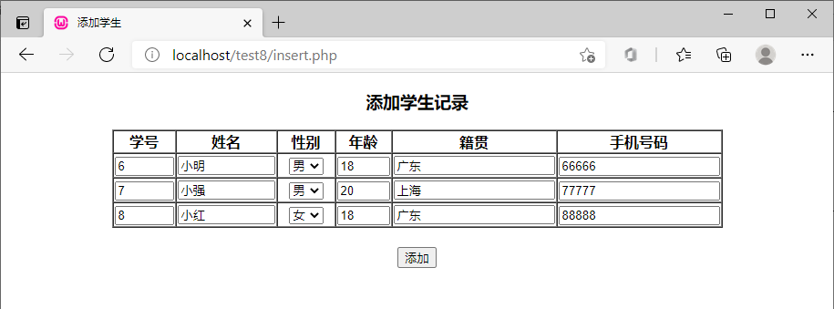
图3 添加学生界面
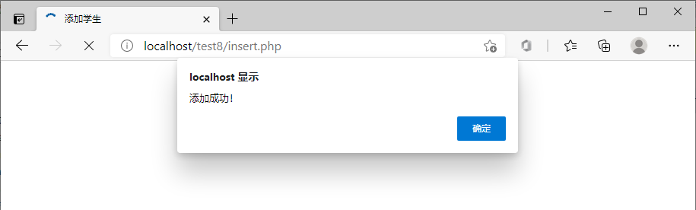
图4 添加成功提示
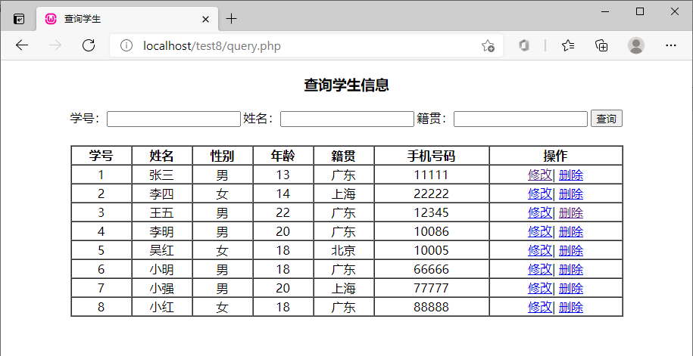
图5 查询学生界面
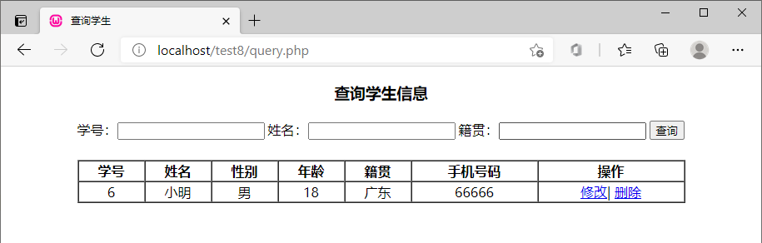
图6 查询学号为“6”的学生
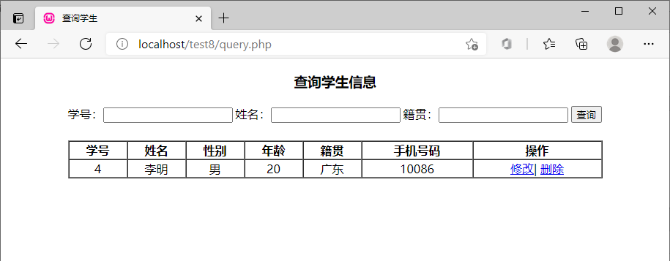
图7 查询姓名为“李明”的学生
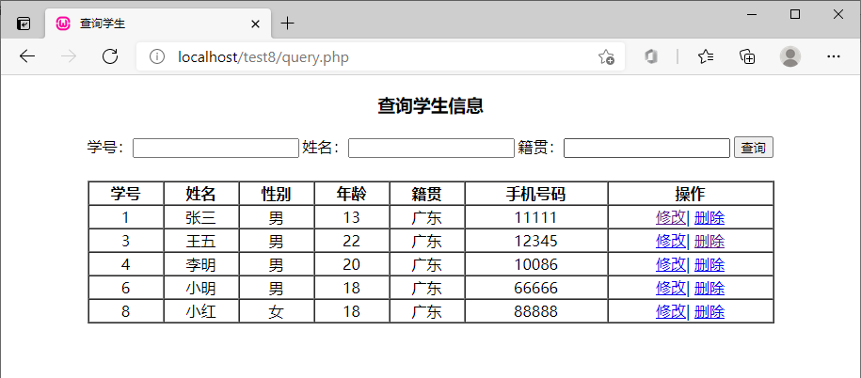
图8 查询籍贯为“广东”的学生
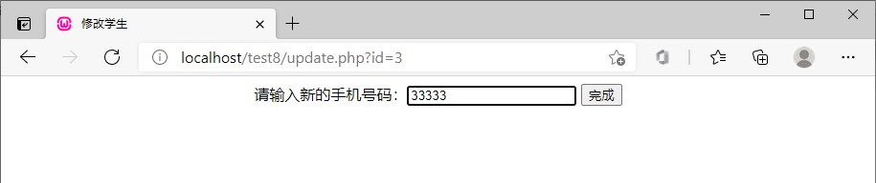
图9 修改学号为“3”的学生的手机号

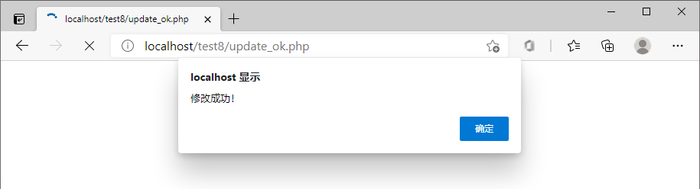
图10 修改成功提示
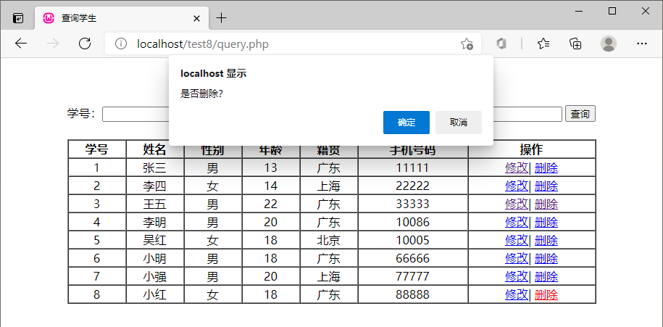
图11 删除学号为“8”的学生前的提示
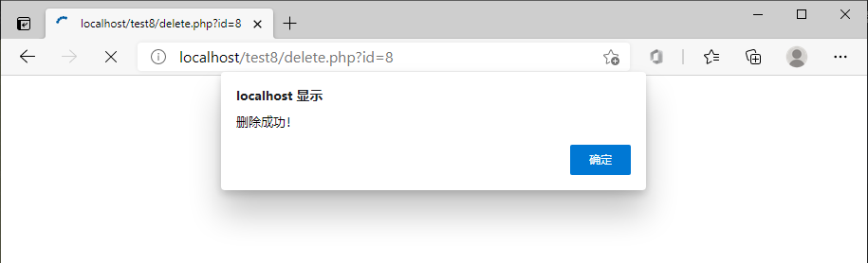
图12 删除成功提示
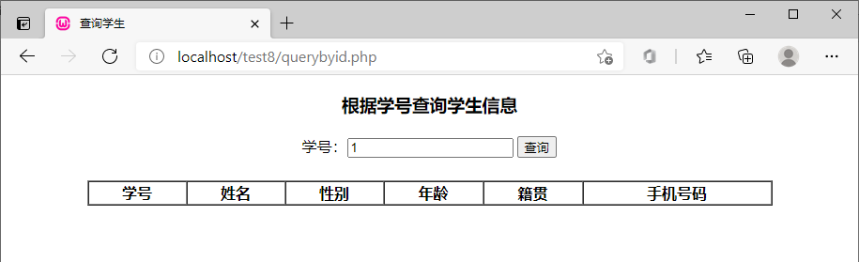
图13 查询学号为“1”的学生
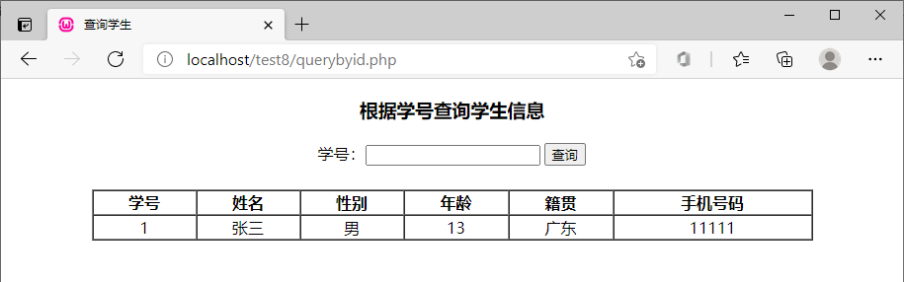
图14 查询结果

