**NAME : Leela** Sekhar Chowdary Mannava

**ID (700#) :**700740979

**E-Mail :**lxm09790@ucmo.edu

**Assignment :**2

**Tools :x Google** Colab

**Programming:** Python

**GitHub**

**Link:** [**https://github.com/LXM09790/ML_ASSIGNMENT2.git**](https://github.com/LXM09790/ML_ASSIGNMENT2.git)

**Question1:**

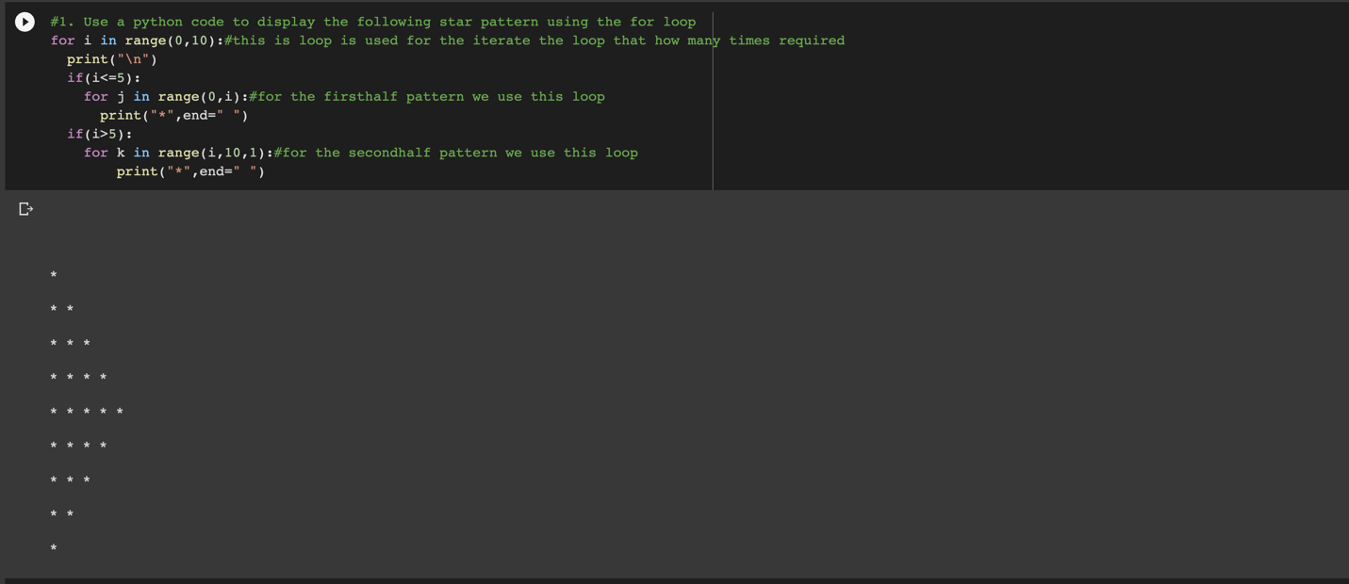

**Explanation:**

1.By using For loop we can print the pattern.

2.Based on pattern size we use range function to iterate the loop and print the pattern.

**Question2:**

**Explanation:**

1.By using for loop we can iterate the elements based on list indexes.

2.To get the values in the odd indexes by using condition i%2! =0 we can get odd indexes.

**Question3:**

**Explanation:**

1.for loop is used to access the elements in the list

1.By using type () we can get the type of elements in the list. And we added the values to the new list.

**Question4:**

1.By using def function we can create a function.

2.By using set () we can remove the duplicates in the list.

3.By using list () we can convert set to the list.

**Question5:**

1.By using def keyword we can create a function.

2.map () is used for accessing the elements with out using for loop.

3.isupper returns the upper-case values.

4.islower returns the lower-case value.