COSTc = resource cost + chain failure cost + feature failure cost

参与调整的概率：

Pc = 1-(COSTc/∑COSTc)^(1/n), c∈CFCa-CFCd

Pc = 1 , c∈CFCj

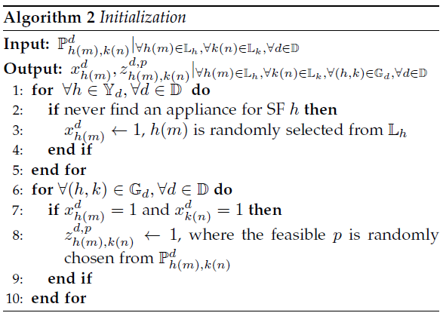

**Initialization过程**

**-----------------------------------------------------------------------------------**

**for** each c ∈CFCj **do**

X(c, Ic) = 1 , Ic从feature集合中随机挑选c的一种实现

**for** each f∈Ic∩Fphy **do**

A(f, n) = 1 , 为每个物理feature选择对应的功能节点

**end for**

**end for**

**-----------------------------------------------------------------------------------**

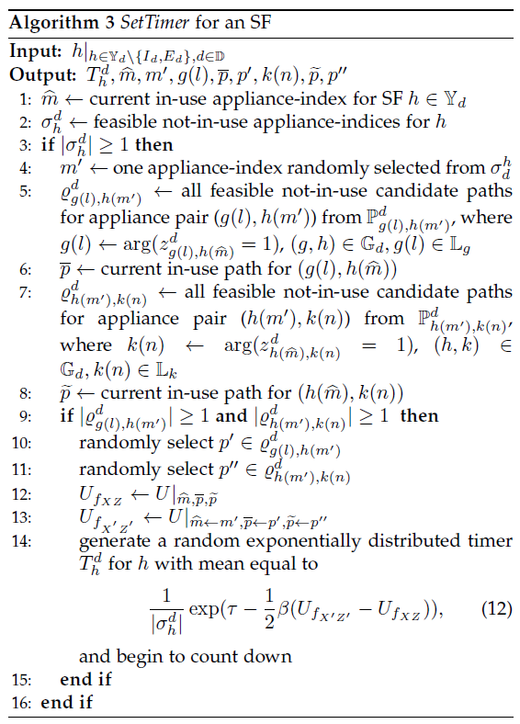

**SetTimer过程**

**-----------------------------------------------------------------------------------**

in-use实现方式Ic以及COSTc

可选的实现方式（除Ic以外）集合Qc

**if** |Qc| > 0 **then**

从Qc中随机选取一个I’c

**for** each f∈I’c∩Fphy **do**

f可用的功能节点集合Nf

**if |**Nf| > 0 **then**

A’(f, n) = 1 , 随机选择功能节点

**end if**

**end for**

**if** each **|**Nf| > 0 **then**

更新选择将得到的COST’c

设定计时器Tc = (1/|Qc|)exp(β(COST’c-COSTc)-τ)并开始倒计时

**end if**

**end if**

**-----------------------------------------------------------------------------------**

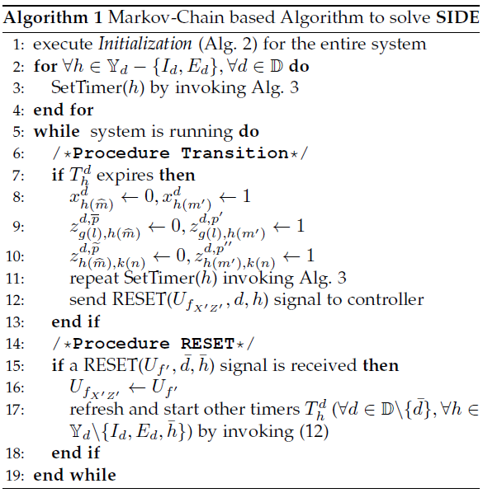

**MC 过程**

**-----------------------------------------------------------------------------------**

**while** program is running **do**

/* 转移状态 */

**if** 计时器Tc过期 **then**

Ic = I’c

A(f, n) = A’(f, n)

调用SetTimer(c)

发送signal(c, A, COSTc)

**end if**

/* 计时器重置 */

**if** 收到signal(c, A) **then**

COSTc = COST’c

重置其他c的所有计时器为刚刚SetTimer计算出的值

**end if**

**end while**

**-----------------------------------------------------------------------------------**

min:

COST = ∑COSTc + ∑(update cost)c, c∈CFCa-CFCd+CFCj