The Stack China Is Building
A Value-Chain Map of China's Indigenous AI Ecosystem
Flagship research report · Data as-of mid-2026 · For financial-market experts, economists & industry analysts
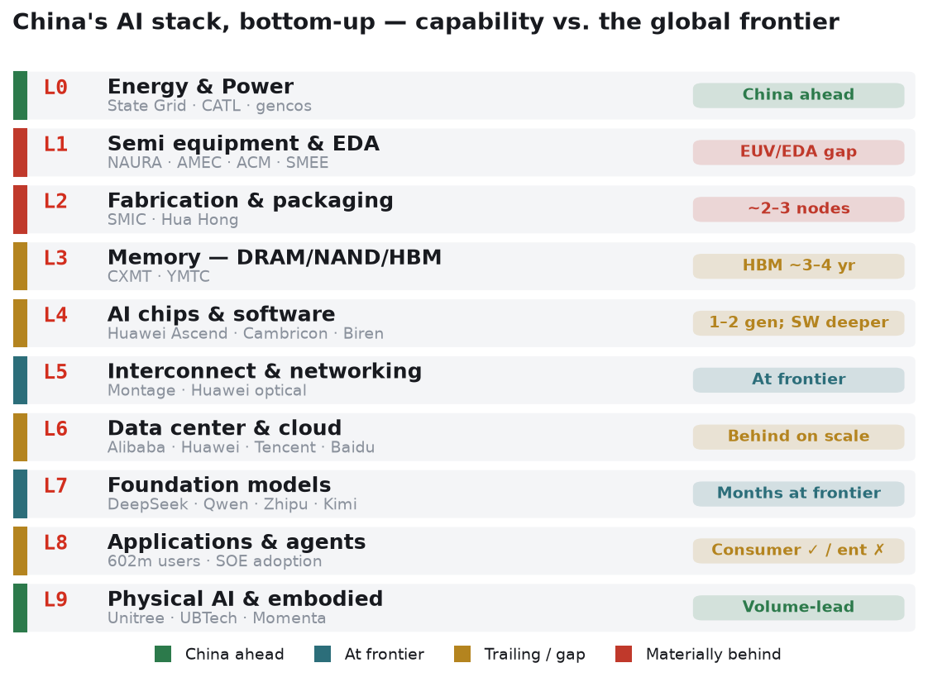

Confidence discipline. Every quantitative claim traces to the evidence database (/database/) with a source ID and an A–D confidence grade (A = filed/audited · B = primary disclosure · C = credible third-party · D = single-source / estimate). In a sector re-rating this fast, treat 2026 point figures — especially pre-listing valuations and private-company numbers — as provisional. Cross-source conflicts are documented in /database/RECONCILIATION.md rather than smoothed over.
Executive summary
The thesis in one line. China is building a parallel, vertically-indigenized AI stack under export-control pressure; it is one to several years behind the US frontier at almost every layer, but the direction, coordination, and capital behind the build-out are creating a distinct investable ecosystem whose value is migrating from where investors still look (consumer internet) to where the work is actually happening (equipment, memory, compute, interconnect, power, and embodied AI).
Seven things a professional investor should take away:
1. The binding constraint is lithography, and it is not close to resolved. Without EUV, SMIC's 7nm-class (N+2) line runs at ~30–40% yield vs. TSMC's >80%, ~2.5× cost/wafer, and ~30× the lithography steps (WEB-014, C). Every downstream ambition — more Ascend chips, indigenous HBM — is rationed by this one chokepoint. The indigenous-EUV "2028 goal" is realistically a lab-prototype milestone, not volume parity (WEB-007, D).
2. China's answer to a chip-level deficit is a system-level bet. Huawei's Ascend 910C is ~60% of an H100 on inference (WEB-028, C), but CloudMatrix / Atlas 950 rack-scale designs lash together up to 8,192 NPUs (16 PB/s aggregate interconnect) to compete with Nvidia's GB200 NVL72 at the rack — at ~4× the power (metrics L4/L5, C). "Lose at the chip, win at the rack, pay for it with electricity."
3. Power is China's one unambiguous structural advantage. China generates ~10,000 TWh/yr vs. the US ~4,600 (WEB-001, C), added +1,840 GW of wind+solar (2025), and is engineering curtailment arbitrage into data centers. If — and only if — domestic silicon closes the compute gap, latent power lets the build-out run faster than most Western models assume (a conditional, D-grade inference, not a fact).
4. The software moat (CUDA) is the deepest, slowest-closing gap — 3–5+ years — even as Huawei open-sources CANN and Chinese labs (DeepSeek, Zhipu) demonstrate frontier training on domestic silicon.
5. The capital-markets regime is the real 2026 catalyst. A deliberate "slow-bull" equity policy (since Sept-2024) has produced an IPO cluster — Zhipu, MiniMax, Biren, Iluvatar and Montage's H-share all listing within ~5 weeks; Moore Threads/MetaX STAR debuts up +468%/+693% day-one — turning national champions into public, tradeable, and often extremely richly-valued securities.
6. Investability ≠ listing. The highest-momentum names (Moore Threads, MetaX, Biren, Kunlunxin) sit on the US Entity List and, increasingly, Treasury's outbound-investment (OISP) net — trading freely in Shanghai/Hong Kong yet effectively closed to US capital. The cleanest foreign-investable exposures are the platform incumbents (Alibaba, Tencent) and a handful of un-listed-constraint names (Montage, CATL).
7. The valuation structure is policy-driven, not earnings-driven. Cambricon briefly crossed a RMB 1tn market cap (first STAR company to do so) on ~$0.9bn revenue; CXMT's pre-listing valuation guidance spans RMB 295bn–3tn. This is a market pricing captive demand and national-champion sponsorship, not current cash flows — the opportunity and the risk are the same fact.
How to read the map. Sections 3.0–3.9 walk the stack bottom-up; each layer resolves into market structure → capability vs. the global frontier (with a timeline) → moats & economics → bottlenecks → named players → an investability read. Section 5 synthesizes: where value is captured, a China-vs-US scorecard, the stack-mapped basket, scenarios, and risks.
1. Why China's AI stack is its own investment universe
Two doctrines. US frontier labs treat AI as a race to superintelligence, where a few months' lead may compound into permanent advantage; the effort concentrates on the frontier model. China treats AI as infrastructure — like electricity, water, or the internet — to be diffused across the whole economy, with a pronounced tilt toward the physical world (manufacturing, robotics) where China is already dominant (REF-BW-03). This is not merely rhetorical: it shapes where capital goes (systems and diffusion, not only frontier training), what "winning" looks like (90% economy-wide AI penetration targeted by 2030; ~70% by 2027 — L8 metrics, C), and why China tolerates a chip-level deficit while racing on rack-scale systems, power, and embodied AI.
The self-sufficiency imperative. US export controls — on advanced chips, EUV lithography, HBM, and semiconductor equipment — reframed every foreign dependency as a weaponizable vulnerability. China's response is to indigenize every choke point. This is the origin of the investment opportunity that Sands Capital and Bridgewater both identify: policy manufactures captive domestic demand and national-champion sponsorship for any firm that can climb the technical curve. The corollary, per Bridgewater, is that this is a diversifying bet — the indigenous names do not price off the global AI supply chain, because their fortunes turn on Chinese policy and domestic substitution, not on Nvidia's order book.
The macro backdrop (context). China's economy is deliberately uneven: a ~4.5% headline growth target (about half the high-growth-era pace), weak property and consumption, but hyper-competitive strategic-export industries and a top-down reallocation of fiscal and financial resources toward AI, robotics, and the industrial build-out (REF-BW-03). The same mercantilist dynamic that pressures Europe and fuels the global tariff cycle is what funds the AI stack. For allocators, Chinese AI equities are attractive less as a growth-beta play than as a diversifier with a policy put ("slow bull") beneath the equity market.
2. The macro frame: compute supply–demand and the capex cycle
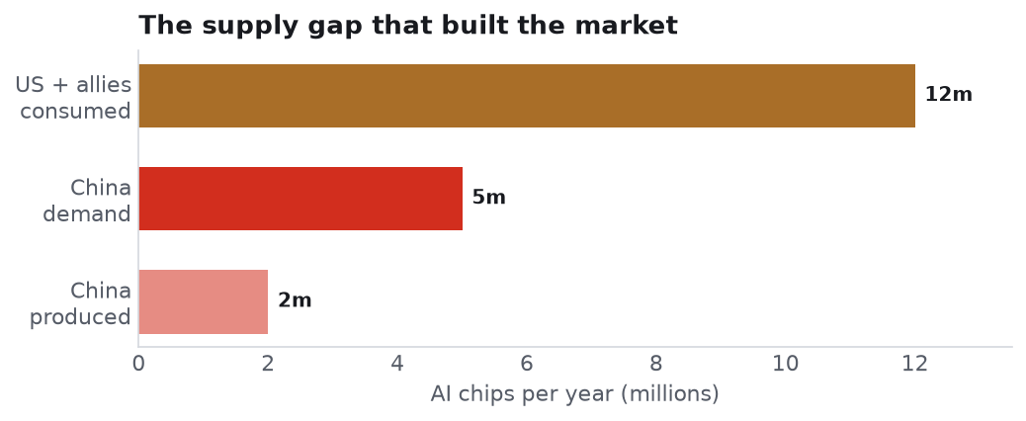
Figure 1 — The supply gap that built the market. Sources: REF-SANDS-01 (C), REF-BW-01 (D).
A low base. Bridgewater's triangulation puts total compute accessible to Chinese AI firms at ~3.8 GW (including capacity housed abroad), of which ~2.5 GW is available for inference (~65% split) — a fraction of the major US labs' fleets (C→D, REF-BW-01). The supply gap is stark at the device level too: the US and allies consume ~12m AI chips/year; China produces ~2m domestically against demand that may already exceed 5m (REF-SANDS-01, C).
The squeeze is showing up in prices. After years of aggressive discounting, Alibaba, Baidu and Tencent all raised AI-compute list prices in 2026, and Chinese model vendors priced their latest flagships above predecessors — behavior consistent with compute (not demand) as the binding constraint (REF-BW-01). Zhipu, in its first post-IPO print, named compute capacity as the limiting factor on its business.
The capex response is captive. The 15th Five-Year Plan (Mar-2026) elevated AI to the primary national objective; a draft ~$295bn national AI data-center grid mandates ≥80% domestic technology (L6 metrics, B/C). Because policy guarantees demand, the domestic build-out does not face the demand uncertainty that haunts early-stage tech elsewhere — the risk migrates from "will there be customers?" to "can the technology scale?" That is the single most important reframing for valuing these names.
The efficiency offset. Chinese models are unusually compute-efficient in inference (DeepSeek's architecture work is the emblem), partially offsetting the hardware deficit. Even doubling the effective compute requirement, China's inference fleet remains well below the US majors' — but the gap in deliverable intelligence is narrower than the raw GW gap implies.
3. The stack, layer by layer

Figure 2 — Value-chain map: China's AI stack, bottom-up, with capability vs. the global frontier.
3.0 Energy & Power (L0)
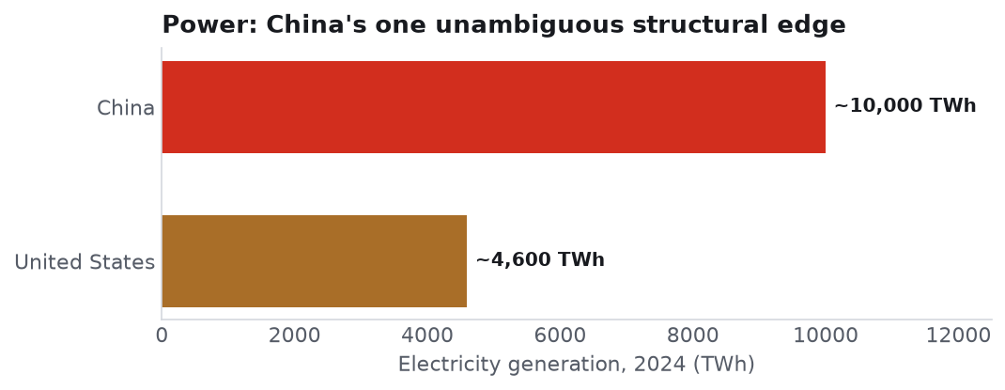
Figure 3 — Electricity generation, China vs. US, 2024. Sources: WEB-001 (C).
Market structure. The one layer where China leads outright. Generation ~10,000 TWh (2024) vs. US ~4,600, +~500 TWh added in 2025 alone (WEB-001, C). Installed data-center capacity ~32 GW (2025), forecast to ~40 GW (2026) and ~60 GW (2030) (Rystad, WEB-002, C). A $580bn 15FYP grid-capex program and 15 new UHV lines move power from the renewable-rich west to demand centers (WEB-005, C). Wind+solar installed base hit ~1,840 GW in 2025, surpassing thermal for the first time (WEB-024, C).
The arbitrage. Curtailed renewables (solar ~9.2%, wind ~8.5% early-2026) are being routed into data centers via the "East-Data-West-Compute" program (63% hub occupancy; ~$33bn cumulative investment) (WEB-003/004, C). Green-DC policy targets PUE ≤1.25 and ≥80% renewable sourcing for new builds (WEB-023).
Capability vs. frontier / the conditional edge. The US faces a power ceiling: data-center demand ~31 GW (2025) → ~66 GW (2027), with a forecast ~49 GW delivery shortfall by 2028 (Morgan Stanley/Grid Strategies, WEB-021, D). China faces no such near-term ceiling. But abundant power is necessary, not sufficient: the payoff to China's energy advantage is gated on domestic silicon closing the compute gap (L1/L3/L4). This is the report's central conditional — a D-grade inference, not a citable fact.
Investability. State Grid is unlisted (uninvestable). The cleanest listed proxy is CATL (SZSE:300750 / HKEX:3750, ~$420bn; grid-storage revenue ~$8.6bn, 121 GWh shipped 2025) — foreign-investable, no Entity-List flag. Nuclear (110 GW target by 2030) and the UHV/grid-equipment complex are secondary plays for a dedicated pod to size.
3.1 Semiconductor equipment & EDA (L1)
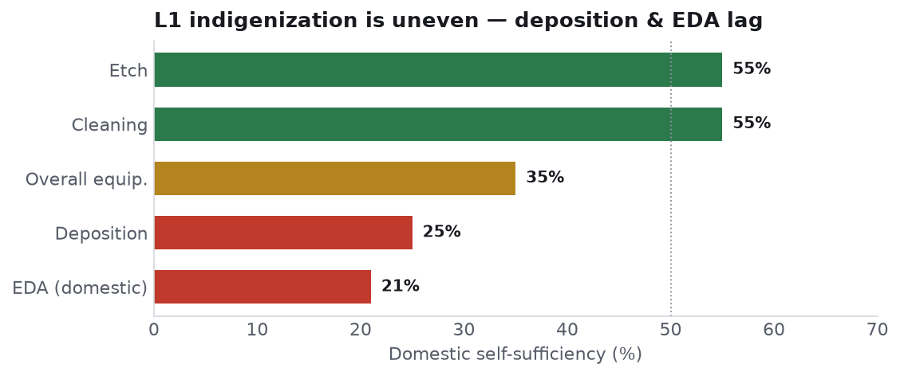
Figure 4 — L1 self-sufficiency by segment. Sources: WEB-009/011/019 (C→D).
Market structure. A broad domestic roster is climbing segment by segment: NAURA (SZSE:002371, ~$82.5bn) is the breadth champion (etch, deposition, clean, thermal); AMEC (SSE:688012, ~$29.8bn) the etch specialist with a genuine world-class ambition; ACM Research (SSE:688082 / NASDAQ:ACMR, ~$6.4bn) in cleaning; plus Piotech (deposition), Kingsemi (track/coat), Hwatsing (CMP). In EDA, Empyrean (SZSE:301269) and Primarius (SSE:688206) anchor a consolidating sector. SMEE (state, unlisted) carries the lithography burden, and SiCarrier (Huawei-linked, unlisted, ~$9bn est., D) is the wild-card full-stack entrant.
Capability vs. frontier. Overall equipment self-sufficiency ~35% (Jan-2026, C), but wildly uneven: etch and clean ~55%, deposition only ~25% (the weakest major sub-segment), and lithography/EDA the widest gaps. Collectively, Chinese WFE vendors are still only ~6.5% of the global WFE market (up from 1.2% in 2021) (WEB-009/010, C→D). EDA is the widest gap by market value — Empyrean+Primarius vs. Synopsys+Cadence is a ~20×+ mismatch — and the May-2025 US EDA ban acted as a demand subsidy: Empyrean's H1 revenue grew but profit fell ~92% on import-substitution spend (WEB-011, C).
EUV, quantified. The indigenous LPP light source measured ~100–150W mid-2025 vs. >250W needed for high-volume manufacturing; a separate SSMB/synchrotron effort at Tsinghua/Xiong'an is years from product (WEB-007, D). Read the 2028 target as a lab demo. Meanwhile DUV multipatterning imposes the ~2.5× cost and ~30–40% yield penalty that rations everything above it.
Moats & economics. Two moat types: AMEC's process-knowledge compounding (every wafer run improves the next tool — not purchasable, not reverse-engineerable), and NAURA's breadth-as-lock-in (a fab qualified on NAURA across four process steps faces years of switching cost). The 50% domestic-equipment mandate for new fabs converts these into near-guaranteed order books (WEB-018, C).
Investability. All the pure-plays are A-share/STAR listed and Stock-Connect/QFII-restricted for foreign capital; NAURA's subsidiary and SMIC R&D units were added to the Entity List in Mar-2025, and the proposed MATCH Act names NAURA/AMEC/ACM/SMIC/Hua Hong explicitly (WEB-016, C). ACMR (the US-listed parent line) is the one partial exception. Net: high strategic conviction, constrained access.
3.2 Fabrication & advanced packaging (L2)
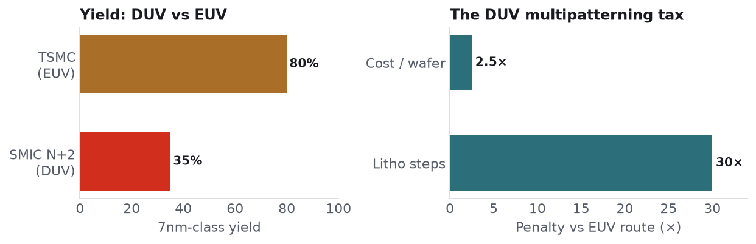
Figure 5 — 7nm-class yield and the DUV multipatterning penalty. Sources: WEB-014 (C).
Market structure. Two national champions: SMIC (HKEX:0981 / SSE:688981, ~$90bn) and Hua Hong (HKEX:1347 / SSE:688347, ~$23.5bn). SMIC runs the 7nm-class (N+2) line that fabs Huawei's Ascend; Hua Hong's Huali JV targets initial 7nm output (a few thousand wpm) by end-2026, which would make it China's second advanced-node line.
Capability vs. frontier. Stuck at 7nm-class for the foreseeable future without EUV; 5nm-class exists only in pilot and at punishing yield. SMIC's advanced-node yield ~20–46% (cross-checked ~35%) vs. TSMC >80% (C). 2026 capex ~$8.1bn, mostly for mature-node expansion (~340k wpm across four new fabs) — capacity, not frontier. Advanced packaging (TSV, CoWoS-analogs, hybrid bonding) is a co-binding constraint, ~3 years behind the frontier (WEB-015, D) and pivotal to any indigenous HBM.
Economics & investability. Foundry is the scarce shared resource behind nearly every L4 chip vendor — SMIC capacity is the system chokepoint, and China's own 5× 7nm-and-under capacity target by end-2027 is already constraining 2026 shipment plans. Both are dual-listed (HK + STAR); SMIC is Entity-Listed. HK lines offer the most (still-restricted) foreign access.
3.3 Memory — DRAM / NAND / HBM (L3)
Market structure. CXMT (DRAM; global share risen to ~7.7%, #4 behind Samsung/SK hynix/Micron) and YMTC (3D NAND; ~14.5% share) are the two champions, both pivoting toward the AI memory stack. CXMT's Q1-2026 was a coming-of-age print: RMB 50.8bn revenue, RMB 24.76bn net profit (+1,688% YoY), 95.7% utilization, ~80% DDR5 (G3) yield (WEB-001/002, C).
The HBM path. HBM is the acute AI-memory bottleneck. Indigenous HBM requires both a domestic DRAM base and TSV/hybrid-bonding packaging — YMTC's Phase-3 (~50% of capacity to DRAM + TSV via its XMC unit) is building toward exactly this. CXMT targets HBM2E in 2026 as a bridge, with HBM3 slipping toward 2027 on yield/thermal issues (WEB-003, D). China's global HBM share today is negligible against SK hynix (~62%), Samsung (~21%), Micron (~17%) (metrics L3, C).
Capital markets — the next big test. Both filed in May-2026. CXMT cleared STAR review (~$4.3bn raise; valuation guidance a very wide RMB 295bn–3tn); YMTC is in IPO counseling (estimates RMB 500bn–3tn). These are the largest, and most valuation-contested, listings in the pipeline — treat any point valuation as D. Both are Entity-Listed (YMTC since Dec-2022, litigating; CXMT added to DoD 1260H in Jun-2026), so foreign access will be restricted even post-listing.
3.4 AI chips & software ecosystems (L4)
Market structure. The most crowded, most strategically-central, and most-constrained layer. Huawei Ascend is the flagship (private; est. ~$12bn AI-chip revenue 2026, C). Listed challengers: Cambricon (SSE:688256, ~$120bn), the four "little dragon" GPU firms — Moore Threads (SSE:688795), MetaX, Biren (HKEX:6844), Iluvatar (HKEX) — plus Baidu Kunlunxin and Alibaba's T-Head (captive) and ByteDance's in-house silicon.
Capability vs. frontier — the two-level story. At the device level China is ~1–2 generations behind: Ascend 910C ≈ 60% of H100 inference (DeepSeek's own benchmark, WEB-028, C). At the system level Huawei's CloudMatrix 384 / Atlas 950 SuperPoD scales to 8,192 NPUs (~300 PFLOPS BF16; 16 PB/s interconnect) and claims to match/exceed GB200 NVL72 at the rack — at ~4× the power. The software gap is the deep one: CANN/MindSpore vs. CUDA is a 3–5+ year moat, though Huawei has open-sourced CANN and DeepSeek/Zhipu have shown frontier training without Nvidia (WEB-026/027, C→D).
The procurement mandate is the demand engine. 50% domestic-chip rule for state-funded DCs (Aug-2025) → full foreign-accelerator ban in state projects (Nov-2025) → the draft ≥80%-domestic national grid (2026). Nvidia's China data-center share fell from ~95% (2023) to <60% (H2-2025) toward the CEO's "~0" 2026 framing — yet reporting is unreconciled (ByteDance alone reportedly planned ~$14bn of 2026 Nvidia purchases). This contradiction is a flagged open question, not resolved.
Investability — the sharpest constraint in the report. Nearly every merchant GPU name is Entity-Listed (Biren and Moore Threads named in the Oct-2023 action) and increasingly OISP-flagged. HK-listed Biren/Iluvatar are the most open; STAR-listed Cambricon/Moore Threads/MetaX are Connect/QFII-restricted; Huawei/ByteDance are fully closed. Valuations are policy-driven: Cambricon briefly hit RMB 1tn on ~$0.9bn revenue then corrected ~14% on its own risk warning; the GPU IPOs popped +468% to +693% day-one. The purest exposure is the least accessible to US capital.
3.5 Interconnect & networking (L5)
Market structure. The quiet chokepoint where China has a genuine global leader. Montage (SSE:688008 / HKEX:6809) holds ~36.8% of the global memory-interface market (MRCD/MDB, CKD, PCIe/CXL retimers) — an oligopoly with Rambus/Renesas, high qualification barriers, long lifecycles, a JEDEC board seat. FY2025 revenue RMB 5.456bn (+50%), gross margin ~62%; interconnect-segment revenue +93.8% YoY in Q1-2026; 1m+ cumulative PCIe retimers shipped (WEB-007/008, B/C). Huawei supplies the scale-up optical fabric (8,192-NPU clusters, 16 PB/s). Optical-module names Innolight and Eoptolink ride Nvidia/global 800G demand (Innolight ~60% of Nvidia 800G orders, C).
Why it matters. As models scale, the binding constraint migrates from compute to data movement — memory bandwidth and node-to-node latency. Montage is expanding from memory-interface into PCIe/optical/Ethernet exactly as that layer becomes the bottleneck. It is the rare China name that is a global incumbent leader, not a substitute.
Investability — a bright spot. Montage carries no Entity-List flag and is foreign-investable (esp. via HKEX:6809). Its H-share IPO (Feb-2026) priced at a 44% discount to the A-share, popped +64% on debut, and by mid-2026 A/H had converged to near-parity — a notable reversal of the historical A-premium and a signal of international conviction. Optical-module names are A-share-restricted.
3.6 Data center & cloud (L6)
Market structure. Alibaba Cloud leads China's AI cloud (~35.8% 2025 → ~38.1% 2026; revenue growth re-accelerated to +38% YoY in Q1-2026) and is the closest China analog to a Western hyperscaler — its own chips (T-Head), its own models (Qwen), and deep enterprise integration (WEB, B/C). Huawei Cloud is #2 in overall China cloud-infra (~17% Q4-2025; external revenue ~RMB 32bn). ByteDance's Volcengine is the fastest-rising AI-cloud (~14.8% AI-cloud share; MaaS revenue targeting RMB 15bn in 2026 from RMB 1.5bn, and ~RMB 200bn AI capex, D). Baidu AI Cloud grew AI-infrastructure revenue +79% YoY (Q1-2026, B). Tencent Cloud rounds out the majors.
Capability & economics. Structurally behind the US hyperscalers on scale and unit cost (global benchmark: ~$7.9bn to own+operate 1 GW; $2tn cumulative hyperscaler capex through 2026 — REF-EV-01), but growing off a low base with a captive market and the national data-center grid (~$295bn, ≥80% domestic) as a demand floor. The cloud layer is where Alibaba's "compounding infrastructure" thesis lives: every enterprise that builds on Alibaba Cloud + Qwen deepens a switching-cost moat the retail narrative ignores.
Investability. Alibaba (HKEX:9988 / NYSE:BABA, ~$231bn), Tencent (HKEX:0700, ~$520bn), Baidu (HKEX:9888 / NASDAQ:BIDU, ~$38bn) are the most liquid, foreign-investable AI exposures in China, trade at a discount to global hyperscaler peers (weighed down by non-AI legacy lines), and are not Entity-Listed. Huawei Cloud and Volcengine are trapped inside private/closed parents.
3.7 Foundation models (L7)
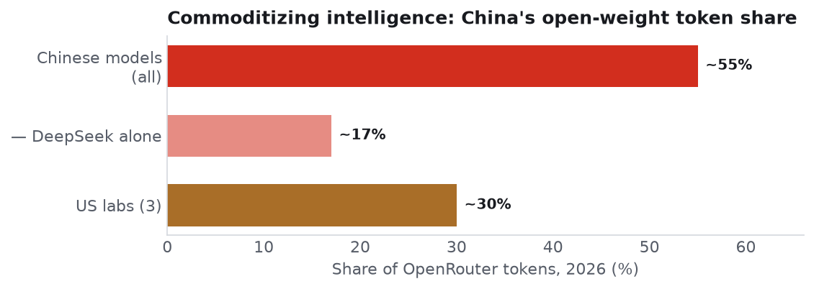
Figure 6 — Chinese-model share of OpenRouter tokens, 2026 (C).
Market structure. A vibrant, largely open-weight field: DeepSeek (R1 the Jan-2025 catalyst; V4 co-optimized for Ascend/Cambricon), Alibaba Qwen (open+closed; 180k+ derivative models by Oct-2025 — the largest open-model ecosystem globally), ByteDance Doubao, Zhipu GLM/Z.ai, MiniMax, Moonshot Kimi, Baidu Ernie, Tencent Hunyuan.
Capability vs. frontier. Behind OpenAI/Anthropic/Google at the very frontier, but the gap is measured in months on many benchmarks and the open-weight tier is globally competitive. Chinese models now take a striking share of third-party token demand: ~33% → as high as ~55–61% of OpenRouter tokens in 2026 (DeepSeek alone ~17%), as US-lab share fell toward ~30% among those self-selecting, cost-sensitive users (metrics L7, C). The strategic play is commoditize the model layer — cheap, open, good-enough intelligence as infrastructure — which simultaneously pressures Western labs' pricing power.
Investability. The listed exposures are the platform parents (Alibaba, Tencent, Baidu). Among pure model labs, Zhipu (~$75–87bn) and MiniMax (~$14–20bn) IPO'd in HK in Jan-2026 (Zhipu beat OpenAI to market and re-rated ~10× intra-year) but are Connect-restricted; DeepSeek (implied ~$52–59bn first external round), ByteDance, and Moonshot remain private. The re-rating of Zhipu is the sharpest illustration of the policy-driven valuation regime.
3.8 Applications, agents & adoption (L8)
Market structure & adoption. ~602m generative-AI users, all on domestic platforms (C). Consumer scale is real: Doubao ~100m DAU (145m Spring-Festival peak), ~260m MAU; Qwen and YuanBao 50–75m DAU at peak; combined top-5 chat/search apps ~900m MAU (D). For scale reference, ChatGPT ~190m DAU globally.
The weak spot. Enterprise SaaS/monetization is thin relative to the US — China's software economy is smaller and less willing to pay per-seat, so the US "AI takes business services" playbook translates poorly. Policy is pushing the other lever: SOE-adoption mandates and the 15FYP diffusion targets (70% by 2027, 90% by 2030). Coding is an instructive gap — GitHub Copilot still leads China's coding-assistant market (~64.5%) with Alibaba's Tongyi Lingma at ~12.9% (C).
Investability. Captured mainly through the platform incumbents (Alibaba, Tencent, ByteDance-private) rather than standalone app equities; the enterprise-AI opportunity is more a margin story for the clouds than a separate investable tier today.
3.9 Physical AI & embodied (L9)
Market structure — China's chosen battleground. The layer most aligned with China's manufacturing edge and infrastructure doctrine. Humanoids: Unitree (STAR IPO approved in a record 104 days, ~$6bn target; 2025 revenue RMB 1.69bn, +335%), UBTech (HKEX:9880; U-series orders >13,361), AgiBot/Zhiyuan (~$6.4bn, HK IPO planned H2-2026), Galbot (~$3bn), Fourier (~$1.1bn). Robotaxi/AV — a direct EV-chain spillover: Baidu Apollo Go (>22m cumulative rides, 27 cities), Pony.ai (NASDAQ:PONY), WeRide (NASDAQ:WRD, ~$2.4bn), Momenta (HKEX:6880, ~$9bn IPO, debuted Jul-2026; ~64.5% of the independent urban-NOA market). Supporting silicon: Horizon Robotics (HKEX:9660).
Capability & economics. China leads on volume and price (295k industrial robots installed in 2024, ~54% of global; humanoids shipping at price points far below Figure/1X) but not yet on profitability — every name is loss-making (Horizon: RMB 10.5bn loss on RMB 3.8bn revenue). Backed by the ~$138bn AI+robotics state fund and ~¥1tn robotics program. US humanoid peers (Figure ~$39bn) carry far higher valuations on far less revenue — a valuation asymmetry worth watching.
Investability — the most open China-AI layer for foreigners. Several names are US- or HK-listed and not obviously Entity-flagged: WeRide, Pony.ai, Momenta, UBTech, Horizon Robotics. This is where a foreign investor can get relatively clean embodied-AI exposure — with the caveat that these are early, cash-burning, and volatile.
4. The horizontal overlay
4.1 Policy & industrial strategy
Four reinforcing tracks: (1) the 15th FYP (AI as primary national objective; diffusion targets); (2) mega-funds — ~$295bn national DC grid, ~$138bn AI+robotics fund, the "Big Fund" Phase III at RMB 344bn (~$47.5bn, largest phase, now explicitly covering HBM/AI-semis); (3) mandates — 50% domestic equipment for new fabs, escalating domestic-chip rules for state DCs (50% → full foreign-accelerator ban → ≥80% grid), SOE adoption; (4) the Aug-2025 "AI+" State Council initiative. The through-line: policy converts technical uncertainty into demand certainty.
4.2 Export controls & geopolitics (timeline)
Controls turned bidirectional in 2025–26. Tightening peaked with Dec-2024 HBM + Foreign-Direct-Product-Rule controls and rolling Entity-List additions (Mar-2025 tranche hit NAURA/SMIC units). But H20 (banned Apr-2025, restored with a 15% fee Aug-2025) and H200 (case-by-case since Jan-2026 with a 25% tariff, capped at ≤50% of US-customer volume) both loosened — while China paused (not repealed) its rare-earth/gallium/germanium leverage through ~Nov-2026 as part of a post-summit truce. The proposed MATCH Act would ban all ASML DUV to China (~20% of ASML 2026 revenue) and names the champions explicitly. Taiwan remains the tail risk: not the modal 12-month outcome per the reference analysts, but a portfolio-defining scenario whose mere possibility is itself an inflationary, spending-inducing force.
4.3 Talent & R&D
China's edge is applied engineering density and open-source contribution (DeepSeek, Qwen, Kimi, MiniMax all ship influential open weights). The state has grown protective as the stack has gained value — credible reports of intervening against talent/IP moving abroad (e.g., via Singapore vehicles) and restrictions on staff at leading labs. Treat the talent layer as a strategic asset that is increasingly managed like one.
4.4 Capital markets, the IPO wave & the investable basket
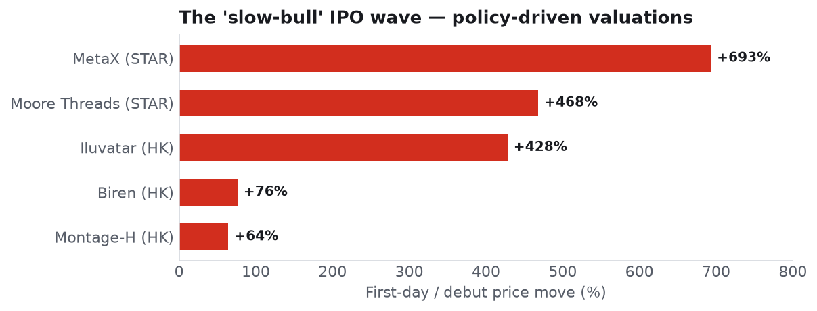
Figure 7 — 2025–26 China AI-stack IPOs, debut price moves. Sources: WEB (B/C).
The Sept-2024 "slow-bull" pivot reframed the equity market as a strategic financing tool for national champions and a savings vehicle to replace property. The result is the 2025–26 IPO cluster: Zhipu, MiniMax, Biren, Iluvatar and Montage's H-share all listing within ~5 weeks; Moore Threads/MetaX on STAR with +468%/+693% day-one pops; CXMT and YMTC the next, much larger tests. Montage's A/H premium inverted (H went from a 44% discount to a premium), a marker of international conviction. Forward P/Es for the broad China-AI set sit ~18–19 — similar to global peers — but off a far lower earnings base, which is the bull case and the reason earnings are unstable enough to make multiples unreliable (REF-BW-01).
The access overlay (decisive for allocators). Treasury's OISP (broadened by the Dec-2025 NDAA/COINS Act) now overlaps heavily with Entity-List flags on Moore Threads, MetaX, Biren, and Kunlunxin — making the highest-momentum GPU IPOs effectively closed to US capital even while they trade freely in Hong Kong. Foreign-investable, non-flagged exposures cluster in the platform incumbents (Alibaba, Tencent, Baidu), Montage, CATL, and parts of L9 (WeRide, Pony.ai, Momenta, UBTech, Horizon).
5. Synthesis
5.1 Where value is captured — bottleneck economics
Margin pools where a scarce, hard-to-replicate capability meets captive demand. Today that is: lithography/EUV (the ultimate chokepoint, but not yet investable domestically), advanced foundry (SMIC — the shared scarce resource), memory interface/interconnect (Montage — a genuine global incumbent), advanced packaging/HBM (emerging), and power (China's structural edge, best played via CATL/grid). The model and app layers are commoditizing by design — China's strategy is to make intelligence cheap infrastructure, which caps value capture there and pushes it down into hardware and up into physical AI.
5.2 China-vs-US scorecard (capability gap · timeline · access)
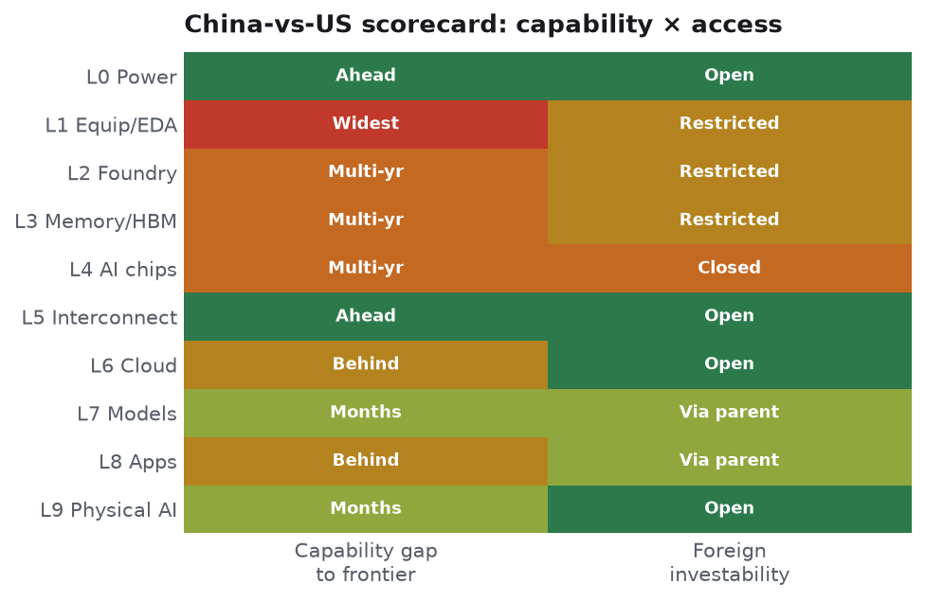
Figure 8 — Scorecard: capability gap × foreign investability, by layer.
Layer | Gap to frontier | Timeline to parity | Foreign-investable?
L0 Power | China ahead | — | Yes (CATL)
L1 Equipment/EDA | 1–3 gen (EUV/EDA widest) | EUV: lab ~2028, HVM 2030s | Restricted
L2 Foundry | ~2–3 nodes | Gated on EUV | Restricted (HK)
L3 Memory/HBM | HBM ~3–4 yr; DRAM closing | HBM3 ~2027+ | Restricted post-IPO
L4 AI chips | ~1–2 gen device; closer at rack | SW (CUDA) 3–5 yr | Mostly closed to US
L5 Interconnect | China at frontier (Montage) | — | Yes (Montage)
L6 Cloud | Behind on scale/cost | 3–5 yr | Yes (BABA/Tencent)
L7 Models | Months at frontier; open-weight competitive | Rolling | Parents yes; labs restricted
L8 Apps | Consumer ahead; enterprise behind | — | Via parents
L9 Physical AI | Volume-lead; profitability-behind | — | Most open
5.3 The investable basket (stack-mapped)
- Core, foreign-investable, high-conviction: Alibaba (L4/6/7), Tencent (L6/7), Montage (L5), CATL (L0), Baidu (L4/6/7).
- High-conviction, access-constrained: NAURA, AMEC, ACM (L1); SMIC, Hua Hong (L2); Cambricon (L4) — own via HK lines or Connect where eligible; watch Entity/OISP.
- Event-driven / pipeline: CXMT, YMTC (L3 IPOs); Kunlunxin (L4 IPO); Unitree, AgiBot (L9 IPOs).
- Cleaner embodied-AI access: WeRide, Pony.ai, Momenta, UBTech, Horizon (L9).
Construct as a diversifier (low correlation to the global AI supply chain), sized for the Entity-List/OISP overlay and the policy put beneath the market — not as concentrated growth beta.
5.4 Scenarios (2027 / 2030)
- Base: Indigenization advances unevenly — foundry/memory/interconnect/power progress, EUV lags. China fields competitive rack-scale systems and open models; capex cycle sustained by policy. China-AI equities compound off a low base with high dispersion.
- Bull: A domestic EUV or HBM breakthrough, or a decisive rack-scale win, closes the compute gap; power advantage converts into a build-out that outpaces US expectations. Champions re-rate toward global peers; the diversifier becomes a growth engine.
- Bear: EUV stalls, yields stay low, the demand mandate outruns deliverable technology; a Taiwan/rare-earth flashpoint or an OISP tightening strands foreign capital. Policy-inflated multiples de-rate hard.
5.5 Risk register
Policy reversal (low — commitment is structural); technology failure at EUV/HBM (the key gating risk); demand-mandate outrunning capability; overbuild/valuation air-pocket (policy-inflated multiples); geopolitical flashpoint (Taiwan/rare earths); investability/regulatory risk (Entity-List + OISP stranding US capital) — the most underappreciated practical risk for Western allocators.
5.6 Second-order effects
Global-equity valuation convergence (US↔non-US risk-premium compression); a structural bid under the memory cycle (indigenous HBM demand); energy/commodities (China's power/grid/storage build); downward pressure on global token pricing as China commoditizes open-weight intelligence; and a persistent mercantilist impulse as strategic-sector strength coexists with weak domestic demand.
Appendix
- A. Methodology & confidence grading — see /database/schema.md and /database/RECONCILIATION.md.
- B. Company master & data — /database/company_master.csv (43 cos.), metrics_timeseries.csv (192), policy_funding_tracker.csv (36), model_catalog.csv (21), chip_catalog.csv (26), sources.csv (119).
- C. Analyst pod memos — full detail in /research/pod1…pod6_*.md.
- D. Key open questions — Nvidia's true China share; CXMT/YMTC valuations; indigenous-EUV timeline; Biren ticker/entity status (see RECONCILIATION.md).
- E. Reference scaffolding — Bridgewater ×3, Sands Capital, Exponential View (sources.csv REF-*).

