# UART

10：配置与rx接收（ok）

11：直接发（ok）

12：burst发（ok）

# I2C

30：配置与i2c scan（ok）

31：直接写（ok）

32：直接读（ok）

35：寄存器写（ok）

36：寄存器读（ok）

37：burst写（ok）

38：寄存器burst写（ok）

33：slave接收（ok），注意device地址如果是0x28，则i2c要写的第一个byte为地址值，应该是0x28<<1=0x50，是不一样的。

34：slave发送（ok，但是只能发一次就结束了，不能一直发）

# ESP8266模块调试

1）这个模块电流极大，500mA以上，需要用单独的板子提供电源和地。这是关键！！

2）命令需要加上换行回车（0d 0a）

3）基本指令流程：

AT+RST //重启wifi

AT //AT测试命令

AT+GMR //版本信息

AT+CWMODE=1 //设置为Station模式

AT+CWLAP //列出当前可用AP

AT+CWJAP=”TP_LINK_92AA06”,”0123456789” //加入AP

AT+CIFSR //查询IP

AT+CIPMUX=0 //设置单连接

AT+CIPSTART=”TCP”,”192.168.1.100”,8080 //连接到服务器

AT+CIPSEND=24 //设置发送数据长度

Hi, I am a wifi module!!! //发送的内容

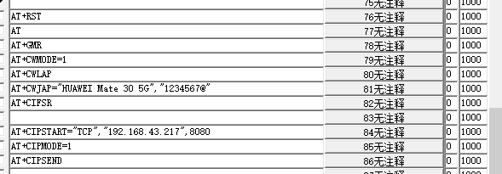

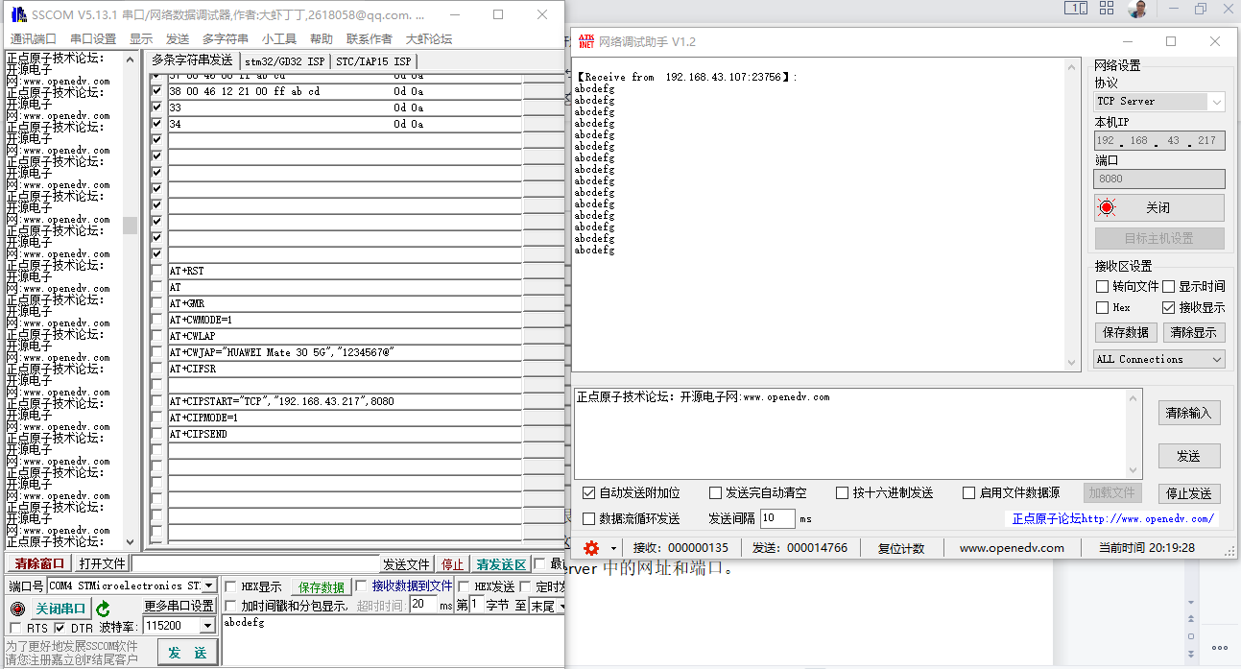

参考正点原子的ATK-ESP8266模块的资料可以很轻松的玩起来。里面的文档步骤很清楚。

需要先用网络调试助手（原子给的资料中这些软件都带有）先建立一个TCP Server。AT+CIPSTART中所填的网址和端口，就是TCP Server中的网址和端口，如上图所示。

# AUDIO CODEC：CS42L51

1. 电源使能信号： PG3=1
2. 开启PG3=1后，启动i2c scan，将会扫描到2个地址：0x70和0x94。0x70是用于CS42L51设备控制管理的地址，0x94是用于CS42L51配置的地址。







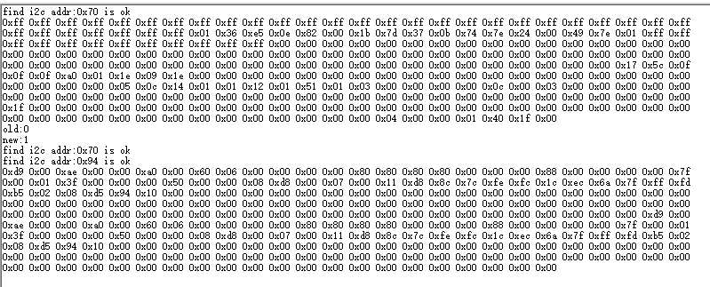

注意0x70的地址可以用36指令读（设置基地址0x00，长度0xff后一次性burst读出来，地址自动自增加）

0x94的地址需要用39指令读（one_by_one的读，因为地址不能自动增加）

上面的读的结果：上面是0x70开头的256个地址数据。下面是0x94开头的256个数据。用的是不同指令读的。这个数据与CS42L51的手册对比了一下，是对的。

# 关于FrameBuffer的选择导致HardFault

如果FrameBuffer选择AXI SRAM，当用jpeg时会产生Hardfault。

如果FrameBuffer选择SDRAM，则用jpeg时候正常。

原因未知，折腾了一个周末。

建议先用SDRAM作FrameBuffer，待以后细细研究。

# NRF24L01

移植原子的代码，非常精简清晰。只需要修改和实现底层的spi读写函数即可驱动起来。

## 发射

|  |  |  |  |  |  |  |  |  |  |  |
| --- | --- | --- | --- | --- | --- | --- | --- | --- | --- | --- |
| Time [s] | Packet ID | MOSI | MISO |  |  |  |  |  |  |  |
| 0 | 0 | 0xFF | 0x0E |  |  |  |  |  |  |  |
| 0.000012048 | 1 | 0x30 | 0x0E | 发送地址，用于检测nrf24l01是否存在 |  |  |  |  |  |  |
| 0.000023766 | 1 | 0xA5 | 0x00 |  |  |  |  |  |  |  |
| 0.000035484 | 1 | 0xA5 | 0x00 |  |  |  |  |  |  |  |
| 0.000047206 | 1 | 0xA5 | 0x00 |  |  |  |  |  |  |  |
| 0.000058928 | 1 | 0xA5 | 0x00 |  |  |  |  |  |  |  |
| 0.000070648 | 1 | 0xA5 | 0x00 |  |  |  |  |  |  |  |
| 0.000083272 | 2 | 0x10 | 0x0E | 读回地址，与发送的一样，说明nrf24l01存在 |  |  |  |  |  |  |
| 0.000094964 | 2 | 0xFF | 0xA5 |  |  |  |  |  |  |  |
| 0.000106658 | 2 | 0xFF | 0xA5 |  |  |  |  |  |  |  |
| 0.00011835 | 2 | 0xFF | 0xA5 |  |  |  |  |  |  |  |
| 0.000130038 | 2 | 0xFF | 0xA5 |  |  |  |  |  |  |  |
| 0.000141726 | 2 | 0xFF | 0xA5 |  |  |  |  |  |  |  |
| 0.00301804 | 3 | 0x30 | 0x0E | 发送地址，正式 |  |  |  |  |  |  |
| 0.00302979 | 3 | 0x34 | 0x00 |  |  |  |  |  |  |  |
| 0.003041544 | 3 | 0x43 | 0x00 |  |  |  |  |  |  |  |
| 0.003053296 | 3 | 0x10 | 0x00 |  |  |  |  |  |  |  |
| 0.003065046 | 3 | 0x10 | 0x00 |  |  |  |  |  |  |  |
| 0.003076798 | 3 | 0x01 | 0x00 |  |  |  |  |  |  |  |
| 0.0030895 | 4 | 0x2A | 0x0E | 接收P0地址，正式 |  |  |  |  |  |  |
| 0.003101248 | 4 | 0x34 | 0x00 |  |  |  |  |  |  |  |
| 0.003112998 | 4 | 0x43 | 0x00 |  |  |  |  |  |  |  |
| 0.00312475 | 4 | 0x10 | 0x00 |  |  |  |  |  |  |  |
| 0.0031365 | 4 | 0x10 | 0x00 |  |  |  |  |  |  |  |
| 0.003148254 | 4 | 0x01 | 0x00 |  |  |  |  |  |  |  |
| 0.003160878 | 5 | 0x21 | 0x0E | 使能通道0的自动应答 |  |  |  |  |  |  |
| 0.00317247 | 5 | 0x01 | 0x00 |  |  |  |  |  |  |  |
| 0.003185074 | 6 | 0x22 | 0x0E | 使能通道0的接收地址 |  |  |  |  |  |  |
| 0.00319667 | 6 | 0x01 | 0x00 |  |  |  |  |  |  |  |
| 0.00320928 | 7 | 0x24 | 0x0E | 设置自动重发间隔时间:500us + 86us;最大自动重发次数:10次 |  |  |  |  |  |  |
| 0.003220878 | 7 | 0x1A | 0x00 |  |  |  |  |  |  |  |
| 0.003233488 | 8 | 0x25 | 0x0E | 设置RF通道为40 |  |  |  |  |  |  |
| 0.003245084 | 8 | 0x28 | 0x00 |  |  |  |  |  |  |  |
| 0.003257696 | 9 | 0x26 | 0x0E | 设置TX发射参数,0db增益,2Mbps,低噪声增益开启 |  |  |  |  |  |  |
| 0.003269294 | 9 | 0x0F | 0x00 |  |  |  |  |  |  |  |
| 0.003281904 | 10 | 0x20 | 0x0E | 配置基本工作模式的参数;PWR_UP,EN_CRC,16BIT_CRC,发射模式,开启所有中断 |  |  |  |  |  |  |
| 0.0032935 | 10 | 0x0E | 0x00 |  |  |  |  |  |  |  |
| 0.003306934 | 11 | 0xA0 | 0x0E | 写数据到TX BUF 32个字节，此时全部是0x00 |  |  |  |  |  |  |
| 0.003318654 | 11 | 0x00 | 0x00 |  |  |  |  |  |  |  |
| 0.003330374 | 11 | 0x00 | 0x00 |  |  |  |  |  |  |  |
| 0.003342094 | 11 | 0x00 | 0x00 |  |  |  |  |  |  |  |
| 0.003353818 | 11 | 0x00 | 0x00 |  |  |  |  |  |  |  |
| 0.00336554 | 11 | 0x00 | 0x00 |  |  |  |  |  |  |  |
| 0.003377258 | 11 | 0x00 | 0x00 |  |  |  |  |  |  |  |
| 0.003388978 | 11 | 0x00 | 0x00 |  |  |  |  |  |  |  |
| 0.003400696 | 11 | 0x00 | 0x00 |  |  |  |  |  |  |  |
| 0.003412416 | 11 | 0x00 | 0x00 |  |  |  |  |  |  |  |
| 0.003424134 | 11 | 0x00 | 0x00 |  |  |  |  |  |  |  |
| 0.003435856 | 11 | 0x00 | 0x00 |  |  |  |  |  |  |  |
| 0.003447578 | 11 | 0x00 | 0x00 |  |  |  |  |  |  |  |
| 0.003459298 | 11 | 0x00 | 0x00 |  |  |  |  |  |  |  |
| 0.003471022 | 11 | 0x00 | 0x00 |  |  |  |  |  |  |  |
| 0.003482748 | 11 | 0x00 | 0x00 |  |  |  |  |  |  |  |
| 0.003494466 | 11 | 0x00 | 0x00 |  |  |  |  |  |  |  |
| 0.00350619 | 11 | 0x00 | 0x00 |  |  |  |  |  |  |  |
| 0.003517912 | 11 | 0x00 | 0x00 |  |  |  |  |  |  |  |
| 0.003529634 | 11 | 0x00 | 0x00 |  |  |  |  |  |  |  |
| 0.003541354 | 11 | 0x00 | 0x00 |  |  |  |  |  |  |  |
| 0.003553078 | 11 | 0x00 | 0x00 |  |  |  |  |  |  |  |
| 0.003564802 | 11 | 0x00 | 0x00 |  |  |  |  |  |  |  |
| 0.003576524 | 11 | 0x00 | 0x00 |  |  |  |  |  |  |  |
| 0.003588248 | 11 | 0x00 | 0x00 |  |  |  |  |  |  |  |
| 0.00359997 | 11 | 0x00 | 0x00 |  |  |  |  |  |  |  |
| 0.003611692 | 11 | 0x00 | 0x00 |  |  |  |  |  |  |  |
| 0.003623412 | 11 | 0x00 | 0x00 |  |  |  |  |  |  |  |
| 0.003635132 | 11 | 0x00 | 0x00 |  |  |  |  |  |  |  |
| 0.003646854 | 11 | 0x00 | 0x00 |  |  |  |  |  |  |  |
| 0.003658576 | 11 | 0x00 | 0x00 |  |  |  |  |  |  |  |
| 0.0036703 | 11 | 0x00 | 0x00 |  |  |  |  |  |  |  |
| 0.00368202 | 11 | 0x00 | 0x00 |  |  |  |  |  |  |  |
| 0.00417108 | 12 | 0x07 | 0x2E | 读取状态寄存器的值 |  |  |  |  |  |  |
| 0.004182632 | 12 | 0xFF | 0x2E |  |  |  |  |  |  |  |
| 0.004195196 | 13 | 0x27 | 0x2E | 清除TX_DS或MAX_RT中断标志 |  |  |  |  |  |  |
| 0.004206794 | 13 | 0x2E | 0x00 |  |  |  |  |  |  |  |
| 1.510888216 | 14 | 0xA0 | 0x0E | 写数据到TX BUF 32个字节，此时是正式数据 |  |  |  |  |  |  |
| 1.510899944 | 14 | 0x21 | 0x00 |  |  |  |  |  |  |  |
| 1.510911672 | 14 | 0x22 | 0x00 |  |  |  |  |  |  |  |
| 1.510923398 | 14 | 0x23 | 0x00 |  |  |  |  |  |  |  |
| 1.510935122 | 14 | 0x24 | 0x00 |  |  |  |  |  |  |  |
| 1.510946846 | 14 | 0x25 | 0x00 |  |  |  |  |  |  |  |
| 1.51095857 | 14 | 0x26 | 0x00 |  |  |  |  |  |  |  |
| 1.510970296 | 14 | 0x27 | 0x00 |  |  |  |  |  |  |  |
| 1.51098202 | 14 | 0x28 | 0x00 |  |  |  |  |  |  |  |
| 1.510993746 | 14 | 0x29 | 0x00 |  |  |  |  |  |  |  |
| 1.511005468 | 14 | 0x2A | 0x00 |  |  |  |  |  |  |  |
| 1.511017196 | 14 | 0x2B | 0x00 |  |  |  |  |  |  |  |
| 1.511028928 | 14 | 0x2C | 0x00 |  |  |  |  |  |  |  |
| 1.511040658 | 14 | 0x2D | 0x00 |  |  |  |  |  |  |  |
| 1.511052388 | 14 | 0x2E | 0x00 |  |  |  |  |  |  |  |
| 1.511064114 | 14 | 0x2F | 0x00 |  |  |  |  |  |  |  |
| 1.511075842 | 14 | 0x30 | 0x00 |  |  |  |  |  |  |  |
| 1.511087568 | 14 | 0x31 | 0x00 |  |  |  |  |  |  |  |
| 1.511099292 | 14 | 0x32 | 0x00 |  |  |  |  |  |  |  |
| 1.511111018 | 14 | 0x33 | 0x00 |  |  |  |  |  |  |  |
| 1.511122742 | 14 | 0x34 | 0x00 |  |  |  |  |  |  |  |
| 1.51113447 | 14 | 0x35 | 0x00 |  |  |  |  |  |  |  |
| 1.511146194 | 14 | 0x36 | 0x00 |  |  |  |  |  |  |  |
| 1.51115792 | 14 | 0x37 | 0x00 |  |  |  |  |  |  |  |
| 1.511169648 | 14 | 0x38 | 0x00 |  |  |  |  |  |  |  |
| 1.511181372 | 14 | 0x39 | 0x00 |  |  |  |  |  |  |  |
| 1.511193102 | 14 | 0x3A | 0x00 |  |  |  |  |  |  |  |
| 1.511204826 | 14 | 0x3B | 0x00 |  |  |  |  |  |  |  |
| 1.511216554 | 14 | 0x3C | 0x00 |  |  |  |  |  |  |  |
| 1.511228282 | 14 | 0x3D | 0x00 |  |  |  |  |  |  |  |
| 1.511240008 | 14 | 0x3E | 0x00 |  |  |  |  |  |  |  |
| 1.511251736 | 14 | 0x3F | 0x00 |  |  |  |  |  |  |  |
| 1.511263462 | 14 | 0x40 | 0x00 |  |  |  |  |  |  |  |
| 1.511752516 | 15 | 0x07 | 0x2E | 读取状态寄存器的值 |  |  |  |  |  |  |
| 1.511764068 | 15 | 0xFF | 0x2E |  |  |  |  |  |  |  |
| 1.511776634 | 16 | 0x27 | 0x2E | 清除TX_DS或MAX_RT中断标志 |  |  |  |  |  |  |
| 1.511788232 | 16 | 0x2E | 0x00 |  |  |  |  |  |  |  |

## 轮询接收

|  |  |  |  |  |  |  |  |  |  |  |
| --- | --- | --- | --- | --- | --- | --- | --- | --- | --- | --- |
| Time [s] | Packet ID | MOSI | MISO |  |  |  |  |  |  |  |
| -0.000008036 | 0 | 0xFF | 0x00 |  |  |  |  |  |  |  |
| 0.000004016 | 1 | 0x30 | 0x0E | 发送地址，用于检测nrf24l01是否存在 |  |  |  |  |  |  |
| 0.000015742 | 1 | 0xA5 | 0x00 |  |  |  |  |  |  |  |
| 0.00002747 | 1 | 0xA5 | 0x00 |  |  |  |  |  |  |  |
| 0.000039194 | 1 | 0xA5 | 0x00 |  |  |  |  |  |  |  |
| 0.000050918 | 1 | 0xA5 | 0x00 |  |  |  |  |  |  |  |
| 0.000062644 | 1 | 0xA5 | 0x00 |  |  |  |  |  |  |  |
| 0.0000753 | 2 | 0x10 | 0x0E | 读回地址，与发送的一样，说明nrf24l01存在 |  |  |  |  |  |  |
| 0.000087022 | 2 | 0xFF | 0xA5 |  |  |  |  |  |  |  |
| 0.00009873 | 2 | 0xFF | 0xA5 |  |  |  |  |  |  |  |
| 0.000110436 | 2 | 0xFF | 0xA5 |  |  |  |  |  |  |  |
| 0.000122146 | 2 | 0xFF | 0xA5 |  |  |  |  |  |  |  |
| 0.000133854 | 2 | 0xFF | 0xA5 |  |  |  |  |  |  |  |
| 0.003010648 | 3 | 0x2A | 0x0E | 接收P0地址，正式 |  |  |  |  |  |  |
| 0.003022402 | 3 | 0x34 | 0x00 |  |  |  |  |  |  |  |
| 0.00303416 | 3 | 0x43 | 0x00 |  |  |  |  |  |  |  |
| 0.003045918 | 3 | 0x10 | 0x00 |  |  |  |  |  |  |  |
| 0.00305767 | 3 | 0x10 | 0x00 |  |  |  |  |  |  |  |
| 0.003069424 | 3 | 0x01 | 0x00 |  |  |  |  |  |  |  |
| 0.00308208 | 4 | 0x21 | 0x0E | 使能通道0的自动应答 |  |  |  |  |  |  |
| 0.003093678 | 4 | 0x01 | 0x00 |  |  |  |  |  |  |  |
| 0.003106318 | 5 | 0x22 | 0x0E | 使能通道0的接收地址 |  |  |  |  |  |  |
| 0.003117918 | 5 | 0x01 | 0x00 |  |  |  |  |  |  |  |
| 0.003130558 | 6 | 0x25 | 0x0E | 设置RF通道为40 |  |  |  |  |  |  |
| 0.003142158 | 6 | 0x28 | 0x00 |  |  |  |  |  |  |  |
| 0.003154802 | 7 | 0x31 | 0x0E | 选择通道0的有效数据宽度=0x20=32 |  |  |  |  |  |  |
| 0.0031664 | 7 | 0x20 | 0x00 |  |  |  |  |  |  |  |
| 0.003179042 | 8 | 0x26 | 0x0E | 设置TX发射参数,0db增益,2Mbps,低噪声增益开启 |  |  |  |  |  |  |
| 0.003190644 | 8 | 0x0F | 0x00 |  |  |  |  |  |  |  |
| 0.003203288 | 9 | 0x20 | 0x0E | 配置基本工作模式的参数;PWR_UP,EN_CRC,16BIT_CRC,接收模式 |  |  |  |  |  |  |
| 0.003214892 | 9 | 0x0F | 0x00 |  |  |  |  |  |  |  |
| 0.003228102 | 10 | 0x07 | 0x0E | 读取状态寄存器的值 |  |  |  |  |  |  |
| 0.003239704 | 10 | 0xFF | 0x0E |  |  |  |  |  |  |  |
| 0.00325232 | 11 | 0x27 | 0x0E | 清除TX_DS或MAX_RT中断标志 |  |  |  |  |  |  |
| 0.003263924 | 11 | 0x0E | 0x00 |  |  |  |  |  |  |  |
| 0.00338357 | 12 | 0x07 | 0x0E | 读取状态寄存器的值 |  |  |  |  |  |  |
| 0.00339517 | 12 | 0xFF | 0x0E |  |  |  |  |  |  |  |
| 0.003407784 | 13 | 0x27 | 0x0E | 清除TX_DS或MAX_RT中断标志 |  |  |  |  |  |  |
| 0.003419386 | 13 | 0x0E | 0x00 |  |  |  |  |  |  |  |
| 0.003539036 | 14 | 0x07 | 0x0E | 注意：发射1.5ms每次，接收要密集轮询，100us轮询一次，避免丢数据 |  |  |  |  |  |  |

|  |  |  |  |  |  |  |  |
| --- | --- | --- | --- | --- | --- | --- | --- |
| 1.31069573 | 16824 | 0x07 | 0x40 | 接收轮询STAUS，检测到有数据来了 |  |  |  |
| 1.31070733 | 16824 | 0xFF | 0x40 |  |  |  |  |
| 1.31071994 | 16825 | 0x27 | 0x40 | 清除标志 |  |  |  |
| 1.31073154 | 16825 | 0x40 | 0x00 |  |  |  |  |
| 1.310744152 | 16826 | 0x61 | 0x00 | 开始读取数据fifo,32个 |  |  |  |
| 1.310755874 | 16826 | 0xFF | 0x47 |  |  |  |  |
| 1.31076758 | 16826 | 0xFF | 0x48 |  |  |  |  |
| 1.310779288 | 16826 | 0xFF | 0x49 |  |  |  |  |
| 1.310790998 | 16826 | 0xFF | 0x4A |  |  |  |  |
| 1.310802706 | 16826 | 0xFF | 0x4B |  |  |  |  |
| 1.310814416 | 16826 | 0xFF | 0x4C |  |  |  |  |
| 1.31082612 | 16826 | 0xFF | 0x4D |  |  |  |  |
| 1.310837824 | 16826 | 0xFF | 0x4E |  |  |  |  |
| 1.310849528 | 16826 | 0xFF | 0x4F |  |  |  |  |
| 1.310861232 | 16826 | 0xFF | 0x50 |  |  |  |  |
| 1.310872938 | 16826 | 0xFF | 0x51 |  |  |  |  |
| 1.310884642 | 16826 | 0xFF | 0x52 |  |  |  |  |
| 1.310896344 | 16826 | 0xFF | 0x53 |  |  |  |  |
| 1.31090805 | 16826 | 0xFF | 0x54 |  |  |  |  |
| 1.310919754 | 16826 | 0xFF | 0x55 |  |  |  |  |
| 1.31093146 | 16826 | 0xFF | 0x56 |  |  |  |  |
| 1.310943162 | 16826 | 0xFF | 0x57 |  |  |  |  |
| 1.310954864 | 16826 | 0xFF | 0x58 |  |  |  |  |
| 1.310966566 | 16826 | 0xFF | 0x59 |  |  |  |  |
| 1.31097827 | 16826 | 0xFF | 0x5A |  |  |  |  |
| 1.310989972 | 16826 | 0xFF | 0x5B |  |  |  |  |
| 1.311001676 | 16826 | 0xFF | 0x5C |  |  |  |  |
| 1.311013384 | 16826 | 0xFF | 0x5D |  |  |  |  |
| 1.311025092 | 16826 | 0xFF | 0x5E |  |  |  |  |
| 1.311036798 | 16826 | 0xFF | 0x5F |  |  |  |  |
| 1.311048504 | 16826 | 0xFF | 0x60 |  |  |  |  |
| 1.31106021 | 16826 | 0xFF | 0x61 |  |  |  |  |
| 1.311071916 | 16826 | 0xFF | 0x62 |  |  |  |  |
| 1.311083624 | 16826 | 0xFF | 0x63 |  |  |  |  |
| 1.31109533 | 16826 | 0xFF | 0x64 |  |  |  |  |
| 1.311107034 | 16826 | 0xFF | 0x65 |  |  |  |  |
| 1.311118738 | 16826 | 0xFF | 0x66 |  |  |  |  |
| 1.311131472 | 16827 | 0xE2 | 0x0E | 读完数据，清除接收fifo |  |  |  |
| 1.31114307 | 16827 | 0xFF | 0x00 |  |  |  |  |

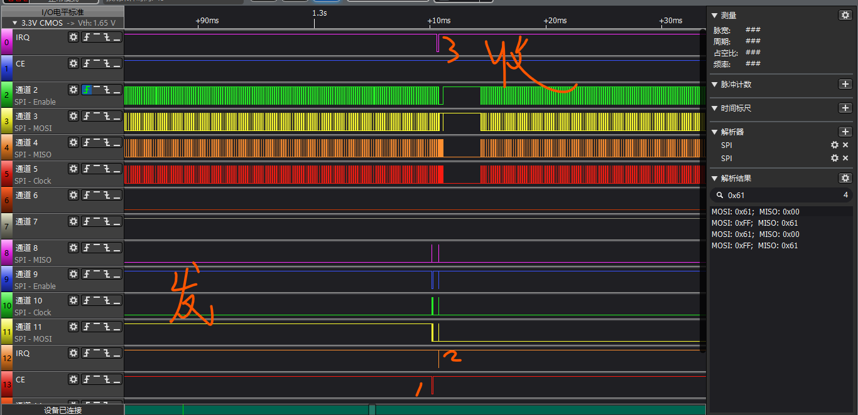

1. 发射每1.5ms一次，接收每100us轮询一次
2. 发射时，图中1：拉低CE开始往fifo发数据，写完拉高CE，正式开始发送。图中2：发送完毕，自动产生IRQ中断pulse。图中3：接收收到数据，产生IRQ中断。如果中断接收，就比较简单了。

## 中断接收

Received DATA:

STUVWXYZ[\]^_`abcdefghijklmnopqr

uartb.cnt=48

53 65 6e 64 65 64 20 44 41 54 41 3a d a 53 54 55 56 57 58 59 5a 5b 5c 5d 5e 5f 60 61 62 63 64 65 66 67 68 69 6a 6b 6c 6d 6e 6f 70 71 72 d a

Sended DATA:

STUVWXYZ[\]^_`abcdefghijklmnopqr

Received DATA:

TUVWXYZ[\]^_`abcdefghijklmnopqrs

uartb.cnt=48

53 65 6e 64 65 64 20 44 41 54 41 3a d a 54 55 56 57 58 59 5a 5b 5c 5d 5e 5f 60 61 62 63 64 65 66 67 68 69 6a 6b 6c 6d 6e 6f 70 71 72 73 d a

Sended DATA:

TUVWXYZ[\]^_`abcdefghijklmnopqrs

Received DATA:

UVWXYZ[\]^_`abcdefghijklmnopqrst

uartb.cnt=48

53 65 6e 64 65 64 20 44 41 54 41 3a d a 55 56 57 58 59 5a 5b 5c 5d 5e 5f 60 61 62 63 64 65 66 67 68 69 6a 6b 6c 6d 6e 6f 70 71 72 73 74 d a

Sended DATA:

UVWXYZ[\]^_`abcdefghijklmnopqrst

Received DATA:

VWXYZ[\]^_`abcdefghijklmnopqrstu

uartb.cnt=48

53 65 6e 64 65 64 20 44 41 54 41 3a d a 56 57 58 59 5a 5b 5c 5d 5e 5f 60 61 62 63 64 65 66 67 68 69 6a 6b 6c 6d 6e 6f 70 71 72 73 74 75 d a

Sended DATA:

VWXYZ[\]^_`abcdefghijklmnopqrstu

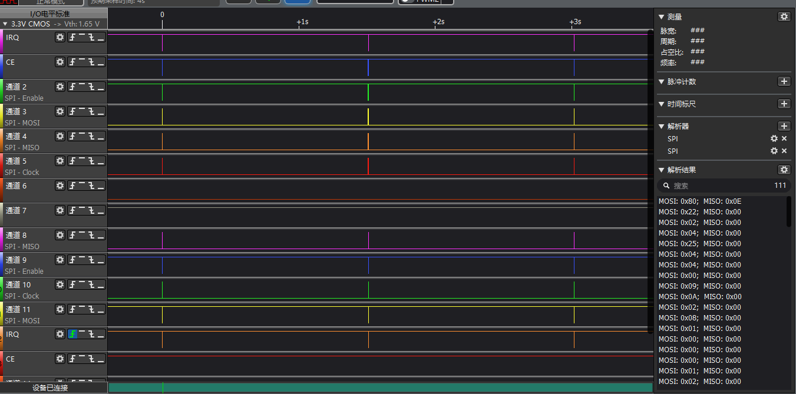

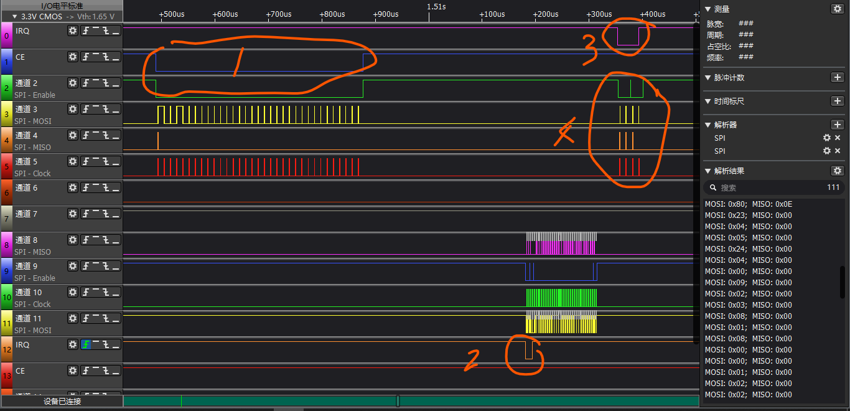

1. TX拉低CE发射数据
2. RX IRQ响应，中断方式读取STATUS并清除STATUS，然后读取数据
3. TX的IRQ拉低，表示数据发送完毕（TX_IRQ在RX_IRQ之后，这个表示应该是有握手的过程。要等到RX接收完成后，TX才确认发送完成）
4. TX读取STATUS并清除STATUS
5. 具体时间：从TX_CE拉到到RX_IRQ时间为304us，从RX数据读完到TX_IRQ时间为40us。